Hosting Accessible Zoom Meetings
Spring 2020, Version 1b

Table of Contents
Before Your First Zoom Meeting 2
Check Zoom Global Settings 2
Allow the host to assign a meeting participant to type closed captions 2
Enable automatically generated transcripts for Zoom cloud recordings 2
Invite Participants to ask for Assistance in Advance 3
Make Materials Available in Advance of a Zoom Meeting 4
Family Education Rights and Privacy Act (FERPA) 4
Within a Zoom Meeting 4
Assign a meeting participant to provide closed captions 4
Provide a variety of methods to Perceive Information 5
To Assist Blind or Visually Impaired Participants: 5
To Assist Deaf or Hard-of-hearing Participants: 6
After a Zoom Meeting 6
Provide a link to meeting recordings 6
Follow-up and Proactively Invite Feedback 6
Remain Flexible 6
If you Need More Help 6
Center for Effective Teaching and Learning (CETL) 6
Office for Students with Disabilities (OSD) 7
Assistive Technology Lab 7
Information Technology Services (ITS) 7
ITS Help Desk Ticket 7
Accessible Technology Initiative 7
Zoom Support Resources 8
Keyboard Shortcuts for the Zoom Windows Desktop Client 8
Acknowledgements 8
Document Properties 9

This guide will assist faculty with the switch to a fully online modality for courses via the Zoom videoconferencing platform and help ensure that their courses remain accessible to all students. Cal State LA students, faculty, and staff have a Zoom Pro account when accessing zoom via Single Sign On (SSO) using their Cal State LA credentials.

Before Your First Zoom Meeting

Check Zoom Global Settings

Log into the Cal State LA Zoom web portal [calstatela.zoom.us] with your GET credentials to enable the following settings in your Zoom default settings page. All future zoom meetings will use these settings, and if so desired, the host can change meeting specific settings for each new meeting.

The need to accommodate a participant in your Zoom meeting may occur spontaneously. By ensuring that the following settings are enabled, you will be better prepared to adapt to future requests.

Allow the host to assign a meeting participant to type closed captions

- Ensure that the toggle button is on for Closed captioning and Save Captions.
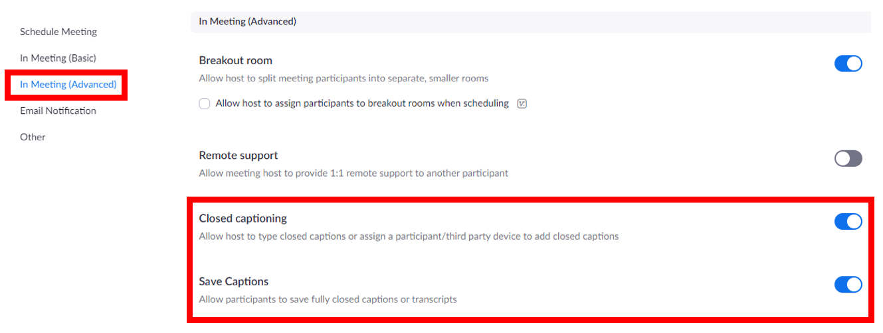Figure 1 – Zoom Global Settings: Closed Captioning

Enable automatically generated transcripts for Zoom cloud recordings

When you record your meeting and save it to the Zoom cloud, Zoom can automatically process the video and provide a machine-generated transcript that follows along as the video plays. Those viewing the video can search this transcript for keywords.

NOTE: The Zoom audio transcription feature may benefit everyone; however, this post-processing transcript does not substitute the need for real-time captions in a meeting for someone who is Deaf or Hard-of-hearing.

- Log in to Zoom through SSO [https://calstatela.zoom.us/]
- Click on Settings>Recording>check the Audio Transcript checkbox>click save
- Zoom will automatically process future cloud recordings and create a machine-generated, searchable transcript that will be viewable alongside the video
- This setting only applies when saved to the Zoom cloud, not to recordings on a local machine
- Processing time for recordings takes at least as long as the recording time, to time and a half to complete

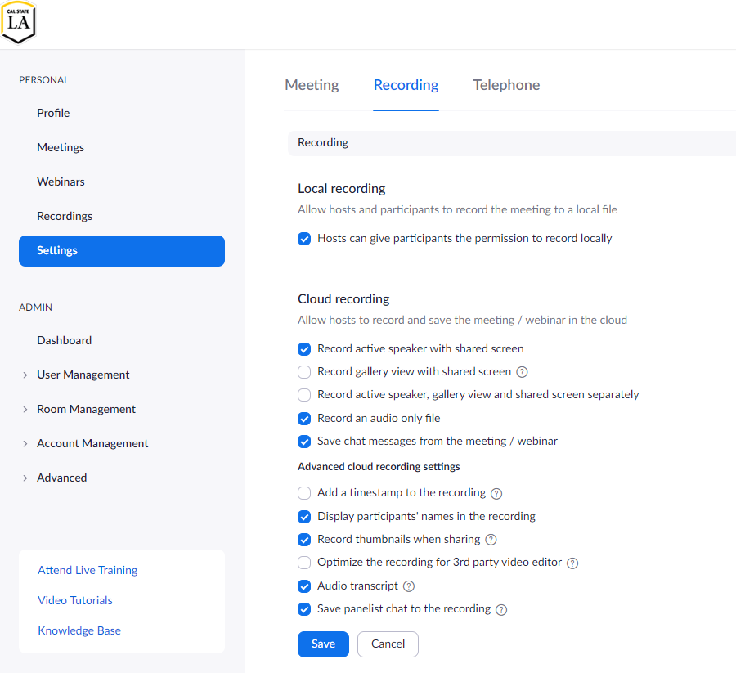
Figure 2 – Audio transcript setting for Zoom cloud recordings

Invite Participants to ask for Assistance in Advance
You can take a proactive stance on accessibility by understanding the limitations of the Zoom meeting format and by communicating these limitations to your participants. Doing so can help increase your participants’ awareness of the challenges that may exist in Zoom.

The sooner you know that a participant will require alternative access, the more time you will have to plan. Actively encourage individuals to speak up about their needs, which can help increase your awareness of the barriers they may be experiencing.

As part of the Zoom meeting invite, relay the following information:

- Encourage individuals who need an accommodation to contact you as soon as possible
- Provide multiple means for participants to contact you
- If the meeting is recurring, include the dates and time of the recurrence

Make Materials Available in Advance of a Zoom Meeting
Some of your meeting participants may join your meeting via the audio-only (call-in) option. There are several reasons why a participant would choose to join the meeting via audio call:

- Limited or no access to a computer or device
- Limited or no internet access
- A screen reader user who prefers to separate Zoom meeting audio from their screen reader audio to make it easier to follow along

To ensure that those participants who are joining your meeting via audio-only are still able to follow your Zoom meeting, you must make all presentation materials or resources available online before the meeting. There are several ways to facilitate this access:

- In the Canvas LMS
- Cloud storage such as OneDrive, Dropbox, or Google Drive
- As an email attachment

Family Education Rights and Privacy Act (FERPA)
Do not post any videos of students where student names or faces are visible --including recorded Zoom sessions--to any public site (e.g., YouTube). Doing so violates the Family Educational Rights and Privacy Act (FERPA). If others outside of the class can see students, that violates student privacy. For more information, contact the Center for Effective Teaching and Learning (CETL)

Within a Zoom Meeting

Assign a meeting participant to provide closed captions
Just as in a physical classroom setting, you must provide real-time captioning in a Zoom meeting for individuals who are Deaf or Hard-of-hearing.
When you create a Zoom meeting, you can designate an attendee to type real-time captions. This designee is typically a professional transcriber using a stenograph machine that allows captions to reach up to 300 words per minute.
NOTE: If you have a student in your class that is receiving captioning accommodations, the Office for Students with Disabilities will notify you and will arrange for a CART professional to provide closed captions for your Zoom meeting.
Once you have been notified of the CART professional’s contact information, within the zoom meeting as the meeting host, follow these steps:
- Provide the Zoom join meeting URL to DHHservices@calstatela.edu so they can provide the information to the assigned CART professional to be a part of your meeting.
  - It would be helpful to include your course subject, number and section (i.e., COUN 1200.001) in the subject.
- At meeting time, once the captionist has joined your meeting, assign them to provide captions by:
  - Clicking the Manage Participants icon at the bottom of the Zoom meeting window to display the participants’ list
  - In the participants' list window click the CART captionist’s name (who will identify themselves as such)
  - Click the More button, and then choose the option on the menu to “Assign to type Closed Captions.”
    - Consider changing the caption size to large in the Zoom settings
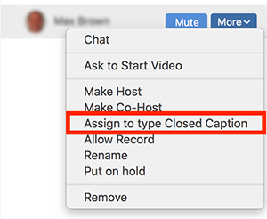
Figure 3 – Assigning a meeting participant to provide Closed Captions

Provide a variety of methods to Perceive Information
Implement UDL principles in your Zoom course online to ensure that information is available in a variety of modalities. Refer to the guidelines below, or for a more detailed introduction, visit the CAST UDL website.

To Assist Blind or Visually Impaired Participants:

- Participants should announce themselves when they speak by saying who they are
- If you are sharing materials in a meeting, fully describe the content out loud while sharing your screen
- Provide access to shared resources outside of Zoom, and in advance of the meeting
  - Consider the accessibility of documents, favor Word over PDF, use the outline view for PowerPoint presentations, caption videos, and provide transcripts for audio-only recordings
- Allow participants to respond to polls or questions via multiple methods:
  - Chat
  - Audio
  - Email
- If addressing questions from the chat window, speak aloud the initial question before answering to ensure everyone can participate, including those individuals who are attending your meeting via the audio-only call-in option.
- Place URLs referenced in the meeting within the chat window. Be prepared to share URLs outside of the Zoom session while the meeting is in session.

To Assist Deaf or Hard-of-hearing Participants:
If you are showing a video during your Zoom meeting, you should have the video closed-captioned before showing it.

NOTE: Even if you have a real-time CART captionist assigned to your Zoom session, they will not provide captions for pre-recorded media; they only caption the audio of presenters and participants.

When selecting videos to share:

- There are usually several versions of a video available; choose the version that has captions
- Arrange to have videos captioned via Automatic Sync. There is a cost for this option that should be covered by your college, division, or department. For more information, contact accessibility@calstatela.edu

If you have a Deaf-or-Hard of hearing participant that is receiving sign language interpretation (ASL) in your Zoom meeting:

- Remind the student to pin the video feed of the sign language interpreter so that the feed will always be in view

After a Zoom Meeting

Provide a link to meeting recordings
If you choose to record a class session or meeting, share the link for the recording with all class participants. It helps to have Zoom automatically provide a searchable transcript of the meeting recording. See the section above to enable post-processing transcription. Note that after the meeting has commenced, the recording will be available after processing of a minimum of a few hours.

Follow-up and Proactively Invite Feedback
To ensure equal access for all participants, proactively invite participants to comment on any potential pain points they experienced soon after your meeting and well before the next session. A follow-up email to invite feedback may give you additional time to make any required alterations to your course format.

Remain Flexible
It is unlikely that faculty will be able to plan for all eventualities in their courses. After taking a proactive stance, the next best advice is to remain flexible and allow students to access your course content via the modalities that work best for them. Keep an open dialogue with your students to ensure that you are eliminating barriers wherever you can.

If you Need More Help
Moving your entire course to a new format will likely reveal limitations in either delivery, content, or consumption of your curriculum and materials. There are several support options available to you to help with this transition.

Center for Effective Teaching and Learning (CETL)
CETL can assist faculty with instructional materials and other issues that could affect the accessibility of courses. Visit the CETL instructional material webpage for more information on the accessibility of instructional materials.

For technical support related to the Canvas LMS and associated faculty technology, email CETLtech@calstatela.edu

Visit the CETL Keep on Teaching webpage for assistance with teaching away from campus

Or email Dr. Carl Schottmiller, CETL Faculty Fellow for Accessibility at cschott@calstatela.edu

Office for Students with Disabilities (OSD)
OSD will proactively inform faculty if they have individuals who require accommodations via email. If you follow the recommendations in this document, you will be in a good position if and when accommodation requests occur. Typical accommodations include:

- Extra time for tests
- In class note-taking
- Audio recording
- Captions
- Alternate media/E-text

For additional information on accommodations, visit the faculty information page on the OSD website/ Or contact OSD for additional information.

Assistive Technology Lab
If you find that a student with a disability in your course is having difficulty accessing Zoom, refer them to the OSD Assistive Technology Learning Center webpage Students can receive one-to-one assistance with technology and assistive technology-specific problems. The Assistive Technology and Alternative Media Coordinator, Jose Amenero, can be reached via email at Jose.Amenero2@calstatela.edu

Information Technology Services (ITS)
ITS has set up a special webpage resource to assist faculty and staff with telecommuting. This page has information on the following topics:

- MyCalStateLA Portal
- Software
- Communication Tools
- Collaboration
- Secure Connections

ITS Help Desk Ticket
If you need general technical assistance, open a ticket with the ITS Help Desk:

Submit a ServiceNow ITS Help Desk Ticket

Accessible Technology Initiative
For more information about the content contained in this document, or to inquire about accessibility under the three priority areas of Web, Instructional Materials, or ICT Procurement, visit the ATI website or contact accessibility@calstatela.edu

Zoom Support Resources
There are a variety of online training videos from Zoom that cover specific functionality. Below you will find direct links to Zoom support resources for educators, those that pertain to accessibility, and the most frequently asked support topics:

- Zoom for Educators Pre-recorded Webinar
- Viewing Closed Captions (Functionality must be enabled and assigned in advance)
- Full List of Hot Keys and Keyboard Shortcuts for Zoom
- Getting Started with iOS Zoom Client
- Testing Computer or Device Audio
- How do I Test my Video?
- Zoom Accessibility Features
- Zoom Status (Check the availability of Zoom services)

Keyboard Shortcuts for the Zoom Windows Desktop Client
The following keyboard commands can be used on the Zoom Desktop when attending webinars and meetings.
- F6 – Navigate among Zoom windows
- CTRL+ALT+SHIFT – Move focus to the meeting controls in Zoom
- ALT+A – Mute/unmute microphone
- ALT+S –Start or stop screen share
Note: Will only work when meeting control toolbar has focus
- ALT+T – Pause or resume screen share
Note: Will only work when meeting control toolbar has focus
- ALT+R – Start local recording
- ALT+C – Start cloud recording
- ALT+P – Pause or resume recording
- ALT+F – Enter or Exit Fullscreen
- ALT+H – Display/hide Chat panel
- ALT+U – Display/hide Participants panel
- ALT+Y – Raise/lower hand

Acknowledgments
The information in this guide is made possible by the collaboration of the following Cal State LA campus entities:

- Office for Students with Disabilities (OSD)
  - Assistive Technology Learning Center and Alternate Media Production Center
- Center for Effective Teaching and Learning (CETL)
  - Faculty fellow for accessibility
- Charter College of Education (CCOE)
  - Division of Special Education & Counseling
- Information Technology Services (ITS)
  - Accessible Technology Initiative

Document Properties

- This Word document is fully accessible and ready for electronic distribution
- Created Spring 2020
  - Last revision March 20, 2020, by Leon McNaught
- Next review scheduled for May 1, 2020
  - Send an email with suggestions or comments to include in the next version of this document

