**2018**

Raj Pamula

Cal State LA

Computer Science

Undergraduate Student Handbook

# Undergraduate Student Handbook

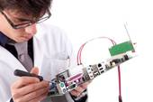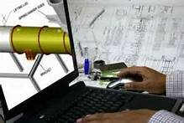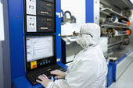

Cal State L.A.

College of Engineering, Computer Science and Technology

Commit to EXCELLENCE,

Engage in COMMUNITY.

Table of Contents

Undergraduate Student Handbook 1

Contact Information 1

Welcome 3

I. Advisement 4

Department Undergraduate Advisement 4

College Undergraduate Advisement 5

II. Objectives and Learning Outcomes 7

Objectives 7

Learning Outcomes 7

III. Useful Web Links 8

IV. General Education Requirements 7

Lower Division General Education Requirements 7

Upper Division General Education Requirements 8

University Requirements 9

V. Major Curricular Requirements 10

Core Course requirements and their prerequisites 10

Prerequisite Flowchart 11

VI. Graduation Roadmaps 12

Plan 1: Freshman Roadmaps (4 Year) 12

Plan 3: Freshman Roadmaps (5 Year) 13

Plan 3: Roadmap for Transfer Students 15

Plan 4: Roadmaps for Students Requiring Remedial Math and English 15

Plan 5: Individualized Roadmap 15

VII. Blended BS+MS Integrated Program 16

VII. Applying for Graduation 17

IX. Academic Standards 19

Appendix A: Quick Curriculum Sheet 19

Appendix B: Advisement Worksheet for CS Juniors/Transfer Students 21

# Contact Information

**Department of Computer Science**

Engineering and Technology, Room A-322

California State University, Los Angeles

5151 State University Drive

Los Angeles, CA 90032-8530

**Department Chair**

**Dr. Raj Pamula**

ET A-322 — (323) 343-6690 office — rpamula@calstatela.edu

**Department Coordinator**

**Valentina Ovasapyan**

ET A-322 — (323) 343-6690 office — (323) 343-6672 fax

VOvasapyan@cslanet.calstatela.edu

**Undergraduate Advisors**

[**Dr. Eun-Young (Elaine) Kang**](http://www.calstatela.edu/faculty/eykang)-eykang@calstatela.edu

**Dr. Zilong Ye** — zye5@calstatela.edu

**Graduate Advisors**

[**Dr. Behzad Parviz**](http://www.calstatela.edu/faculty/bparviz) -- [bparviz@calstatela.edu](mailto:bparviz@calstatela.edu)

**Dr. Yuqing Zhu** — yuqing.zhu@calstatela.edu

**Assessment Coordinator**

**Dr. Chengyu Sun -** [csun@calstatela.edu](mailto:csun@calstatela.edu)

**Senior Design Coordinators**

**Dr. Russell J. Abbott** - [rabbott@calstatela.edu](mailto:rabbott@calstatela.edu)

**Dr. Mohammad Pourhomayoun -** mpourhoma@calstatela.edu

**Full-time Faculty and their Research Interests**

[**Russell J. Abbott**](http://cs.calstatela.edu/abbott/)— [rabbott@calstatela.edu](mailto:rabbott@calstatela.edu)

* Artificial intelligence, Web, Java, Complex Systems

[**Vladimir Akis**](http://www.calstatela.edu/faculty/vakis) — [vakis@calstatela.edu](mailto:vakis@calstatela.edu)

* Computer Graphics, Topology, Dynamical Systems

[**Jiang Guo**](http://www.calstatela.edu/faculty/jguo)— [jguo@calstatela.edu](mailto:jguo@calstatela.edu)

* Software Engineering, Networks, Operating Systems

[**Huiping Guo**](http://www.calstatela.edu/faculty/hpguo)— [hpguo@calstatela.edu](mailto:hpguo@calstatela.edu)

* Computer Networks, Data Security

[**Eun-Young (Elaine) Kang**](http://www.calstatela.edu/faculty/eykang)— [eykang@calstatela.edu](mailto:eykang@calstatela.edu)

* Computer Vision, Computer Graphics, Image processing

**Raj Pamula** — rpamula@calstatela.edu

* Parallel Processing, Distributed Computing, Fault Tolerant Computing

[**Behzad Parviz**](http://www.calstatela.edu/faculty/bparviz) — [bparviz@calstatela.edu](mailto:bparviz@calstatela.edu)

* General Systems Methodology, Information Theory, Software Engineering

**Mohammad Pourhomayoun -** mpourhoma@calstatela.edu

* Big Data Analytics, Large-Scale Machine Learning, Data Science

[**Chengyu Sun**](http://sun.calstatela.edu/~cysun/www/index.html) — [csun@calstatela.edu](mailto:csun@calstatela.edu)

* Database Performance Optimization, Communication, Network Applications

**Zilong Ye** — zye5@calstatela.edu

* Network Architecture, Protocol design

**Yuqing Zhu** — yuqing.zhu@calstatela.edu

* Distributed Computing, Complex Data Mining



# Welcome

Dear Students,

Welcome to the Department of Computer Science! In choosing this course of study, you have selected an exciting and dynamic career that uses technology to make life better for everyone — and sometimes make it more fun!

This handbook has the information and tools that you will need to navigate the requirements that will lead to graduation. I encourage you to read it and keep it handy for your reference. In addition, please know that the faculty and staff are here to help you and we encourage you to ask us for help when you need it.

The curriculum is designed to give you a well-rounded education, with flexibility in your major so that you can focus on areas that most interest you. Becoming a computer scientist will require a lot of study time and hard work. Beyond learning the theories and technical skills, you will learn to collaborate with your fellow students, communicate with diverse audiences, become aware of your environmental and social responsibilities as they relate to your field, and nurture your innovative and creative spirit.

We sincerely hope you will enjoy your time at Cal State L.A. and that you will also take advantage of all the wonderful resources available to you as a student.

Sincerely,

**Dr. Raj Pamula**

# Advisement

All students must receive academic advisement to help them make informed academic choices. Computer Science majors can thus seek advisement both at the department and the college level as described below:

## Department Undergraduate Advisement

The advisor and student go over the student’s degree progress data available on CSNS and GET. The advisor documents the discussion on CSNS, which is then accessible to the student and advising staff. Student advising in the department is considered either Open Advisement or Mandatory Advisement.

Open Advisement:

1. Advisor/staff office visitation: Office hours for the Advisor and the Department chair are posted in the Department Office. Students meet with their faculty advisor: to evaluate class work to date, to discuss issues (if any) impacting their present load, to resolve any GPA issues, and to plan subsequent classes. Students may also seek the advice of any faculty member in evaluating career choices.
2. Email advisement: Students may seek advisement via email.
3. CSNS Advisement Forum: Students may post questions to a Forum hosted by CSNS. Responses are provided by other students or an advisor and are monitored by the Department staff and advisor.

Mandatory Advisement:

Every student is required to meet with their advisor at least once a year. At these meetings students plan their course schedule for the upcoming semester and formulate a longer-term road map to complete all remaining requirements. Advisement meetings are scheduled first with entering first time freshmen or transfer students and then with continuing students.

1. Entering first term students: Admitted freshmen and transfer students attend university-sponsored advising sessions, which are attended by the Department chair and program advisors. Students are informed of the degree requirements, course pre-requisites, laboratory access, computer-related student clubs, and the advising process. Students are given information about the program requirements, which are also posted on the online university catalog and the Department website. Students are also given information in the form of an Undergraduate Student Handbook, which is also posted on the Department website.
2. Freshmen level in CS1010: Entering freshmen or a first year transfer students must enroll in CS1010 during their first term. CS1010 presents a comprehensive overview of higher education. Topics include: University rules and regulations; general education requirements; major requirements; evaluation of transfer units; sample road maps; individualized quarterly planners; and graduation checks. Instructional videos from CS1010 remain accessible online. Additionally, Professional Staff Advisors and the Placement Coordinator schedule a class visit during the semester to provide career-advising, overview of university and college resources, and academic advising in preparation for next semester’s class registration.
3. Sophomore level in CS2011: CS2011 is a required course usually taken as the first required course at the sophomore level. The undergraduate faculty advisor visits all the CS2011-CS2013 sections for an in-class advisement session. Students are reminded to keep pace with the General Education, Math and Physics requirements along with CS requirements as specified in the *Undergraduate Student Handbook*. Any questions are clarified. All the students are reminded of the registration “hold” and are mandated to make an appointment with the College Professional Advisor who checks on their GPA and guides them to take particular MATH/PHYS/CS courses. Both the College Professional Advisor and the undergraduate advisor give assistance in modifying their roadmaps.
4. Transfer student advisement: All incoming transfer students are required to attend a mandatory orientation session organized by the College of ECST. These students are sent a worksheet (Appendix B in the Student Handbook) and a questionnaire to be filled out before coming to the orientation (similar to <https://csns.calstatela.edu/department/cs/survey/response/edit?surveyId=5895951>). The intent is to expedite the transfer evaluation process. The University is committed to complete the official transfer evaluation and reflected in the student transcripts on GET by the transfer orientation date. Transfer students are then ready to take on further classes having completed any of the prerequisites in their transfer institution.
5. Junior level in CS3112: CS3112 is usually taken as the first required course at the junior level. The advisor creates a group of all students registered for CS3112 or any other CS3000 level courses. All these students are sent a worksheet (Appendix B in the Student Handbook) to create an individualized roadmap and attend a mandatory advising session. Students roadmaps are checked to see if they are on pace to take the senior design the next year. This advising session will serve as a pre-graduation check and students make adjustments to their planner during this session. A “hold” is placed on the students till they complete this task
6. Senior level in CS4961. CS4961 is the front end of the senior design sequence. The advisor sends email with Graduation Application Information to all CS4961 students. Students are required to schedule a one-on-one meeting with an advisor and complete a formal graduation check which involves a *Degree Completion Worksheet* and an *Undergraduate Graduation Application* with the advisor to ensure that they are on track to graduate by the end of the academic year.

## D.2 College Undergraduate Advisement

The College of ECST Student Success Center is committed to delivering quality advising services to students to assist them in achieving their educational, career, and personal goals. To deliver advising services, our college practices a split advising model in which advising is carried out by professional staff advisors in theECST Advising Center (EAC), and by faculty advisors in their departments. These services include: academic advisement through professional staff and peer advisors, the engagement of freshman in learning communities, and academic excellence workshops.  Advisement is mandatory every semester for the first two years and completion of all lower division MATH/PHYS/CS2000-level requirements. To enforce this mandatory advising to students, the professional advisor places an “Advisement Hold” on GET every semester and any student will be able to register for the next semester if one meets with an advisor.

* Advance appointment guarantees advisement time with a Professional Staff Advisor or Peer Advisor. Appointment may be made either by
  + Visiting the ECST Advising Center (Engineering and Technology building, A-125),
  + Calling the office Front Desk at 323-343-4574, or
  + Visiting [http://www.calstatela.edu/ecst/success/academic-advising](http://www.calstatela.edu/ecst/success/academic-advising%20) and clicking on the “Student Success Collaborative” icon.
* The professional staff advisor and student go over the student’s degree progress data available on GET.

## Career Guidance

The College of ECST has a Professional Placement Coordinator who provides a link to industry, the University Career Development Center, and other university departments focused on leadership and professional development. In an effort to ensure that all students are receiving career guidance, workshops are offered in key courses that are required for all students. These courses include: ENGR 1500/CS 1010 (freshmen- Introduction to Higher Education), ENGR 3010/ CS 3801 (junior- Ethics), and CE 4960/EE 4961/ME4971/CS 4961 (senior design project). The content of the workshops are developmentally appropriate based upon the students' academic level. Every session will begin with the ECST motto "Commit to Excellence and Engage in Community." Further, each workshop will focus on two online resources:

• Golden Eagle Career Link <http://www.calstatela.edu/univ/cdc/careerlink> : Cal State L.A.’s online source for jobs, internships, mentoring, and career events.

• Career Express <http://www.calstatela.edu/univ/cdc/careerexpress> : Career Express provides online resources organized into four career preparation areas, 1. Self-Assessment, 2. Researching Careers, 3. Preparing for the Job Search and 4. Job Searching

In addition to the resources listed above, all students receive the core career development topics which include, Resume Writing, Effective Interview Skills, Networking at a Career Fair, Career Fair Follow-up, and Creating an Elevator Speech (30 Second Commercial). Other workshop topics include the following:

Freshmen Workshop Topics:

• Academic Excellence- Strive to perform well in your classes so that you will be in the best position to obtain scholarships and internships.

• The importance of researching different career fields within the major

• Attending conferences and professional development workshops

• Establishing a Board of Directors

Junior Workshop Topics:

• Developing a professional identity

• The importance of social media to land a job

• Research Experience for Undergraduate Students (REU) search strategies.

Senior Workshop Topics :

• How to effectively use your senior design project

• Tailoring your resume to each particular company

# Objectives and Learning Outcomes

## Objectives

Program Educational Objectives are broader statements that will describe what graduates are expected to attain within a few years of graduation**.**

1. Students who had entered the workforce will have established themselves as effective professionals by having solved real problems through the use of their computer science knowledge and their communication, critical thinking, and problem-solving skills.
2. Students who had continued in academia will have been successful in pursuing advanced degrees and in demonstrating their ability to master advanced areas of computer science.
3. Students will have demonstrated their ability to adapt to a rapidly changing environment by having learned and applied new knowledge and skills.

## Learning Outcomes

Student Learning Outcomes are specific skills that the students will possess on completion of the degree program. Students will:

1. be able to apply concepts and techniques from computing and mathematics to both theoretical and practical problems.
2. be able to demonstrate fluency in at least one programming language and acquaintance with at least three more.
3. have a strong foundation in the design, analysis, and application of many types of algorithms.
4. have a fundamental understanding of computer systems.
5. have the training to analyze problems and identify and define the computing requirements appropriate to their solutions.
6. have the training to design, implement, and evaluate large software systems working both individually and collaboratively.
7. be able to communicate effectively orally and in writing.
8. have the knowledge, skills, and attitudes for lifelong self-development.
9. have the ability to analyze the local and global impact of computing on individuals and society.
10. have a fundamental understanding of social, professional, ethical, legal, and security issues in computing.

# Useful Web Links

|  |  |
| --- | --- |
| **description** | **web address** |
| University home page | <http://www.calstatela.edu/> |
| Department of Computer Science home page | <http://cs.calstatela.edu/>  <http://www.calstatela.edu/cs> |
| Golden Eagle Territory (GET) provides basic online student services. | <http://get.calstatela.edu> |
| Computer Science Network Services (CSNS) is used as a Learning Management System. | <http://csns.calstatela.edu> |
| Important student information | <http://www.calstatela.edu/student/> |
| University online catalog | <http://ecatalog.calstatela.edu> |
| University Library | <http://www.calstatela.edu/library> |
| Student Chapter of the Association for Computing Machinery | <http://acm.calstatela.edu> |

# 

# General Education Requirements

**The total required units for the undergraduate BS degree is 120 units which is divided into General Education Requirements and Major Requirements.**

**General Education Requirements (48 units, of which 21 units are in the major)**

**Lower Division General Education Requirements (27 units)**

* IHE - Introduction to Higher Education for Computer Science Majors – CS1010 (3)
* Oral Communication (3)
* Written Communication (3)
* American Institutions – US History (3)
* American Institutions - US Constitution and State/Local Govt. (3)
* Biological Sciences OR Interdisciplinary Physical-Biological Science (3)
* Arts and Humanities – Select 3 units from Arts (3)
* Social Science - Select 6 units from Social Science (6)

## 

**Upper Division General Education Requirements – (0 additional units; Met in major)**

|  |  |
| --- | --- |
| Natural Science and Quantitative Reasoning | **Met by CS 3112, CS 3186** |
| Arts & Humanities | **Met by CS 4961, CS 4962** |
| Social Sciences | **Met by CS 4961, CS 4962** |

## University Requirements

A minimum 2.0 grade average is required in (i) Overall at CSULA (ii) Major requirements and (iii) Overall at CSULA. In addition, students must check on the course designations describe below:

|  |  |
| --- | --- |
| *Cl* | Computer Science students fulfill this requirement in the major (IHE -CS1010 and Senior Design - CS4961/CS4962). |
| *Wi* | Computer Science students fulfill this requirement in the major (Senior Design - CS4961/CS4962). |
| *d/re* | Students must complete at least one diversity course (with *d* designation), and one race and ethnicity course (with *re* designation). They should be fulfilled in the lower division General Education requirements. These courses are designated as (re) and (d) in the course listing. |

Note:

1. “Cl” and “Wi” requirement is met by major courses;
2. “d/re” requirement must be met by the General Education courses.



# Major Curricular Requirements

The Computer Science core curriculum provides students with basic knowledge, training, discipline, and skills, as defined by the Computer Science Program Student Learning Outcomes. Through its lower division required courses, the curriculum provides students with the basic mathematical and science framework. Through its upper division required courses, the curriculum builds upon the fundamental principles of computer science for more advanced study. Through its upper division technical electives, students gain additional breadth and/or depth in computer science by an appropriate selection of courses.

**Requirements for the Major (93 units)**

A grade of "C" or better is required for all prerequisite courses in the major.

**Lower Division Required Courses (39 units)**

CS 1222 Introduction to Relational Databases(3)

CS 2011 Introduction to Programming I (3)

CS 2012 Introduction to Programming II (3)

CS 2013 Programming with Data Structures (3)

CS 2148 Discrete Structures (3)

ENGL 2030 Introduction to Technical Writing (3)

MATH 2110 Calculus I (4)

MATH 2120 Calculus II (4)

MATH 2550 Introduction to Linear Algebra (3)

PHYS 2100 General Physics I (5)

PHYS 2200 General Physics II (5)

**Upper Division Required Courses (33 units)**

CS 3035 Programming Language Paradigms (3)

CS 3112 Analysis of Algorithms (3)

CS 3186 Introduction to Automata Theory (3)

CS 3220 Web and Internet Programming (3)

CS 3337 Software Engineering (3)

CS 3801 Societal and Ethical issues in Computing (3)

EE 3445 Computer Organization (3)

CS 4440 Introduction to Operating Systems (3)

CS 4961 Software Design Laboratory I (3)

CS 4962 Software Design Laboratory II (3)

CS 4963 Computer Science Recapitulation (3)

**Electives (21 units)**

**Mathematics Electives (3 units)**

Select 3 units of lower division or upper division course(s) in the Mathematics area with prior approval of the Computer Science undergraduate adviser. Recommended course is in the area of Probability/Statistics.

**Computer Science Electives (18 units)**

Select 18 units of upper division Computer Science (CS3xxx/CS4xxx) courses.

## Prerequisite Flowchart

The prerequisite flowchart for the B.S. in Computer Science curriculum is depicted in the figure below. The courses are structured with the lower division requirements shown in Rows 1 – 3. The advanced required CS courses are shown in Rows 4 – 6. Elective courses should be scheduled between Rows 4 – 6.

As a general rule, students are advised to finish the courses in a particular row before progressing to the next row and follow the graduation roadmaps described in the next section.

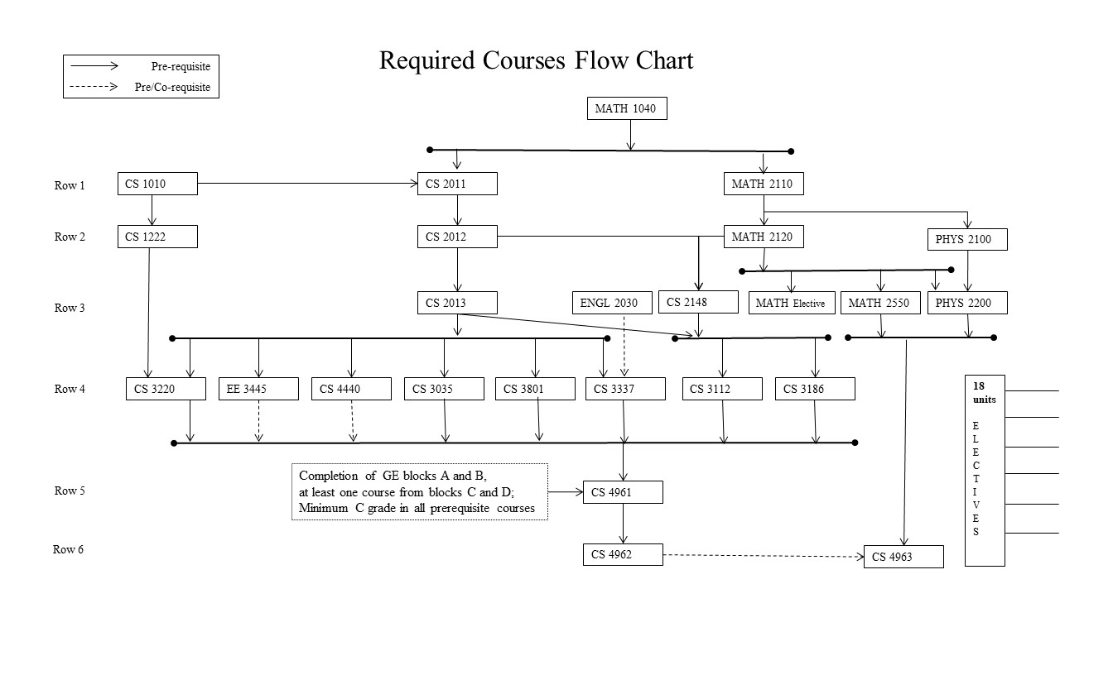

# Graduation Roadmaps

Graduation roadmaps are suggested academic plans designed to inform students about the sequence of courses needed to satisfy degree requirements. The roadmaps adhere strictly to the prerequisites and scheduling patterns of the courses.

### Plan 1: Freshman Roadmaps (4 Year completion taking 5 courses/term)

This roadmap is described for students who enter Cal State LA directly from high school as freshman. It assumes that the freshmen students are ready to take MATH 2100 and ENGL 1010 and do not need to take any remedial mathematics or English courses. This ideal roadmap provides a pathway for students to complete their undergraduate requirements in four years.

|  |  |  |  |
| --- | --- | --- | --- |
| **year**  **1** | **summer** | **fall** | **spring** |
|  | MATH 2110 | MATH 2120 |
|  | ENGL 1010 | HIST 2020 |
|  | COMM 1100 | POLS 1000 |
|  | GE B2/B3 | CS 1222 |
|  | CS 1010 | CS 2011 |

|  |  |  |  |
| --- | --- | --- | --- |
| **year**  **2** | **summer** | **fall** | **spring** |
|  | MATH Elective | GE D1 |
|  | MATH 2550 | ENGL 2030 |
|  | PHYS 2100 | PHYS 2200 |
|  | CS 2012 | CS 2013 |
|  | GE C1 | CS 2148 |

|  |  |  |  |
| --- | --- | --- | --- |
| **year**  **3** | **summer** | **fall** | **spring** |
|  | CS 3035 | CS 3186 |
|  | CS 3112 | CS 3801 |
|  | CS 3220 | CS 4440 |
|  | CS 3337 | CS Elective |
|  | EE 3445 | GE D2 |

|  |  |  |  |
| --- | --- | --- | --- |
| **year**  **4** | **summer** | **fall** | **spring** |
|  | CS 4961 | CS 4962 |
|  | CS Elective | CS 4963 |
|  | CS Elective | CS Elective |
|  | CS Elective | CS Elective |
|  |  |  |
|  |  |  |

### Plan 2: Freshman Roadmaps (5 Year completion taking 4 courses/term)

|  |  |  |  |
| --- | --- | --- | --- |
| **year**  **1** | **summer** | **fall** | **spring** |
|  | MATH 2110 | MATH 2120 |
|  | ENGL 1010 | HIST 2020 |
|  | COMM 1100 | POLS 1000 |
|  | CS 1010 | CS 1222 |
|  |  |  |

|  |  |  |  |
| --- | --- | --- | --- |
| **year**  **2** | **summer** | **fall** | **spring** |
|  | MATH Elective | GE D1 |
|  | MATH 2550 | ENGL 2030 |
|  | CS 2011 | CS 2012 |
|  | GE C1 | GE B2/B3 |
|  |  |  |

|  |  |  |  |
| --- | --- | --- | --- |
| **year**  **3** | **summer** | **fall** | **spring** |
|  | CS 2013 | CS 3112 |
|  | CS 2148 | CS 3801 |
|  | GE D2 | EE 3445 |
|  | PHYS 2100 | PHYS 2200 |
|  |  |  |

|  |  |  |  |
| --- | --- | --- | --- |
| **year**  **4** | **summer** | **fall** | **spring** |
|  | CS 3035 | CS 3220 |
|  | CS 3186 | CS 3337 |
|  | CS 4440 | CS Elective |
|  | CS Elective | CS Elective |
|  |  |  |

|  |  |  |  |
| --- | --- | --- | --- |
| **year**  **5** | **summer** | **fall** | **spring** |
|  | CS 4961 | CS 4962 |
|  | CS Elective | CS 4963 |
|  | CS Elective | CS Elective |
|  |  |  |
|  |  |  |

### 

### Plan 3: Roadmap for Transfer Students

This roadmap is for students who transfer to Cal State LA directly from another institute of higher education. The plan assumes that the students have entered Cal State LA with completion of all lower division GE requirements and all lower division required math, computer science and physics PHYS courses.

This ideal roadmap provides a pathway for students to complete their remaining upper division (300/400 level) undergraduate course requirements as laid out in either Plan1 or Plan2 above.

### 

### Plan 4: Roadmaps for Students Requiring Remedial Math and English

Students needing some remediation to MATH and ENGL courses are placed into remedial courses. This is likely to add up to an extra year on the roadmap. Students will then continue on and follow the roadmaps (Plan1 or Plan2) described above.

### Plan 5: Individualized Roadmap

It is a fact that every student's situation is unique. Therefore, the roadmaps described above should be used as guides. Note the following two characteristics described in the roadmap plans above:

* The roadmaps describe the suggested plan of study (by year and semester term) for students assuming that a student plans for the regular fall and spring semesters. These roadmaps do not include courses during the summer sessions. This leaves the option for students to take classes during the summer session to finish earlier or to reduce the number of units per semester.
* The roadmaps are designed for individuals who are devoting full-time to their studies and thus taking a full load of 12 to 15 units per semester.

It is essential that every student should see a faculty academic advisor and complete an Individualized Advisement Plan (IAP).This should be updated if any situation changes down the road.

The blank roadmap on the next page can be used as a draft to prepare the individualized planner. Students should consult with an advisor while making any changes to the plan.

|  |  |  |  |
| --- | --- | --- | --- |
| **year** | **summer** | **fall** | **spring** |
|  |  |  |
|  |  |  |
|  |  |  |
|  |  |  |
|  |  |  |

|  |  |  |  |
| --- | --- | --- | --- |
| **year** | **summer** | **fall** | **spring** |
|  |  |  |
|  |  |  |
|  |  |  |
|  |  |  |
|  |  |  |

|  |  |  |  |
| --- | --- | --- | --- |
| **year** | **summer** | **fall** | **spring** |
|  |  |  |
|  |  |  |
|  |  |  |
|  |  |  |
|  |  |  |

|  |  |  |  |
| --- | --- | --- | --- |
| **year** | **summer** | **fall** | **spring** |
|  |  |  |
|  |  |  |
|  |  |  |
|  |  |  |
|  |  |  |

|  |  |  |  |
| --- | --- | --- | --- |
| **year** | **summer** | **fall** | **spring** |
|  |  |  |
|  |  |  |
|  |  |  |
|  |  |  |
|  |  |  |

# Blended BS+MS Integrated Program

The Blended BS/MS program (<http://www.calstatela.edu/ecst/cs/integrated-bsms>) in computer science provides an accelerated route for academically excellent upper-division students in the BS degree program to complete the MS degree program while simultaneously completing the BS requirements. The main objectives of the program are:

* To provide an accelerated route to a graduate degree, with simultaneous awarding of both bachelor's and master's degrees.
* To provide a seamless process whereby a limited number of select students can progress from undergraduate to graduate status.

### Program Features

* Simplified application process
* BS and MS coursework can be taken concurrently
* **Nine** common elective units between BS and MS programs.
* Access to graduate student facilities
* TA appointments (if available)
* The scheduling flexibility provided by the program enables students to complete the BS and MS degrees efficiently.

The eligibility requirements for admission to the Blended BS/MS program are:

* Students must have completed a minimum of 90 semester units of coursework.
* Students must have a CSULA GPA of > 3.0.
* Students must have completed all CS2000 level and the six required CS 3000-level courses in the BS degree program with a minimum grade of "B".

Eligible and interested students should contact the Academic Advisor for further information.

To apply, please discuss with the advisor.

# Applying for Graduation

Students must apply for graduation to notify the university that they are ready to complete their degree program. It follows an audit process as described below:

1. Students take note of all the information (application deadlines, fees, diploma, commencement, transcripts, etc.,) as described at <http://www.calstatela.edu/sites/default/files/groups/Graduation/Docs/graduation_application_for_undergrad.pdf>.
2. Students complete the 2-page ***Degree Completion Worksheet*** and 1-page ***Undergraduate Graduation Application*.**

* Students will review their Academic Requirements report on GET to complete the Degree Completion Worksheet.
* The Academic Requirements Report (an audit report generated on GET) gives a visually clear picture of the requirements; completed requirements; transfer credits etc. as shown in Figure 1.2. Students thus have a general idea of the graduating quarter and discuss the program requirements with the advisor.

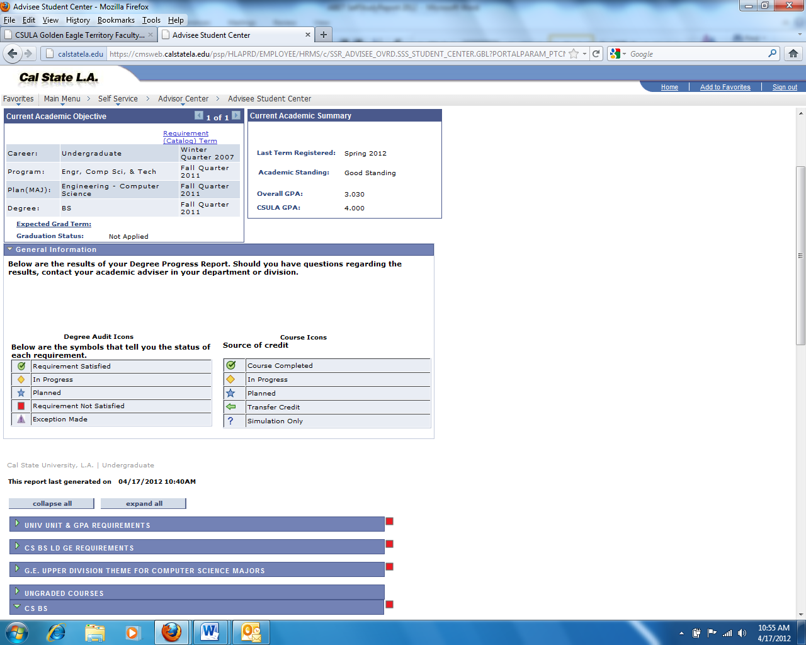

**Figure 1.4: Academic Requirements Report on GET**

1. Students make an appointment with the Advisor to discuss the Academic Requirements Report and resolve/plan out all the remaining requirements (which are indicated as RED flags). The Advisor reviews the *Degree Completion* Worksheet and the *Undergraduate Graduate Application*. Both the applications are signed off by the Advisor.
2. Students submit the signed Graduation Application and Degree Completion Worksheet to the Cashier's Office (ADM 128) and pay the Application ($20) and Diploma ($10) fees. The Cashier's Office will forward the form to the Graduation Office for processing and do the final audit.
3. Degree dates are posted at the end of the semester in which all requirements are met. On completion of the degree requirements, the transcripts on GET indicate the following:

|  |  |
| --- | --- |
| Degree: | Bachelor of Science |
| Confer Date: | (date) |
| Plan: | Computer Science |

1. If the students donot graduate during the term declared on their **Graduation Application**, then they must file a **Request to Change Graduation Term.** The following steps have to be completed before the students will be able to register for classes beyond the previous declared graduation term.

* Students make a graduation advising appointment with the Advisor to determine the correct term at the end of which all graduation requirements are completed.
* Complete and sign the **Request to Change Graduation Term** form; available at [**h**](http://www.calstatela.edu/graduation)**ttp://**[**www.calstatela.edu/graduation**](http://www.calstatela.edu/graduation)
* Pay the $25 late filing fee to the Cashier’s Office
* Cashier's Office will forward the form to the Graduation Office for processing.

# Academic Standards

As a student, you are now joining an academic community. The privilege of membership has certain obligations. Academic Integrity is very important. Cheating will not be tolerated. Cheating on any assignment or exam will be taken seriously. Failure to meet established standards may result in various penalties. In extreme cases this could result in expulsion from the University.

Please visit the Cal State LA, Judicial Affairs Office website where you will find examples of what constitutes cheating and plagiarism so that you become familiar with the guidelines, and consequences of not following them.

We hope that behavior standards never become an issue, but it is important that you prove worthy of the trust we place you in. Honesty is extremely important both for the operation of the University and for your personal development*.*

# Appendix A: Quick Curriculum Sheet

**Curriculum for B.S. Degree in Computer Science (120 units)**

# California State University, Los Angeles

**(Effective Fall 2016 Semester Term)**

**Lower Division General Education Requirements (27 units)**

|  |  |
| --- | --- |
| BLOCK A – Basic Subjects | **Written Communication (3)** |
|  | **Oral Communication (3)** |
| American Institution | **United States History (3)** |
|  | **United States Constitution and State/Local Government (3)** |
| BLOCK B − Natural Sciences & Mathematics/Quantitative Reasoning | **1 course from B2 or B3 (3)** |
| BLOCK C – Arts & Humanities | **1 course (3)** |
| BLOCK D – Social Sciences | **2 courses (6)** |
| BLOCK E – Lifelong Understanding & Self-Development | **CS 1010 Introduction to Higher Education for Computer Science Majors (3)** |

**Upper Division General Education Requirements – Met in major (No extra units)**

**Lower Division Major Requirements (39 units)**

|  |  |
| --- | --- |
| CS 1222 | **Introduction to Relational Databases (3)** *Prerequisite:* CS1010, Computer Literacy |
| CS 2011 | **Introduction to Programming I (3)** *Prerequisite:* CS1010, MATH 1040 or consent of the instructor |
| CS 2012 | **Introduction to Programming II (3)** *Prerequisite*: CS 2011, recommended MATH 2110 |
| CS 2013 | **Programming with Data Structures (3)** *Prerequisite*: CS 2012, recommended MATH 2120 |
| CS 2148 | **Discrete Structures (3)** *Prerequisites*: CS 2012, MATH 2120 |
| ENGL 2030 | **Introduction to Technical Writing (3)** *Prerequisite*: ENGL 1010 |
| MATH 2110 | **Calculus I (4)** *Prerequisite*: MATH 1040 with a minimum C grade, or MATH 1081 and MATH 1083 both with a minimum C grade |
| MATH 2120 | **Calculus II (4)** *Prerequisite*: MATH 2110 with a minimum C grade |
| MATH 2550 | Introduction to Linear Algebra (3) *Prerequisite*: MATH 2120 |
| PHYS 2100 | **Mechanics and Thermodynamics (5)** *Prerequisite*: High school physics or equivalent, or permission of the department, MATH 2110 or equivalent (may be taken concurrently) |
| PHYS 2200 | **Electromagnetism and Optics (5)** *Prerequisite*: PHYS 2100, or co-requisite: MATH 2120 |

**Upper Division Major Requirements (33 units)**

|  |  |
| --- | --- |
| CS 3035 | **Programming Language Paradigms (3)** *Prerequisite:* CS 2013, CS 2148. |
| CS 3112 | **Analysis of Algorithms (3)** *Prerequisite:* CS 2013, CS 2148 |
| CS 3186 | **Introduction to Automata Theory (3)** *Prerequisite:* CS 2013, CS 2148 |
| CS 3220 | **Web and Internet Programming (3)** *Prerequisite:* CS 1222, CS 2013 |
| CS 3337 | **Software Engineering (3)** *Prerequisite:* CS 2013, *Prerequisite or corequisite:* ENGL2030. |
| CS 3801 | **Societal and Ethical Issues in Computing (3)** *Prerequisite:* CS 2013 or permission of the instructor |
| EE 3445 | **Computer Organization (3)** *Prerequisite:* CS 2013 or permission of the instructor |
| CS 4440 | **Introduction to Operating Systems (3)** *Prerequisite:* CS 2013 |
| CS 4961 | **Software Design Laboratory I (3)** *Prerequisite:* Completion of blocks A and B4, an additional course from block B, and at least one course each from blocks C and D. Minimum C grade in all courses: CS 3112,CS3220,CS3035,CS3337,CS3186, CS3801  co-requisite: CS 4440, EE 3445 |
| CS 4962 | **Software Design Laboratory (3)** *Prerequisite:* CS 4961 |
| CS 4963 | **Computer Science Recapitulation (3)** *Prerequisite:* MATH 2550, PHYS 2200,  co-requisite: CS 4962 |

**Program Electives (21 units)**

**Mathematics Electives (3 units) -** *Select 3 units of lower division or upper division course(s) in the Mathematics area with prior approval of the Computer Science undergraduate adviser. A typical course is in the area of Probability/Statistics (MATH2740)*

**Computer Science Electives (18 units)** – *Select 6 lecture courses from the following (and any new CS3000/4000 courses). Check with the advisor*

|  |  |
| --- | --- |
| CS 3034 | **Widely-used Programming Languages (3)** Prerequisites:CS2013,CS2148; Co-requisite: CS3112 |
| CS 3660 | **Complex Social and Economic Systems (3)** Prerequisite: CS2148, Corequisite: CS3112. |
| CS 4075 | **Concurrent and Distributed Programming (3)** *Prerequisites*: CS 3112, CS 3035 |
| CS 4112 | **Competitive Programming (3)** *Prerequisite*: CS 3112 |
| CS 4188 | **Compilers (3)** *Prerequisites*: CS 3035, CS 3112, CS 3186 |
| CS 4220 | **Current Trends in Web Design and Development (3)** *Prerequisites*: CS 3112 and CS 3220 |
| CS 4222 | **Principles of Database Systems (3)** *Prerequisites*: CS 1222 and CS 3112 |
| CS 4470 | **Computer Networking Protocols (3)** *Prerequisite*: CS 3112 |
| CS 4471 | **Computer Networks Configuration and Management (3)** *Prerequisite*: CS 4440 |
| CS 4540 | **Special Topics in Computer Science (1-3)** *Current topics of special interest to students in computer science, as announced in Schedule of Classes* |
| CS 4550 | **Computer Graphics (3)** *Prerequisites*: CS 3112, MATH 2550 |
| CS 4551 | **Multimedia Software Systems (3)** *Prerequisite*: CS 3112 |
| CS 4555 | **Introduction to 3D Computer Game Programming (3)** *Prerequisite*: CS 3112 |
| CS 4556 | **Multiplayer Online Game Design and Development (3)** *Prerequisites*: CS 3112 and CS 3220 |
| CS 4635 | **Modeling and Simulation (3)** *Prerequisites*: CS 3112 and CS 3660 |
| CS 4660 | **Artificial Intelligence (3)** *Prerequisite*: CS 3112 |
| CS 4661 | **Introduction to Data Science (3)** *Prerequisite*: CS 3112 |
| CS 4662 | **Advanced Machine Learning (3)** *Prerequisite*: CS 4661 |
| CS 4780 | **Cryptography and Information Security (3)** *Prerequisite*: CS 3112 |

# Appendix B: Advisement Worksheet for CS Juniors & Transfer Students

**Step 1:** Based on your Academic Requirements report on GET, **cross out** all the completed GE courses in the chart below. (i.e., these courses are shown as met in GREEN color on the report). Don’t worry about the areas indicated as “Met in major” 

**Step 2:** Based on your Academic Requirements report on GET, mark the flow chart as described below

1. **Cross out** all the completed courses (including currently enrolled in Fall 2017). (shown as met in GREEN)
2. **Cross out and write the** transfer course that meets the requirement (shown in RED, which should be GREEN)
3. Indicate any completed MATH Elective and CS Electives



**Step 3:** Make a tentative plan and list the courses for the next two years starting this Fall semester Refer to the Graduation Road Maps in Section

|  |  |  |  |
| --- | --- | --- | --- |
| **year**  **2017-2018** |  | **fall 2xxx (Current)** | **spring 2xxx** |
|  |  |  |
|  |  |  |
|  |  |  |
|  |  |  |
|  |  |  |

|  |  |  |  |
| --- | --- | --- | --- |
| **year**  **2018-2019** | **summer 2xxx** | **fall 2xxx** | **spring 2xxx** |
|  |  |  |
|  |  |  |
|  |  |  |
|  |  |  |
|  |  |  |