1 | Date: Click or tap here to enter text.  Originator: Click or tap here to enter text.  Proposals will be submitted for AY 2024-25: Click or tap here to enter text.
 | Department Committee Schedule | College Committee Schedule | University Level
2 | Spring 2023: Click or tap here to enter text.  Fall 2023:Click or tap here to enter text. | Spring 2023:Click or tap here to enter text.  Fall 2023:Click or tap here to enter text. | Refer to the bubbles #11, 12
3 | 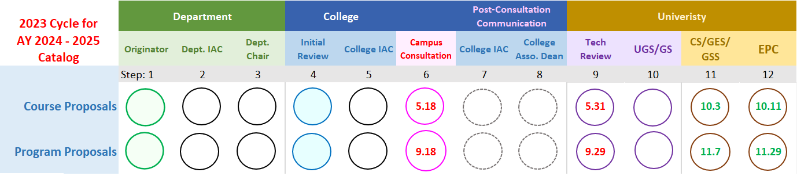
4
5
Instructions
Dates in bubbles #6, 9, 11, and 12 are in year 2023.
Row 1: List the proposals that this Originator will submit for this curriculum review cycle .
Row 2: List all the meeting dates.If committee member will review proposals outside the meeting, indicate the last date when thier final decision will be made on the completed proposals. Circle the dates that are prior to the bubbles# 6 on rows 4 and 5.
Rows 4 and 5:
- College timeline- work with the departmet, select a circled date from row 2, enter it to bubbles #5 repectively for different type of proposals. Work up an internal timeline for bubbles #4.
- Departmental timeline- work with the originator, select a circled date from row 2, enter it to bubbles #2 respectively. Work up internal timeline for bubbles # 3 and 1
2022.7.25

