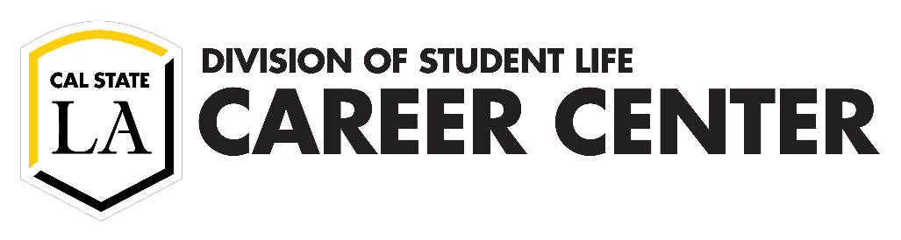

Guide to Customizing Your Résumé to the Job Position

This document will take you step-by-step through the résumé writing process. Whether you’re applying to a job, internship, graduate program or any other type of position, it’s always important to customize your résumé to the position description. There is no ‘one-size-fits-all’ résumé – keep your audience in mind when you write your résumé to address their specific needs.

Step 1: Prepare

Experience has shown that the chance of receiving a response from an employer increases exponentially when a résumé is customized to the position, and here is why. The employers take the résumé and put it alongside the job description to see whether you qualify. Although a general résumé may be impressive, it is likely to result in a lack of responses because it is about you, not about them. So, how do you tailor a résumé? Here are the essential steps:

|  |  |  |
| --- | --- | --- |
| **Status** | **Action** | **Description** |
|  | Identify keywords specific to the position in the responsibilities and requirements | Highlight keywords in the position's responsibilities and requirements. You will use these keywords to guide the description of your experiences.  You may want to put these keywords into themes (e.g., teamwork/collaboration, customer service, communication, leadership, problem-solving, critical thinking, planning and organizing, technical knowledge, quantitative ability/numeracy, creativity/innovation, etc.) |
|  | Circle the keywords that you have previously done | Circle the keywords (e.g., verbs, specific phrases) that match your prior experience (e.g., conduct outreach to build partnerships, track data, adhere to policies, represent programs and services, solve a complex issue or problem). |
|  | Note specific examples of your related experience | Give examples of when you did each circled action (e.g., conduct outreach to high school students in South Los Angeles to help them prepare for college admissions).  Consider your experiences in-class projects, volunteer work, student organizations, internships, jobs, research, etc. (use the Brainstorm Worksheet). |
|  | Consider additional skills that employers value to describe other experiences | Use the [NACE Top Attributes Employers Want to See on Résumés](https://www.naceweb.org/about-us/press/2020/the-top-attributes-employers-want-to-see-on-resumes/) |
|  | Choose a résumé style | There are four styles of résumé: reverse chronological (traditional), functional, combination, and creative (see the Résumé Samples). |

Step 2: Create

Now that you know what the position requires and how your experiences match the company’s needs, you are ready to create your résumé. You can choose your résumé style based on your situation. (Samples are provided towards the end of this document.)

Traditional: Choose the reverse chronological résumé whenever you have more than one professional experience. The dates of your experiences are organized in reverse chronological order meaning you start with the current date and then go back in time. Most employers prefer this style.

Functional (caution: recruiters may not prefer this format): If you need to focus on areas of expertise rather than on individual experiences, choose the functional résumé. You will describe the areas of expertise in detail without indicating when and where the experiences occurred. At the end, you write the timeline of your experiences in reverse chronological order without providing a description. This résumé works better for candidates who have gaps in work history.

Combination: If a reverse-chronological list of your past experiences does not immediately highlight your abilities, choose the combination résumé. The combination résumé includes a section at the top that focuses on your relevant skills and accomplishments. The next section describes your relevant experiences in reverse chronological order. This résumé works better for candidates who are recent graduates, career changers, veterans, have multiple-track job histories or have a work history with gaps.

Other: If you are seeking positions in creative industries, use the creative résumé.

|  |  |  |
| --- | --- | --- |
| **Status** | **Action** | **Description** |
|  | Add your contact information | This includes your name, city & state, email address (remember to use a professional address), phone number (be sure to set a professional voice message), and LinkedIn URL. You do not need to include your full mailing address. |
|  | Add your education | This includes your full degree(s), name of institution(s), and graduation date (e.g., Spring 2020). If you haven’t graduated yet, put the intended date. You may also consider including your GPA, academic honors, and awards in this section. |
|  | Add your position titles | This includes position titles for relevant experiences, including jobs, class projects, volunteer positions, etc. Write each experience with the job/position title, name of organization, city & state, and beginning & end dates (e.g., 08/2019 – 05/2020). |
|  | Add your accomplishments | Each position title will need accomplishment statements written in bullet points (use the Accomplishment Formula). |
|  | Add your skills | This includes your technical knowledge, language skills, and other specialized knowledge for your position. |

When writing your experiences, list your accomplishments. Start each accomplishment statement with a verb and then describe the task and finish it with the outcome (Verb + Task + Results). Prioritize the order in which you list your accomplishments in each position, with the most relevant ones first. If some experience is related to the job you are targeting, and some are not but taught you valuable transferrable skills, you can list your experiences in two sections, “related” and “other” experience. **Note:** Do not structure the statements with pronouns referring to you.

Accomplishment Formula

|  |  |  |
| --- | --- | --- |
| **Action Verb** | **Task** | **Result** |
| * Designed | a 25-page athletic catalog using Adobe Photoshop & InDesign | to attract diverse audiences |
| * Collaborated | with a diverse group of deans, faculty, staff, and students | to update policies on inclusivity |
| * Persuaded | passers-by to learn about our club while tabling at 10 events | recruiting 50 new members |

Step 3: Review

Many employers say that they would turn down an application due to a typo. The reason is that the résumé is a sample of how you will represent the organization in the role. Be sure that you always spell your words correctly and make sure that any autocorrection provided a relevant word to the context. Here are a few mistakes to look out for:

|  |  |  |
| --- | --- | --- |
| **Status** | **Action** | **Description** |
|  | Check your spelling and grammar | Accurate spelling and grammar are essential for making a strong impression. Mistakes can cost you the position. Ask another person to review your résumé to ensure that autocorrect did not add irrelevant words (writing tutors are available at the [Center for Academic Success](https://www.calstatela.edu/academic-success)). |
|  | Check for consistency | Use minimal changes in font style (e.g., only bold and font size changes) and be consistent across each label (e.g., bold all position titles, bold all degree titles, abbreviate all months). |
|  | Check your use of space | Use standard margins, include space between each section title, and align dates to the right using the right tab function. Ensure the information is not cluttered and can easily be scanned by reviewers. |
|  | Check your verb usage | Ensure that you use past tense action verbs when the position is in the past and present tense when the experience is current. |
|  | Check your length | Most résumés for undergraduate students are one full page. If you have several years of experience in the field, you may go to two pages. Be sure that the experiences you include best match the position. Do not include experiences that detract from the position in an attempt to make your résumé longer. This can make it more difficult for the reviewer to see how you fit the role. |

Step 4: Bonus

|  |  |  |
| --- | --- | --- |
| **Status** | **Action** | **Description** |
|  | Watch videos with advice from global experts | [Career Spots](http://www.careerspots.com/secure/vidplay_links_secure.aspx?aid=702&vidnum=21) provides real-world career advice from global experts on starting the internship and job search, résumés and communication, networking, your personal brand and elevator speech, internships, interview dress, interview before-during-after, salary and negotiation and social media in the job search. |
|  | Use Optimal Resume software | [SkillsFirst](https://skillsfirst.com/organizations/calstatela)helps you build your résumé based on a variety of formatting styles. You can also browse sample résumés based on industry and level of work experience. New users: In the Student Users box, type in your **@calstatela.edu** email address. (Alumni will click on the Alumni button and use a personal email address.) |
|  | Research the organization | Review the company’s website, visit their [LinkedIn](http://www.linkedin.com/) page, and read reviews on [Glassdoor](https://www.glassdoor.com/index.htm). The more you know about the company, the more prepared you will be during the application process. |