macOS: How to Remote Connect to Windows Computer using Remote Access Tool

2-Hour Time Limit
There is a 2-hour time limit when using Windows computer via remote connection. When there are 2 minutes left, the dialogue box below will appear. Once time is up, the remote connection will be ended, and all unsaved work will be lost. Please remember to periodically save work to OneDrive.
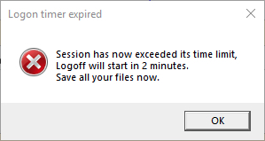

*Note: Please remember to periodically save your work.*

The following document contains four sections. If you have already downloaded an installed VPN, skip to Section 3.

Section 1: Download and Install VPN

Section 2: Setting Up VPN

Section 3: Remote Connect to Windows Computer

Section 4: Saving File Locally and Uploading/Downloading to Cloud Storage

Section 1: Download and Install VPN
- Open an internet browser and go to CalStateLA VPN to install VPN.
- Type in your MyCalStateLA ID credentials and click LOG IN.
- macOS needs to download and install Mac 32/64-bit GlobalProtect agent.
- When the Welcome window displays, click Continue.
- Make sure GlobalProtect is checked and click Continue.
- Click Install.
- When prompted, enter Mac administrator account password and click Install Software.
- If dialogue box titled: System Extension Blocked appears, click OK.
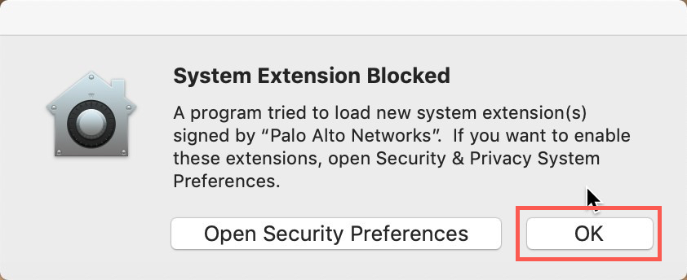
- When the software has finished installing, click Close.

Section 2: Setting Up VPN
- Launch VPN Client by clicking on globe icon that appears in menu bar.
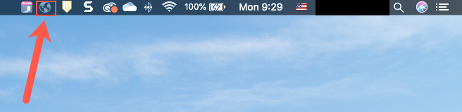
- Type in myvpn.calstatela.edu and click Connect.
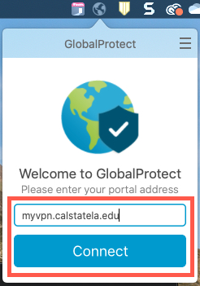
- If you are prompted to enter credentials skip to step 5. Otherwise go to System Preferences > Security & Privacy > General and look for message stating: “System software from developer ‘Palo Alto Networks’ was blocked from loading.” and click Allow.
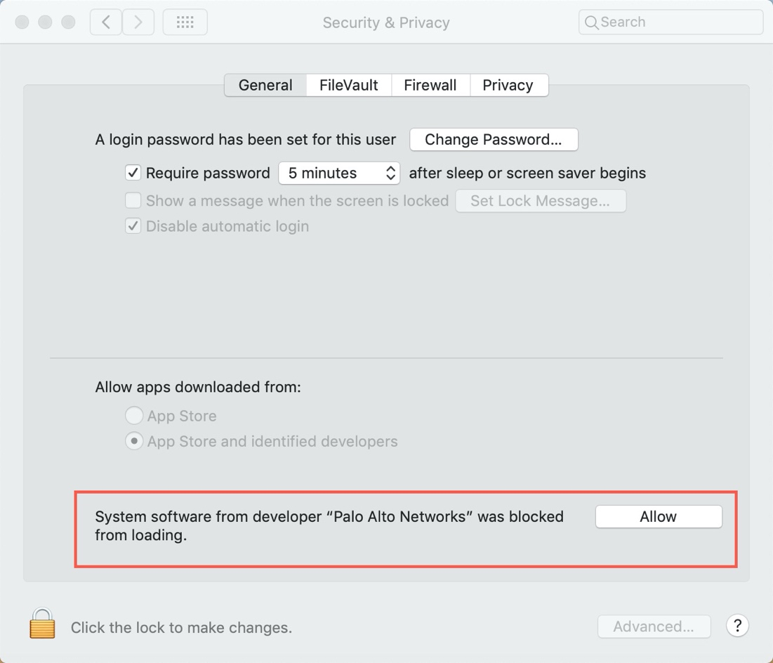
- If prompted, enter Mac administrator account password.
- Type in your MyCalStateLA ID credentials and click Sign In.
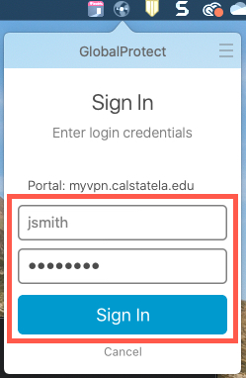
- You are now connected to Cal State LA Network. You may close GlobalProtect window.
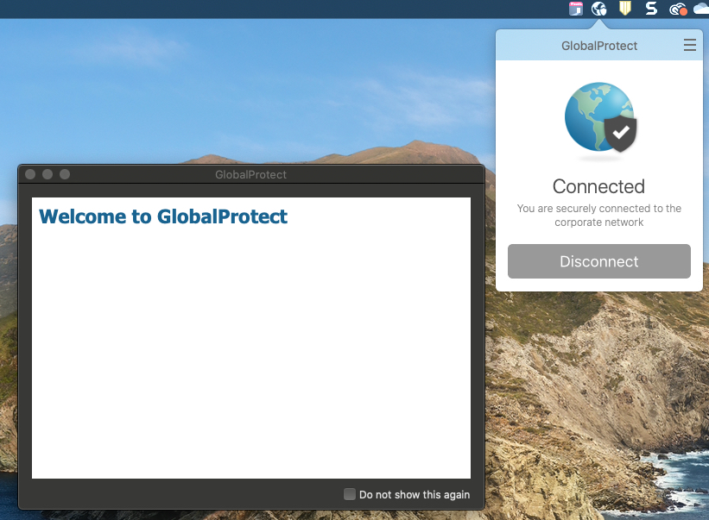

Section 3: Remote Connect to Windows Computer
- Launch Applications > App Store.
- Search and download the following application: Microsoft Remote Desktop.
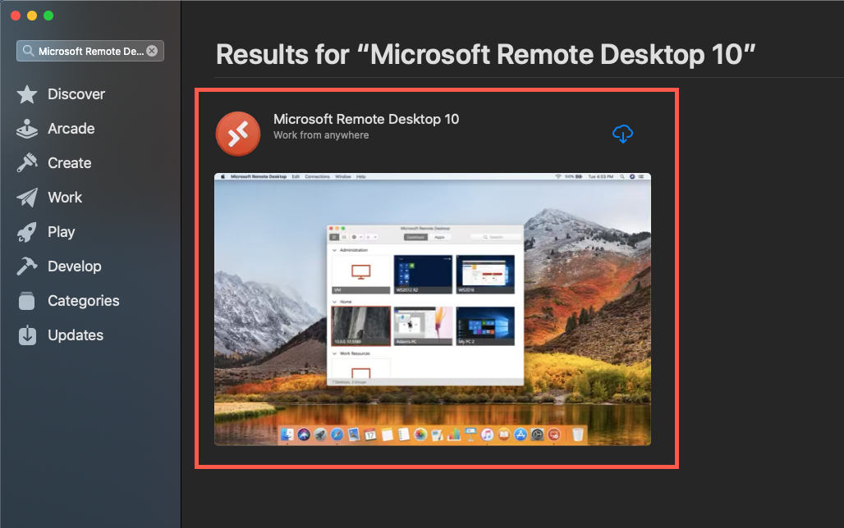
- Open an internet browser and go to CalStateLA Remote Access Labs.
- On the left side of the page, select a Computer Lab.
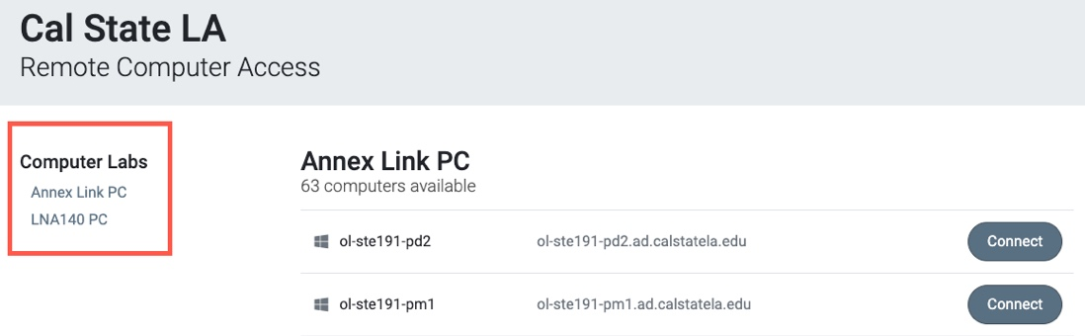
- Select an open computer, highlight and copy its name then click Connect.
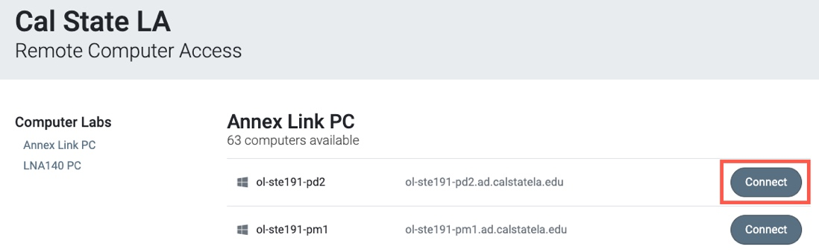
- Click Download (Remote Desktop Protocol) file. When file has finished downloading, double-click to open it.
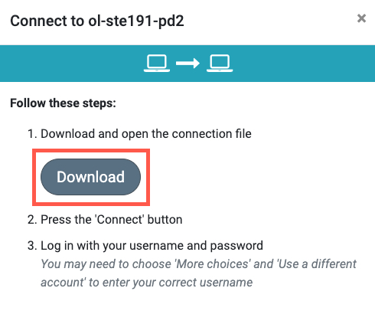

- Click Continue
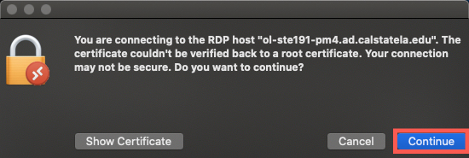
- The following pop-up will appear. Click Close and open Microsoft Remote Desktop application.
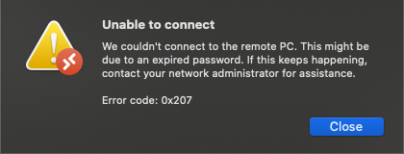
- Click Add PC.
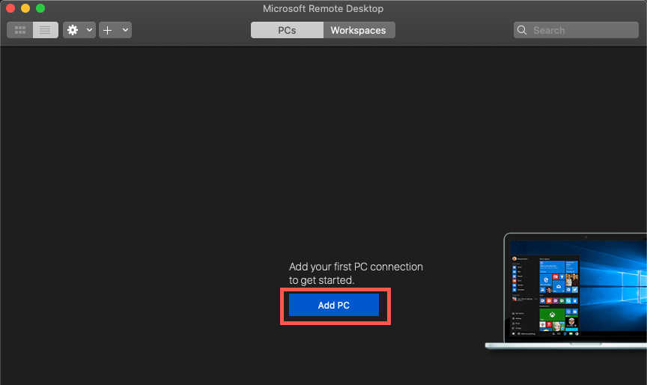
- Paste the computer name for PC name (Step 5) and select Add User Account… for User account.
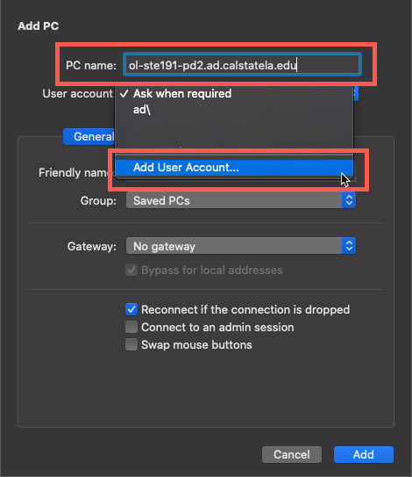

- Type in MyCalStateLA ID credentials and click Add.
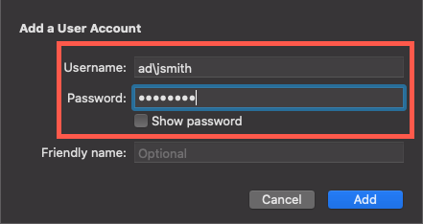
- Double-click on the image with PC icon and click Continue.
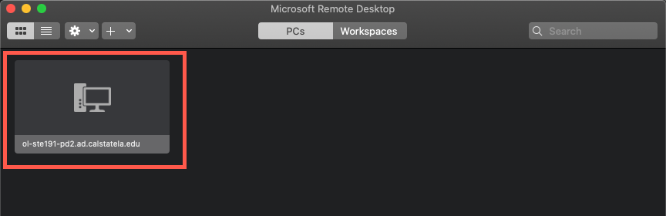

- You are now connected remotely to the computer.
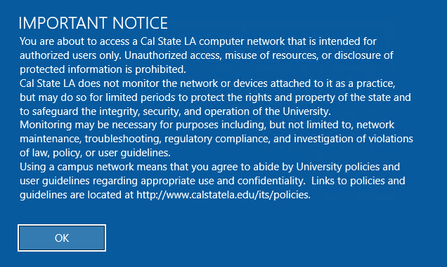
- To end remote connection, sign out of computer and close window.

Section 4: Saving File Locally and Uploading/Downloading to the Cloud Storage
*Note: Please remember to periodically save your work.*
Saving File on Microsoft Office (Word, PowerPoint, Excel)
- To Save As a file, go to File > Save As > Browse > Documents.
  - File Name: Enter the name of your File
  - Save as type: Select the type of file you want to save as (Word Document, PDF, etc.)
- Click Save.
- The file has been saved into the computer’s Documents folder.
*Note: Many applications allow you to Save As, which allows you to specify the name and location of the file you are saving.

Upload File to OneDrive
- Open any browser and go to mymail.calstatela.edu
- Log with campus email and password.
- On the top left corner of the page, click the App Launcher and open OneDrive.
- Click Upload > Files > Documents > (Select your document) > Choose
- Upload time varies depending on size of file.
- The file is now uploaded to OneDrive and accessible on any device.

Download File from OneDrive
- Open any browser and go to mymail.calstatela.edu
- Log with campus email and password.
- On the top left corner of the page, click the App Launcher and open OneDrive.
- Select a file, then click Download.
- Download time varies depending on size of file.
- The file is now downloaded on your device.

*Note: Other cloud storage services include Google Drive, Dropbox, and Amazon Drive. Alternatively, the file can be sent via email as an attachment.

