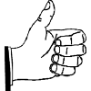
Professional Attire Guidelines
Definitely Okay

Men
- Suits with a tie
- Neatly trimmed beard
- Polished Shoes

Women
- Long sleeves/ short sleeves
- Some shimmer
- Cropped pants in dressy fabrics
- Lace camisole under a button-down
- Knee-length skirts
- Earrings
- Panty hose/ Dark socks
- Pumps/closed-toe high heels
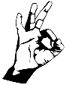
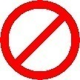
Unacceptable

Men
- Denim
- Shorts
- Untucked dress shirts
- Three-day old stubble
- Shoes without socks

Women
- Spaghetti straps/ strapless tops
- Sequined dresses
- Short-shorts
- Underwear as outerwear
- Micro-minis
- Denim jackets
- Sandals, sneakers, stilettos
Usually Acceptable

Men
- Sport coats
- Sweaters
- Growing in a beard accents

Women
- Sleeveless tops (women only)
- Sequined or beaded
- Lace camisole peeking from blouse
- Above-the-knee skirts
- Multiple small earrings
- No hose with pumps
- Peep-toe shoes
- Flats

If while picking an outfit…
- your clothes are see-through…
- you feel it may not be appropriate…
- you must sit a certain way to cover up your legs in a skirt…
- you feel it may be revealing …
- you would be embarrassed to run into your parents…
- your feet are hurting…
- your pants are so tight that eating lunch might not be a good idea…
- you aren’t sure that the colors match…
- you detect an odor…
- you see wrinkles…
- the outfit draws more attention than your resume…

THE OUTFIT IS NOT ACCEPTABLE!!!

“Business” or
“Business Formal”
Attire

- Interviews
- Formal Networking Events (e.g., Meet the Firms)

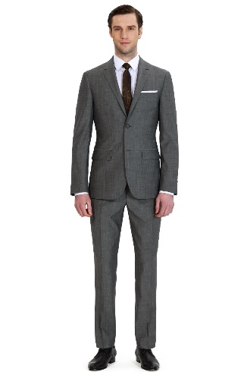

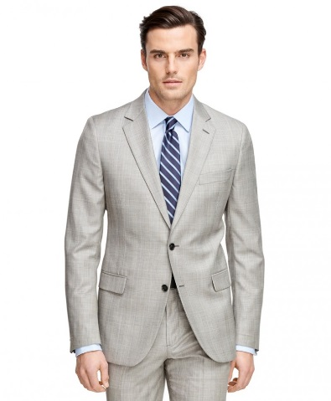

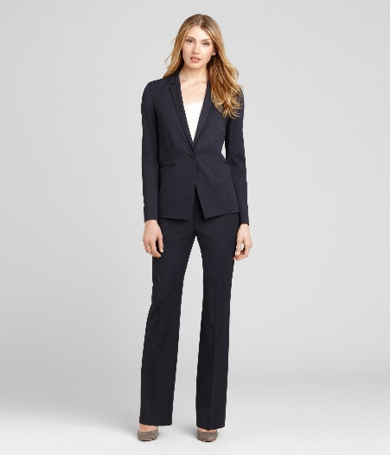

“Business Casual”
Attire

- Casual Networking Events
- On the job (if not a normal setting)

