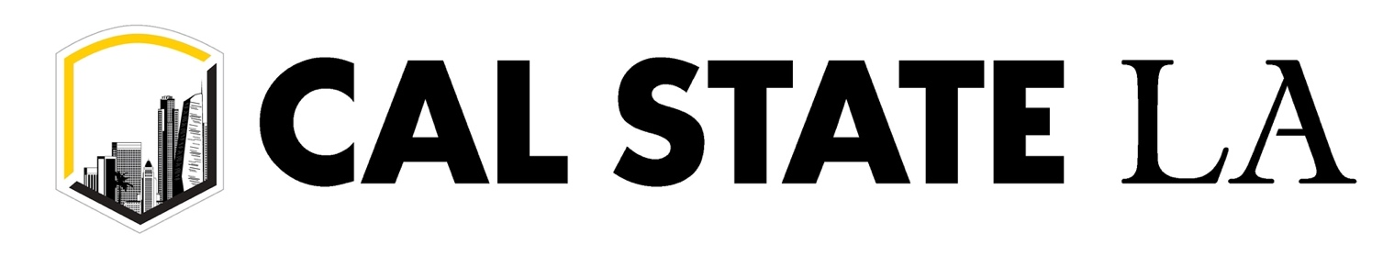
PHOTO CONSENT FORM
I, _____________________________________________________ grant permission to Cal State LA, College of ECST for the use of the photograph(s) or electronic media images as identified below in any presentation of any and all kind whatsoever. I understand that I may revoke this authorization at any time by notifying Cal State LA, College of ECST hsimon@calstatela.edu in writing. The revocation will not affect any actions taken before the receipt of this written notification.
Name  Address  City  Phone | _____________________________________________________________________  _____________________________________________________________________  ________________________ State ________________ Zip _________  _____________________________ Email ___________________________________
Signature | _________________________________________ Date __________________

Image(s) Description: Cal State LA, College of ECST Honors Convocation on Thursday, April 14, 2022. The photos and video from this event may be used for various promotional and advertising purposes in the future.
DISCLAIMER: When you attend a California State University, Los Angeles event, you enter an area where photography, audio recording, and video recording may occur. By entering the event premises, you consent to such media recording and its release, publication, exhibition, or reproduction to be used for news, webcasts, promotional purposes, telecasts, advertising, and inclusion on websites. You further waive all rights you may have to any claims in connection with any exhibition, streaming, webcasting, televising, or other publication of these materials, regardless of the purpose or sponsoring of such exhibiting, broadcasting, webcasting or other publication.

