MyCalStateLA Keyboard Accessibility Quick Start Guide
Spring 2021, Version 2
Table of Contents
MyCalStateLA Keyboard Accessibility Quick Start Guide 1
Information for Screen Reader Users 2
Alerts 2
Navigating the Hub Menu 2
Navigating the Site Menu 3
Content Sections 3
News 3
Featured Content 4
My Frequented Sites 5
Twitter 5
Video Content 6
Other Content 6
MyCalStateLA Portal Accessibility Statement 7
Limitations and alternatives 7
Contact Accessibility 7

Information for Screen Reader Users
In addition to the standard navigation via the keyboard, screen reader users can take advantage of navigation in the following ways:

- Skip to main content link (the first link on the page). This link bypasses the menu items and moves to the content on the page.
- Navigate via headings (INS + F7) on most popular screen readers will reveal a list of heading on the page, they are:
  - Quick Launch
  - University Updates
  - Featured News
  - WellBeing U
  - Upcoming Events

Alerts
After the navigation menus and before the main page content, there may be several banner alerts. These announcements will frequently change and are read by your screen reader, followed by a close button to dismiss the alert.

Navigating the Hub Menu
The Hub Menu is at the top of and is consistent across all intranet pages. It links to resources outside of MyCalStateLA and to sites that are part of the intranet.

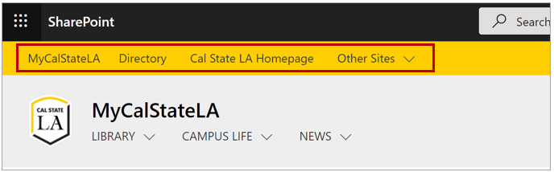
Figure 1 - Hub Menu

To navigate the Hub Menu:
- Press Tab until MyCalStateLA is selected
  - Press Enter to select the MyCalStateLA link
- Press Tab again to access the other links
- Once Directory is selected, use the Left and Right arrow keys to navigate to the other options
  - Press Enter to select an option
- To access the Other Sites submenu:
  - Tab until Other Sites is selected
  - Press Enter
  - Use the Up and Down arrow keys to navigate submenu options
  - Press Enter to select an option
  - Press Escape to exit the submenu
- Press Tab to move off of the Hub Menu and on to the next page element

Navigating the Site Menu
The Site Menu is below the Hub Menu and will vary for each page on the intranet. It links to resources and pages relevant to the site.

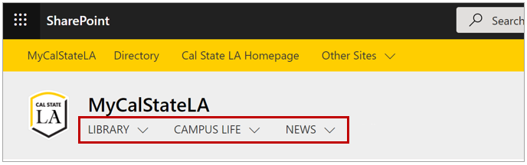
Figure 2 - Site Menu

To navigate the Site Menu:
- Press Tab until the first option is selected
- Use the Right and Left arrow keys to navigate options
- Press Enter to select an option
- To access a submenu:
  - Tab until the desired submenu is selected
  - Press Enter
  - Use the Up and Down arrow keys to navigate submenu options
  - Press Enter to select an option
  - Press Escape to exit the submenu if no item is selected
- Press Tab to move off of the Site Menu and on to the next page element

Content Sections

News
The news section on MyCalStateLA will have news articles and links from all sites on the intranet. Individual sites will have news content relevant to each site.

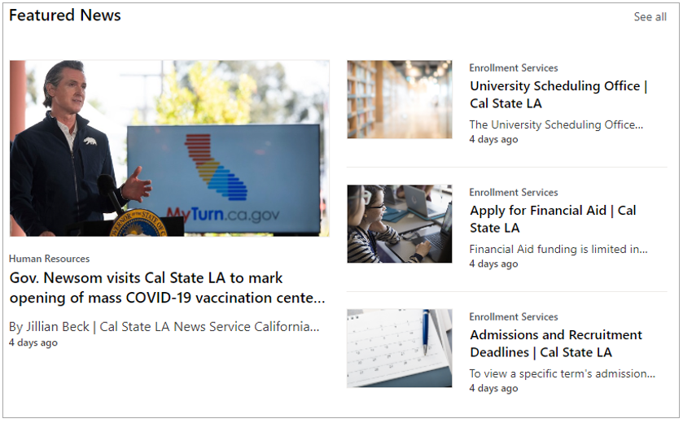
Figure 3 - News

To navigate News:
- Press Tab until See All is selected
  - Press Enter to see all available news
- Press Tab again to select the first featured news item
- Use the Up and Down arrow keys to navigate between news items and sources
- Press Enter to select a news item or news source
- Press Tab to move off of News and on to the next page element

Featured Content
Featured Content, also called “Hero Content,” highlights upcoming events and notices. It may show up to five items.

Figure 4 - Featured Content

To navigate Featured Content:
- Press Tab until the first item is selected
- Use the arrow keys to navigate between items
- Press Enter to select an item
- Press Tab to move off of News and on to the next page element

My Frequented Sites
My Frequented Sites is a listing of sites you visit often.

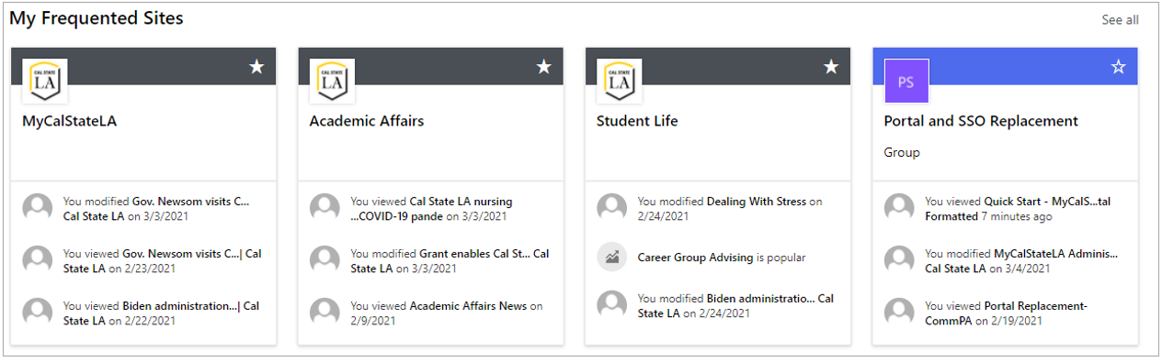
Figure 5 - My Frequented Sites

To navigate My Frequented Sites:
- Press Tab until See All is selected
  - Press Enter to see all frequented sites
- Press Tab again to select the first listed site card
- Press Enter to open the selected site card
- Press the Left and Right arrow keys to select another site card
- Use the Up and Down arrow keys to select the actions section of the site card
  - Press Enter to select an action
  - Press Escape to exit the actions section of the site card
- Press Tab to move off of My Frequented Sites and on to the next page element

Twitter
The Twitter content section shows the Twitter feed for a given address

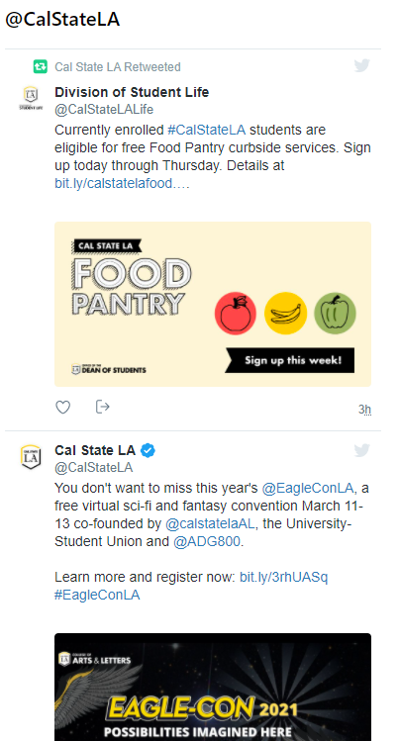
Figure 6 - Twitter

To navigate Twitter:
- Press Tab until the Twitter feed is selected
- Press Enter to interact with the feed
- Press Tab and Shift-Tab to move between links and actions in the feed
- Press Enter to select a link or action
- To move off of the Twitter feed, press Tab or Shift-Tab until the next content element is selected

Video Content
To access video content:
- Press Tab until the video is selected
- Press Enter to interact with the video
- Press Tab or Shift-Tab to move through the video actions (such as Play)
- Press Enter to select the action
- To move off of the video content, press Tab or Shift-Tab until the next content element is selected

Other Content
To access other content (such as Quick Links or My Links)

- Press Tab or Shift-Tab until the content is selected
- Press Enter to interact with the content

MyCalStateLA Portal Accessibility Statement

Limitations and alternatives
Despite our best efforts to ensure the accessibility of MyCalStateLA, there may be some limitations. Below is a description of known limitations and potential solutions. Please contact us if you observe an issue not listed below.
Known limitations for MyCalStateLA:
- Menu Navigation: When navigating via keyboard, the discovery of all top-level menu items requires both the tab and the arrow keys. Tabbing from the top of the page, after landing on “Accessibility,” to progress to different menu options, you must then use the right arrow key. At the end of the menu bar, press the tab key again to move to the next menu; once you tab to “Library,” use the right arrow key to reveal additional menu options. To open or enter a collapsed drop-down menu, use the down arrow key; within the menu drop-down, the up and down arrow keys and the tab key loop through the available options; if no selection is chosen, you must use the escape key to back out of an expanded drop-down menu.
- When tabbing to the heading sections “University Updates” and “Featured News,” the tab key lands on the first item within each category; use the arrow keys to navigate additional content within each section.
We have opened a ticket with Microsoft to investigate this behavior.

Contact Accessibility
If you require additional information or assistance, or if you have additional recommendations that you would like incorporated in the guide, please email accessibility@calstatela.edu

This guide and the MyCalStateLA Portal accessibility statement is available online via the CalStateLA Accessibility website

Link to MyCalStateLA portal

