California State University, Los Angeles

Department of Mathematics

Math 1085-xx&xx Discrete Mathematical Models

Fall 2021

COURSE INFORMATION

Instructor Information
Instructor: <your name>
Office Location: N/A
Email: <your email>
Office (Student) Hours: I invite you to join me in my Zoom Café for a chat, math or other questions, and just to hang out. Tentative office hours (unless they do not fit student’s schedules) are on <give hours & link>. Feel free to adjust the wording.

General Course Information
Class Days/Time: Math 1085-xx TR tt:tt – tt:tt followed by Math 1085-xx TR tt:tt – tt:tt
Prerequisites: Grade of C or better in any of MATH 1081, MATH 1082, or ESM 1082. Rudimentary knowledge of Microsoft Excel.

Course Structure
This section is offered entirely online through Zoom. Sessions at take place at the scheduled time of the class as per GET. You will participate in the course using the Cal State LA learning management system Canvas. All class sessions will be recorded, and the links to the recordings can be found in the Zoom section in your Canvas course.

Course Description
University Catalog Description: Sinusoidal, exponential and logarithmic functions in a biological context. Formulation and analysis of basic discrete models in biology. Matrix operations, Eigenvectors and Eigenvalues, Leslie matrices.

Topical outline: Overview of the modeling process; linear models and least square analysis; unit conversion; error computation; review of polynomial, rational, exponential, and logarithmic functions in biological context; allometric models; trigonometric functions and oscillations; discrete-time linear and non-linear models; analysis of discrete-time models; matrix operations, Eigenvectors and Eigenvalues, Leslie matrices. These topics are grouped into four major areas illustrated in the diagram on the next page, which gives a visual overview of the connections between the different topics.

What these topics have in common is that they use functions and other mathematical structures to describe patterns, which is what we will call a model in this course. We may know that a particular type of function or model is appropriate for a given situation, and we use information to determine the constants or parameters. In other instances, we have a larger set of data and need to first determine which type of function or model is appropriate, and then go to the second step of finding the parameters. The functions are typically created by using data, and we will investigate how to determine which function fits a given situation best. We will also learn how to assess how good that fit is, so we know how confidently (or cautiously) we can make predictions using our model (function). We will look at both continuous-time and discrete-time models and their uses in the life sciences.

At the end of this course, you will have gained an understanding of the different ways that models can be created, and their many uses in the life sciences in areas ranging from population conservation to modeling the COVID-19 pandemic. Mathematical models are everywhere – just open a newspaper or your electronic device and you will read a report with an underlying mathematical model. Taking this class, you will know that a model is only as good as the assumptions and data on which it is based, and that new data may require that the model is adjusted to reflect the larger data set.
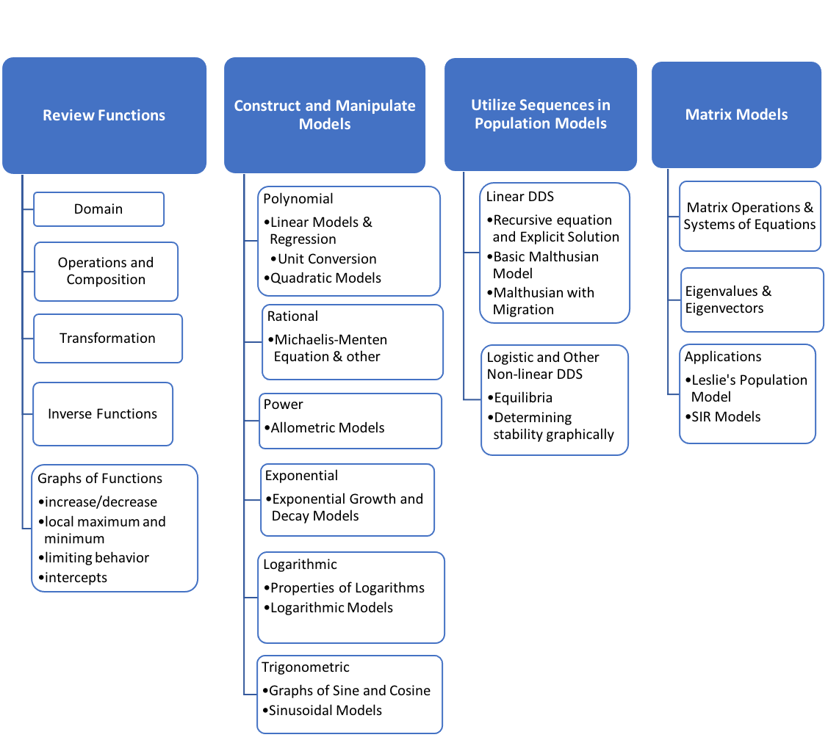

Student Learning Outcomes
Upon successful completion of this course, students will be able to:
- Explain the mathematical modeling process and the role data plays in the process
- Define and recognize basic function types and apply them to solve problems in the life sciences.
- Use linear regression and parameter estimation to fit basic types of functions to data to find a mathematical model of a biological process
- State and interpret the basic Malthusian and logistic growth models and their variations
- Formulate a simple discrete-time model in one variable and determine the stability of its equilibrium values and its long-term behavior
- Identify whether matrix operations are possible and if so, to perform them.
- Set up a Leslie matrix from information about an age-structured population.
- Explain the meaning of eigenvalues and eigenvectors for the Leslie matrix and their use in determining the long-term behavior of a population.

COURSE REQUIREMENTS

Textbook
Title: Calculus for the Life Sciences 2nd Ed.
Author: Margaret Lial, Nathan P. Ritchey, and Raymond N. Greenwell
Edition: E-book custom edition
ISBN: 9781323492109

This textbook will also be used for MATH 2045.

The E-book custom edition listed above is a package that consists of a MyLabMath access code. This code can be purchased at the bookstore or at www.mymathlab.com. This custom edition contains the e-text and supplementary items such as videos and study problems. We will NOT use MyLabMath for homework and exams.

Instead of the custom edition listed above, you can purchase a stand-alone electronic or paper copy of this book, which may be cheaper than the custom edition, but does not include the supplementary resources. We will use an open-access system (MyOpenMath) for online homework and mini-exams instead of the MyLabMath software which is purchased with the access code.

Other equipment / material requirements
Worksheets for the course which you will work on during class time will be posted on Canvas. For the exploration assignments you should have some rudimentary knowledge of Excel or Google sheets (or some other spreadsheet software). As a Cal State LA student, you have free access to Excel either through Outlook 365 (web-based version) or through MyTools (http://www.calstatela.edu/its/software/mytools). Alternatively, you can do the computations in Google sheets, which is available for free. You will also need the ability to scan in your written work for posting to Canvas or shared (Google) documents. If you have an iPhone, then the built-in Notes app works well for scanning. For Android phones, Fast Scanner and Tiny Scanner are free apps that work well and allow for multiple pages to be scanned into a single PDF document. DO NOT just take pictures of your work – they are hard to grade because the background is darker.

Computer Requirements
You will need a phone, notebook, desktop or laptop computer with an up-to-date browser, and you need to have the Zoom app installed on that device. Make sure to download the newest version just before the beginning of the semester so that we can use all the current features of Zoom in class.

Course assignments and all course materials will be posted in the Canvas course, and you will be accessing the online homework (and possibly the electronic textbook) through a link in your Canvas course. The online homework assignments will require you to connect to the Internet regularly with a stable Internet connection. If needed, download and install Adobe Acrobat Reader software onto your computer. If you need technical assistance, please check the ITS Helpdesk Student Resources page.

Software/Phone APPS/Calculator/Gmail Account
- For the exploration assignments you should have some rudimentary knowledge of Excel or Google sheets (or some other spreadsheet software). As a Cal State LA student, you have free access to Excel through MyTools (http://www.calstatela.edu/its/software/mytools) or through Outlook 365 (web-based version). Alternatively, you can do the computations in Google sheets.
- You will also need the ability to scan in your written work for posting to Canvas or shared (Google) documents. If you have an iPhone, then the built-in Notes app works well for scanning. For Android phones, Fast Scanner and Tiny Scanner are free apps that work well and allow for multiple pages to be scanned into a single PDF document. DO NOT just take pictures of your work – they are hard to grade because the background is darker.
- You will need a scientific Calculator or Calculator App.
- We will use shared documents for group work and explorations. If you do not already have a Google account, please go to https://support.google.com/accounts/answer/27441?hl=en to create an account.

Minimum Technology Skills
- Regularly checking your official calstatela.edu email account.
- Creating, saving, locating, and opening different types of files on a computer.

COURSE POLICIES

Course Logistics
The course will be held synchronously at the time stated in GET. You will get most out of the course if you attend the synchronous Zoom sessions, and I expect you to be there at the beginning of class and stay the entire class period. Attendance will be taken at each class session. If you have to miss a class, please notify me as soon as possible. Make sure to check in with either your study buddy or me to find out what we discussed in class, and to watch the Zoom recording of that day.

We will start class with all participants muted to avoid distractions from background noise. If you want to ask a question, please raise your hand and I will unmute you, or put your question into the chat, either to “everyone” or just to me. Make sure to mute yourself after having asked your questions. So that I know who you are, I require you to adjust your participant name to your full name.

CLass Community
Active participation is expected from each student because that is how we learn as a class community. You will regularly be put into breakout rooms to work in smaller groups, and we will also have whole-class discussions.
To establish a learning environment where we can learn from each other and everybody can be successful, we need to be respectful of each other, allow everybody to speak and participate, and to listen to all classmates and value their opinion. In addition, everybody should try their best to participate in discussions and to contribute to the learning environment with questions and assistance.

I value the perspectives of individuals from all backgrounds, reflecting the diversity of the Cal State LA student body. I broadly define diversity to include race, gender identity, national origin, ethnicity, religion, social class, age, sexual orientation, political views, and physical and learning ability. My goal is to make this classroom an inclusive space for all students. If you see ways I can improve, please let me know.

COURSE COMMUNICATION

Interaction with Instructor
I will make every effort to communicate regularly with you through announcements and postings within Canvas. Post any questions or comments you have about the course content or requirements in the Muddiest Point discussion. Questions of a more personal nature can be sent to me via email or you can talk to me before or after class. Please email me from within Canvas; otherwise, please make sure to put MATH 1085 in the subject heading so that I can easily identify the emails for this class. If I am unavailable for more than a day during the workweek (Monday – Friday), I will make sure to have an automatic reply in my email to alert you to that fact.

Questions
Posing questions, asking questions (and if you have them) giving answers is how we learn. Don’t let an opportunity to ask a question go to waste – if you don’t ask, then you cannot figure out what is missing for you. Questions may be about the math, but also concern clarification about assignments, course materials, or assessments. Please ask those questions in the chat, post them in the Muddiest Point discussion, or email me.

Discussion Forums and Netiquette
There will be some assignments in the form of discussion forums. They will be graded for completion rather than correctness, since they may consist of a reflection (no right answer). Any such assignment will count toward participation (see below). When posting on the discussion boards and chat rooms, it is essential to understand how to interact with one another online, netiquette. You can read more about the rules of netiquette at 15 Rules of Netiquette for Online Discussion Boards.

Turnaround/Feedback
During the week (Monday - Friday), I will check email messages once a day. The Muddiest Point discussion will be checked at least twice a week before class so that I can answer any remaining questions at the beginning of the class session. Everybody is welcome to answer another student's question on the Muddiest Point discussion.

Student Hours (also known previously as Office Hours)
My student hours are a time that is set aside to help individual students (or groups of students) on their specific problems. We all have different backgrounds and different gaps in our knowledge. Student hours are the perfect place to identify any gaps, to clarify what may be muddy, and to assist you in being a successful student. I welcome you to ask me questions – please visit me in my Zoom Café.

ASSIGNMENTS AND GRADING POLICY
Your understanding of the course content and your achievement of the student learning outcomes will be assessed by a mixture of online homework, in-class worksheets, mini-exams, explorations, and a final. Here are the details:

ONline Homework Assignments:
Online homework will be assigned after we have completed a section or topic and consists of both review problems from prerequisite courses as needed and problems similar to the worksheet problems. The problems contain a mixture of multiple-choice, computation, and reflection, and you will get immediate feedback on your understanding of the course content. Some of the questions also have videos or examples that might be helpful if you are stuck. You have three attempts for each problem on an assignment and the highest score will be the one that is recorded for each problem. The purpose of the online homework assignments is to give you feedback on whether you have gained the necessary skills. The lowest homework score will be dropped.

Mini-Exams:
The four mini exams will give you feedback on your understanding of the course content after we have completed a set of related topics. The mini-exams will be accessible for a period of 28 hours (Friday at 8 PM – Saturday 11:59 PM). You can open the mini-exam at any point during this window and will have 50 – 60 minutes to complete the questions, plus an additional 10 minutes for uploading your work. They will take place during week 4, 7, 10, and 14 of instruction (see Canvas syllabus). There will be no make-up mini exams except for documented health and similar reasons (see catalog).

Explorations:
You will work on four explorations, using spreadsheets and/or other software to work on problems that take more time that is available on an exam. They will complement the mini-exams and can be done either individually or as a pair of students.

Active Course Participation:
Active course participation can take a variety of forms:
- Active participation in class and in group work, such as asking and answering questions and making sure each group member has understood the solution. If you feel shy about asking questions in class, you can always ask a question using the private chat function.
- Completion of prep work. Particularly for the review topics from Math 1081/1082 or similar course, you will be asked to watch some videos/read some notes to refresh your memory as needed. Then you will be asked to take a little “quiz” to check your understanding. You will be graded on whether you have seriously attempted that “quiz”, not so much on whether you got all the answers correctly. We will do a review in class based on the outcome of these quizzes, so please take them seriously. On occasion, prep work will consist of some other task to prepare you for class.
- Active participation in the completion of worksheets and other in-class activities. These activities are mainly there to give you practice with problem-solving and prepare you for the mini-exams and the final. You will be graded on whether you participated and helped your group move forward, not so much on whether your group had the correct answer. This is where you practice and hone your skills, and where you find out what you may not know.
- Participation in discussion forums, for example, the Muddiest Point. Both posting and answering questions are equally valuable.
- The end of semester reflection on your growth as a user of mathematics.

FINAL:
A course final is an assessment of how well you have mastered the course topics and what you have learned in the course. It connects all the different strands of the course together and requires you to review everything we have done throughout the semester. The final will be comprehensive and will give you an opportunity to improve your grade on one of the mini-exams if you do better in the final on the questions from that mini-exam.

Grading Criteria
You can view your grades using the GRADES button in the Canvas course navigation. Please check your grades regularly to make sure that I have received all your assignments. If you have a question about a grade or other personal concerns, please email me.
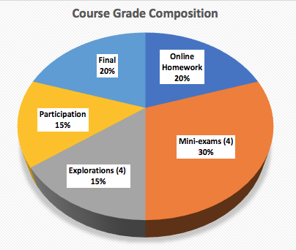

Assignment | Weight
Online Homework | 20% (lowest grade to be dropped)
Mini-exams (4) | 30% (7.5% each one)
Explorations (4) | 15% (3.75% each)
Participation | 15%
Final | 20%
Total: | 100%

Grading Scale
Course percentages at boundaries of grades are rounded up or down to the nearest integer value. The cut-off scores indicate the lowest percentage needed for that grade.

Letter Grade | Cut-off | Letter Grade | Cut-off | Letter Grade | Cut-off
 |  | A | 93% | A- | 90%
B+ | 87% | B | 83% | B- | 80%
C+ | 75% | C | 70%
D+ | 67% | D | 63% | D- | 60%

Rubrics (Explorations, Mini-exams, AND Final)
Explorations will be graded using rubrics that guide you in what I expect of you. These expectations are also listed in the instructions for the explorations.
While I may not explicitly use a rubric for grading your mini-exams and the final, a rubric will be attached to these assignments to guide you in checking your work before you submit it. The rubric will let you know my expectations of what it means to solve a math problem. The task consists not only of calculating a correct answer, but it also requires communicating the process you used, using proper mathematical notation to explain that process, and to communicate your answer in the context of the application, together with units (if applicable). The rubrics will remind you of those expectations.

HELPFUL STUDENT RESOURCES

Canvas Student Support
Information for students on how to be a successful online student and how to use Canvas:
- Canvas Student Guide
- Canvas Student Tour Course

Quick help on Canvas can also be found in the Canvas Help & Technical Support Resources module in the Canvas course.

Technical Resources
Information on Cal State LA Information Technology Services (ITS): Technical Support Resources. Up-to-date information (open hours, location) on the campus Open Access Computer Labs can be found here.

Student Support Resources
Information on Cal State LA student support resources for students: Student Support Resources

Academic Support Resources
Information on Cal State LA academic support resources for students: Academic Support Resources.

Glazer Family Dreamers Resource Center
The Erika J. Glazer Family Dreamers Resource Center promotes the success of undocumented students and students from mixed-status families at Cal State LA through a variety of resources, services, and community engagement opportunities. Such programs and services are weekly immigration legal clinics, California Dream Act Application for Financial Aid Assistance, and professional and academic development workshops.

First Generation Students
Many of you are the first in their family to go to college, and you may find the college experience, at times, bewildering. Do not give up! Cal State LA has many resources to assist you. Make sure to use them – that is what they are here for. A detailed list of resources can be found in the First Generation Students module in the Canvas course.

UNIVERSITY POLICIES

Student Conduct
You are responsible for being aware of all announcements that are made in class or on Canvas, such as changes in exam dates, due dates of homework and papers, and cancellation of class due to instructor's absence, even on days that you are absent. You also need to turn on appropriate notifications in Canvas (and if desired, add a secondary email address) because email and announcements through Canvas will be the primary mode of communication. Failure to do so may result in missed deadlines or other consequences that might adversely affect you. Additional information on student rights and responsibilities, standards of conduct, etc., can be found by visiting the Cal State LA University Catalog Appendices.

Dropping and Adding
You are responsible for understanding the policies and procedures about add/drops, academic renewal, etc. To find out about the current deadlines and penalties for adding and dropping classes visit the GET home page. In particular, your instructor cannot drop you after the Add deadline, so it is your responsibility to do so if you cannot complete the course for some reason. If you just drop out without filling out the relevant paperwork, then your grade will be a WU, which will count as an F.

Americans with Disabilities Act (ADA)
Reasonable accommodation will be provided to any student who is registered with the Office of Students with Disabilities and requests needed accommodation. If your accommodation includes additional time on tests, your test time on the quizzes will be adjusted accordingly. If you have any other accommodations, please communicate with me early so that we can make sure your needs are being met in the online environment. For more information, visit the Office for Students with Disabilities home page.

Academic Honesty
Many incidents of plagiarism result from students' lack of understanding about what constitutes plagiarism. However, you are expected to familiarize yourself with the Cal State LA Academic Honesty Policy, including Appendix D – Academic Honesty and Appendix E - Student Conduct / Student Conduct Procedures. All work you submit must be YOUR OWN scholarly and creative efforts. Copying the work of others, cheating on exams, and similar violations will be reported to the University Discipline Officer, who has the authority to take disciplinary actions against students who violate the standards of academic honesty.

COURSE PACING GUIDE/SCHEDULE OF Major ASSIGNMENTS

Important Dates Fall 2021
- Sep 6 (M) – Labor Day, Campus closed
- Sep 7 (T) – Last Day for No record drop; Last day to Add classes
- Nov 11 (R) – Veteran’s Day (Campus Closed)
- Nov 22 – 27 (M - Sat) – Fall Recess and Thanksgiving (no classes M – W, campus closed R - Sat)
- Nov 19 (F) – Withdrawal period ends
- Dec 10 (F) - Emergency Withdrawal period ends
- Dec 13 – 18 (M - Sat) – Finals Weeks

Tentative Schedule
Each class session consists of a lecture and an activity component. The latter will be used for work on problem sets and other group activities, to review before mini-exams, and to get you started on the explorations. The tentative schedule shows the topics to be discussed so you can prepare for class. Each weekly module/page on Canvas will also list the activities for the week.

Dates for mini-exams and due dates for explorations are shown in purple the tentative schedule below. All assignments will be posted on Canvas, so please make sure to consult the Canvas Calendar or the Syllabus link regularly. Online Homework is due on Sunday night of the week in which they were given, so you may want to get started on the first part after Tuesday’s class. Late assignments may be accepted at the instructor's discretion but will incur a deduction in points.

Week | Date | Chapter | Lecture Topic | Activity
1 | Tues, Aug 24 |  | Before first class:  - Slides introduction before class  - Read through syllabus  First class  - Syllabus quick overview (10-15 mins on either first or second day)  - Overview - What are mathematical models;  - What does it take to be successful?  - Practice in identifying key terms in word problems | Group activities  - What does it take?  - Jamboard/Google slides for leaning/community activity  - Practice in identifying key terms in word problems
 | Thu, Aug 26 | 1.3 | Review of functions/polynomials practice quiz – go over main mistakes:  - Basic function properties  - Polynomials, including linear and quadratic functions –  - Identify linear, quadratic/polynomial  - End behavior | WS 1 - Basics of functions & polynomials
2 | Tues, Aug 31 | 1.1 | Linear functions and unit conversion | WS 2 - Unit conversion
 | Thu, Sep 2 | 1.2 | Modeling – Finding a good linear model  Follow activity with overview of least squares | - Group Activity – Finding a good linear model  - Introduction to Excel/Google sheets - how to produce a graph, how to write formulas  - Intro to Extended Exploration 1
3 | Tues, Sep 7  (Rosh Hashanna) | 1.2 | Least squares line, absolute and relative error, SSE, R-value | WS 3 - Sum of squared errors, computing errors
 | Thu, Sep 9 | 1.5 | - Polynomial functions  - Power functions and their relation to polynomials (different domain)  - review of domain and piecewise functions  - Determining parameters of model from a few given points (# points = # parameters) | - Model fitting with Excel/Google sheets for polynomials and power functions (Extended exploration 1 continued)  - WS 4 (skills) - Domains, piecewise functions skills  - WS 5 - Polynomial /power function word problems
4 | Tues, Sep 14 | 1.5 | - Rational functions  - End behavior of rational functions  - Application: Michaelis Menten | WS 6 - Rational functions
 | Thu, Sep 16 |  | Review for Mini-exam 1  Mini-exam 1 (Friday/Saturday)
5 | Tues, Sep 21 | 2.1 | Review of basics of solving exponential and logarithmic equations based on practice quiz | WS 7 (skills) - Solving exponential and logarithmic equations; Identifying power versus exponential function; log vs exponential functions
 | Thu, Sep 23 | 2.2 | Extended exploration 1 due  Applications of Exponential & Logarithmic functions in the life sciences | WS 8 - Exponential & Log Models – finding parameters from a few points
6 | Tues, Sep 28 | Based on notes | CONTRAST  - known the type of model, then we can use a few points to find parameters;  - unknown type of model, but data set: Use of EXCEL/Google sheets trendlines – how does the software do it??  FINDING TYPES OF MODELS FROM DATA:  - Finding parameters for Exponential models  - Finding parameters for Allometric (power) models;  - Finding parameters for some rational functions (Michaelis Menten)  - Logistic model as a mixture of rational with exponential | WS 9 - Allometric & exponential models; Use of semilog and log-log plots to determine type of model. Using least squares fit to transformed data to determine parameters from large set of data.  Intro to Extended Exploration 2 – Fitting a logistic model experimentally
 | Thu, Sep 30 |  | - Review right-angle trigonometry based on review quiz  - Radian measure and conversion to degrees  - Unit circle and trig functions | WS 10 - Radian measure, unit circle
7 | Tues, Oct 5 | 2.4 | Extended exploration 2 due  - More on unit circle and trig functions  - Review of transformations of graphs  - Graphs of trig function | Group activities with Geogebra to explore transformations of trig graphs
 | Thu, Oct 7 |  | Review for Mini-exam 2  Mini-exam 2 (Friday/Saturday)
8 | Tues, Oct 12 | 2.4 | Finding sinusoidal models from data – finding parameters | WS 11 - Sinusoidal Models  Intro to Extended Exploration 3
 | Thu, Oct 14 | 14.1 | Recursive and explicit sequences  Intro to linear DDS | WS 12 (skills) - Computing terms in sequences; creating equations from word descriptions.
9 | Tues, Oct 19 | 14.2-3 & notes | Stability of Equilibrium for linear, explicit solution; Application: Malthusian Growth Model | WS 13 - Linear DDS – explicit solutions; equilibria/stability
 | Thu, Oct 21 | 14.2-3 & notes | Extended exploration 3 due  DDS with non-linear updating functions | WS 14 (skills & applications) - Nonlinear DDS
10 | Tues, Oct 26 | 14.2-3 & notes | More on DDS with non-linear updating functions | WS 15 - Equilibrium values and stability for non-linear DDS
 | Thu, Oct 28 |  | Review for Mini-exam 3  Mini-exam 3 (Friday/Saturday)
11 | Tues, Nov 2 | 10.1 | Systems of Equations and Matrices; solving systems of two equations | WS 16 – Solving systems of equations, matrices
 | Thu, Nov 4 | 10.1 | Gauss Jordan method (generalizes substitution method) - work through some examples by hand? | WS 17 (skill) - Gauss Jordan method via calculators - identify types of solutions (none, exactly one, many); write solutions and check
12 | Tues, Nov 9 | 10.2 - 3 | Matrix operations & dimension | WS 18 (skill) - Matrix operations
 | Thu, Nov 11 |  | Veteran’s day – no class (university closed)
13 | Tues, Nov 16 | Notes | Compartmental models in general and in specific:  - SIR models  - Leslie matrices (can be visualized also as such models) | - Activity – Compartmental models with Excel/Google  - Owl model
 | Thu, Nov 18 |  | SIR model for spread of disease | Intro to Extended Exploration 4
 | Nov 22 – 27 |  | Fall Recess & Thanksgiving - no class (university closed Nov 25-27)
14 | Tues, Nov 30 | 10.5 | - Eigenvalues and Eigenvectors introduction and visualization  - Interpretation of largest eigenvalue as long-term growth factor - | Exploration of owl model
 | Thu, Dec 2 |  | Review for Mini-exam 4  Mini-exam 4 (Friday/Saturday)
15 | Tues, Dec 7 |  | Review for final | Review for final
 | Thu, Dec 9 |  | Extended exploration 4 due  Review for final | Review for final

