- Download and install GlobalProtect VPN
  - Download & Detailed instructions here https://www.calstatela.edu/its/network/vpn
- Download and install VNC Viewer
  - Download page here https://www.realvnc.com/en/connect/download/viewer/

- Launch and connect to GlobaProtect VPN
  - Use a student username and password (e.g. jsmith4)
- Launch VNC Viewer from Start Menu
  - Click “File”
    - Select “New Connection”
  - In the pop-up window
    - Enter the IP given to you by your instructor or from the Excel spreadsheet into the “VNC Server” field.
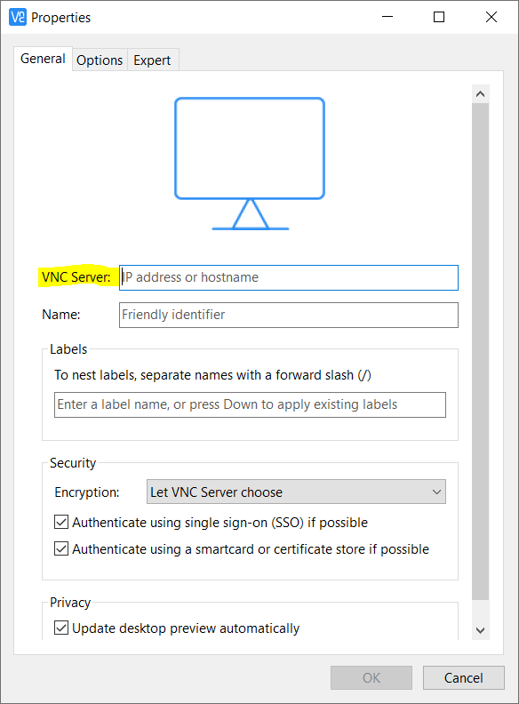
    - You may also want to enter an easily identifiable name or “Friendly Identifier” in the “Name” field. This will help you identify and reconnect to this specific computer more easily in the future.
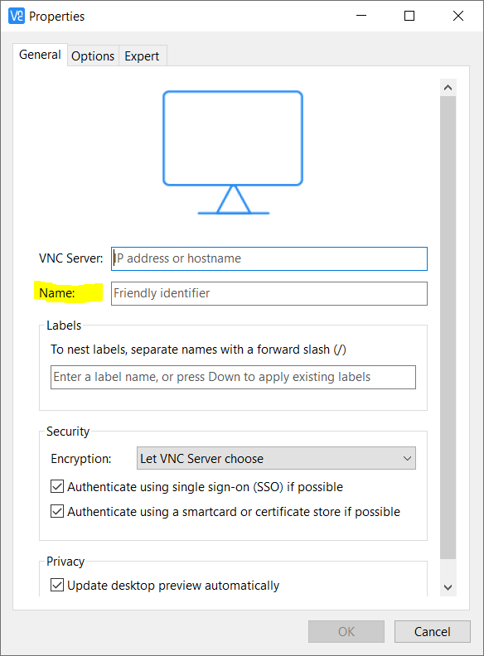
    - Then click “OK”
    - After clicking “OK” a new connection icon will show up in VNC Viewer
    - Double click the new icon to connect
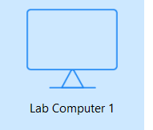

    - You may get a warning pop-up, if you do select “continue”. You may also check the “Don’t warn me about this again” box if you like.
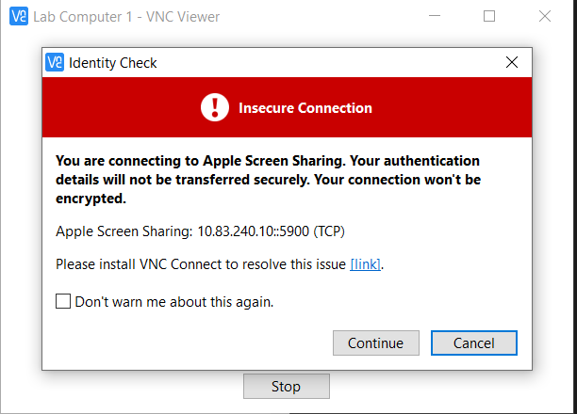
    - You will then get an authentication pop-up. Please enter your username and password (e.g. jsmith4) once more and click “OK”
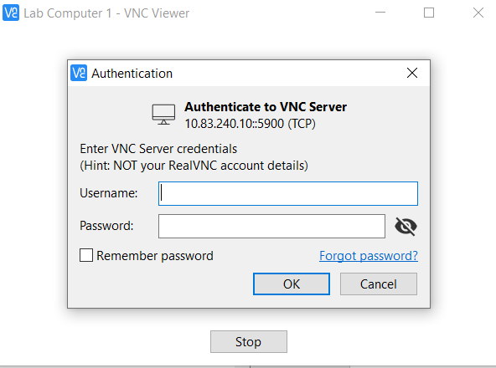

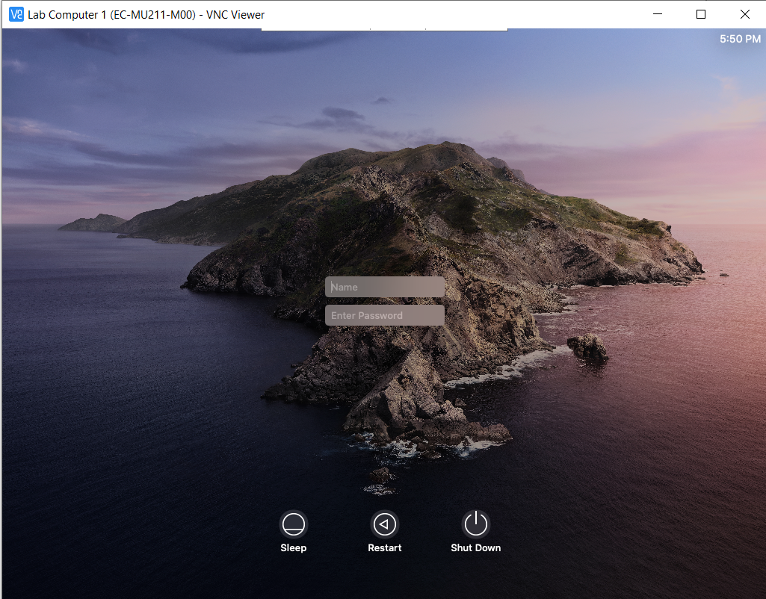
    - If the connection is successful you should then see a new window with the macOS login screen
    - Enter your username and password, once more to login and make use of the Campus Lab computer
    - Please make sure to properly log out when done using the lab computers, thank you!

Please make sure to properly log out when done using the lab computers, thank you!

