Download and install GlobalProtect VPN

* + Download & Detailed instructions here <https://www.calstatela.edu/its/network/vpn>

Launch and connect to GlobaProtect VPN

* + Use a student username and password (e.g. jsmith4)

Open Screen Sharing

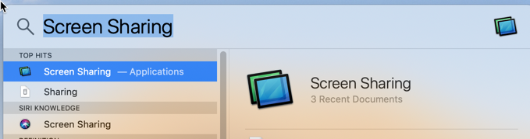

Enter the IP given to you by your instructor or from the Excel spreadsheet into the “Connect To” field.

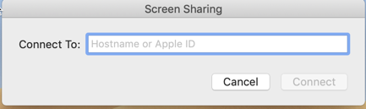

Enter your user name and password to continue.

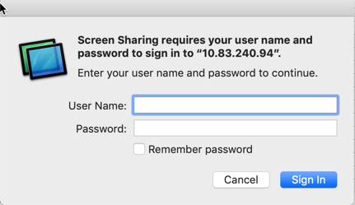

If the connection is successful you should then see a new window with the macOS login screen

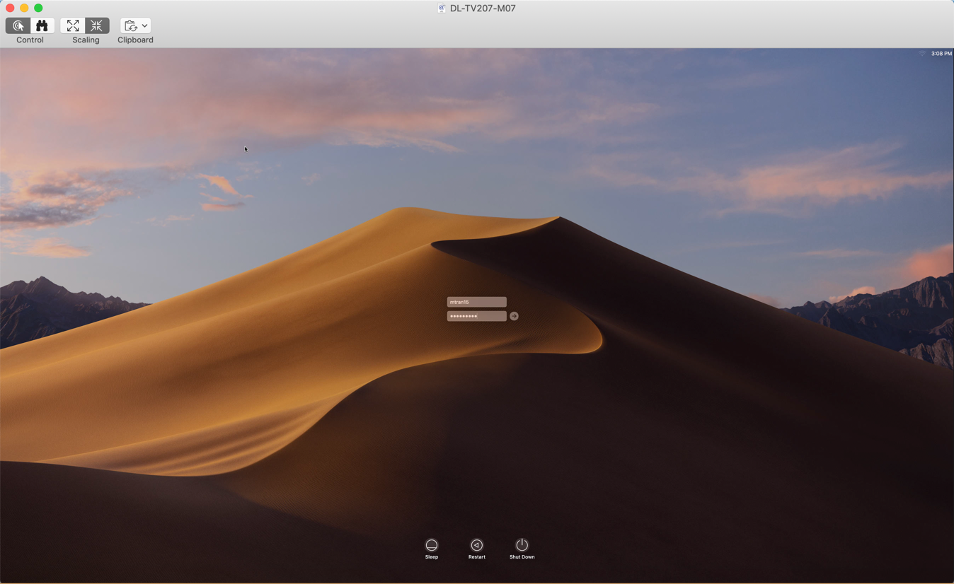

Enter your username and password, once more to login and make use of the Campus Lab computer

**Please make sure to properly log out when done using the lab computers, thank you!**