Instructions for Completing, Sharing, and Forwarding

DEPT. CHAIR RTP Reviews

The Department Chair is responsible for:

- Completing the form in Interfolio
- Sharing the report with the candidates
- Forwarding the case to the next level

Please note: If you were part of the department committee, you still have to fill out the form, share the report with the candidate, and move the case forward. On the form, you will need to indicate that you were part of the committee, and you will not be writing a separate report.

  - Enter the case the same way you would to review the file.
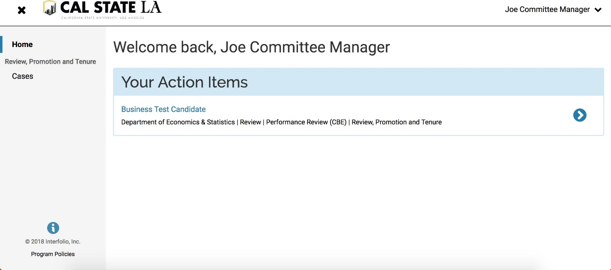

  - Click on “Case Details”.

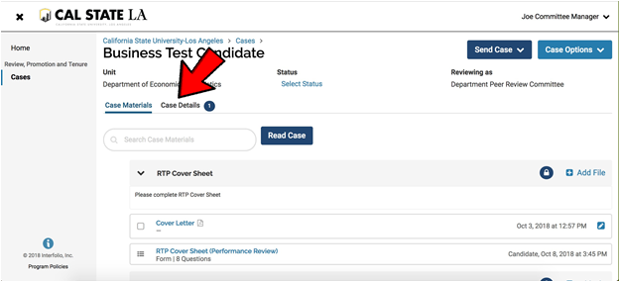

  - Under required documents, you will see a place to fill out a form. Click on “Fill Out Form.”

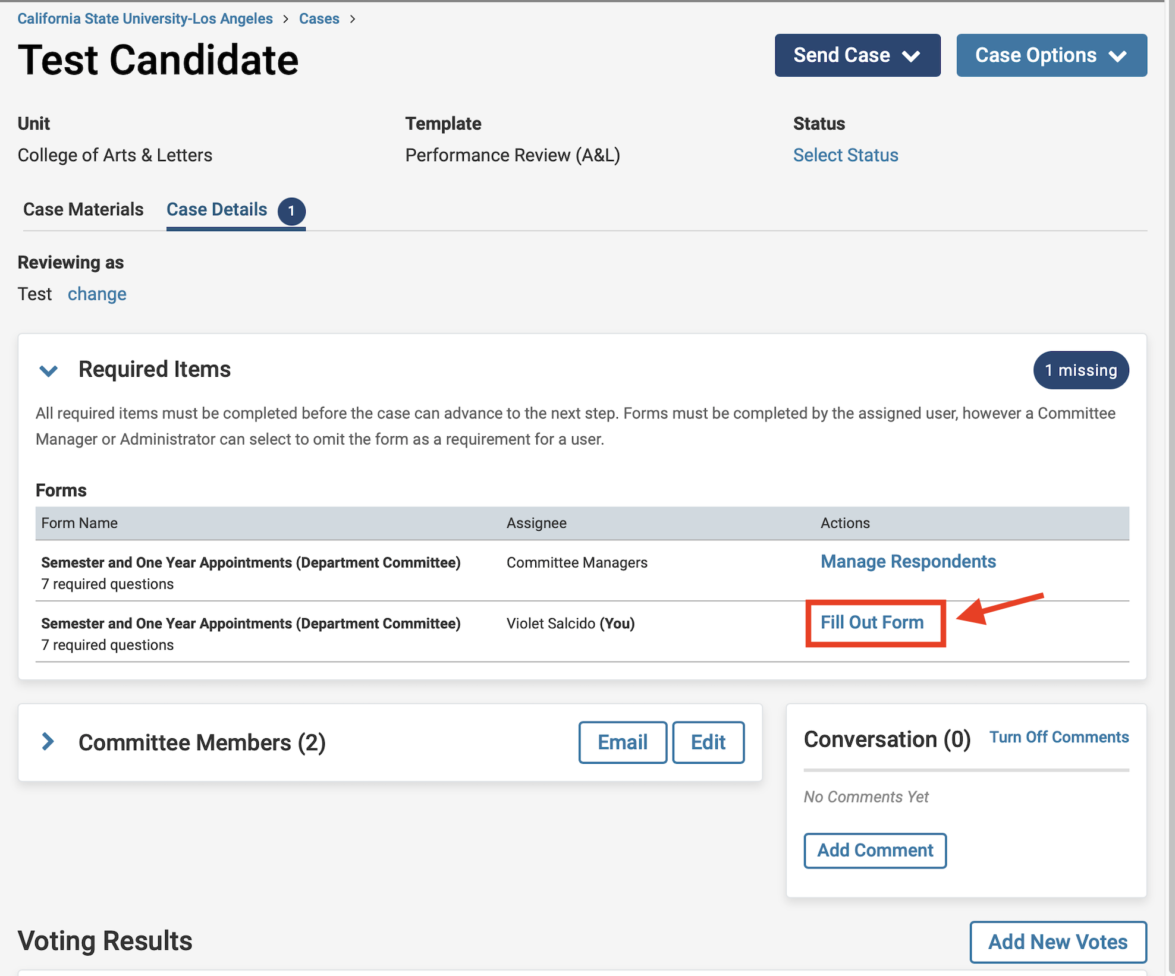

  - If you want to cut and paste from an existing document, you will have to use “CTRL + V” to paste it in the Interfolio form. You cannot paste tables.
- Please keep in mind that there is an 8000 character limit in each section and 10,000 overall. If you have more than 8000 characters in a section, you will need to contact Faculty Affairs. We will remove the form requirement and you will need to upload the document.

  - After you finish completing the form, click on “Submit Form”.
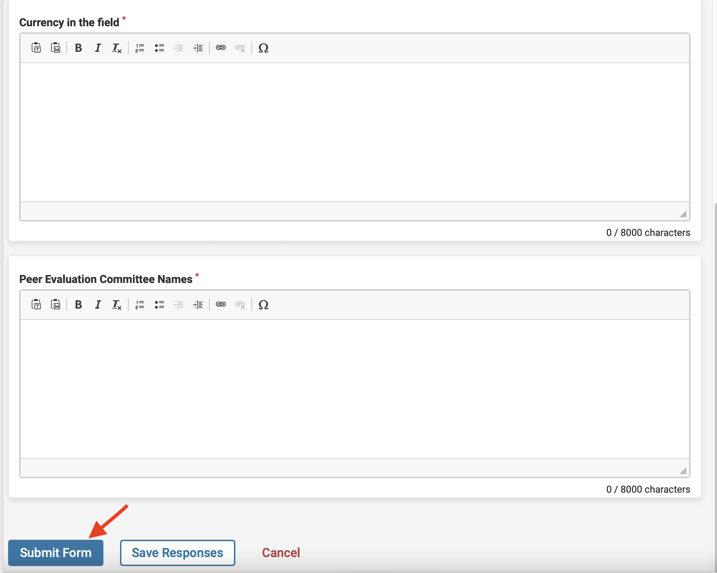
  - After submitting the form, you will see “Edit Submission”. That means that you have completed the form, but you can still change your responses, as long as you have not moved the case forward or shared it with the candidate.
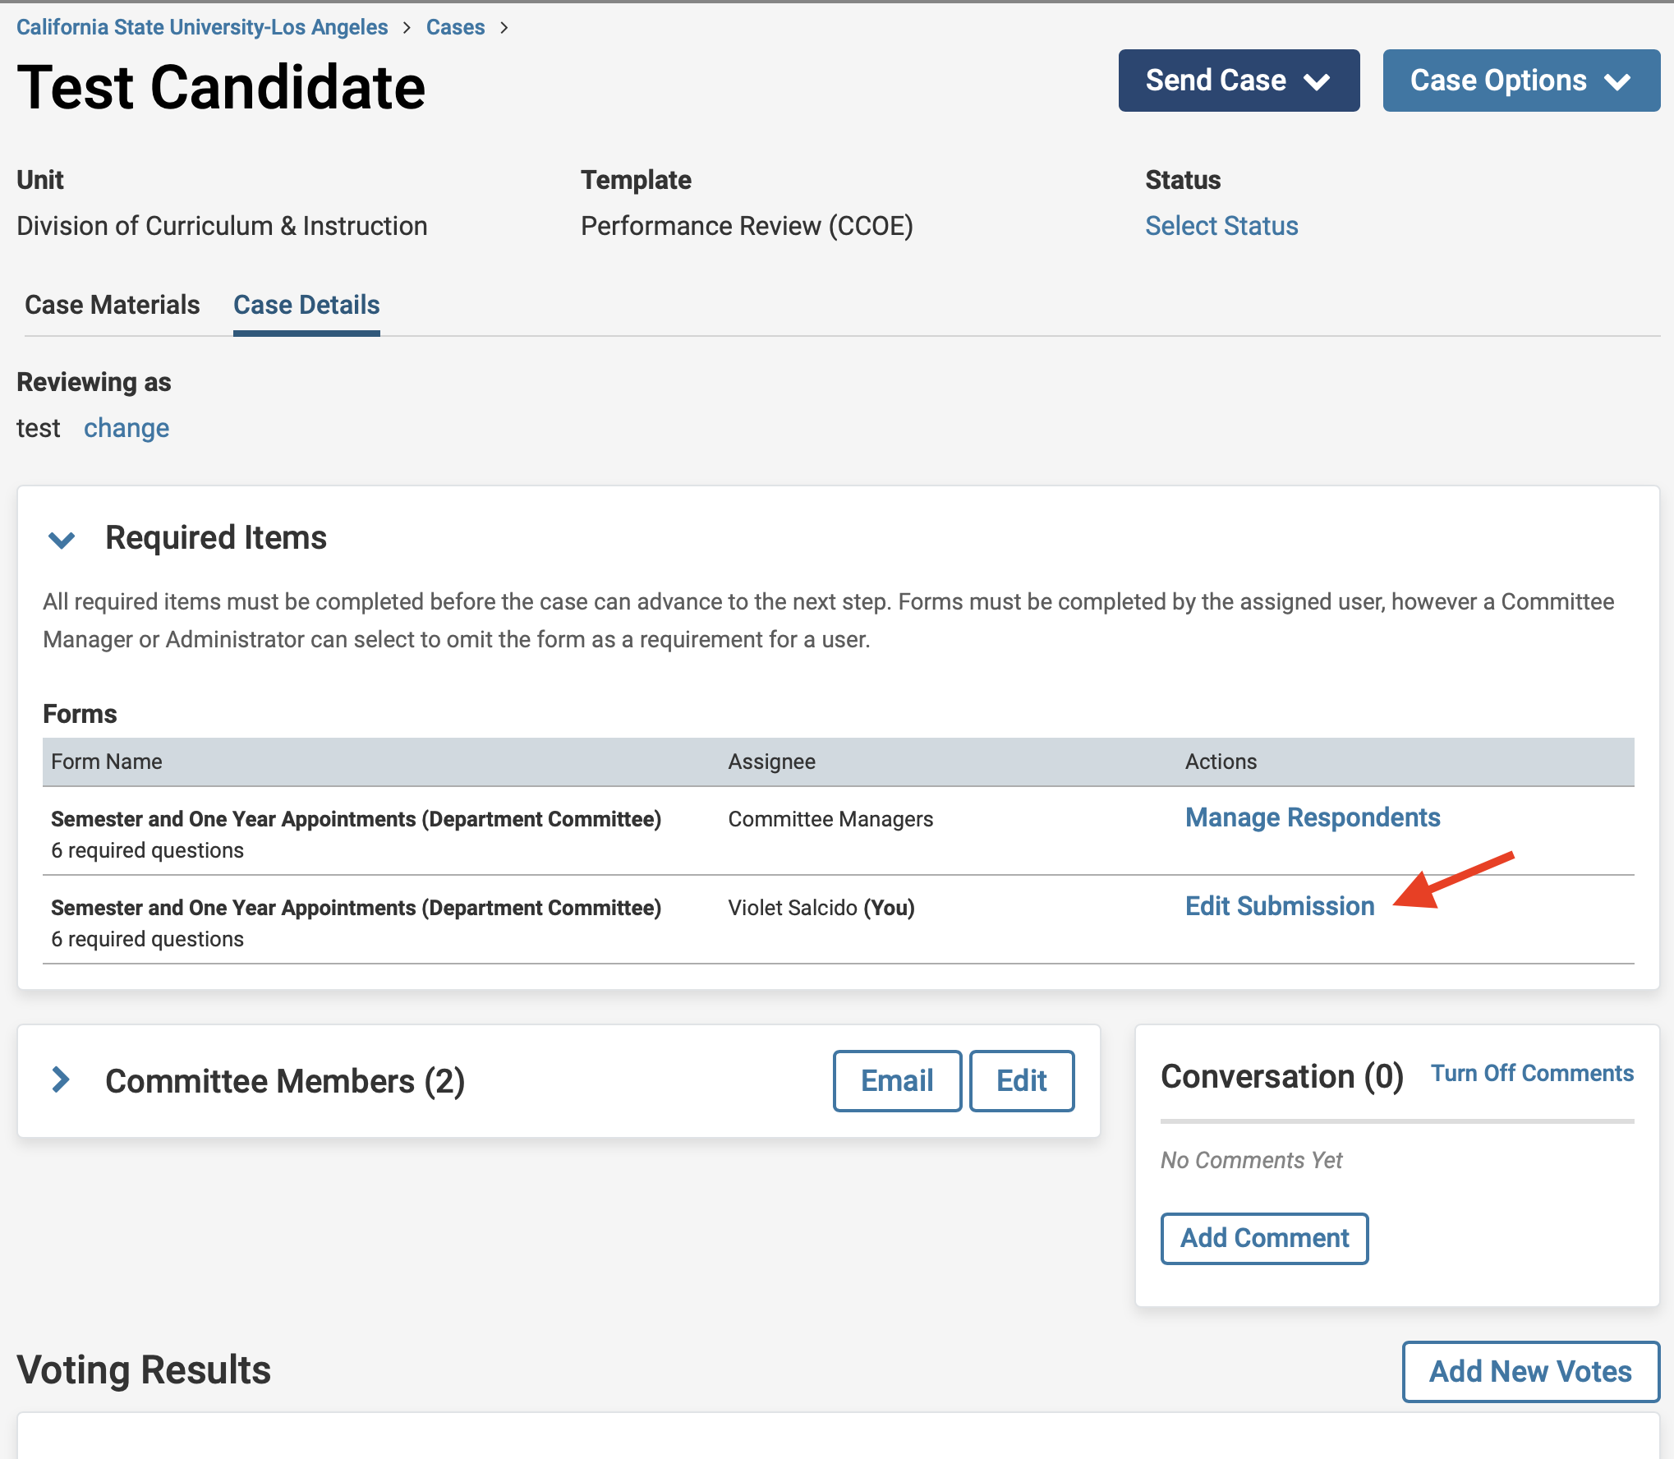

  - IMPORTANT: Click on “Case Materials” near the top-left of the page.

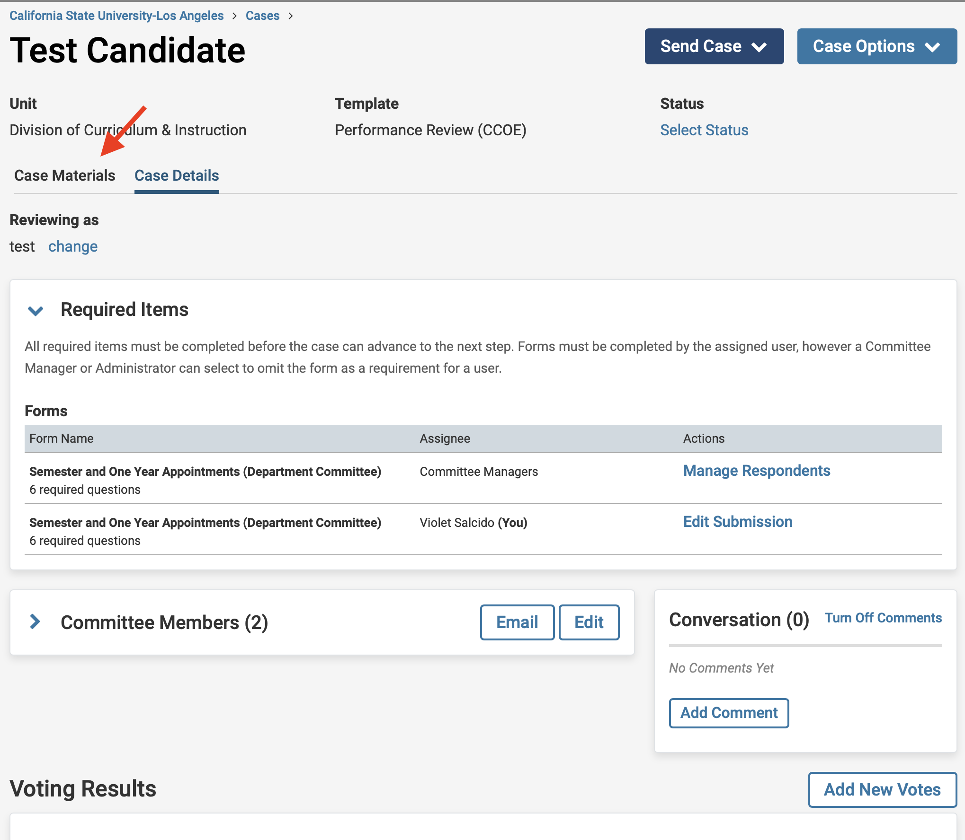
  - NEXT, SCROLL DOWN to “(Periodic Evaluation or Performance Review) Report Submission (All Levels)” and CHECK THE BOX NEXT TO THE DOCUMENT TITLE.

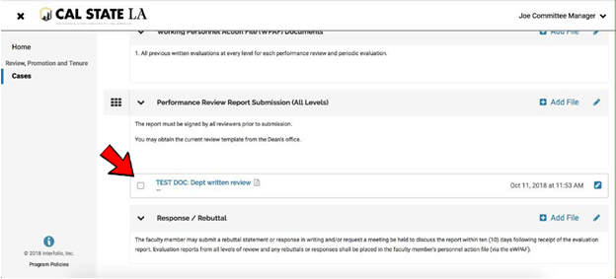
  - Click on the box next to the file name. Please make sure that the report has finished uploading and it does not say pending. It should not take more than 2 minutes to load. Refreshing the page sometimes helps.
- Click on “Share,” and when the pull-down menu opens, select “With Candidate.”

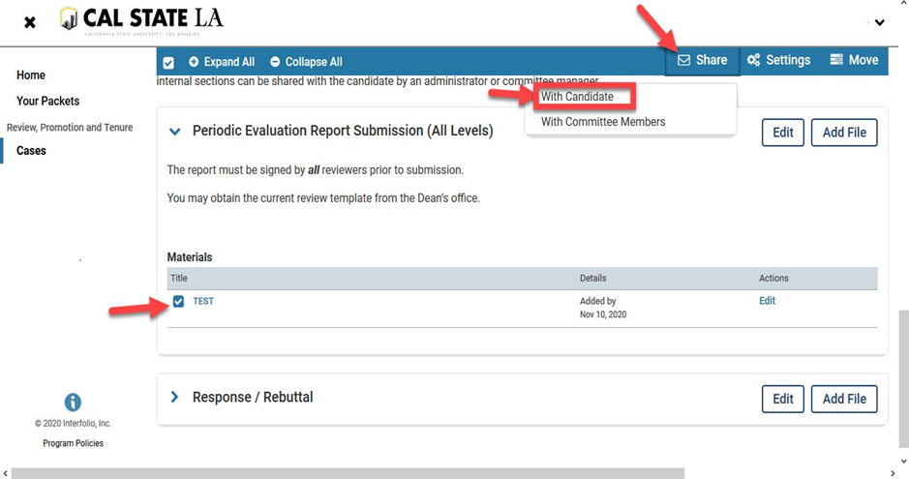

  - If you were part of the committee and are not writing a separate report, skip #3-6.
1. In the Subject line box, type:

“Your Department Chair Review”

- In the Message Box type one of the messages below:
- “Please see your review document. You have 10 days (after the committee deadline as posted on the University RTP Calendar, http://www.calstatela.edu/FacultyAffairs/current-calendars) to provide an optional response or rebuttal to this review. A response or rebuttal is not required. ”
- If you are not writing a separate report, please type “Please see your review document.”

- In the grey box on the right, click “Enable.” If you do not see the enable box, you did not click on the box next to the file name and there is nothing attached, or the file is still pending.
- The attachment appears below the message. If there is nothing there, no file is attached.
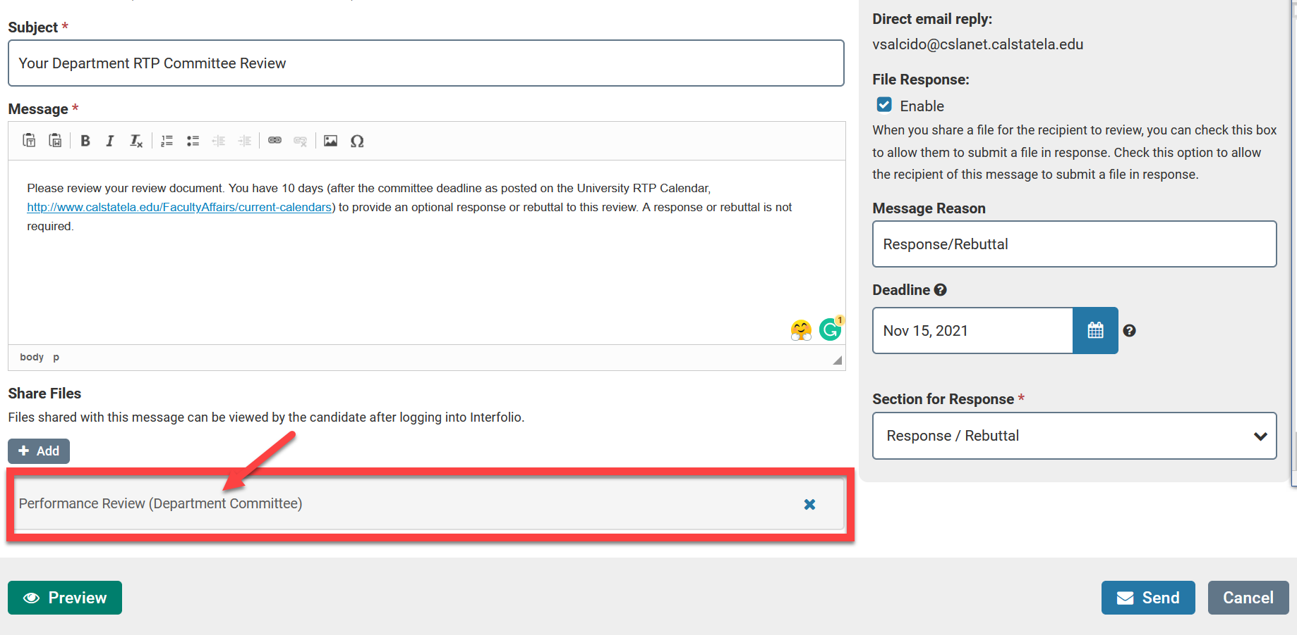

- In Message Reason, type “Response/Rebuttal.”

- For “Deadline,” use the correct Optional Rebuttal Deadline from the RTP Calendar.

- From the pull down menu on the bottom-right side, select: “Response/Rebuttal”
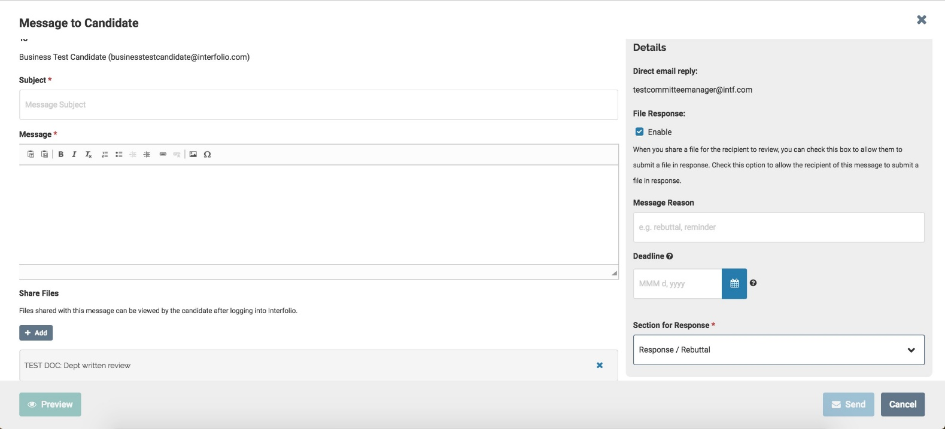

  - Click “Send.”

  - After sharing the evaluation with the candidate, send the case forward to the next level.
    - At the top of the page, click “Send Case”.
    - Click “Forward to Administrative Check”.
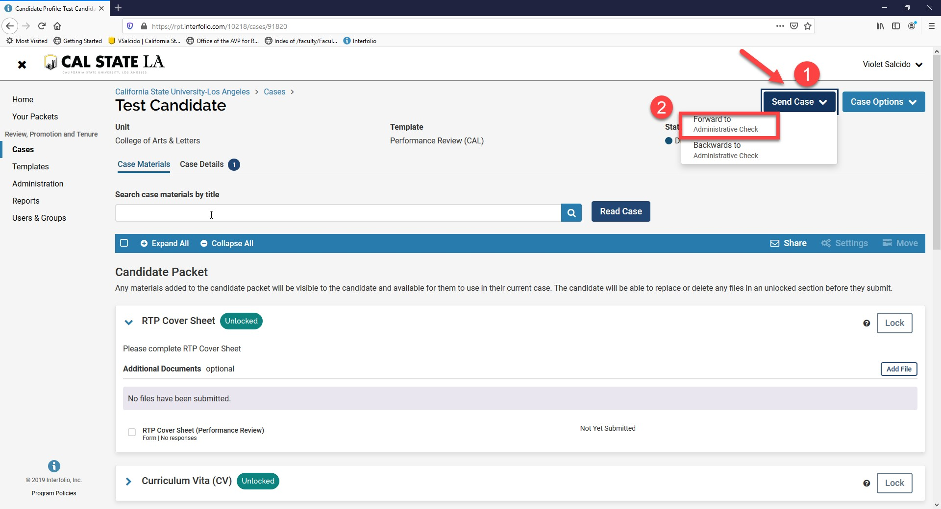

  - Uncheck the box that says "Send a message to the reviewers gaining access to the case" and click "Continue".

