Space Type is Invalid: Correcting APDB C-139 Errors
In GET, navigate to Maintain Scheduled of Classes.

Check APDB Detail Reports for C-139 Space Type Is Invalid.

Search by entering Academic Institution CSULA, Term (YYYT) (Year: 2018 = 218) (1 Winter; 2 Spring; 3 Summer; 9 Fall), Subject Area, Catalog Nbr (Listed as Crse # in error report). Click Search.

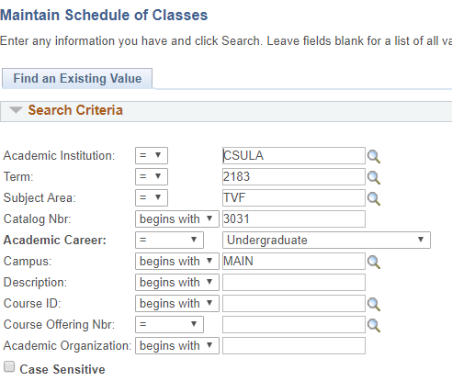

On the Meetings Tab, you will find the Meeting APDB Mapping Values.
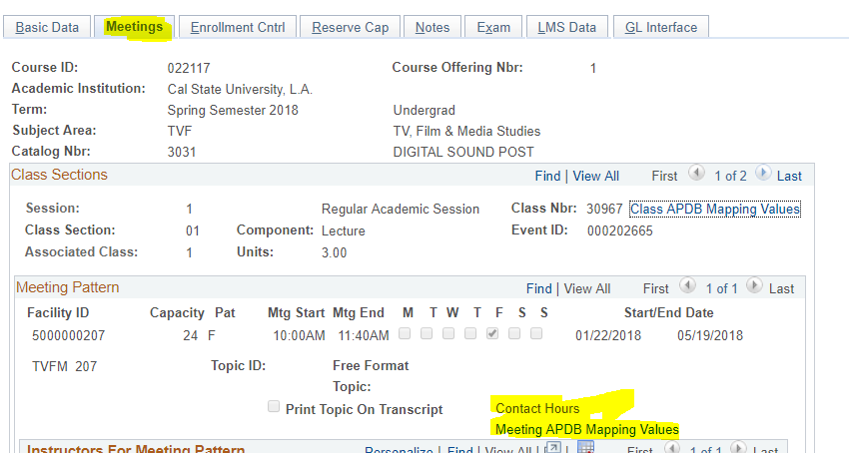

The Meeting APDB Mapping Values – Space Type must correspond to the Course Catalog’s Space Type.
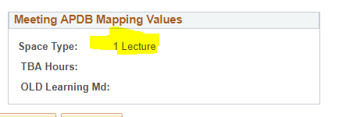

To find the Course Catalog value, go to Curriculum Management > Course Catalog > Course Catalog.
Search for the course.
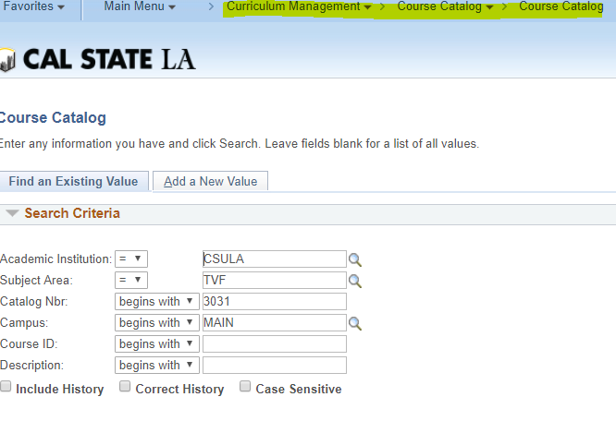
Under the Components tab you will find the CS Number.

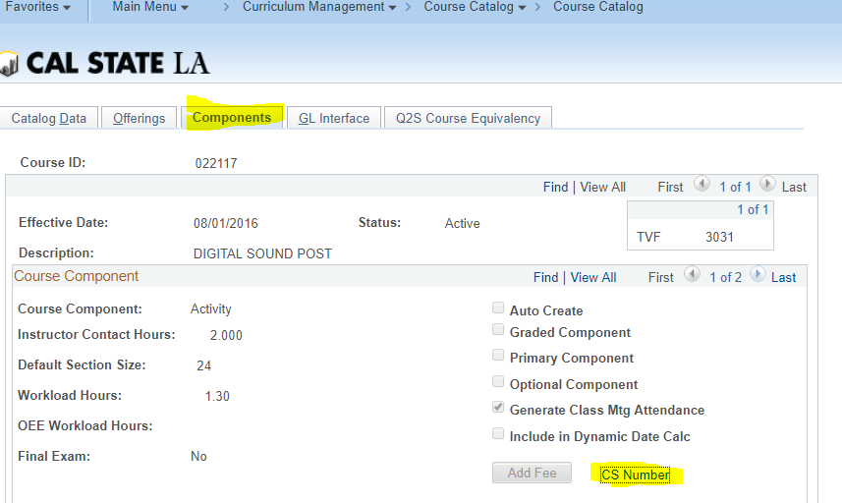
The Meeting APDB Value (slave) needs to match the Course Catalog’s Space Type Value (master).
Go back to the Meeting APDB Value and enter the same value as the Course Catalog Space Type.

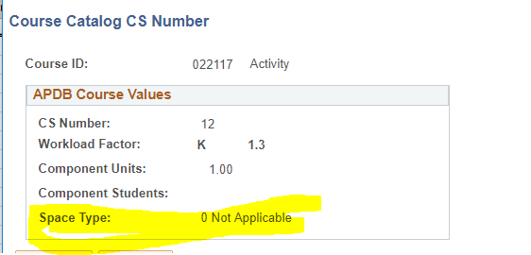
*If the Course Catalog is wrong and APDB is indeed correct, please contact the registrar’s office and have them correct the course catalog.

