**ADMIN LEVEL ‘0’ IS NOT ALLOWED FOR NON-ZERO IAF: Correcting APDB C-101 Errors in 58**

**ADMIN LEVEL MUST BE ‘0’ WHEN IAF IS ZERO: APDB C-108 IN 58**

Run the LA_IR_APDB_IAF_BY_TERM to see if “Admin Level” field is blank. If it is blank, make the department add the “assign type reason” code by clicking the link found in the image below. If the instructor is not listed on the query, someone may have mistakenly entered IAF fraction and assignment, therefore IAF should be corrected to 0 and the workload assignment should be removed.

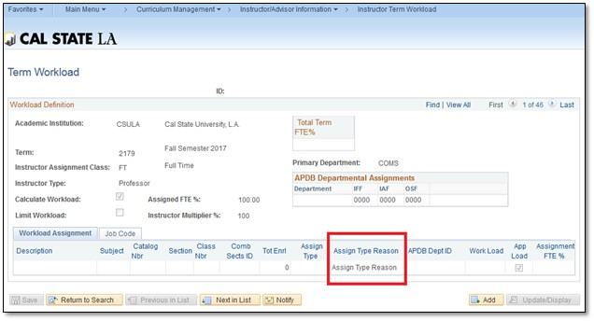

To resolve C-108, check if the workload assignment is supposed to be IAF. If yes, then they need to correct the “ADPB Departmental Assignments” IAF value from 0 to whatever the IAF value is.