Days and/or Times are Invalid for Synchronous Learning Mode 2, 4, 10, 11: Correcting APDB C-098 Errors
Courses that are synchronous learning mode 2, 4, 10, 11 require a meeting time and/or day.
*If the course is online and generates this error code, please skip to page 5 of this document.*
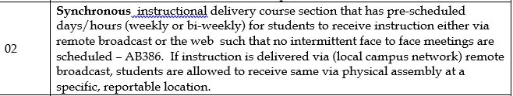
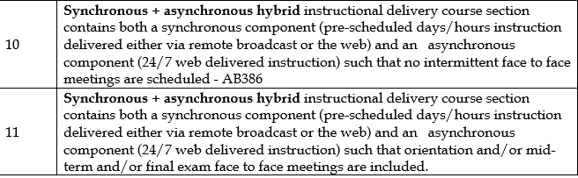

In GET, navigate to Maintain Scheduled of Classes.

Check APDB Detail Reports for C-098 Invalid for Synchronous Learning.

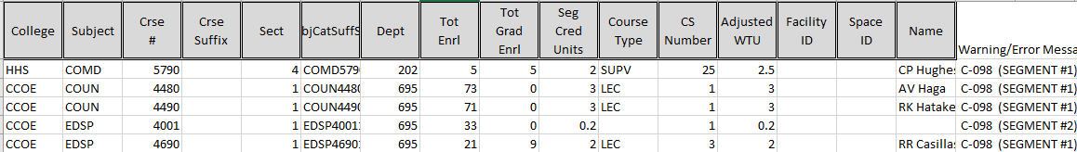

Search by entering Academic Institution CSULA, Term (YYYT) (Year: 2018 = 218) (1 Winter; 2 Spring; 3 Summer; 9 Fall), Subject Area, Catalog Nbr (Crse #). Click Search.

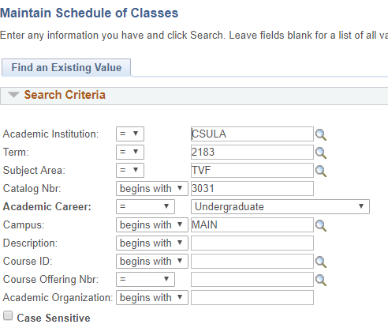

Under the Meetings’ tab, input days and/or time for the class. APDB will not accept TBA for synchronous learning mode.
*If the course is online but APDB Learning Mode has mapped it to have a meeting pattern skip to the next page.
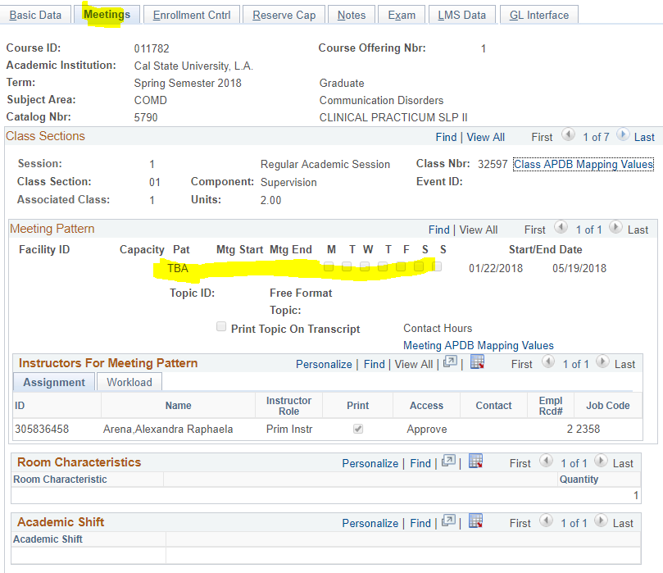
If the meeting is online but APDB has mapped it to have a meeting pattern. You can tell if a course is online by looking at the basic data tab.
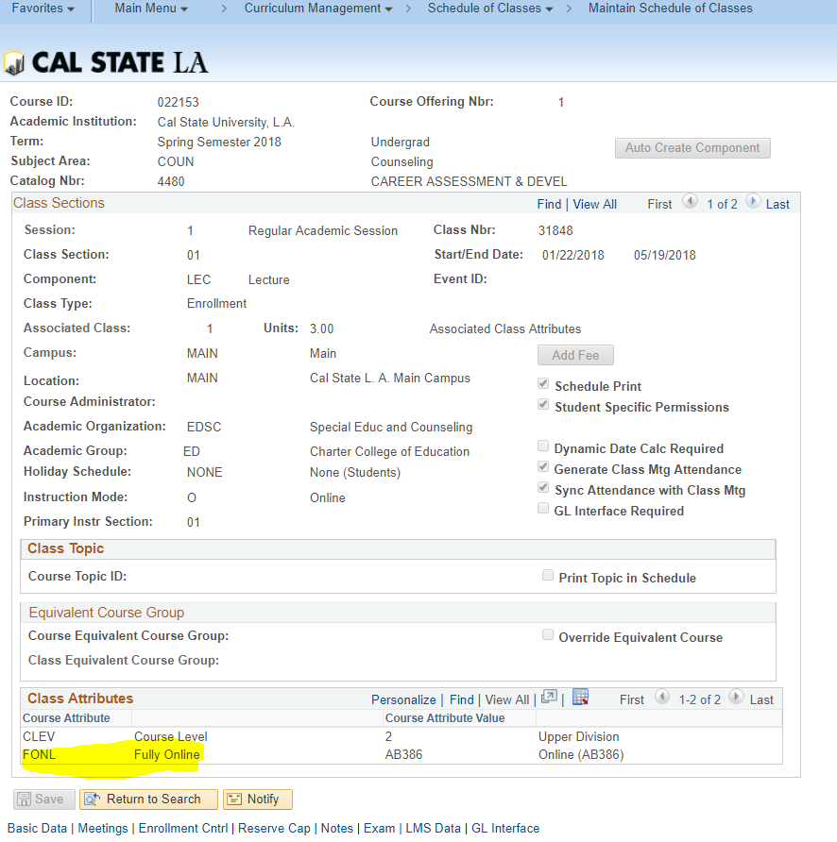
Go to the Meeting tabs > APDB Mapping Values
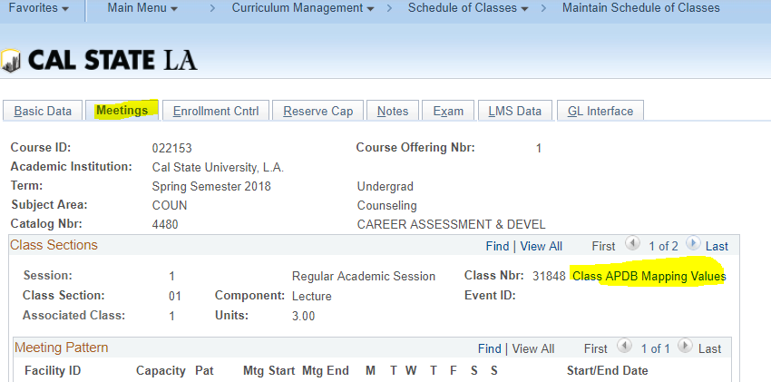

The below course was an online course that had an APDB Learning Mode of 02, instead It should have a value of 01.

