Learning Mode 5, 6, 9 Require Non-Blank Meeting Days: Correcting APDB C-091 Errors

Check APDB Detail Reports for: C-091 Learning Modes ‘05’, ‘06’, ‘09’ Require Non-Blank…
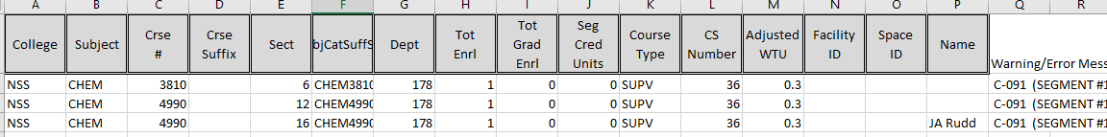
Learning Modes:
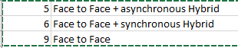

These learning modes are all face to face classes, therefore APDB will require these values:
- Facility ID (Space) – None for TBA
- Meeting Pattern (Time) OR TBA

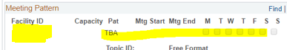

In GET go to Maintain Schedule of Classes.

Search by entering Academic Institution CSULA, Term (YYYT) (Year: 2018 = 218) (1 Winter; 2 Spring; 3 Summer; 9 Fall), Subject Area, Catalog Nbr. Click Search.
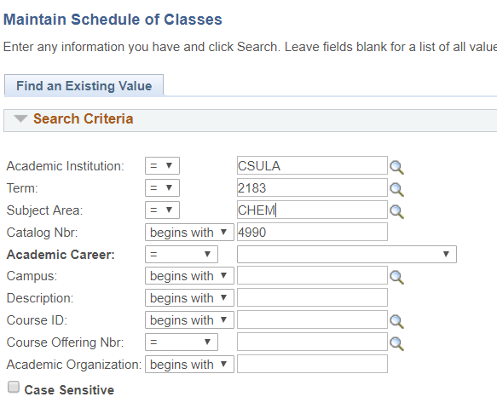
On the Basic Data tab in Class Attributes, check to see if this class is indeed face to face. If it says the class is online, then values on APDB need to be changed. If the class is indeed a face to face class move to the next step. IF COURSE LEVEL IS MISSING PLEASE NOTIFY THE REGISTRAR.
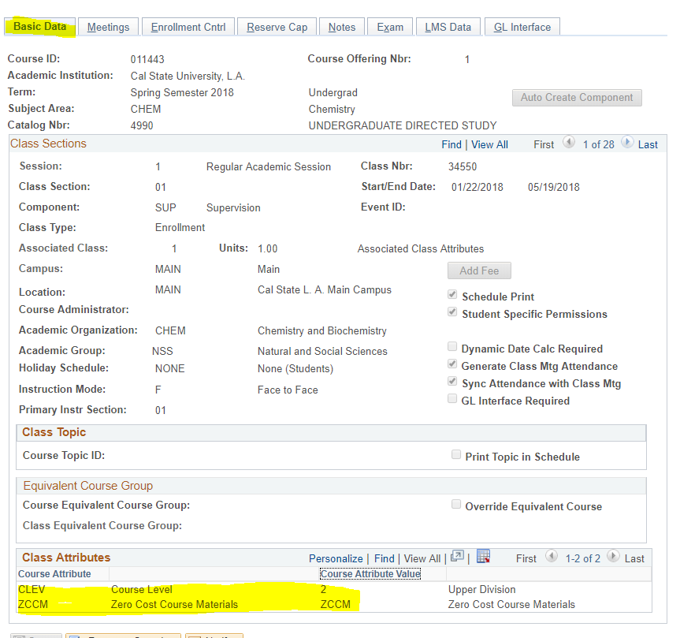
Click on the Meetings tab, and edit the Facility ID and Meeting Pattern for the course. If the course is an online course, then move on to the Class APDB Mapping Values.
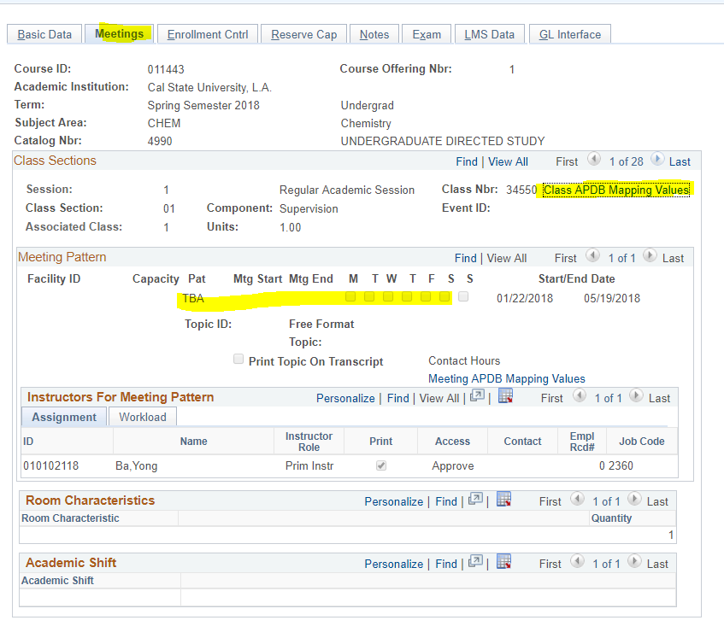

This is the area that the APDB pulls the learning mode from. If the course is online, but shows face to face, please change that value to the correct mode.
