Team Teaching Fraction is not 1.000: Correcting C-089 Errors.
Find Maintain Schedule of Classes
Search for the Class using the C-089 Team Teaching Fraction Report
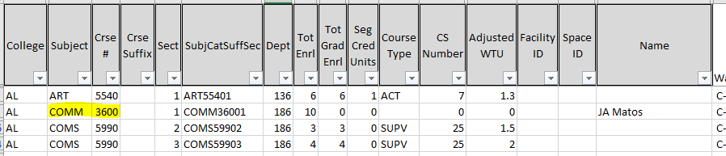

Search by entering Academic Institution CSULA, Term (YYYT) (Year: 2018 = 218) (1 Winter; 2 Spring; 3 Summer; 9 Fall), Subject Area, Catalog Nbr.

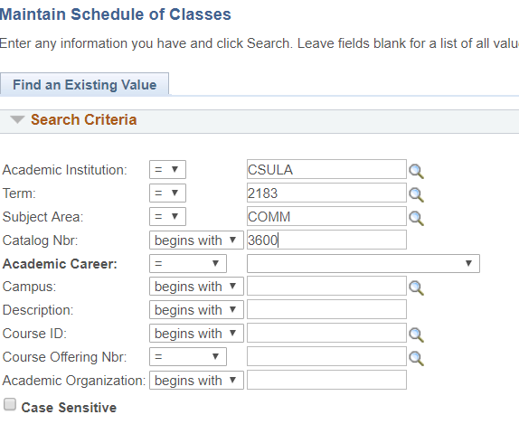
Click on Meetings tab and then Workload tab on the bottom. The example shown below caused an error because Load Factor did not add up to 1 (100).
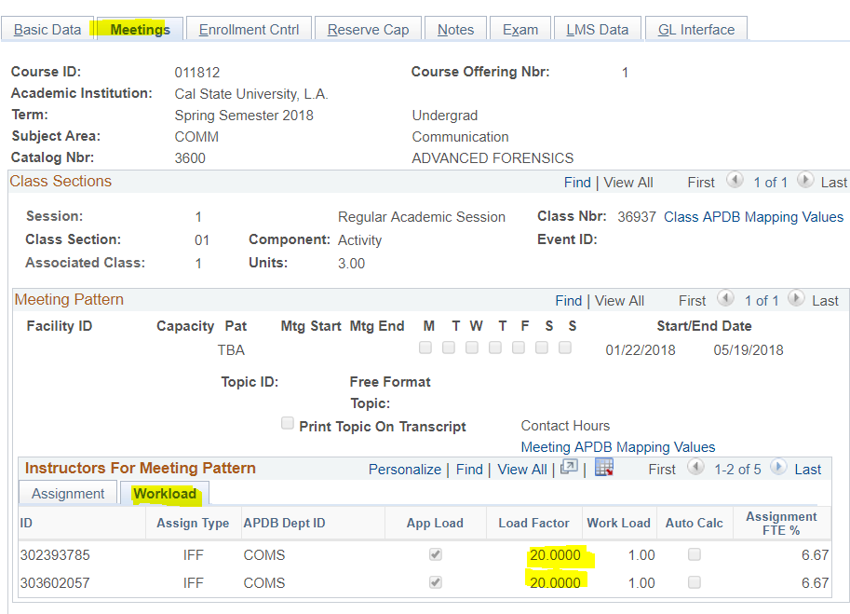

Load Factor must add up to 100.00 as shown below.
Reasons for not adding to 100.00
- C-058 errors, may cause an error because instructors are not updated into calculations.
- Entry Errors
- Rounding errors, 33.33+33.33+33.33=99.99 (NOT EQUAL TO ONE).
  - Errors can also be caused by too many digits, APDB can only read XX.X, tenth digit, so the example 33.3333 will cause an error.
- If one of the faculty is do not include update that faculty’s TTF to zero.

