Entering the Department codes associated with courses: Correcting C-058 Errors.
Find Instructor’s workload, by using their EID.

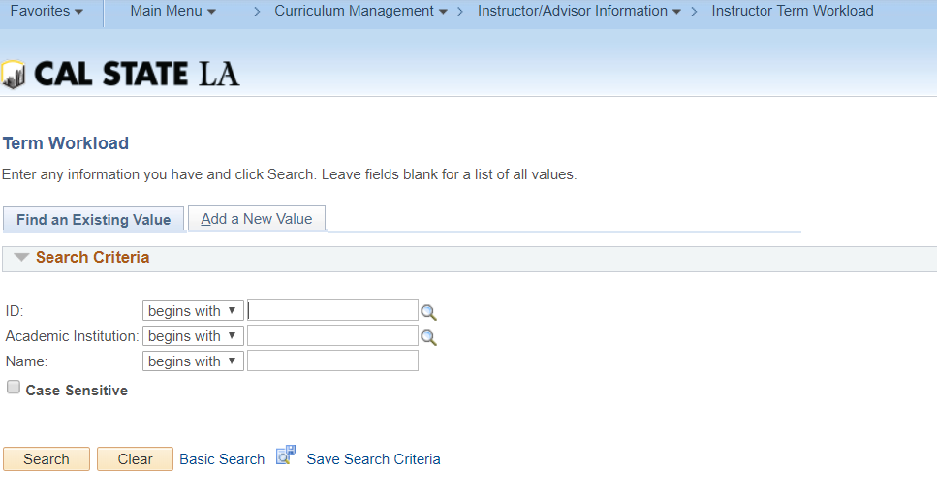

Use the C-058 Instructor SSN No Matching Report (Excel) and filter by your department.
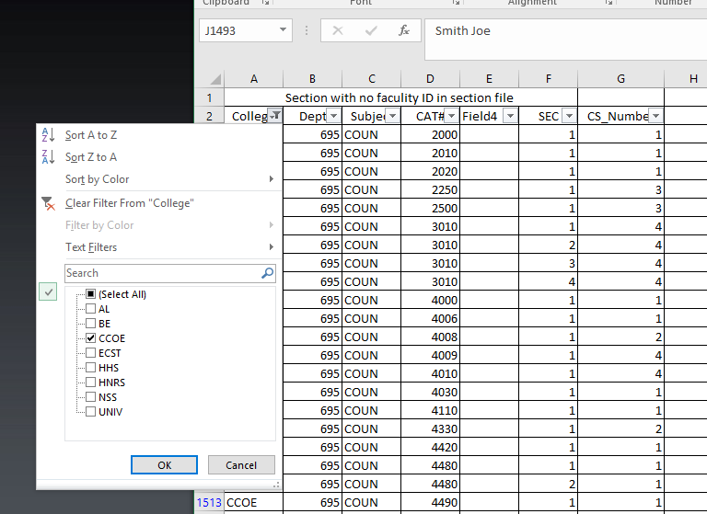
Copy and Paste EMPLID – By selecting the EID, and using the copy function. Insert the EID, by using the paste function.
(This is faster process than typing out EID, where two key strokes vs 9, and reduces EID errors)
- Windows: Copy – Hold CTRL on the left side of your keyboard with your left pinky and press C. Paste – Hold CTRL and press V.
- Macs: Copy – Hold Command ⌘ and press C, Paste Hold Command ⌘ and press V.

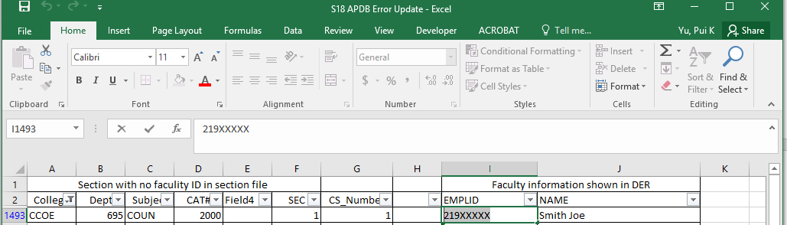

Make sure you are in the correct TERM (YYYT). (Year: 2018 = 218) (1 Winter; 2 Spring; 3 Summer; 9 Fall)

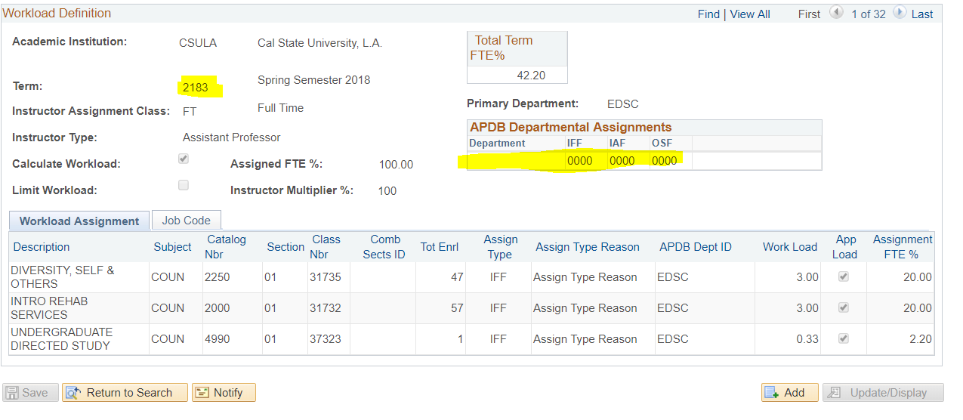
Errors occur because the APDB Departmental Assignments are blank.
Enter the Department, found in the APDB Dept ID.
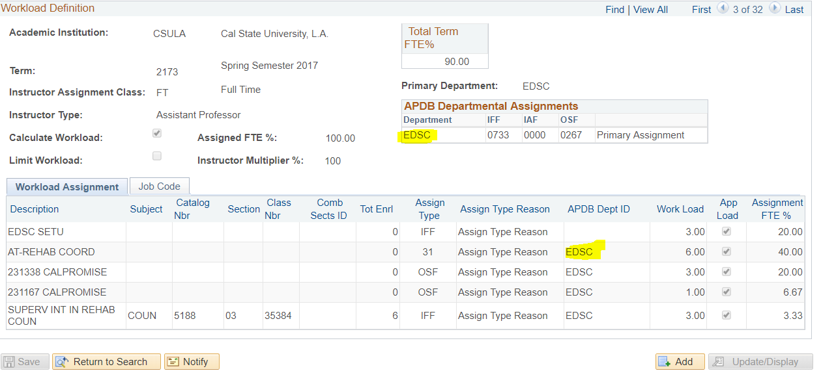
IFF, IAF, and OSF is Calculated based on Funding. Only the resource managers will know how each instructor should be funded.
- IFF is Instructional Faculty Time – assigned for teaching assignments
- IAF is Administrative Time – using administrative funds, should only be used for Deans, Associate Deans, or other management personnel plan (MPP) employees with retreat rights to a faculty position
- OSF is Other Supported Time – using grant funds, reimbursed, or non-instructional funds.
In the above example the instructor is funded by 0733 by IFF (Teaching Assignment) and 0267 by OSF (Grants)
HIT SAVE BEFORE LEAVING

