STEP 1
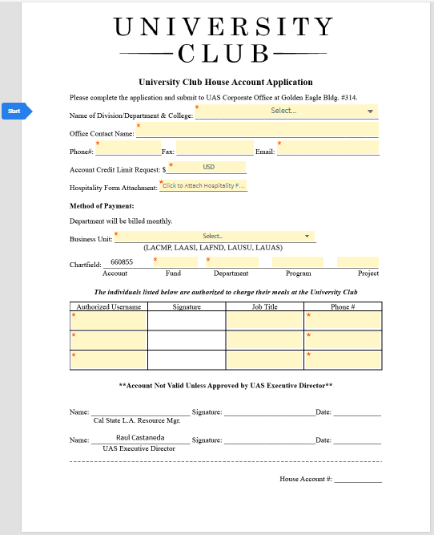
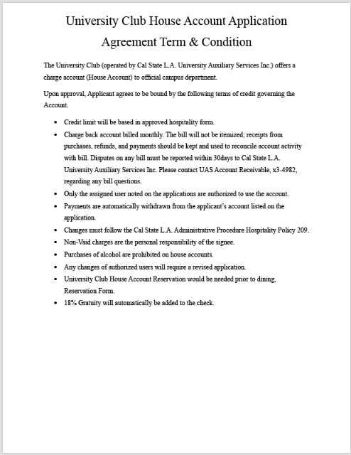
Users will navigate to our site to obtain the University Club Account Application. They will be prompted to fulfill all fields with a red asterisk next to it. All other fields are optional and to be filled out at our first users discreation. All users are required to attach a copy of their approved Hospitality Form so UAS can be in correspondence with the approved information. If a user has not already completed a Reservation Form prior to dining, there will be a provided hyperlink labeled “click here” to start the reservation process. Upon completetion of all required fields our first user will be prompted to then input their name and email and can now move forward.
STEP 2
After completing the agreement, the first participant will now be required to input information for all the authorized users associated with the account so they can sign and officially be added to the account. A red asterisk next to a participant’s name indicates that person is required. Once all participants are assigned, the users will now be prompted to click next.
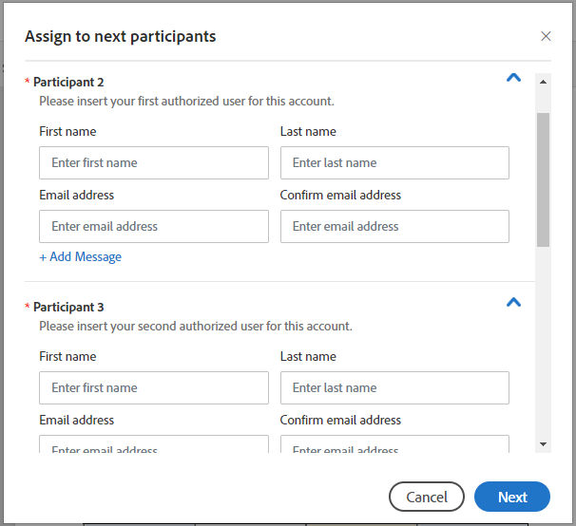
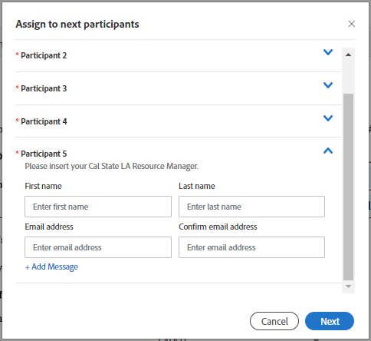
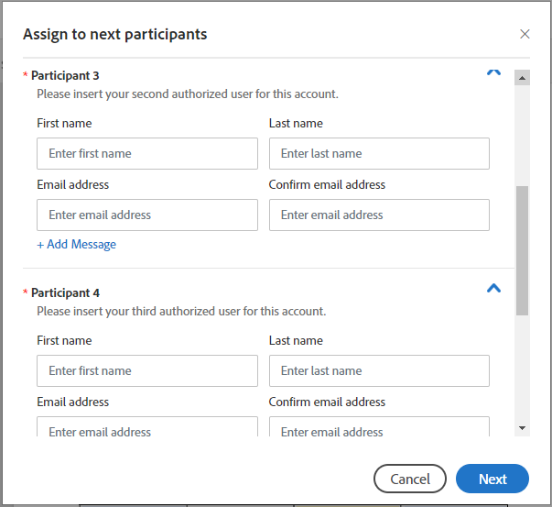
STEP 3
To complete the initiation process, our first user will be prompted to confirm their email address. This is a feature built into Adobe Sign that cannot be turned off. The purpose of this is to prevent unwarranted agreements being spammed into department mailboxes. Once the user has navigated to their email inbox, they’ll receive a notification from Adobe Sign asking them to confirm. Upon confirmation our first participant is done and will receive a final copy once all participants signs.
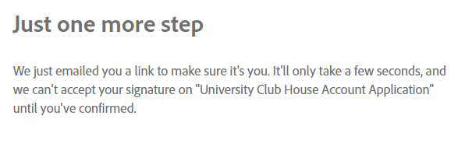
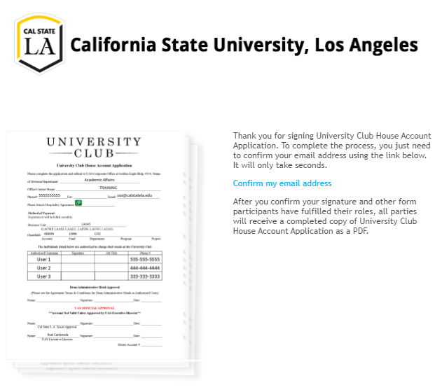
STEP 4
The following participants will be prompted to review and sign through their email inbox. Upon completion from all authorized users on the University House Account Application it is sent to the Cal State LA Resource Manager for the next approval step.

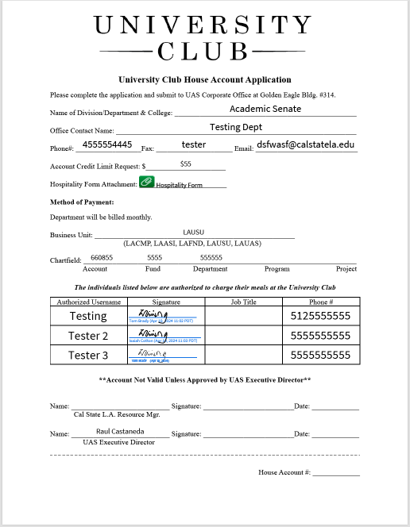
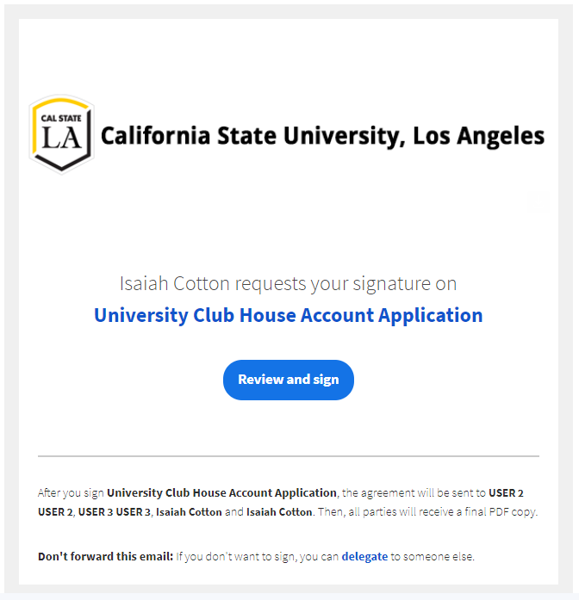
Step 5
The form is now routed to the designated Cal State L.A. Resource Manager and passed to UAS Director, Raul Castaneda. Once both users have signed, all participants will receive a final version sent to their email inbox for their filing along with a CC’d version sent to uasconf_events@calstatela.edu.
