Instructions for Accessing Interfolio
It is recommended that you use Google Chrome, Firefox or Safari (Mac) as your browser when accessing the Interfolio website.
- Go to www. Interfolio.com Click LOG IN
- Click on Partner Institution
- Type California State University, Los Angeles on the drop-down menu. Click Sign IN.
- Sign in using your campus email and password
- Click on the Cal State LA logo.
- If your case is ready, it will be under: “Your Action Items”

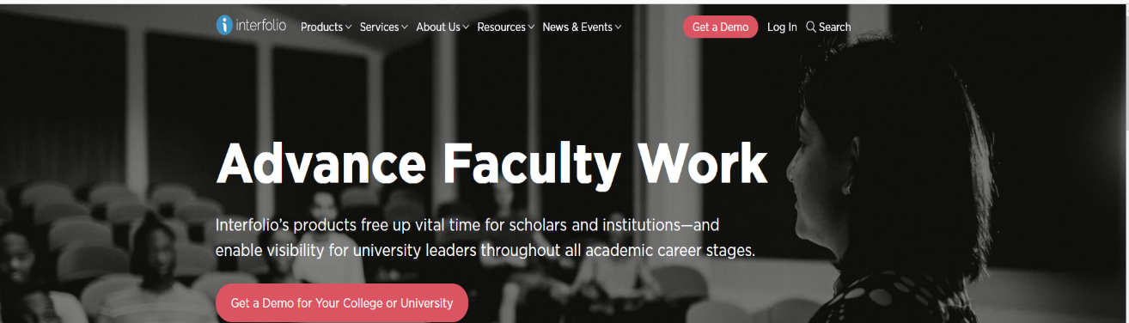

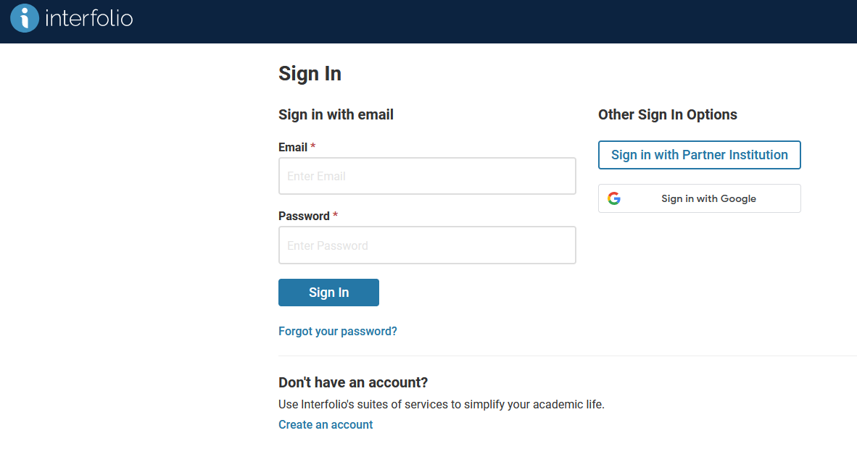
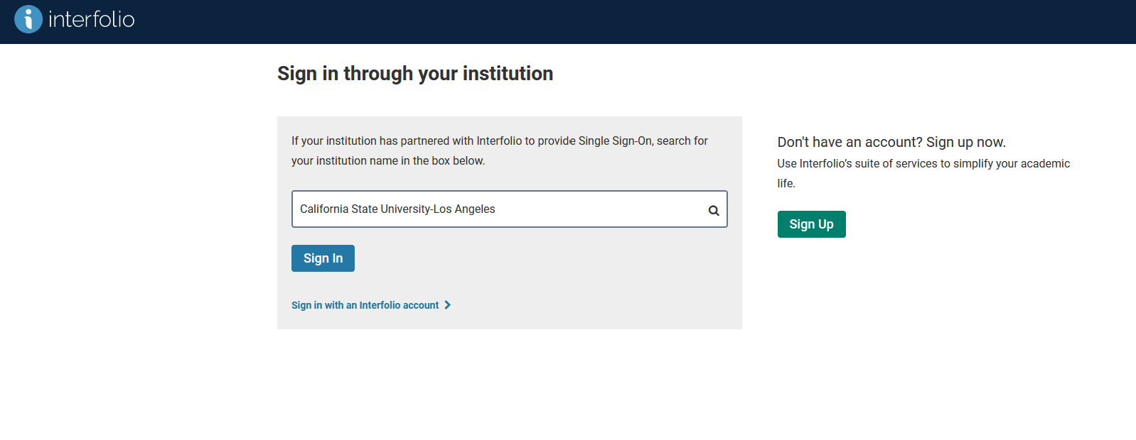
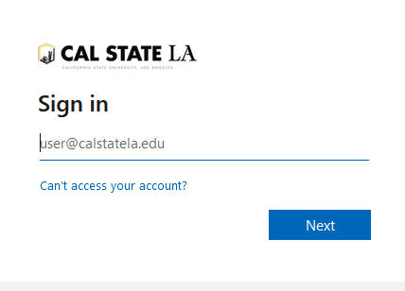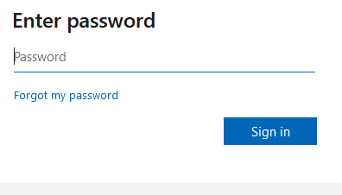

Section: Interfolio Instructions
Faculty Instructions (Performance)
Preparing Your Documents for the
Working Permanent Action File (WPAF)
The University will upload these items:
• Student Opinion Surveys (aka Student Evaluations of Teaching)
• Peer Observations
- For probationary faculty, your previous evaluations (all levels) and any rebuttal/responses will also be uploaded to your Interfolio case
You will need to prepare the following for upload:
• An updated CV
(It is highly recommended that you organize your CV in the order of the main
categories of evaluation:)
A. Educational Performance
- Teaching Performance
- Related Educational Activities
• B. Professional Achievement
• C. Contributions to the University
• Narrative Statements for Categories A, B, and C:
- Educational Performance, B. Professional Achievement, and C. Contributions to the University
• Supporting Documents as evidence of your performance, achievements, and contributions

Instructions on how to upload materials:
Please Note: Do not make PDF files into a Portfolio PDF. Portfolio PDFs are not visible to the committees.
Naming Conventions and Uploading Files – WPAF (Interfolio)
1. All files are converted in PDF format upon upload. It is not necessary to convert MS
Word files or other file types to PDFs format prior to upload. (Reminder: PDF Portfolios cannot be accessed by reviewers in Interfolio.)
2. All files uploaded into Interfolio must use basic naming conventions designed to assist reviewers with identifying the file.
3. Student Opinion Surveys and Peer Observations uploaded by the University will use the following naming conventions (see examples). Please do not alter.
SOS_LASTNAME_2020-2024
PEEROBS_LASTNAME_2020-2024
4. Files that you upload will begin with the semester of the initial inclusion, except for your CV and Narrative Statement. Your CV and Narrative Statement should have the current term.
Examples:
F23_CV (current term and descriptor)
F23_Narrative Statement (current term and descriptor)
Syllabi_2018-2023 (supplemental files can be combined and uploaded into one file instead of individual files, but please do not use PDF portfolio.)
5. To upload files under each required section, click on “Edit”
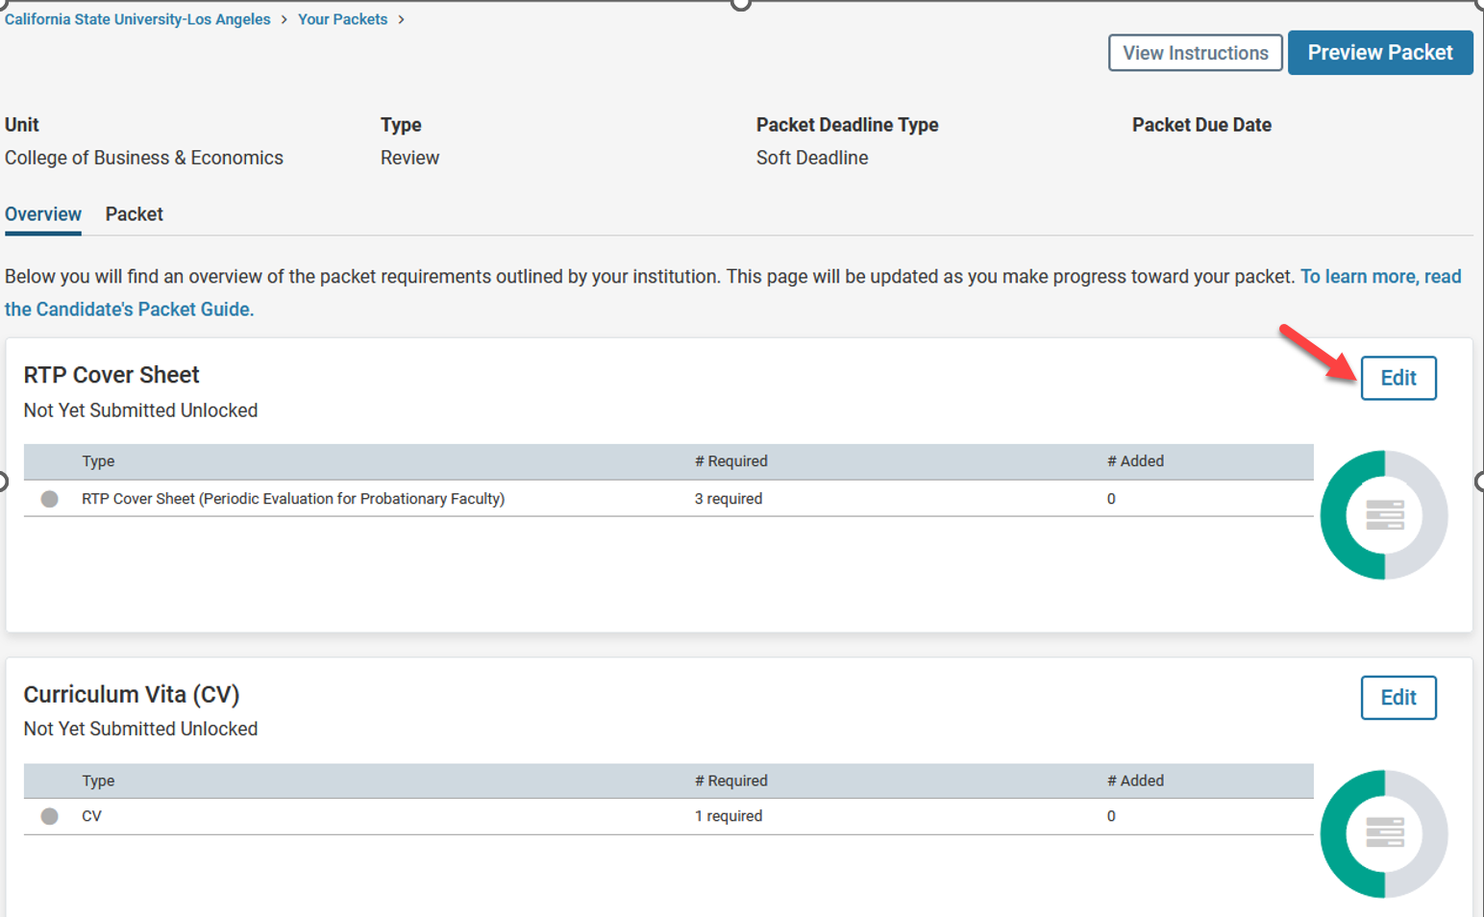
6. Click on “Fill Out Form” for the RTP Cover Sheet. After you enter the information, click
on “Submit”
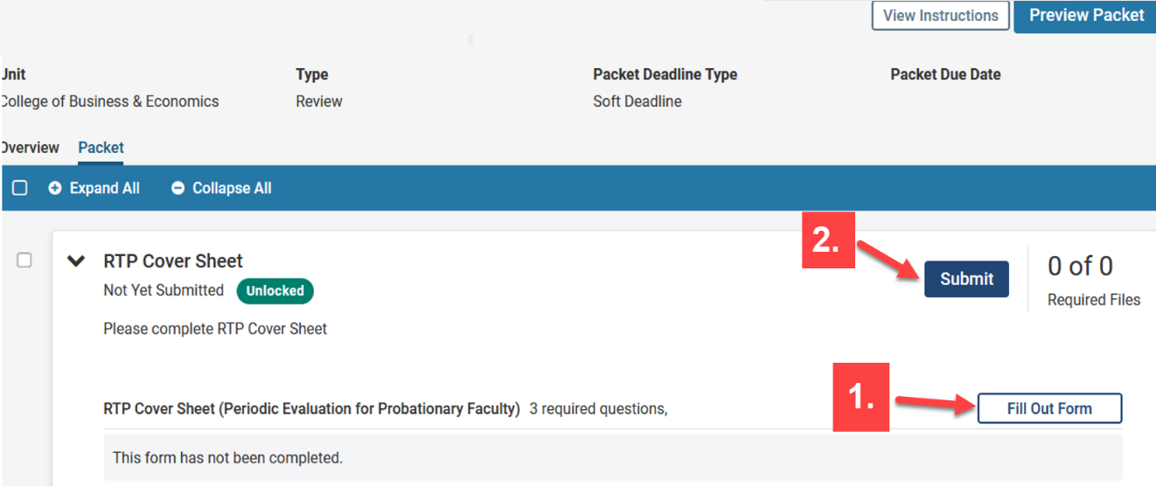
7. Click on “Add” for all other sections required.
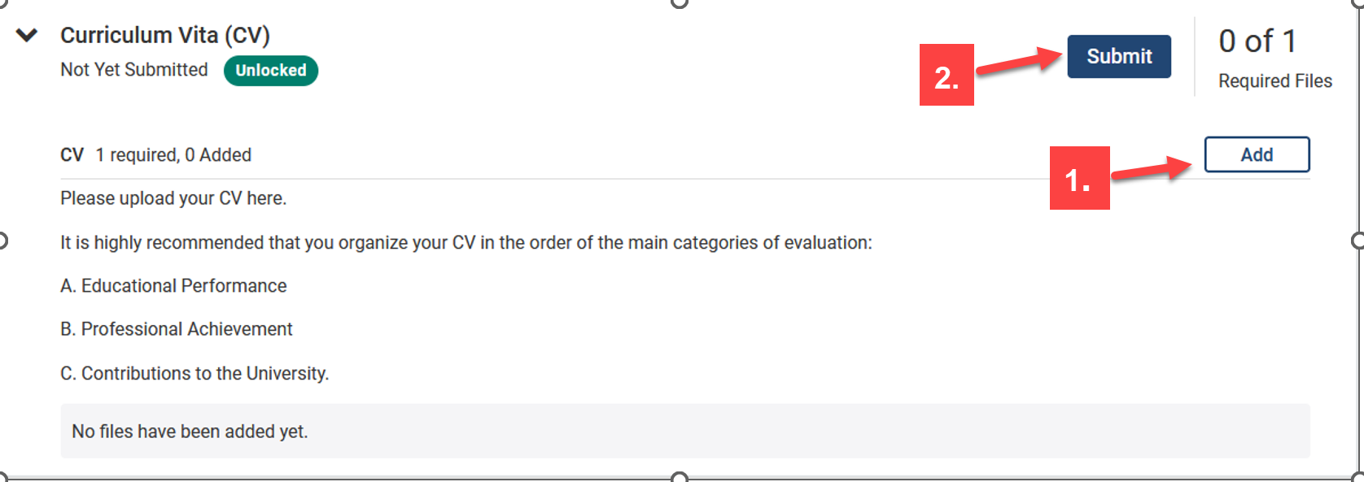
8. You can add a new file or you can choose existing files from previous packets.
• To Add a New File, Click on the “Add New File” tab.
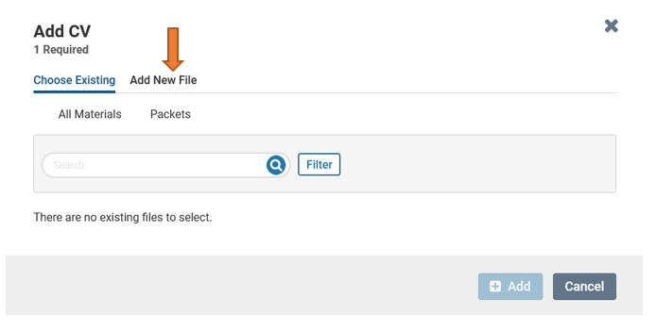
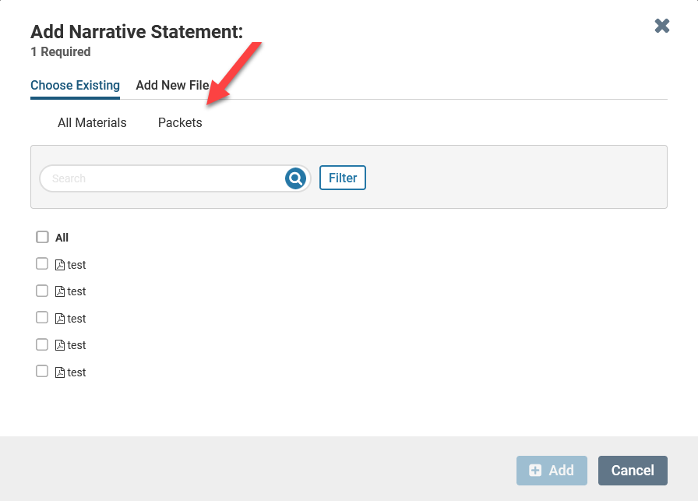
9. After you upload your files, or choose from existing files, click on “Add”.
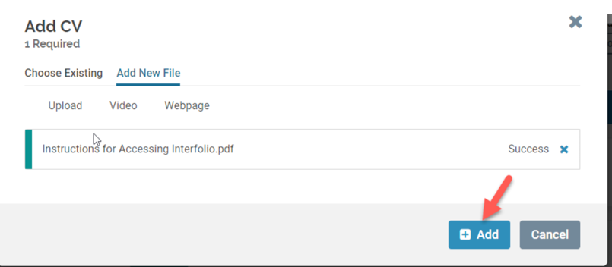
10. After uploading all required files, click “Submit” for all sections.
• Please keep in mind that once you click submit for a section, you will not be able
to edit that section anymore. If you need to edit a submitted section and it is still
before the deadline, please contact Faculty Affairs.
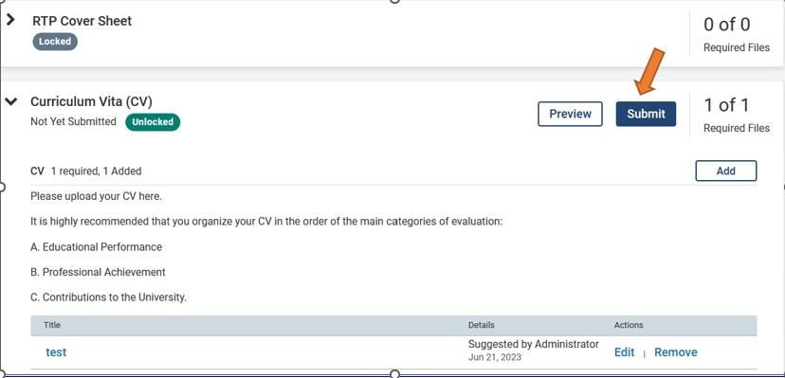
11. You will not receive an email confirmation from Interfolio that your file has been
submitted. You can verify that each section has been submitted when you see that it is
locked. Please make sure that all sections have been submitted.
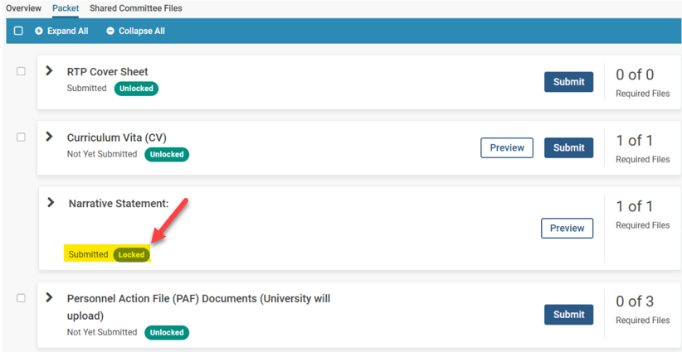

How to view/download a report, and submit a response/rebuttal
How to download Committee Reports & Submit a Rebuttal/Response
1. Click on "Your Packets" in the left-hand navigation and select the case
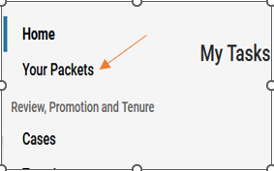
2. Open the "Shared Committee Files" tab of the case packet
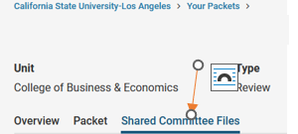
3. Files shared with you will appear listed
You can download the file or copy it to your Dossier, where it will appear in your Dossier
materials.
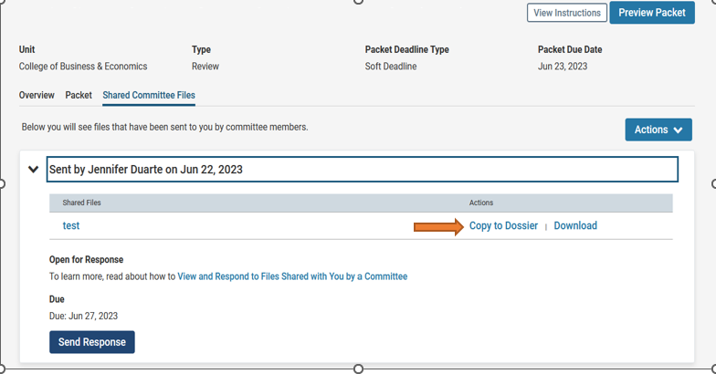
If you click "Copy to Dossier," you will have the option to add the file directly to a collection of
materials (if you have any collections available).
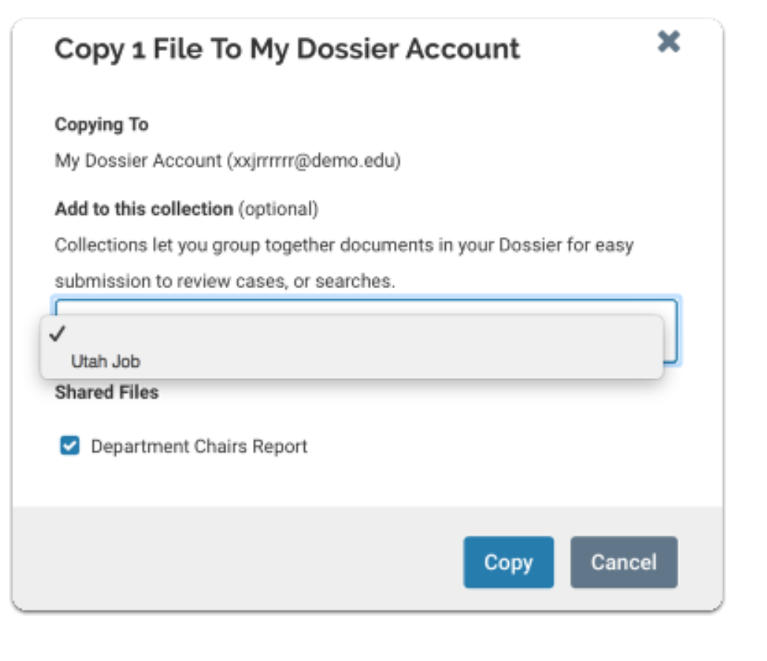
You can also click the "Actions" button to the right of the page to copy or download all shared files.
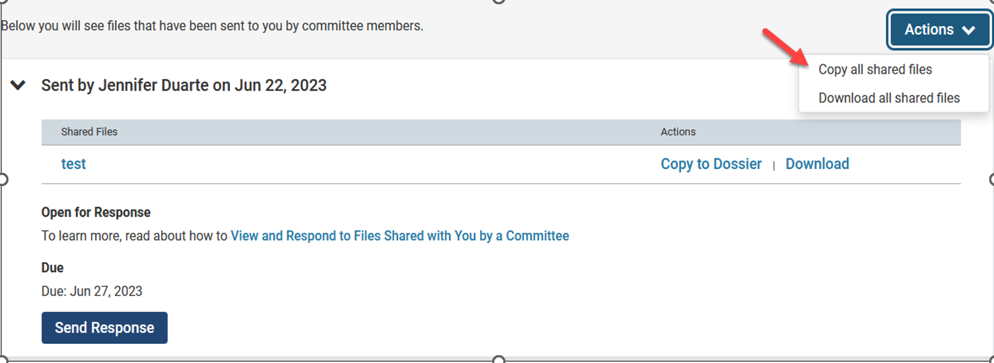
4. Click "Send Response" to respond to the file
If you are allowed to respond to the file’s content, you will see a link labeled "Send
Response," and a due date for when your response is due.
Please Note: This is a hard deadline, and you must respond to shared files before the due date.
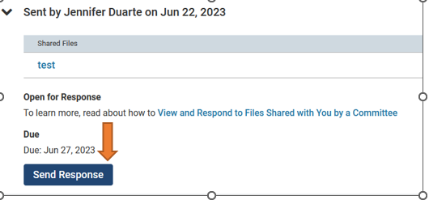
5. Give your response a title and upload the document file
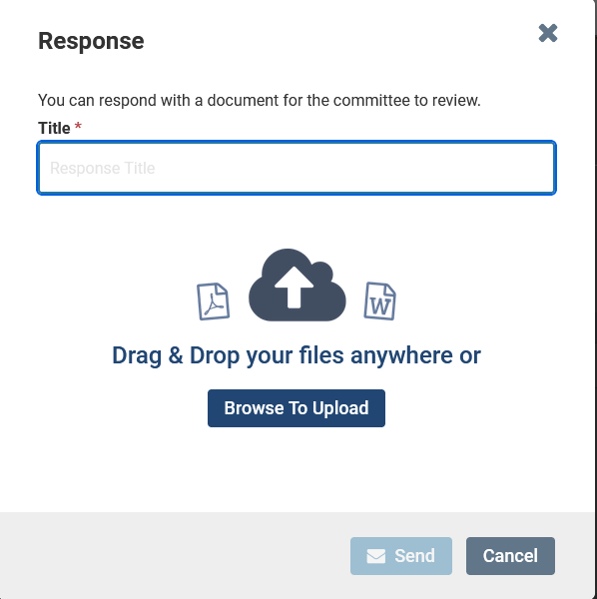

6. Your response will appear in the list of shared files
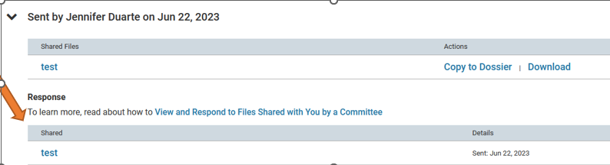
How to add a link or webpage
- Open the webpage tab of the “Add File” window.
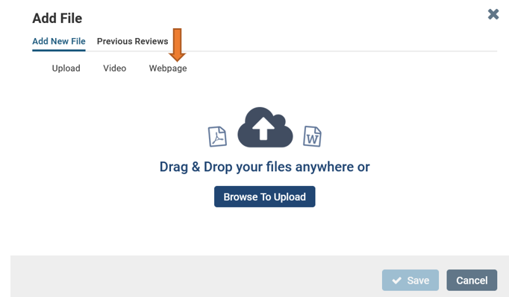
2. Give your webpage a title

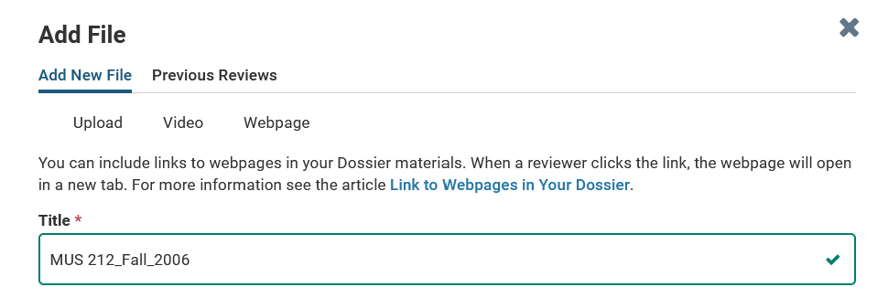
3. Enter the URL of the webpage
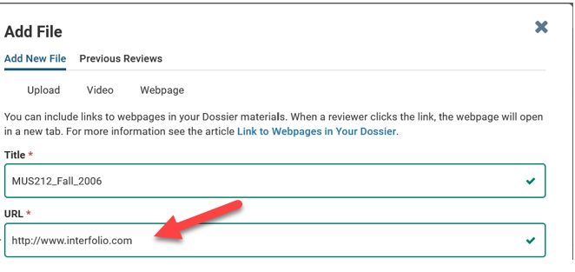
4. Enter a description to provide information or context for your webpage.
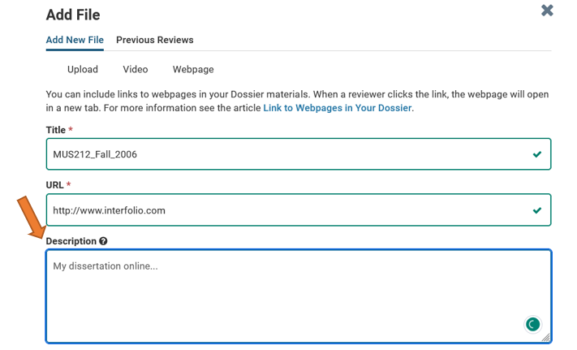
5. Click “Add,” and the link to your webpage will be added to the list of materials in your
Dossier.
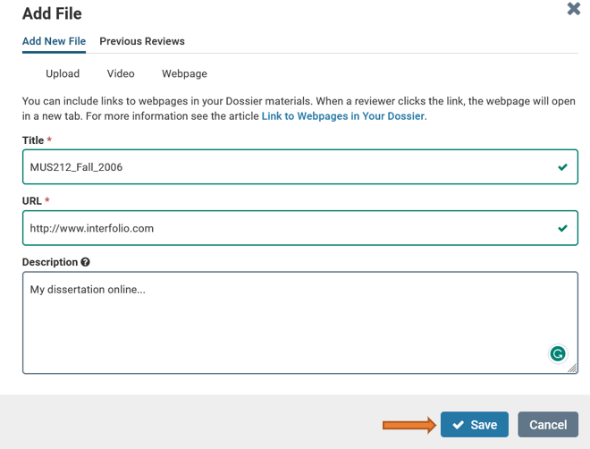

If after referring to these instructions you find that you are still having trouble, please contact the Office of Faculty Affairs between 8:00 – 5:00 Monday through Friday at 323-343-3810 or through email on RTP_Interfolio_Help@calstatela.edu. We are here to help.

