

Department of Chemistry & Biochemistry California State University, Los Angeles

GRADUATE HANDBOOK

Revised March 2026

INDEX (TABLE OF CONTENTS)

Chair’s Greeting 4

General Information 5
  - Choosing a Degree Option
  - Selecting a Research Advisor
  - Graduate Coursework Planning

Two-Year Roadmaps – Sample Coursework for M.S. Students 7

Academic Policies 8
  - University Catalog Policies
  - Department Requirements for Master’s Degree
  - Unit Requirements
  - Course Requirements by Option

Degree Program Options 10
  - Option I: Physical and Analytical Chemistry
  - Option II: Inorganic and Organic Chemistry
  - Option III: Biochemistry

Prospectus Requirement 14

Graduate Program Requirements 15
  - Grade Point Average Requirements...........................................................................
  - Introductory Research Requirement (CHEM 5910)

University Continuous Enrollment (UNIV 9000) 16

Culminating Experience Requirements 19
  - Thesis Option
  - Comprehensive Examination Option

Graduate Student Classification Levels 20
  - G1: Conditional Graduate Standing
  - G2: Classified Graduate Standing
  - G3: Advanced to Candidacy
  - G4: Post-Baccalaureate Student

Advancement to Candidacy Requirements 21

Graduate Seminar Requirements (CHEM 5110 & CHEM 5120) 22

Completion of Program Requirements 23

College and University Policies 24
  - Residence Requirement
  - Course Substitutions
  - Transfer Courses

Graduate Enrollment Policies 25
  - Full-Time Unit Load for Graduate Students
  - Seven-Year Time Limitation Rule

Continuing Student Status and Leave of Absence 26

Maintaining Enrollment for Thesis 27

Applying for Graduation 28

Financing Your Education 29
  - Graduate Assistantships and Research Assistantships

- International Graduate Student Tuition Waiver Program
- Federal and State Financial Aid Programs
- State University Grant
- Federal Work-Study Program
- Unsubsidized Federal Direct Loan

Appendices 31
  - Graduate Seminar Grading Sheet (CHEM 5120)
  - M.S. Degree Thesis Committee and Prospectus Guidelines
  - Graduate Thesis Policies and Procedures
  - Comprehensive Examination Policy and Procedures
  - Comprehensive Exam Grading Categories

Chair’s Greeting

On behalf of the University, the College of Natural and Social Sciences, and the Department of Chemistry and Biochemistry, we welcome you as you embark on a two-year commitment to master a specialized area of chemistry and biochemistry. This mastery will come from your acquisition of both enhanced academic knowledge through graduate coursework and practical laboratory skills through your immersion in a research project. You have joined a Department with a long-standing record of excellence in graduate education. We wish you the utmost success and stand ready to help you in any way possible.

Krishna Foster, Ph.D. Michael Hayes, Ph.D.
Chair Associate Chair

GENERAL INFORMATION
Your first major decision will be choosing an option (I. Physical and Analytical Chemistry, II. Inorganic and Organic Chemistry, or III. Biochemistry). Clearly, this option should reflect both your interests and your career goals.
Your degree requirements include three portions: core requirements, option requirements, and culminating experiences. The core requirements are pre-defined and will apply to all students. Your option will dictate your options requirements. The M.S. degree program encourages breadth of study through its elective courses, so your choice of option does not mean you cannot pursue your interests in other areas of chemistry. You will choose one of the two culminating experiences: thesis, or comprehensive examination.

Your next step will be choosing a research advisor. This is an important decision that should be made thoughtfully. Learn about the research areas of the faculty by consulting web pages and research publications. While research advisors are associated with some traditional subdisciplines of chemistry because of the courses they teach, each faculty member may have research projects in various disciplines. The most current research projects may not be published or on the web, so talking to faculty in person about their current research projects is important. Your research advisor will assist you in requesting a permit to enroll in your first-semester graduate research course, CHEM 5910, after you enroll in the Chemistry, MS program and no later than 10 business days prior to the course add period of your first enrollment term. Your learning/research, communication, and personality may work better with some advisors than with others. You are also strongly encouraged to talk to students working in the research group who are well positioned to share insights that may be useful in your decision.

Your next step will be to plan your coursework in consultation with the Graduate Advisor and your research advisor. This plan lists courses you will take based on your degree option, research project, and interests.
The next couple of pages illustrate key milestones and sample coursework for a 2-year timeline to complete the M.S. degree.

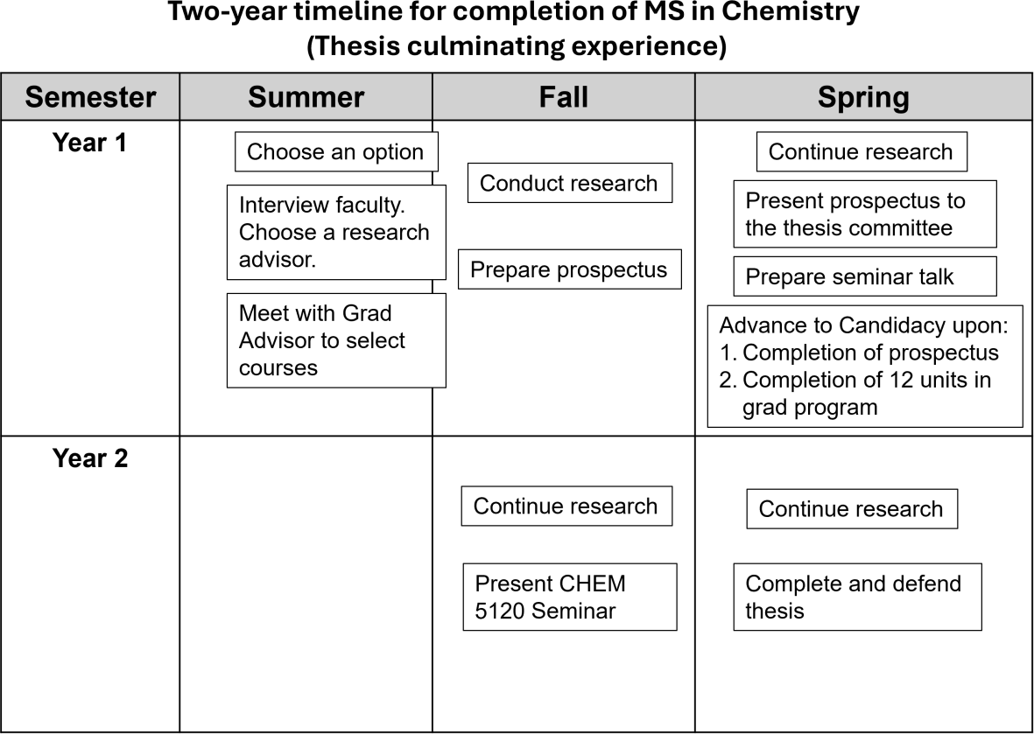

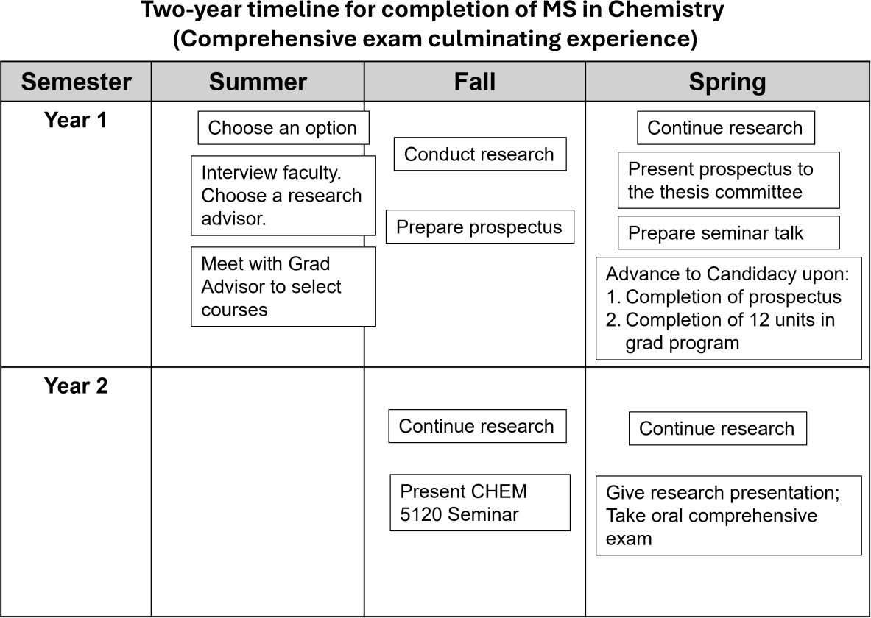

TWO-YEAR ROADMAPS – sample coursework for M.S. students
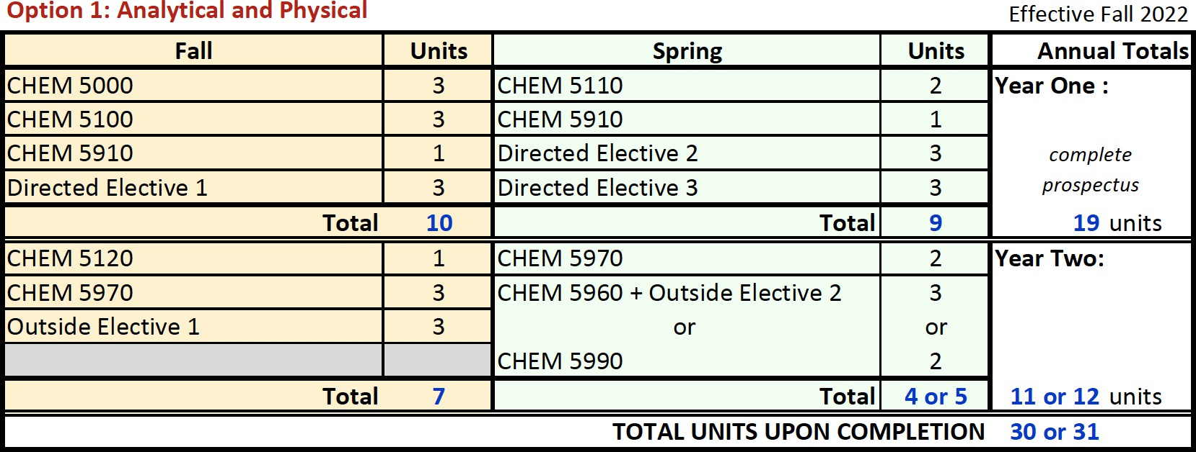

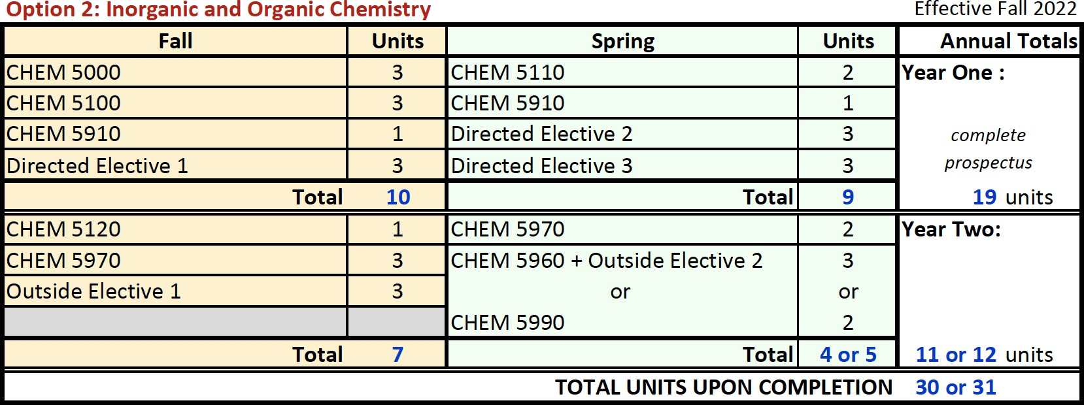

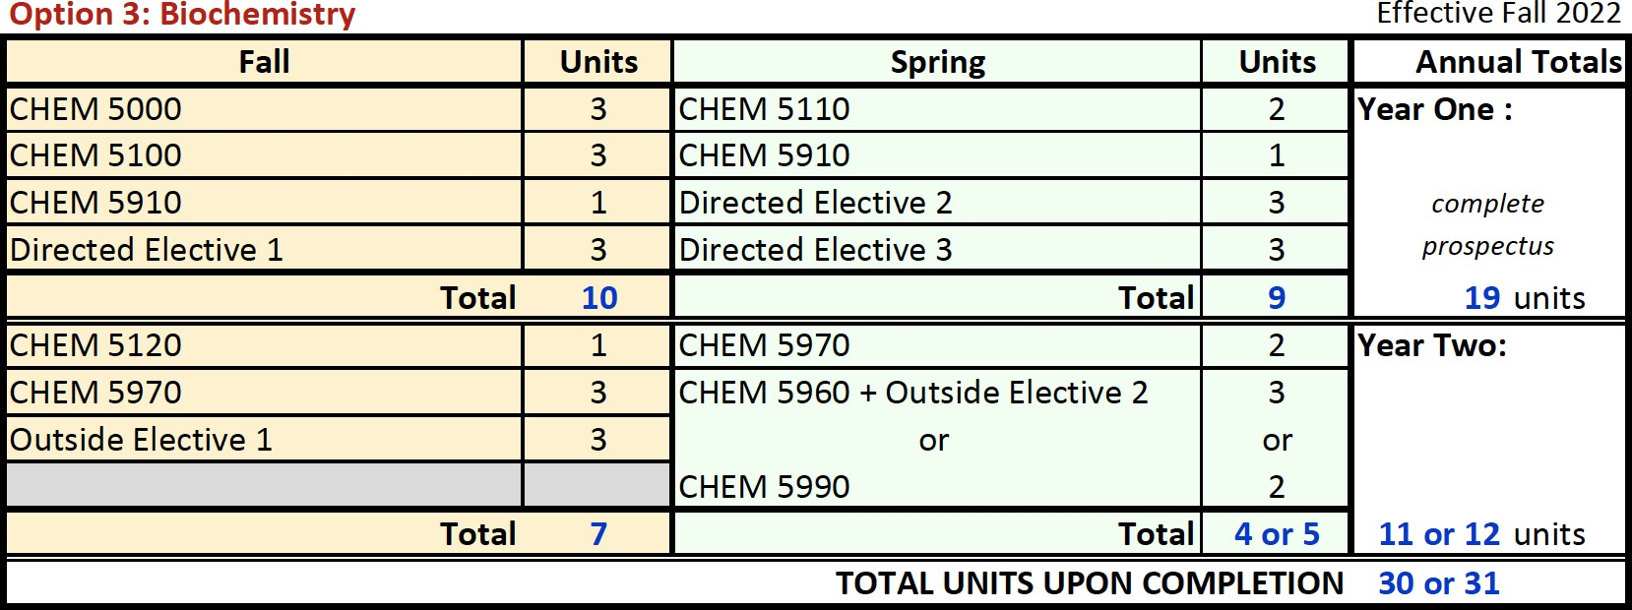

ACADEMIC POLICIES

University Catalog: Graduate students are governed by University policies and regulations as stated in the University Catalog in effect at the time they achieve classified standing (G1, G2 or G3 level), provided that they maintain continuous registration every Fall and Spring semester (Summer term excluded). Please use the following link to access “Graduate and Post-Baccalaureate Studies: General Information” in the current University Catalog:

https://ecatalog.calstatela.edu/content.php?catoid=75&navoid=10907

On rare occasions, changes are made to our M.S. requirements. However, the M.S. requirements for your personalized graduate program are described in the online catalog available at the Cal State LA website. It may be useful for you to print out the Chemistry section of that the online catalog so that you will always have a record of the University, College, and Departmental MS requirements that apply to you.

Department Requirements for Master’s Degree

All candidates for master’s degrees in chemistry must select an option (physical and analytical chemistry, inorganic and organic chemistry, biochemistry, or chemical education) and declare a culminating experience (thesis or comprehensive examination). For the degree, they must fulfill the following minimum requirements.

Unit Requirement: Completion of 30-31 semester units in approved courses, of which at least half (15 units) must be graduate (5000-level) courses.

Requirements for Option I: Physical and Analytical Chemistry (30-31 units):

- Core Requirements (16 units)
  - Core Courses (9 units)
CHEM 5000 Interdisciplinary Discoveries in Chemistry and Biochemistry (3) CHEM 5100 Introduction to Research (3)
CHEM 5110 Graduate Seminar: Chemistry I (2) CHEM 5120 Graduate Seminar: Chemistry II (1)
  - Research Requirements (7 units)
CHEM 5910 Advanced Laboratory (1) (complete 2 units)
CHEM 5970 Graduate Research (1-3) (complete 5 units)
- Option requirements (12-15 units)
  - Directed Course within Option (8-10 units)
(Note: Comprehensive Exam (CHEM 5960) students select 8 or 9 units. Thesis (CHEM 5990) students select 9 or 10 units)
CHEM 4450 Introduction to Atmospheric Chemistry (3) CHEM 4460 Drug Delivery (3)
CHEM 4510 Advanced Analytical Chemistry: Optical Spectroscopy (2) CHEM 4520 Advanced Analytical Chemistry: Analytical Separations and Mass

Spectrometry (2)
CHEM 4530 Advanced Analytical Chemistry: Electrochemistry and Surface Techniques (2)
CHEM 5400 Quantum Chemistry (3)
CHEM 5410 Nuclear Magnetic Resonance Spectroscopy (3) CHEM 5510 Thermodynamics and Kinetics of Materials (3)
  - Electives outside Option (3 or 6 units)
Select courses from the directed electives in Options II and III. Comprehensive Exam (CHEM 5960) students must complete 6 units. Thesis (CHEM 5990) students complete 3 units.
- Culminating Experience (0 or 2 units) Select one course.
CHEM 5960 Comprehensive Examination (0)
CHEM 5990 Thesis (1-3) (complete 2 units)

Requirements for Option II: Inorganic and Organic Chemistry (30-31 units):

- Core Requirements (16 units)
  - Core Courses (9 units)
CHEM 5000 Interdisciplinary Discoveries in Chemistry and Biochemistry (3) CHEM 5100 Introduction to Research (3)
CHEM 5110 Graduate Seminar: Chemistry I (2) CHEM 5120 Graduate Seminar: Chemistry II (1)
  - Research Requirements (7 units)
CHEM 5910 Advanced Laboratory (1) (complete 2 units)
CHEM 5970 Graduate Research (1-3) (complete 5 units)
- Option requirements (12-15 units)
  - Directed Elective within Option (9 units) CHEM 4200 Advanced Organic Chemistry I (3) CHEM 4210 Polymer Chemistry (3)
CHEM 4850 Bioinorganic and Bioorganic Chemistry (3)
CHEM 5200 Synthetic Organic Chemistry: Analysis, Design, and Methodology (3)
CHEM 5210 Organic Structure Determination (3)
CHEM 5600 Advanced Inorganic Chemistry (3)
  - Electives outside Option (3-4 or 5-6 units)
Select courses from the directed electives in Options I and III. Comprehensive Exam (CHEM 5960) students must complete 5-6 units. Thesis (CHEM 5990) students complete 3-4 units.
- Culminating Experience (0 or 2 units) Select one course.
CHEM 5960 Comprehensive Examination (0)
CHEM 5990 Thesis(1-3) (complete 2 units)

Requirements for Option in Biochemistry (30-31 units):

- Core Requirements (16 units)
  - Core Courses (9 units)
CHEM 5000 Interdisciplinary Discoveries in Chemistry and Biochemistry (3) CHEM 5100 Introduction to Research (3)
CHEM 5110 Graduate Seminar: Chemistry I (2) CHEM 5120 Graduate Seminar: Chemistry II (1)
  - Research Requirements (7 units)
CHEM 5910 Advanced Laboratory(1) (complete 2 units) CHEM 5970 Graduate Research (1-3) (complete 5 units)
- Option requirements (12-15 units)
  - Directed Elective within Option (9 units)
CHEM 4850 Bioinorganic and Bioorganic Chemistry (3) CHEM 4860 Bioinformatics (3)
CHEM 5320 Protein Structure (3)
CHEM 5330 Transcriptional Control of Gene Expression (3) CHEM 5350 RNA Structure and Function (3)
  - Electives outside Option (3-4 or 5-6 units)
Select courses from the directed electives in Options I and II. Comprehensive Exam (CHEM 5960) students must complete 5-6 units. Thesis (CHEM 5990) students complete 3-4 units.
- Culminating Experience (0 or 2 units) Select one course.
CHEM 5960 Comprehensive Examination (0)
CHEM 5990 Thesis (1-3) (complete 2 units)
Prospectus: Within six months after choosing a research advisor, each student, in consultation with their research advisor, will establish a Thesis or Comprehensive Exam Committee of four faculty members (see Graduate Thesis Policies and Procedures in the Appendix). A copy of the written Prospectus must be provided to each committee member no later than one week before a scheduled oral defense (or later with the consent of the entire committee). The student will present the Prospectus to the Thesis or Comprehensive Exam Committee at the oral defense. If the Committee approves, the “Application for Advancement to Candidacy” (GS-10) Form will be signed and approved by the Committee members. Guidelines for preparing the Prospectus are also given in the Appendix.
The GS-10 (see appendix) form must be submitted, along with an abstract to the Graduate Coordinator in the Department of Chemistry and Biochemistry. The Graduate Coordinator will ensure that the form is submitted to the College of NSS. After approval of the Prospectus, the student may enroll in the Graduate Research course (CHEM 5970) and the Thesis course (CHEM 5990).
Grade Point Average (GPA) Requirement: Achievement of a minimum B (3.0) grade point average in all courses on the approved degree program. A grade of C is allowed on the program; however, any grade below C, including C-, requires that the course be repeated with both grades computed in the grade point average. Following is a breakdown of the grading system:

Traditional Grading System:

A | 4.0
A- | 3.7
B+ | 3.3
B | 3.0
B- | 2.7
C+ | 2.3
C | 2.0
C- | 1.7
D+ | 1.3
D | 1.0
D- | 0.7
F | 0.0

Any grade lower than a C is a failing grade and must be repeated.

Non-Traditional Grading System:

CR/NC: Credit/No Credit (Grade received for Comprehensive Exam CHEM 5960). RP: Report in Progress (Grade received for CHEM 5970, 5980, 5990 until the student passes the thesis defense. After the student passes, RP is changed to CR for CHEM 5970 and 5990; the RP is changed to a letter grade for CHEM 5980).

Introductory Research Requirement (CHEM 5910): This is the first research course that you will take. Your research advisor will describe the requirements for CHEM 5910.

University 9000 (UNIV 9000):

The information below is all taken from the UNIV 9000 webpage:
(http://www.calstatela.edu/page/university-9000-univ-9000)

A graduate/doctoral degree student is required to maintain continuous enrollment in every fall and spring semester from the beginning of the program of study until the awarding of the degree. Enrollment during Winter or Summer Session is required only if the student plans to graduate during that particular term. All students must be enrolled during the term in which they graduate. Unless granted an approved leave of absence, a graduate/doctoral student who fails to register each semester has discontinued enrollment in the graduate/doctoral degree program. The purpose of this policy is to keep students on track to completion within the required seven-year period.
Every semester, graduate/doctoral degree students must be registered in a course, or University (UNIV) 9000, or must have an approved leave of absence. Registration in UNIV 9000 is restricted to graduate/doctoral degree students who have been advanced to candidacy and have completed all coursework (including all allowable research units) but need additional time to complete their thesis, project, or dissertation. If a student wishes to take a semester off before resuming coursework, she or he must take a Leave of Absence, not UNIV 9000. Although UNIV

9000 is a zero-unit course, the fee is based on one unit of credit for payment purposes; no unit credit is added to the student's program or transcript. This course is not eligible for financial aid.
You are responsible for maintaining your graduation progress through the Graduation Office (SSB-3380). For more information regarding filing for graduation or graduation date changes, contact the Graduation Office at (323) 343-3890.You must enroll by the University Add Deadline. Upcoming dates can be found online.

Please note that students who register for UNIV 9000 may be required to start paying back student loans because UNIV 9000 is a zero unit course.

Below is the registration Process for UNIV 9000.
- Complete the Graduate Continuous Enrollment Form provided by the College of Professional and Global Education (PaGE).
- Obtain the approval of a Graduate Advisor on the Graduate Continuous Enrollment Form. Before signing the form, a Graduate Advisor will check to make sure that the student has been Advanced to Candidacy and that all of the student’s coursework has been completed. A plan and timeline for completing the thesis, project, or dissertation must be established with the graduate advisor and committee chair as a condition of approval for enrollment in UNIV 9000.
- Scan and email the completed Graduate Continuous Enrollment Form to PaGE Enrollment Services to be registered. Payment is due at the time of enrollment.
  - Registration must be completed by the University Add Deadline of the session in which the student wishes to maintain continuous enrollment. Upcoming dates can be found online, or contact PaGE for enrollment deadlines.
  - If paying with a debit or credit card, a link to submit payment will be forwarded to you once your paperwork is received. Payments processed via credit/debit will be accessed a Cashnet service fee of 2.65%.
  - If paying with a check, please make checks payable to Cal State LA. You will submit payment at One Stop Financial Services, Student Services Building (SSB) #2380. IT IS IMPORTANT TO INCLUDE YOUR CIN ON THE CHECK.
  - Enrollment during Summer Session is only required if the student wishes to graduate during that term.

Students who elect a comprehensive examination as their Culminating Experience are not permitted to enroll in UNIV 9000.
Culminating Experience Requirement: A thesis or a comprehensive examination is required of all students.
Requirements for Enrollment in Graduate Research and Thesis Units (CHEM 5970, 5990): The student has an approved master’s degree program in the College Graduate Dean’s Office, has Advanced to Candidacy (G3) classification, has an approved Request for Thesis or Project Committee and Title (GS-12 form) with the abstract of the Prospectus on file in the NSS Graduate Dean’s Office. See the appendix for departmental policies and procedures for the master’s thesis.

Requirements for Enrollment in Comprehensive Examination (CHEM 5960): the student has an approved master’s degree program in the NSS Graduate Dean’s Office, has an approved Request for Thesis or Project Committee and Title (GS-12 form) with the abstract of the Prospectus on file in the NSS Graduate Dean’s Office, has Advanced to Candidacy (G3) classification, has an overall GPA of 3.0 or higher on all coursework completed in master’s degree program, and has no more than one course remaining to be completed on master’s degree program. See the appendix for departmental policy and procedures for the comprehensive examination.

Classification Levels:

G1: Conditional Graduate Standing. A student who has been admitted to a master’s degree program but does not have an official, approved Graduate Program for the degree on file in the Associate Dean’s Office.
G2: Classified Graduate Standing. A degree-seeking master’s student who has an official,
approved Graduate Program for the degree but has not been Advanced to Candidacy.

G3: A degree-seeking master’s student who has been Advanced to Candidacy (see below).
G4: A post-baccalaureate student who is eligible to enroll in non-restricted classes but has not been officially admitted to a degree program.
Advancement to Candidacy to Undertake Culminating Experience: Advancement to candidacy is granted by the college graduate dean upon completion of the requirements listed below and upon the department's recommendation. It is the University's prerequisite to enrolling for the graduate research (CHEM 5970) thesis (CHEM 5990) and comprehensive examination (CHEM 5960) units. Advancement to candidacy requires:

- Previously classified graduate standing (G2).
- An approved master’s degree Graduate Program on file in the college graduate studies
office.
- Completion of a minimum of 12 semester units of the master’s degree Graduate
Program with an overall B (3.0) grade point average or higher.
- Recommendation of the department.
- Approval of the college graduate dean.
Only students who are Advanced to Candidacy (G3) are eligible to enroll for graduate research (CHEM 5970), thesis (CHEM 5990) and comprehensive examination (CHEM 5960) units.

CHEM 5110 and CHEM 5220 – Graduate Seminar: There are two courses that culminate in the student making a department presentation on a topic outside of their research area. Students should register for CHEM 5110 (preparation for the talk) in their second semester and for CHEM 5120 (giving the talk) in their third semester. In both these courses, students attend the department seminar series. Although students only register for the Graduate Seminar courses for two semesters, they are expected to attend all of the departmental seminars every semester

whether they are registered or not registered for these courses. Contact Dr. Michael Hayes (phone: 323-343-2144); e-mail: mhayes3@calstatela.edu) to schedule your seminar. Dr. Hayes needs to be notified a semester in advance of your scheduled presentation. See the appendix for the grading criteria for Graduate Seminar.

Completion of Program: Completion of a master’s degree requires:

- Completion of the final approved program with an overall B (3.0) grade point average or higher.

- Filing of a thesis approved by the candidate’s thesis committee and cleared by the
University Library or passing a comprehensive examination within two attempts.

College/University Policies and Procedures

Residence Requirement: At least 21 semester units for the master’s degree must be completed
in residence at Cal State L.A.

Course Substitutions: It may be necessary to change an Academic Graduate Program based upon special circumstances. The substitution of a course on your Graduate Program is done with the approval of the Graduate Advisor and your thesis advisor. This transaction is done by the Graduate Advisor by email request with written approval from your thesis advisor.

A course may NOT be added to or deleted from a master’s degree Graduate Program AFTER it has been taken. Any change in the Graduate Program must be approved in advance by the Graduate Advisor, department chair, and college graduate dean. When such a change has been approved, it becomes part of the Graduate Program.

Transfer Courses. Students may transfer up to nine units of previously completed coursework toward the master's degree, with Graduate Advisor approval. These may include continuing education courses, transfer courses, courses completed before the filing date for the program, or a combination thereof. Transfer courses must be equivalent to 4000- or 5000-level course work at Cal State L.A. and must be acceptable for graduate credit in an advanced degree program at the institution where they were taken. The student will need to provide the graduate advisor with a course description of the course(s) he/she wants to transfer to Cal State LA. The student should also submit unofficial transcripts to the advisor. The courses must not have been used as part of their undergraduate degree requirements, and the cumulative undergraduate GPA must be 2.75 or greater. Once the advisor determines the courses are transferrable, the Graduate Advisor will use GET to incorporate these courses into the degree program.

Full-Time Unit Load for Graduate Students: For full-time enrollment certification by the University, graduate students must carry a unit load of 8 units of approved prerequisite, corequisite, or graduate program courses. Upon recommendation of a student's major department/division/school and approval by the appropriate college dean, a student enrolled in any of the following department/division/school courses may be certified as full-time with fewer than 8 units: 5960, 5970, 5990. The maximum unit load for students working towards a graduate

degree is 16 units per semester. Authorization to enroll in more than 16 units requires a petition approved by the student's major department/division chair or school director and the appropriate college dean.

Time Limitation (Seven-Year Rule): No subject, unit, or grade credit will be granted for any course completed more than seven years before the date of completion of the master’s degree. In extraordinary circumstances, students may petition for, and the college may grant, permission to validate such an expired course by an examination given by, and with the concurrence of, the department/division/school that offers the course. An expired course taken at another institution may not be validated by examination. See the NSS Graduate Handbook for the procedures used to validate an expired course. Students are allowed to validate three courses (9 semester units or 12 quarter units).

Continuing Student Status and Leave of Absences:
Students maintain their continuing student status for registration purposes only by attending at least one of the two semesters immediately preceding the semester in which they plan to enroll (excluding the summer term). Students who were admitted and enrolled in one of the last two semesters preceding the semester in which they plan to enroll will also maintain their continuing student status for registration purposes. Absence for more than one of any two consecutive semesters without an approved leave of absence will cancel continuing registration eligibility.
Please see the Leaves of Absence form for additional instructions and information.

Please note: there are additional criteria for students who are Advanced to Candidacy (see below).

Procedure for continuing student status:

Conditionally classified and classified students must be enrolled in one of the two semesters during an academic year. For example, if a student registers for Fall 2025, they can take off Spring 2026, and still be eligible to enroll for Fall 2026. However, if that student knows that they cannot register for Fall 2026, they will need to complete a leave of absence form and give it to the Office for Graduate Studies before the deadline.

Advanced to Candidacy students MUST be enrolled every semester from the time they are advanced to candidacy until they complete their degree. Please note that students cannot register for UNIV 9000 until after they register for all of their 5990 and 5970 units. If the student decides not to enroll in a semester, that student needs to complete a leave of absence before the deadline. Request forms are available at: https://www.calstatela.edu/sites/default/files/leave_of_absence.pdf

Maintaining Enrollment for Thesis: Students must be advanced to candidacy and must obtain the approval of the associate dean with the assistance of the Graduate Advisor before registering for graduate research and thesis units. When all units for CHEM 5970 and 5990 classes have been completed, a student must maintain continuous enrollment by registering for thesis or research units using the UNIV 9000 course number each semester until completion of the thesis/project. Furthermore, students must be officially enrolled during the term they expect to

graduate.

Thesis Requirements: Students who choose to write a thesis as their master’s degree culminating experience should consult the Gradutate Studies Graduate Thesis, Project, and Dissertation Guidelines. It provides information about the following: procedures, regulations, and responsibilities governing the master’s thesis or project; general requirements for thesis preparation and acceptance; format requirements for the thesis; and special instructions for projects and project reports. In addition, students must obtain specific department/division requirements from their Graduate Advisor. See the appendix for departmental policies and procedures for the master’s thesis.
Graduate students who complete graduate research units (5970) and thesis units (5990) required for master’s degrees must be regularly enrolled during any semester in which they use University facilities or consult with faculty. This means you must be enrolled during the term in which you hold your thesis defense, file your thesis with the University Library, and graduate.
Students who have previously enrolled in all allowable research units (5970) and are not enrolled in any other credit-bearing courses or thesis units (5990) but who will use University facilities or consult with faculty must register for UNIV 9000.

Applying for Graduation: Information below is from University Graduation Office.
The Graduation Application is used by the student to notify the university that they are ready to complete their degree program. All coursework for the degree program must be completed prior to the award date (end of graduation term). The student’s record may not be altered following the awarding of the degree so it is critical that the Graduation Application be accurate at the time of filing. A Graduation Application is filed once for a degree program. The student pays a $20 application and $10 diploma fee ($30 total) at the time of filing. Once the Graduation Application is filed it may be updated (e.g. change term, major, option, etc.) by using the Request to Change Graduation Term form and paying a $25 late filing fee.

Procedure for applying to graduate:

You can find the graduation application and deadlines in the University Graduation Office.

The graduate student needs to complete the graduation application and have the graduate advisor sign the form. The graduate advisor needs to log in to GET and review the student’s CAAR to check the following:

- Is the student listed in the correct option?
- Is the student’s catalog date correct?
- Is the student advanced to candidacy?
- Have all the course substitutions been entered on CAAR?
- Has the student completed all or almost all of his/her coursework for their program?
- Will the courses the student is planning to enroll in for his/her last semester at Cal State LA fulfill any missing requirements that are listed on CAAR?
- Is the student’s program GPA a 3.0 or above?

- Are the program units that the student has completed listed correctly on GET? It is always good to hand count the units the student has completed for his/her program and compare those units with CAAR.
A copy of the graduation form must be submitted to the department office for the student’s file. After the application form has been signed by the graduate advisor and a copy given to the department, the form needs to be submitted to the One-Stop Financial Services Office by the student.

Financing Your Education
Departmental Graduate Assistants, Teaching Assistants, and Research Assistants: The Department of Chemistry and Biochemistry has some funding opportunities available and we encourage you to explore the following options:
  - MORE Programs – (323) 343-2395
  - CREST-CATSUS – catsus@calstatela.edu
  - Graduate Assistants/Teaching Assistants – (323) 343-2300
  - Research Assistants – Many faculty have research grants that allow them to pay graduate students for laboratory research.
International Graduate Student Tuition Waiver Program: A limited number of non-resident tuition fee waivers or tuition fee reductions may be granted to non-resident graduate students who are either domestic non-resident students or citizens of a foreign country.

Federal / State Financial Aid Programs: Graduate students may apply for financial aid but they must realize that many of the grant programs (Pell Grant, Cal Grant, etc.) that might have been available as an undergraduate are no longer available to graduate students.

The financial aid application, either the Free Application for Federal Student Aid (FAFSA) or the California Dream Act Application (CADAA) for AB 540-eligible students, becomes available each year on October 1 for the upcoming academic year. Students are strongly encouraged to submit their application by the March 2 priority deadline to be considered for the maximum amount of federal, state, and institutional aid. After submitting your FAFSA or CADAA, you will be notified by the Center for Student Financial Aid regarding your eligibility and any additional documentation required. If you are selected for verification, you must submit the requested documents before your financial aid award can be finalized. Once your financial aid file is complete, processing typically takes several weeks before an official award offer is issued.

Graduate students must meet enrollment requirements to receive financial aid. For most federal loan programs, students must be enrolled at least half-time (6 units per semester). For graduate academic purposes, 8 units per semester is considered full-time enrollment; however, financial aid awards may be adjusted based on enrollment level.

Students must reapply for financial aid each academic year and meet all eligibility and deadline requirements.

For more information on financial aid programs, deadlines, and enrollment requirements, please visit: http://www.calstatela.edu/financialaid
- State University Grant: This is "gift" money: funds that you do not have to repay.

- Federal Work-Study (FWS): The FWS Program enables you to become employed in an on-campus student assistant position. Eligible students may work a maximum of 20 hours per week.

- Unsubsidized Federal Direct Loan: The Federal Direct Unsubsidized Loan is an educational loan provided by the U.S. Department of Education. Eligible graduate students may borrow up to
$20,500 per academic year, subject to school certification and federal eligibility requirements. The aggregate (lifetime) limit is $138,500, which includes all Federal Direct Subsidized and Unsubsidized Loans borrowed as an undergraduate and graduate student combined. The interest rate on Federal Direct Loans is fixed and is set annually by Congress for loans disbursed during a specific academic year. Repayment begins six months after graduation, withdrawal, or dropping below half-time enrollment. Under the Standard Repayment Plan, you may have up to 10 years to repay the loan, though alternative repayment plans (including income-driven options) are available.
Interest on an Unsubsidized Federal Direct Loan begins to accrue immediately after the loan is disbursed. You are responsible for paying all accrued interest, including interest that accumulates while you are in school, during the grace period, or during deferment.

For more information about current interest rates, loan limits, and repayment options, please visit: https://studentaid.gov

APPENDICES


Application for Advancement to Candidacy
GS-10
Part 1: To be completed by the STUDENT

Last Name(s), First and Middle Names (must match EXACTLY as on Cal State LA transcript) CIN #

CalStateLA.edu Student Email Address Phone Number

Graduate Degree, Program, and Option
Part 2: To be completed by the STUDENT and the FACULTY GRADUATE ADVISOR


Advancement to Candidacy Requirements:
Completed Graduate Writing Assessment Requirement (GWAR): Met or will meet by end of current term Completed minimum of 12.0 semester units of your study plan: Met or will meet by end of current term Earned minimum 3.0 grade point average: Met or will meet by end of current term
Additional Departmental or Program Coursework Requirements for Advancement to Candidacy (if any; e.g., defend proposal, complete required courses, etc.):
1.
2.
3.

Culminating Experience:
◻
◻
◻
Comprehensive Examination (complete this section then complete Part 4) Project (complete this section, Part 3, and Part 4)
Thesis or Dissertation (complete this section, Part 3, and Part 4)


By signing this form, we certify that the student has adhered to their study plan and completed all requirements for Advancement to Candidacy.

Student Name | Signature | Date
Faculty Graduate Advisor Name | Signature | Date
Part 3 (Thesis, Project, or Dissertation ONLY): To be completed by the STUDENT and the COMMITTEE CHAIR

Proposed Thesis, Project, or Dissertation Title
Committee Chair Name | Signature | Date
Names of Additional Committee Members (signatures not required) |  | Style Manual, if known (APA, MLA, IEEE, ACS, etc.)
Part 4: DEPARTMENT CHAIR AND COLLEGE ASSOCIATE DEAN APPROVAL
Advancement to Candidacy: Approved Not approved

Department Chair Name Signature Date

Approved Not approved

College Associate Dean’s Name (or designee) Signature Date

Send one copy each to GRC@calstatela.edu, records@calstatela.edu, faculty graduate advisor, and student Rev. 6/2022

CALIFORNIA STATE UNIVERSITY, LOS ANGELES APPROVAL PAGE FOR GRADUATE THESIS,
GS-13
PROJECT REPORT, OR DISSERTATION

SUBMITTED IN PARTIAL FULFILLMENT
OF THE REQUIREMENTS FOR THE DEGREE OF MASTER OF ARTS
AT CALIFORNIA STATE UNIVERSITY, LOS ANGELES BY

Candidate Last Name, First and Middle Names CIN#

Department and Degree Program

TITLE:

Committee Chair

Member

Member

Member

Department Chair
Signature

Signature

Signature

Signature

Signature

Date

Grading Sheet for Graduate Seminar (CHEM 5120)

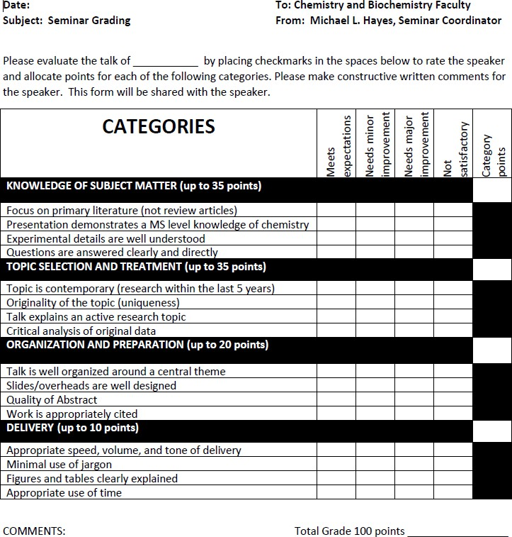

M.S. Degree Thesis Committee and Prospectus Guidelines Department of Chemistry and Biochemistry

Within the first semester, each student, in consultation with his or her research advisor, shall establish a Thesis Committee. The student will subsequently (usually during the second semester) present to their Thesis Committee a prospectus for their thesis research program. The Thesis Committee will meet with the student at least every six months thereafter. The Thesis Committee, in cooperation with the student’s research advisor and the Department Graduate Advisor, will monitor the progress of the student until the completion of the degree program.

The approved Prospectus and the College GS-10 Form listing the names of the members of the Thesis Committee must be submitted to the Department Office. The Department Chair will only approve the College GS-10 Form when an approved prospectus has been submitted.

Guidelines for Preparation of the Prospectus
All text is to be typed single-spaced in 12-point type (or larger). Margins should be one inch on all sides.
All pages must be numbered at the bottom center of each page.

- Title

  - Conveys the specific nature of the proposed study.
  - Formatted such that:
    - Only the first word and proper nouns are capitalized, or
    - All words except for articles, prepositions, and conjunctions are capitalized.

- Abstract – maximum 500 words.

The abstract briefly conveys what the study is about in a form comprehensible to a general audience. Acronyms, abbreviations, and technical jargon specific to the field should be avoided. The abstract should include a hypothesis or objective of the study, an overview of methods, and a brief statement of expected results and their significance.

- Objectives – maximum one-half page.

  - Includes specific hypothesis (or hypotheses) to be tested, expressed as a statement.
  - If work will not test a hypothesis, this section should clearly state the objective(s) to be met.

- Background – maximum two pages.

  - Introduces topic to a reader outside of the field.
  - Should include literature reviewand summary of information relevant to the proposed research.
    - Literature review should synthesize information, not state a disconnected list of facts.
    - Relevant unpublished data can be included.
    - All published and unpublished work discussed must be properly referenced.
  - Should restate Objectives section and explain how objectives relate to earlier work covered in the literature review.

- Materials and Methods – maximum one page.

An overview of the experimental design, including a summary of any experiments to be conducted, is presented. This section should discuss the experimental system or conceptual approach of the study.
- Significance – maximum one-half page.

How will the proposed work contribute to the advancement of scientific knowledge?

- References – maximum one page, with a minimum of 12 peer-reviewed papers from scientific journals.
  - All references mentioned in text should be listed here.
  - All chemistry prospecti must follow the ACS Reference Format. A brief online guide on the proper format is at http://pubs.acs.org/books/references.shtml. Prospecti in biochemistry may follow either the ACS Format or the Journal of Biological Chemistry.
  - References should be numerical order, according to order mentioned in text, and referenced in the text by number.
- Figures and Tables – optional.

A small number of relevant Figures and/or Tablesare acceptable. All Figures and Tables must include titles and concise, explanatory legends.

Evaluation of the Prospectus:
The Prospectus will be evaluated at two different levels: (1) by the Research Advisor and (2) by the Thesis Committee. The Research Advisor will work with the student until the Prospectus is in its final form, ensuring that the scientific reasoning is correct, the Prospectus is organized, and the writing is clear. The members of the Thesis Committee will then carry out an in-depth evaluation that includes content, format, organization, style, clarity of writing, depth of student knowledge, and writing skills (grammar, spelling, etc.). The Thesis Committee will also evaluate whether the project proposed in the Prospectus is reasonable for a Master’s degree student. At the end of this two-part evaluation, it should be concluded whether or not the student being evaluated can successfully complete the proposed research project in approximately two years.

Following review by the Thesis Committee, the Prospectus will be approved, conditionally approved, or not approved. If conditionally approved, or not approved, it will be returned to the student with suggestions for improvement, after which the student will resubmit it to the Thesis Committee within one month.

Graduate Thesis Policies and Procedures Department of Chemistry and Biochemistry
Title V Requirements: A thesis or project that is submitted in partial fulfillment of the requirements for a graduate program at California State University, Los Angeles, must satisfy the following definitions excerpted from Section 40510, Title V, of the California Code of Regulations (prior to January 1, 1988, referred to as the California Administrative Code). This code defines a graduate thesis as follows:

“A thesis is the written product of the systematic study of a significant problem. It identifies the problem, states the major assumptions, explains the significance of the undertaking, sets forth the sources for and methods of gathering information, analyzes the data, and offers a conclusion or recommendation. The finished product evidences originality, critical and independent thinking, appropriate organization and format, and thorough documentation. Normally, an oral defense of the thesis will be require d.”

Thesis Committee: The thesis is ultimately approved (or rejected) by a thesis committee. The MS Thesis Committee is composed of four tenured/tenure-track faculty members: Thesis Committee Chair (also known as the thesis research advisor or the student’s PI), two department faculty members, and one additional faculty member from any department whose expertise must be outside the area of specialization with approval of the Thesis Committee Chair. For the purposes of this policy the areas of specialization are analytical/physical, organic/inorganic, biochemistry, and chemical education, as defined in our graduate program.

Thesis Committee Chair: The Thesis Committee Chair has the leading role in guiding the student in a thesis or project, from its inception to acceptance by the university, and assumes a special mentoring role to help the student during the preparation of the thesis. The thesis committeechair should offer constructive criticism of the various drafts of the thesis.
Selection of Thesis Committee Members: The thesis Committee Members are selected by the student, subject to approval by the student’s principal research advisor. Those faculty members that agree to serve on a candidate's committee are responsible for reviewing all submissions by the candidate in a timely fashion and for offering appropriate constructive responses. They are further responsible for meeting with other committee members to perform duties and assessments as needed.
Student Responsibilities: The Student preparing the thesis is ultimately responsible for the successful completion of their theses, including submission of information and drafts in a timely fashion. Theses must evidence originality and independent thinking, appropriate form and organization, and a rationale. The student's responsibility includes not only completing the work of the thesis itself in a professionally competent manner, but also knowing and adhering to all university, college, and department requirements related to the master's thesis. It also entails adequate and regular contact, as appropriate, with individual faculty members and committees.
Plagiarism: It is common that several students in one research group work on one large project and/or that a graduate student continues on a research project originally started by another student. In all cases, any work not done by the author of the thesis must clearly be identified as someone else’s work and properly referenced. Likewise, quotations from a prior thesis must be properly referenced. Quotation of large sections from other works (i.e. several paragraphs) is not acceptable. Likewise, work performed as an undergraduate student (at CSULA or elsewhere) may not be presented as the student’s original thesis research. It may be mentioned in a background section, but must be properly referenced. Failure to do follow these rules constitutes plagiarism and will be dealt with accordingly.

Thesis and References Format: The Committee on Professional Training (CPT) of the American Chemical Society (ACS) has developed guidelines for preparations of research reports. Students may find the definitions of the various sections (Introduction, Results, Discussion, etc) helpful. While a thesis is typically longer than a research report, it contains the same sections, namely Title, Abstract, Introduction, Experimental Details or Theoretical Analysis, Results, Discussion, Conclusions and Summary, and References. These guidelines are available on the web at
http://portal.acs.org:80/portal/fileFetch/C/CTP_005606/pdf/CTP_005606.pdf

All chemistry theses must follow the ACS Reference Format. A brief online guide on the proper format is at http://pubs.acs.org/books/references.shtml. Theses in biochemistry may follow either the ACS Format or the Journal of Biological Chemistry. Additional information on the formatting of a thesis at Cal State LA is given on the library homepage at http://www.calstatela.edu/library/guides/thesbk.htm, especially in Chapter 3. Failure to follow these regulations will lead to rejection of the thesis.

Thesis Evaluation Criteria: Master’s theses are evaluated both in form and content. In accordance with the thesis definition given in Title V at the beginning of this document, a thesis that does not contain evidenceof a significant amount of the student’s independent original work shall be rejected. As mentioned above, a thesis must contain Title, Abstract, Introduction, Experimental Details and/or Theoretical Analysis, Results, Discussion, Conclusions and Summary, and References.

Thesis Defense: An oral defense of the thesis before the thesis committee is required by the Department of Chemistry and Biochemistry. The defense is open to the public and is publicized through distribution of a thesis abstract. A typed draft of the thesis must be provided to each committee member no later than one week before the scheduled oral defense (or later with the consent of the entire committee). The final draft of the thesis is prepared following the defense. Three copies of the approval page should be signed only after the final draft has been reviewed and approved by the committee members. Students who are submitting the final draft of the thesis must be formally registered as classified graduate students (G3) for the semester in which the thesis is submitted.

Upon successful completion of the oral and written components of the Thesis Defense, students must obtain signatures for the GS-13 form, and turn them into the Graduate Coordinator in the Department office.

Comprehensive Examination Policy and Procedures
Department of Chemistry and Biochemistry

Only students who have successfully completed the prospectus requirement shall be allowed to register for the comprehensive exam class (CHEM 5960).

The comprehensive exam consists of two parts: A presentation of the student’s research in the graduate program at Cal State LA, and an oral examination that asses the student’s ability to address complex scientific problems related to their field of research, including reviewing and critiquing the scientific literature at a level of expertise beyond that acquired during undergraduate studies. The oral examination is based on three papers related to the student’s area of research.
The date and time for the research presentation and the oral examination shall be selected by the student’s committee and the student. The research presentation shall be the first part of the exam. The second part (the oral examination) must take place within three weeks following the initial research presentation. One week prior to the date of the oral examination, the student’s committee will select three papers related to the student’s research on which the examination will be based. These papers may include papers cited in the student’s Prospectus. The Committee Chair has the main responsibility for selecting these papers. The committee will approve five questions relating to the material in these papers. These questions may range from details about experimental methodology to the theory and background of the work to the broader impact of the research. The papers will be given to the student one week prior to the scheduled exam. Students shall be allowed to use copies of the papers and notes during the exam.

The student will be asked to provide answers to the five questions during the oral examination. The questions may lead to a broader scientific discussion about the issues at hand. Students will be evaluated primarily on the overall understanding of the science discussed in the papers. Knowledge of critical details sufficient for an explanation of the manuscripts at the level of a .S.M.S. in Chemistry is expected. The evaluation of the student’s answers is based on a grading rubric similar to what was develo ped for our graduate seminars. These categories are listed on the next page. An overall grade of B or better is required to pass the comprehensive exam.
Upon successful completion of the comprehensive exam requirements, students must obtain signatures for The Report of Comprehensive Examination, and turn it into the Graduate Coordinator in the Department office.

COMPREHENNSIVE EXAM GRADING CATEGORIES | Exceeds expectations | Meets expectations | Needs improvement | Not satisfactory
Understanding of current literature related to the assigned
Answers emphasize analysis over paraphrasing text
Critical analysis of original data is emphasized
Presentation shows knowledge of the molecular sciences pertinent to the assigned papers at a level that is appropriate for a Masters student
Experimental details are well understood
Jargon including abbreviations are correctly explained

Overall grade: Additional notes:

Submit two typed copies to College Graduate Studies Office Narural and Social Sciences
Check one: 1'^{t} attempt _
2nd attempt _ FINALATTEiMPT -

CALIFORNlA STATE UNNERSITY, LOS A GELES SCHOOL OF NATURAL AND SOCIOL SCIENCES GRADUATE STUDIBS
REPORT OF COMPREHENSIVE EXAMINATIO

Student Ldentificatlon number: Date


on

(Day, Month,.Year)

a(n)

(Passed or� (Written and/or Oral)

comprehensive examination in partial fu]fillment of the requirements for the MASTER OF ART/SCIENCE degree in the field of

Names and signatures of Members
of ,examination comrnitte-e:

Cornnuttce Charrperson

Prmc1pal Graduate Advisor

Department Chauperson

College Graduate Dean

