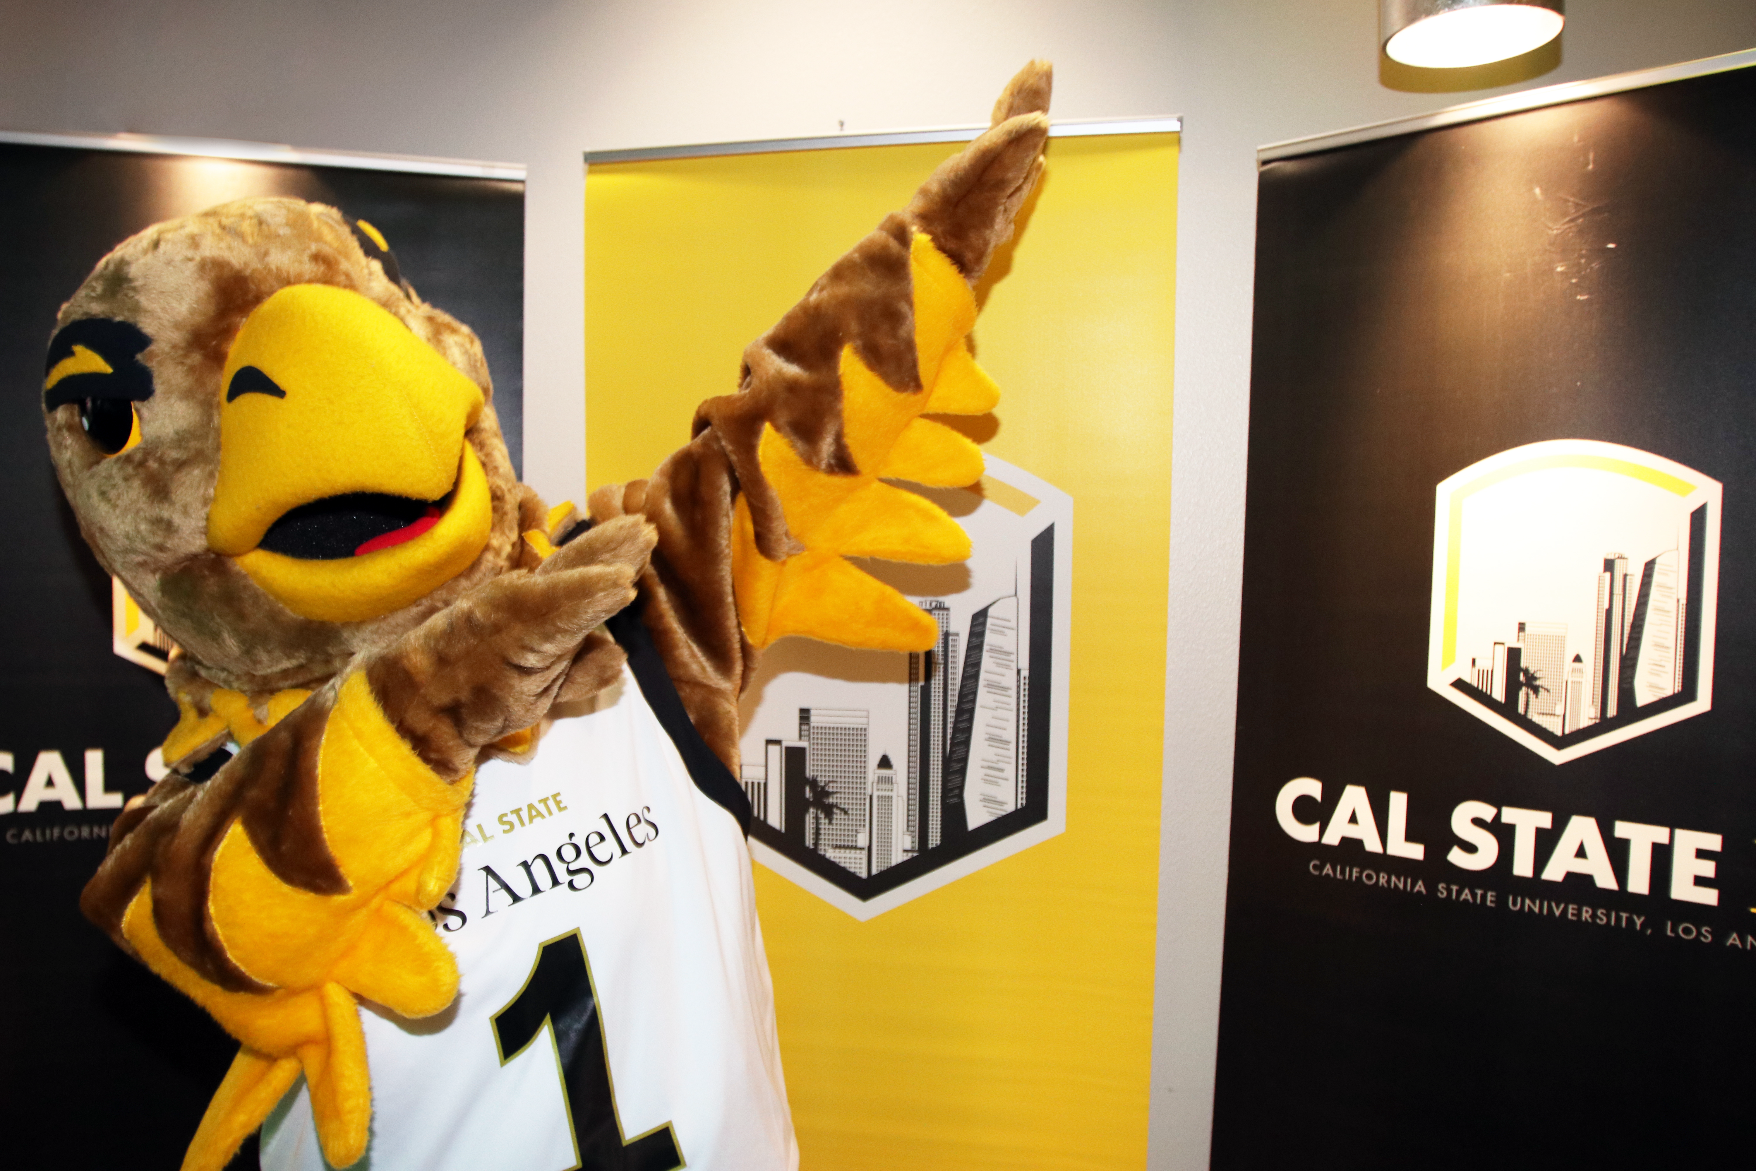
The Master of Science degree in Applied Behavior Analysis
Information Session

When: October 20 and November 10
Time: 6-7pm via zoom
Zoom Link: https://calstatela.zoom.us/j/87545339832

Contact information
Dr. Michele Wallace: mwallac@calstatela.edu
Dr. Jennifer Weyman: jweyman@calstatela.edu
Dr. Denice Rios: driosmo@calstatela.edu

