CSU California Unmanned Aerial System Competition (C-UASC)

MOJAVE AIR & SPACE PORT at RUTAN FIELD

Mojave, California

June 7, 2025

Organized by:

Cal State University – Los Angeles

and

Mojave Air & Space Port at Rutan Field

Competition Rules

Rev. 1. 2025-01-20

Contents

About this document 4

About the Competition 4

Purpose and Tasks 4

Introduction to Rules 4

Use of Mojave Air & Space Port 4

Requirements Imposed by the CSU 5

Registration 5

Safety and Emergency Operations 5

Standard Operations Plan 5

Emergency Operations Plan 5

Team Description and Composition of Teams 5

Development Team 5

Competition Team 6

Key Competition Team Members 6

Team Captain 6

Advisor 6

Team Pilots 6

Nominal Pilot Team 6

Safety Pilot 6

GCS Operator 7

Payload Operators 7

Pilot-In-Charge (PIC) 7

Competition Guests 7

Flight Competition and Demonstration 7

UAS Vehicles Type and Weight 7

UAS Types 7

UAS Weight 7

Minimum UAS Capability 8

Visual Line-of-Sight and Location of the Pilot and Ground Control Station 8

Facilities Infrastructure, Flight Boundaries and Environment 8

Course Map 8

Available Runway 9

Flight Boundaries 9

Geofence Bounds (LAT LONG): 9

Radio Frequency (RF) 9

Flight Qualification and Proof of Safe Flight 10

Flight Demonstration 10

Mission Time and Order of Flights 10

Target for Package Drop and Package Delivery 10

Flight/Mission Timing 10

Flight Start 10

Flight Finish/Landing 10

Flight/Mission Definitions 11

Qualification Flight 11

Waypoint Navigation Flight 11

Data Collection 11

Package Drop 11

Package Delivery 11

Target Localization 11

Score for Flight Evaluation 12

Total Score 12

Waypoint Navigation Score 12

Package Delivery Score 13

Package Delivery Accuracy 13

Package Drop Score 13

Package Drop Accuracy 13

Package Drop Time 14

Identification, Classification and Localization Score 14

Caution: Impact of Heat and Wind 14

Design Competition 14

Rules Governing Design Team and Design Competition Entries 14

Score for Design Competition 15

# About this document

This document contains the official rules for the C-UASC competition. Updates to the document will be released as needed to clarify or augment rules. The chief author of the document is Michael Thorburn. The rules are established by the organization partners at the California State University and the Mojave Air & Space Port at Rutan Field with consultation from our technical advisors. Updates to the rules will be published periodically to clarify items or make necessary corrections.

* Rev 0 of the C-UASC Competition Rules. Dated 2024-08-11. The initial draft of the rules.
* Rev 1 of the C-UASC Competition Rules. Dated 2025-01-20. Updated to provide information about packages and update the map.

# About the Competition

The competition is organized by California State University and by Mojave Air & Space Port at Rutan Field. It is a student competition, open broadly to teams of students from universities, colleges, and community colleges. All entrants will be required to comply with rules imposed by Mojave Air & Space Port at Rutan Field and by the California State University.

## Purpose and Tasks

The competition requires students to design, integrate, and demonstrate a small Uncrewed Aerial System (sUAS) capable of safe flight and the execution of a set of tasks.

The mission tasks are:

* Waypoint Navigation
* Package Drop, (a package is dropped to a target at a prescribed location)
* Package Delivery, (a package is delivered to a target at a prescribed location with requirements on the impact force)
* Target Identification and Localization. (Various targets on the ground are identified, classified, and localized in a prescribed field)

The UAS aircraft configuration can be a:

* Rotocopter,
* Fixed-Wing Vehicle, or
* VTOL (Vertical Takeoff and Landing) Vehicle

The UAS must include a Ground Control System (GCS). The GCS are the sets of ground-based hardware and software that allow UAS operators to communicate with and control the UAV and its payloads.

# Introduction to Rules

## Use of Mojave Air & Space Port

Teams shall comply with all operational requirements of the Mojave Air & Space Port. These requirements will be posted separately on the competition website. They will include:

* Operation within FAA Part 107 guidelines
* Operation at or below 400 feet above ground level (AGL)
* Always Remaining within Line of Sight (LOS) of the UAS Pilot
* No photos or video taken of personnel or property belonging to entities that are non-participating in this competition.

The agreement with Mojave Air & Space Port at Rutan Field, describing the rules of operation, will be posted on the competition website.

## Requirements Imposed by the CSU

### Registration

Teams will be required to register for the event on the webpage (<https://www.calstatela.edu/ecst/uav-competitions> . Each team will be required to provide all the information requested in the application prior to the competition. This will include information about, but not limited to:

* Insurance and Indemnification
* UAS FAA registration
* Team Members and Pilots

### Safety and Emergency Operations

All UAS must be operated in accordance with safety rules imposed by the CSU and those by the Mojave Air & Space Port at Rutan Field.

#### Standard Operations Plan

Each team must submit a plan that defines standard operations and complies with the safety rules. This plan should include:

* Operations checklists
* Pilot roles and responsibilities

#### Emergency Operations Plan

**Each team must submit a plan for emergency operations. This plan must include a plan for lost link, loss of control, or loss of communication with the UAS during flight!**

# Team Description and Composition of Teams

Teams are composed of students from colleges or universities.

Teams will be organized into three categories:

* Development Team
* Competition Team
* Competition Guests

## Development Team

The development team must consist of undergraduate students who attend school for at least one semester during the academic year. The team may have at most two graduate students participate during the academic year. The team must have at least one student from the school being represented and may have students from other schools. A school may have multiple teams, but a student may only be on one team. There are no limits to the number of students on the Development Team.

## Competition Team

The team of students which participate in the Mission Flight Demonstration. The competition team must be at most a 12-person subset of the development team. Members of the competition team may participate onsite or participate remotely (e.g. over the internet), but remote members cannot hold safety-critical roles or perform safety-critical functions.

## Key Competition Team Members

### Team Captain

One member of the competition team will fill the role of team captain during the competition year. This student will be the primary point of contact for the judges. All questions, comments, statements, and deliverables must be submitted by the team captain. The judges must be immediately notified of any team captain change.

### Advisor

Each team must have a school faculty member/advisor or official point of contact (POC) from the team’s school. Teams whose entire team is age 18 years or above are not required to have the advisor or school official travel with the team, otherwise at least two adults shall travel with the team and shall take full responsibility for the students. The advisor will be permitted to observe the team at the flight line but is forbidden from communicating or otherwise assisting the team during setup, mission, or tear down. While the advisor may teach concepts, answer questions, provide high-level guidance, and review deliverables before submission, the students must design, manufacture, and operate the system on their own and must produce all deliverables on their own.

### Team Pilots

Any member of the team that will control a portion of a UAS flight, for test or for competition, at the competition site will be deemed a UAS pilot.

* UAS pilots must be members of the Academy of Model Aeronautics (AMA). https://www.modelaircraft.org/membership/enroll
* UAS pilots must have completed the FAA Trust Course and have a Certificate. The Recreational UAS Safety Test (TRUST) | Federal Aviation Administration (faa.gov)

Pilots must submit their AMA membership numbers and a copy of their TRUST certificates and be prepared to show them at a safety inspection or at the flight line.

#### Nominal Pilot Team

The nominal Pilot Team will have a Safety Pilot, a GCS Operator, and one or more Payload Operators.

#### Safety Pilot

The Safety Pilot is focused on safety-related functions and communications as defined in the Team’s operational and emergency operations plans. The Safety Pilot used during the year can be a student, the advisor, or non-student. While the UAS occupies the runway or airspace, the Safety Pilot must not have any other roles and must maintain continuous unaided visual line of sight with the vehicle (no FPV). If the Safety Pilot performs any other tasks during mission time, the mission will be terminated. The Safety Pilot counts as one of the members of the competition team. If the pilot is not a member of the development team, then the pilot is limited to safety related functions and communication and must not advise or participate in other roles.

#### GCS Operator

The Ground Control Station (GCS) operator is responsible for operating the autopilot including setting parameters, uploading mission objectives like waypoints, monitoring for performance and compliance, and intervening as necessary. While the UAS occupies the runway or airspace, the GCS Operator must not have any other roles and must maintain situational awareness of the UAS, the autopilot subsystem, and the ground control station. For example, the GCS Operator cannot operate payloads. If the GCS Operator performs any other tasks during mission time, the mission will be terminated. The GCS Operator counts as one of the members of the competition team and is classified as a Team Pilot.

#### Payload Operators

The Payload Operator is a member of the team who is responsible for operating the UAS payloads, such as:

* A package drop mechanism
* A package delivery mechanism
* A camera and any camera gimbal

### Pilot-In-Charge (PIC)

Each flight must have a Pilot-In-Charge (PIC). Every PIC must have a valid FAA Remote Pilot Certificate so that the competition can operate under Part 107 rules. The PIC would nominally be the GCS Operator. If a team does not have a certified PIC, then the competition will provide a PIC to supervise the Pilot Team during the flight under Part 107 rules.

## Competition Guests

Each team will be allowed to bring additional guests to the competition. If desired, these guests may be development team members, but they cannot assist with the mission demonstration.

# Flight Competition and Demonstration

## UAS Vehicles Type and Weight

### UAS Types

The UAS may be:

* Rotocopters,
* VTOL (Vertical Takeoff and Landing) Vehicles, or
* Fixed-Wing Vehicles

### UAS Weight

The UAS weight limits are:

* The fully-loaded UAS must weigh less than 55 pounds (25 kg) as the competition operates under FAA Part 107 rules (14 CFR Part 107 -- Small Unmanned Aircraft Systems)
* The fully-loaded weight includes the weight of the UAS and the Delivery Package.

### Minimum UAS Capability

The UAS must have the ability to:

* Complete any one of the missions with a single flight. (Batteries may be changed between flights.)
* Turn in a radius not larger than 150 ft (46 m)

## Visual Line-of-Sight and Location of the Pilot and Ground Control Station

Location during the UAS mission flights:

* The Pilot-in-Charge (PIC), GCS Operator, Safety Pilot, and Payload Pilots will be located in the Compass Rose throughout the flight.
* The Pilot-In-Charge (PIC) GCS Operator and Safety Pilot must always maintain visual line-of-sight of the UAS.
* The GCS Operator must have continuous uninterrupted access to the GCS display throughout the Mission Demonstration.

## Facilities Infrastructure, Flight Boundaries and Environment

### Course Map

The course is at the Mojave Air & Space Port at Rutan Field in Mojave, California. There are two courses identified. Course 1 is in RED and Course 2 includes the eastern side of Course 1 and adds the additional space on the west denoted in GREEN. The perimeter of Course 1 is approximately 1 mile (1.6 km) and the perimeter of Course 2 is approximately 2 miles (3.2 km).

* Waypoints will be contained in the area defined by both Course 1 and Course 2 together.
* The target of the package drop and the package delivery will be contained in the southern portion of the area defined by Course 2.
* The targets for the identification and localization mission will be contained in the area defined by Course 2.

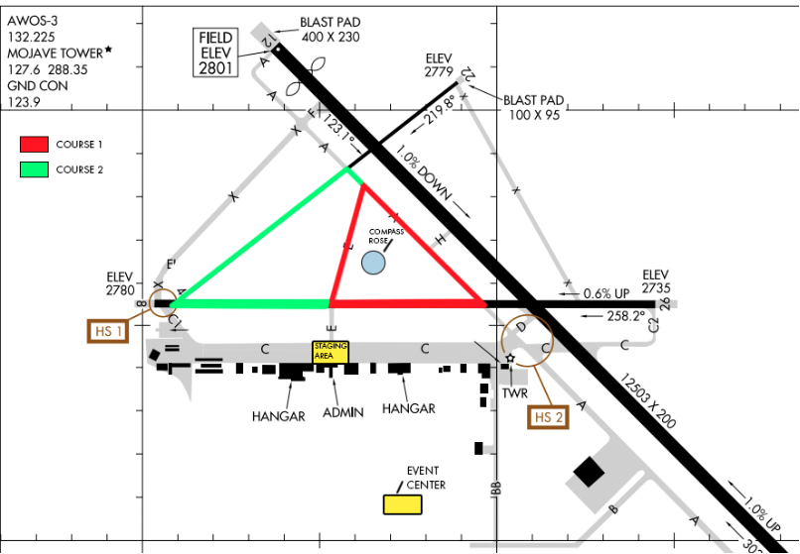

### Available Runway

* Rotocopters and VTOL vehicles will be taking off from and landing at the Compass Rose.
* Fixed-Wing UAS will be able to use the taxiway E, by the compass rose, as a runway.

### Flight Boundaries

UAS must stay within the Geofence Boundary defined by the coordinates below. This corresponds to the area defined within Course 1 and Course 2 defined above.

#### Geofence Bounds (LAT LONG):

The Geofence is defined by the four points in the following table:

|  |
| --- |
| Geofence: LAT, LONG |
| 35.05932281, -118.14901905 |
| 35.06495612, -118.15593094 |
| 35.06061838, -118.16267643 |
| 35.05932281, -118.16267643 |

* The GCS Display must
  + Show a map showing the flight boundaries and the UAS position.
  + Indicate the UAS speed and altitude.

### Radio Frequency (RF)

* The competition management will not provide any RF Spectrum Management
* Each team should expect other teams to be using similar equipment (e.g. same autopilot) and teams must ensure that they don’t allow invalid connections (e.g. connecting to another team’s autopilot).
* Teams found intentionally jamming or interfering with another team’s communications will be eliminated from the competition.

## Flight Qualification and Proof of Safe Flight

* Before the first flight, all UAS must qualify.
  + Before proceeding to Compass Rose to initiate flight, each team must demonstrate that Emergency Operations Software functions properly. This must be signed off by the PIC and recorded by the Field Event Manager.
* Immediately before first flight, the UAS must
  + Demonstrate it can take off and land safely.

## Flight Demonstration

### Mission Time and Order of Flights

* Order of flights will be established by the Field Event Manager.
* Teams must be ready for transportation to the Compass Rose at their appointed time.
  + If a team is not ready, they may lose their turn for that flight.
* After transportation to the Compass Rose, Teams will have 10 minutes to initiate flight.
* Teams will be 10 minutes to complete a flight (for each mission element).

### Target for Package Drop and Package Delivery

The target will be approximately 5 m in diameter. The target will be identified by a large red bullseye.

* 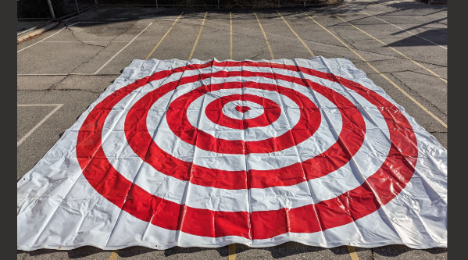Example:

### Flight/Mission Timing

#### Flight Start

Once the teams have assembled at the Compass Rose the Judge will announce, for each flight, the start time. Teams are expected to be ready to go when they arrive at the Compass Rose. UAS should be fully configured, in advance. Judges may allow some time to attach packages or change batteries between flights.

#### Flight Finish/Landing

The UAS will be required to land safely. Judge will determine the time of the completion of the flight and, if necessary, the UAS will be removed from the runway.

### Flight/Mission Definitions

#### Qualification Flight

Before the first flight, each UAS will give a demonstration of its ability to take off and land safely.

#### Waypoint Navigation Flight

Within the region defined by the flight boundaries, there will be as many as 7 waypoints defined.

* The UAS shall fly a path of its own determination passing each of the waypoints.
* The UAS shall complete the Waypoint Navigation Flight in less than 10 minutes.

##### Data Collection

* Teams must stream UAS GPS data to the Ground Control Station (GCS) and the GCS must record it for purposes of evaluating the Waypoint Navigation.

#### A group of colorful balls Description automatically generatedPackage Drop

* The UAS shall drop a package at a well-marked target.
* The package will be provided. It is a beanbag that weighs approximately 130g and is 6.4cm in diameter. An example may be found on amazon.com <https://www.amazon.com/dp/B07YSYLXR4?ref=ppx_pop_dt_b_product_details&th=1>
* The impact of the dropped package will not be measured.
* The time of the flight will be measured and factored into the score.

#### Package Delivery

The UAS will be required to deliver a package to a well-marked target.

* 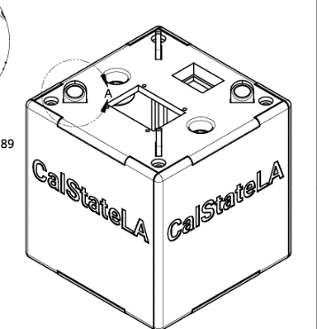The delivery package will be provided.
* The package is a 3D-printed cube. It is approximately 10cm along each side. The detailed description of the cube is posted on the competition website.
* The package will be equipped with accelerometers to measure impact of the delivery. The maximum impact is forthcoming.
* The UAS shall complete the Package Delivery Flight in less than 10 minutes.

#### Target Localization

* Several items will be placed in specified region within the geofence. The UAS will have 10 minutes to identify, classify and localize the targets.
* The targets are Ground Control Points (GCP) used for surveying by drones. They are approximately square. There will be between three and four GCP of approximately 1.2m along a side defining an area in which there will be 5-10 square targets of approximately 0.6 meters along a side. These smaller targets will need to be localized individually and will all have black numbers in one of the white sections.
* You can see examples of the targets on Amazon.com

<https://www.amazon.com/dp/B07PHPFPJ3?ref_=pe_84950070_737224720&th=1>

1.2 meter GCP 0.6m GCP

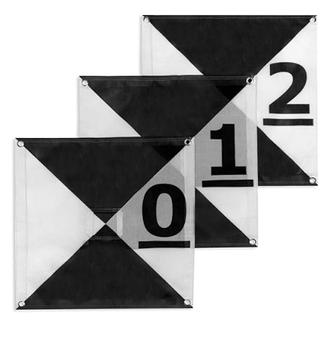

#### Score for Flight Evaluation

The score for the flight evaluation event will be composed of scores measuring:

* the accuracy in which the UAS navigates the course defined by a set of waypoints within an allotted time
* the accuracy in which the UAS drops a small package to a marked target and the time it takes to make the delivery
* the accuracy in which the UAS delivers a small package to a marked target and the impact force of that delivery within an allotted time
* the completeness and correctness of the identification, classification and localization of targets in a specified area of the field within an allotted time

In the following section, details for each of the tasks, and how the UAS performance will be scored, are provided.

#### Total Score

The total score for each team will be the sum of the scores for the missions specified below.

##### Waypoint Navigation Score

* X = square root of sum of squared errors between waypoints and corresponding closest point on UAS path as measured by GPS system.
* M = mean value of X collected from each of the competitors
* S = square root of sum of squared errors collected from each competitor
* The score is then calculated: Z = 10 - (X – M)/S
* The minimum score is 0
* If the UAS does not safely land within the allotted time, the score will be 0 and the value of X will not be used in the computation of the score for other teams.

##### Package Delivery Score

The package delivery will be based on the Package Delivery Accuracy provide that:

* The Package Delivery Impact Force is within the limits defined by the competition
* The package is delivered withing the allotted time.

###### Package Delivery Accuracy

* X = distance of location of dropped package from location of target center
* M = mean value of X collected from each of the competitors
* S = square root of sum of squared errors collected from each competitor
* The score is then calculated: Z = 10 - (X – M)/S
* The minimum score is 0
* If the UAS does not safely land the score will be 0 and the value of X will not be used in the computation of the score for other teams.

##### Package Drop Score

The package drop score will be the mean of the Package Drop Accuracy Score and the Package Drop Time Score specified below.

###### Package Drop Accuracy

* X = distance of location of dropped package from location of target center
* M = mean value of X collected from each of the competitors
* S = square root of sum of squared errors collected from each competitor
* The score is then calculated: Z = 10 - (X – M)/S
* The minimum score is 0
* If the UAS does not safely land the score will be 0 and the value of X will not be used in the computation of the score for other teams.

###### Package Drop Time

* X = the recorded time of flight of the UAS for this mission
* M = mean value of X collected from each of the competitors
* S = squareroot of sum of squared errors collected from each competitor
* The score is then calculated: Z = 10- (X-M)/S
* The minimum score is 0
* If the UAS does not safely land, the score will be 0 and the value of X will not be used in the computation of the score for other teams.

##### Identification, Classification and Localization Score

* Maximum Score will be 10.
* Teams will lose 1 point for each target for which the UAS failed to identify, classify, or localize properly.

## Caution: Impact of Heat and Wind

It can be hot and windy at Mojave Air & Space Port. In 2024 the density altitude at the time of the competition was 6500 ft (1980m) and there were winds at times gusting to 14 kts. The teams need to design their UAS to accommodate the environment.

# Design Competition

In addition to the documentation required from each to for purposes of demonstrating flight qualification, teams are encouraged to submit more design documentation to demonstrate the quality and creativity of the work they have performed. There will be a design and innovation prize awarded based on this documentation.

## Rules Governing Design Team and Design Competition Entries

* All Design Team Members shall be members of the Development Team.
* All design competition entries must also be entries in the Flight Competition.
* All design, analysis, and fabrication of the competition entry is the sole responsibility of the student team members.
* All design work must be performed by undergraduate or graduate students enrolled during at least one of the preceding Fall, Spring, or Summer terms at an accredited college or university.
* Designs may include commercial off-the-shelf parts but the integration of these parts and the design of the overall system, including hardware and software, must be done by the design team.
* Students may only participate on a single team. Faculty advisors may advise more than one team.

# Score for Design Competition

The score for the Design Competition will be based on several factors and evaluated by a panel of judges from industrial and academic partners.

Judges will evaluate:

* Well formulated engineering processes, analysis, and methodology
* Well described engineering design features
* Well described manufacturing processes
* Innovation in processes or materials
* Innovation in aircraft configuration, aerodynamics or structure
* Innovation in control systems, autonomy or computer vision
* Innovation in package-delivery system