Instructions to Download and Access ArcGIS Pro
To download ArcGIS Pro software:
- Log in to the CSULA ArcGIS webpage using “Cal State LA SSO” with your MyCalStateLA ID account
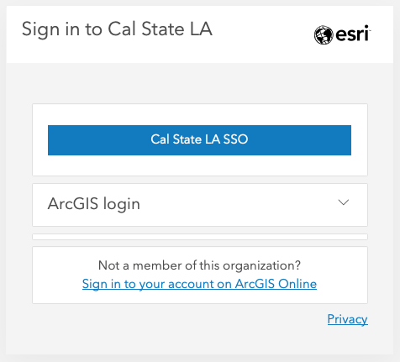
- Click “My settings” > click “Licenses” > click “Download ArcGIS Pro”
- Download and install the software
To access ArcGIS Pro software:
- Open ArcGIS Pro software, click Sign in
- Follow the Steps 1, 2, 3 to log in

Step 1
Expand organization’s URL
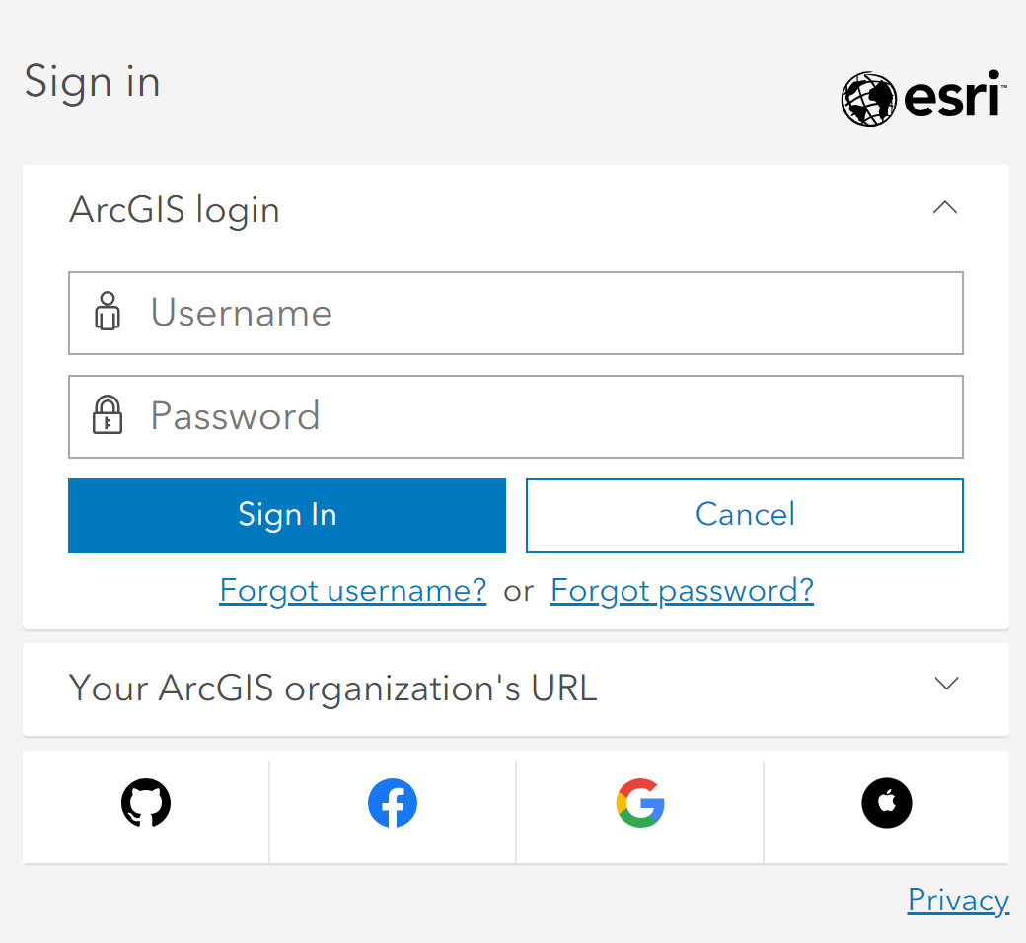
Step 2
Enter “csula” as the org
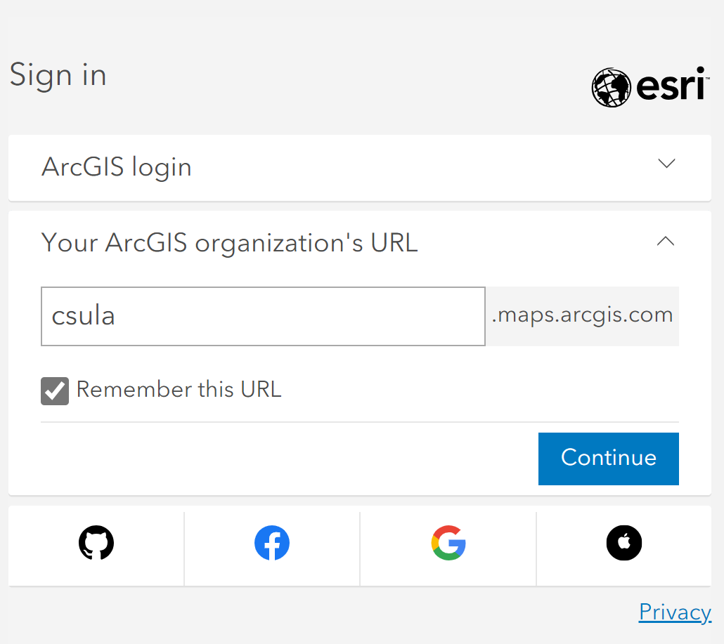
Step 3
Select Cal State LA SSO and enter your credentials
