Instruction:
[1] Select a template that works for your course. Delete the unwanted templates.
[2] Directly work on the selected template, draft in Outline Format.
[3] Copy and paste the draft table to Curriculog.
[4] Define the column widths in Curriculog:  Right click, choose table properties, and adjust the table width to 100%.  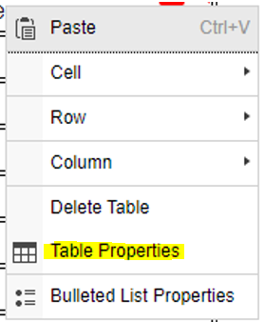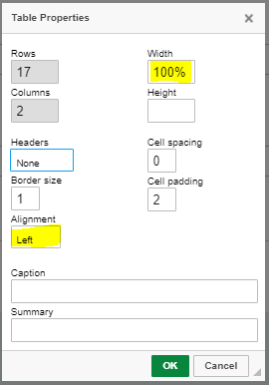 | Move the cursor to the Intended Week cell, right click, choose Cell, then Cell Properties.  Move the cursor to the Topic cell, right click, choose Cell, then Cell Properties.  (set 12% for Intended Week column) (set 80-88% for the Topic column)  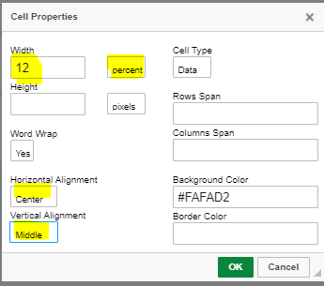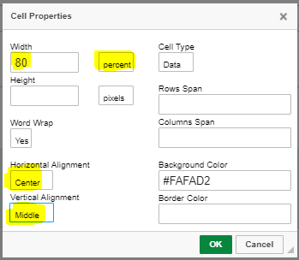  Or split the 88% when multiple columns will be used. Please refer to each template for recommended percentage.
[5] Do not upload the template to your proposal. Attachments on proposal WILL NOT be exported to the database.
Template A (define the column widths: 12% for the intended week column, 88% for the Topics column)
Intended Week | Topics / Content
1
2
3
4
5
6
7
8
9
10
11
12
13
14
15
Signature Assignment or requirement (optional, leave blank if not applicable)

Template B (define the column widths: 12% for the intended week column, 44% for the Topics column, 44% for the Lab column
Intended Week | Topics / Content | Lab / Activities
1
2
3
4
5
6
7
8
9
10
11
12
13
14
15
Signature Assignment or requirement (optional, leave blank if not applicable)

Template C (define the column widths: 12% for the intended week column, 36% for the Topics column, 26% for the Reading column, 26% for the Assignment column)
Intended Week | Lecture Topics / Session Objectives | Readings / Materials | Report / Project / Assignment Due
1
2
3
4
5
6
7
8
9
10
11
12
13
14
15

