DEVELOP A NEW PROGRAM
Projected Degree Proposal Template
Title of Projected Degree | Click or tap here to enter text.
Degree Designation (e.g., BS) | Click or tap here to enter text.
Projected Implementation Date | Click or tap to enter a date.
Campus | California State University, Los Angles
College | Choose an item.
Department | Click or tap here to enter text.
Contact Name(s) and Email(s) | Click or tap here to enter text.

- Delivery mode of program: Face-to-Face ☐ Hybrid ☐ Online ☐
- Support Mode: State-Support ☐ Self-Support ☐
- A brief summary of the purpose for and description of the projected degree:
Click or tap here to enter text.
- List the projected program learning objectives:
Click or tap here to enter text.
- Proposed CIP code: Click or tap here to enter text.
- For new degree programs that are not already offered in the CSU, provide a compelling rationale explaining how the proposed subject areas constitute a coherent, integrated degree program that has potential value to students and that meets CSU requirements for an academic program at the undergraduate or graduate level.
Click or tap here to enter text.
- The projected program’s fit with the campus mission and strategic plan:
Click or tap here to enter text.
- Provide projections in the table below and identify the evidence you have used to make these projections (e.g., US Bureau of Labor Statistics).
Anticipated student demand | At Initiation | After 3 Years | After 5 Years
Number of Majors (Annual) | Click or tap here to enter text. | Click or tap here to enter text. | Click or tap here to enter text.
Number of Graduates (Cumulative) |  | Click or tap here to enter text. | Click or tap here to enter text.

Evidence:
Click or tap here to enter text.
- Workforce demands and employment opportunities for graduates:
Describe the demands and opportunities, as well as the evidence you have used to make these claims.
Click or tap here to enter text.
- Other relevant societal needs:
Click or tap here to enter text.
- An assessment of the required resources and the campus commitment to allocating those resources: Provide a narrative description of resources that will be needed at initiation, after three years, and after five years. Note: Approval of this proposal by campus entities represents the campus commitment to allocating these resources.
Click or tap here to enter text.
- a. Description of Campus Approval Process:
The approval workflow is completed on Curriculog with these steps:
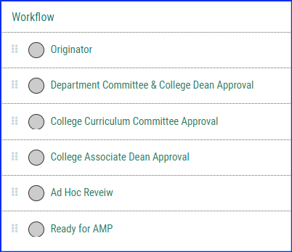
b. Approval Signatures:
Curriculog requires Single-Sign-On.

