**Creating a Private SharePoint team site**

1. Login to your [MyCalStateLA Portal](https://csula.sharepoint.com/sites/MyCalStateLA/).
2. Click on the Waffle icon at the top left corner of the page.

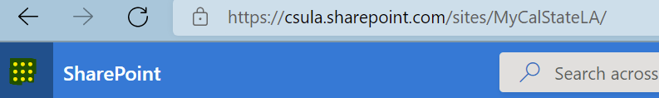

1. Click on the SharePoint icon. You may need to click on the “All apps 🡪” link if SharePoint is not displayed under **Apps**. You will then be redirected to SharePoint.

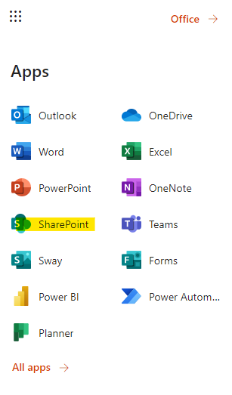

1. At the top left corner of the page, click on the “+ Create site” button.

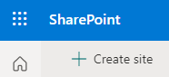

1. The “Create a site” pop-up will show on the right side of the page. Click on “Team Site”.

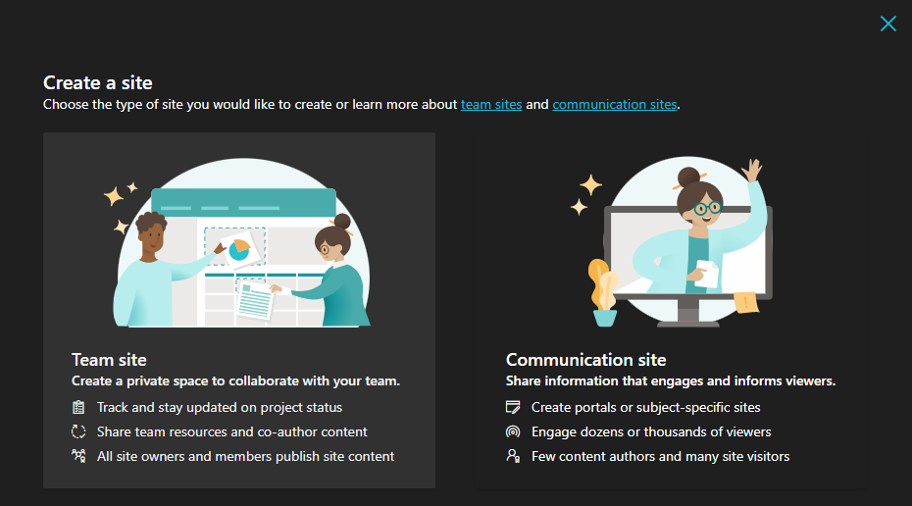

1. Continue creating the private team site by typing in any site name you prefer, and the following settings will show up.

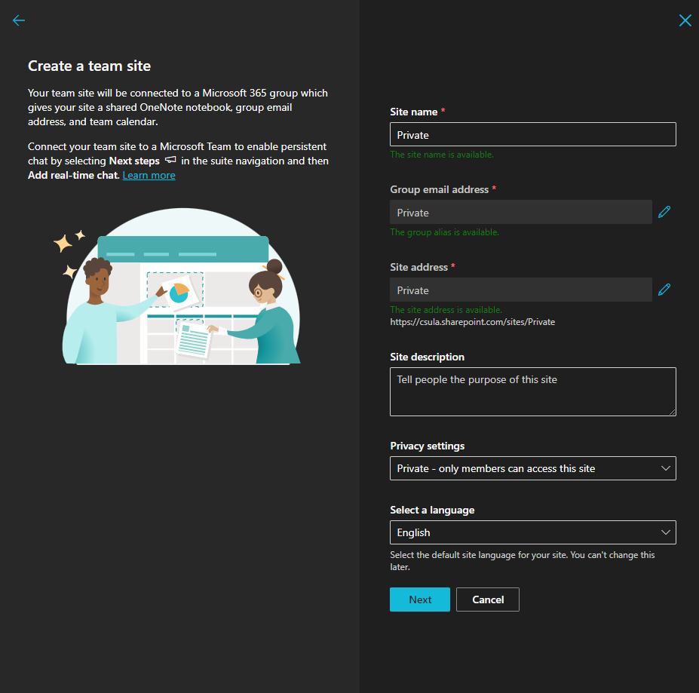

Ensure that **Private** is set under Privacy Settings. Setting the site to Public will allow others to search for your site.

1. Click the “Next” button to continue.
2. It will then ask you to add members to the private site. If others need to view the sensitive documents that you put in the site, you may add them here. Otherwise, click “Finish” to have the site private to yourself only.

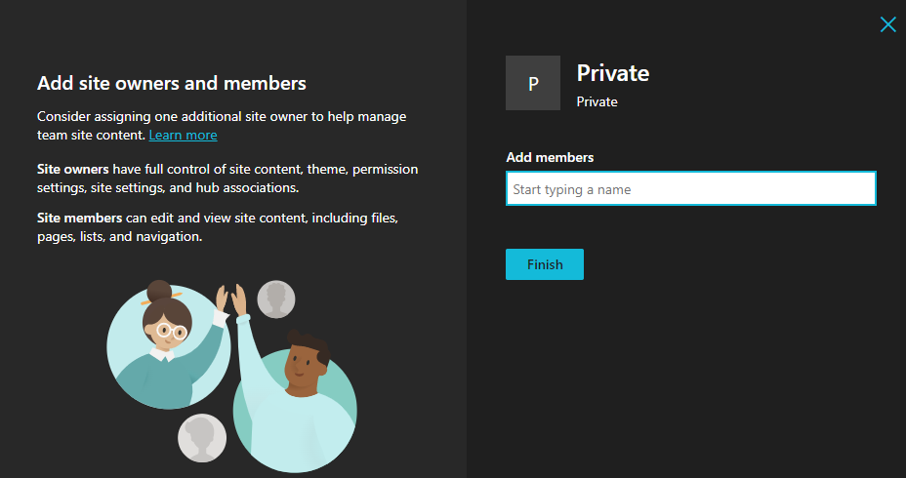

1. You have successfully created a Private team site. It will automatically redirect you to the site’s home page.

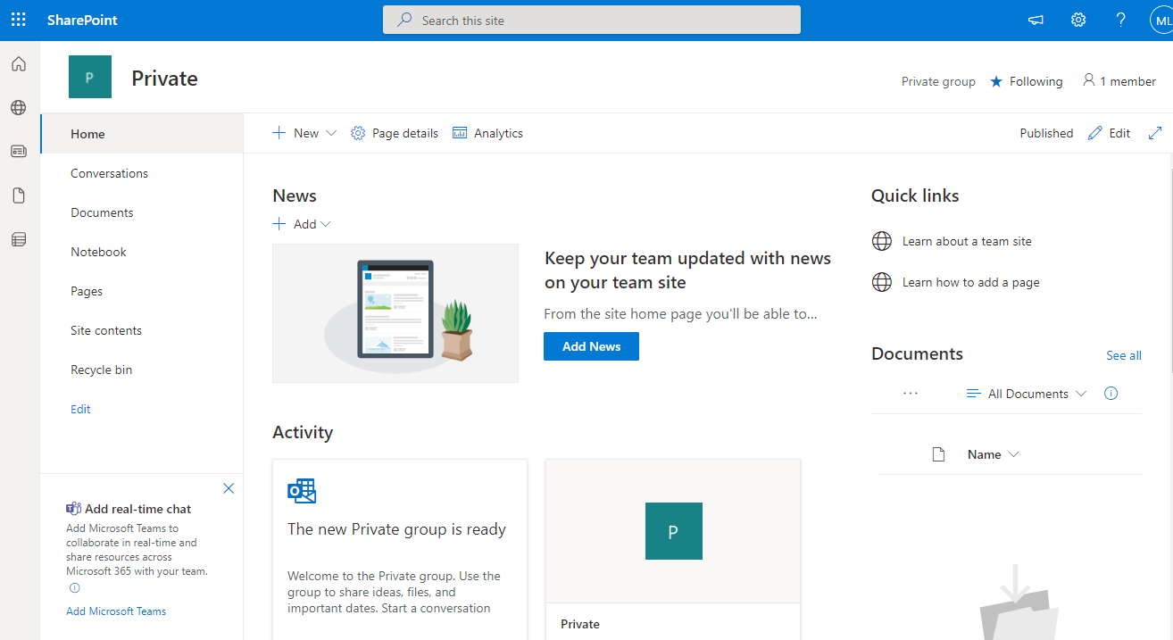

1. Upload all the sensitive data files into the Documents section and delete them from your workstation. Any member of the team site can view the documents.   
   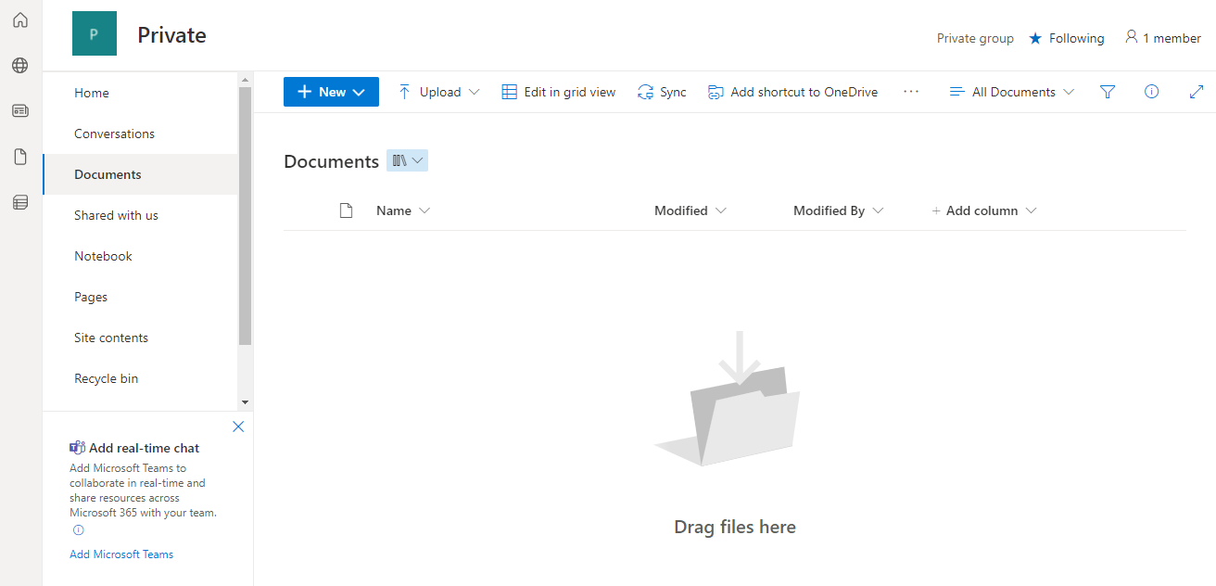

By doing this, you are keeping sensitive data off your workstation and into the cloud. Thank you for your cooperation!

|  |  |
| --- | --- |
|  | **IT Security & Compliance** [**ITSecurity@calstatela.edu**](mailto:ITSecurity@calstatela.edu)**California State University, Los Angeles 5151 State University Drive Los Angeles, CA 90032 T 323.343.2575** [**calstatela.edu**](http://www.calstatela.edu/) **|  *Pushing Boundaries*** |