How to connect MAC remotely.

- Connect VPN using the student account.
- From the web browser, open CalStateLA Remote Computer Access
- Click “Annex Link Mac” then click “Connect” button on OL-STE191-MA1.local”
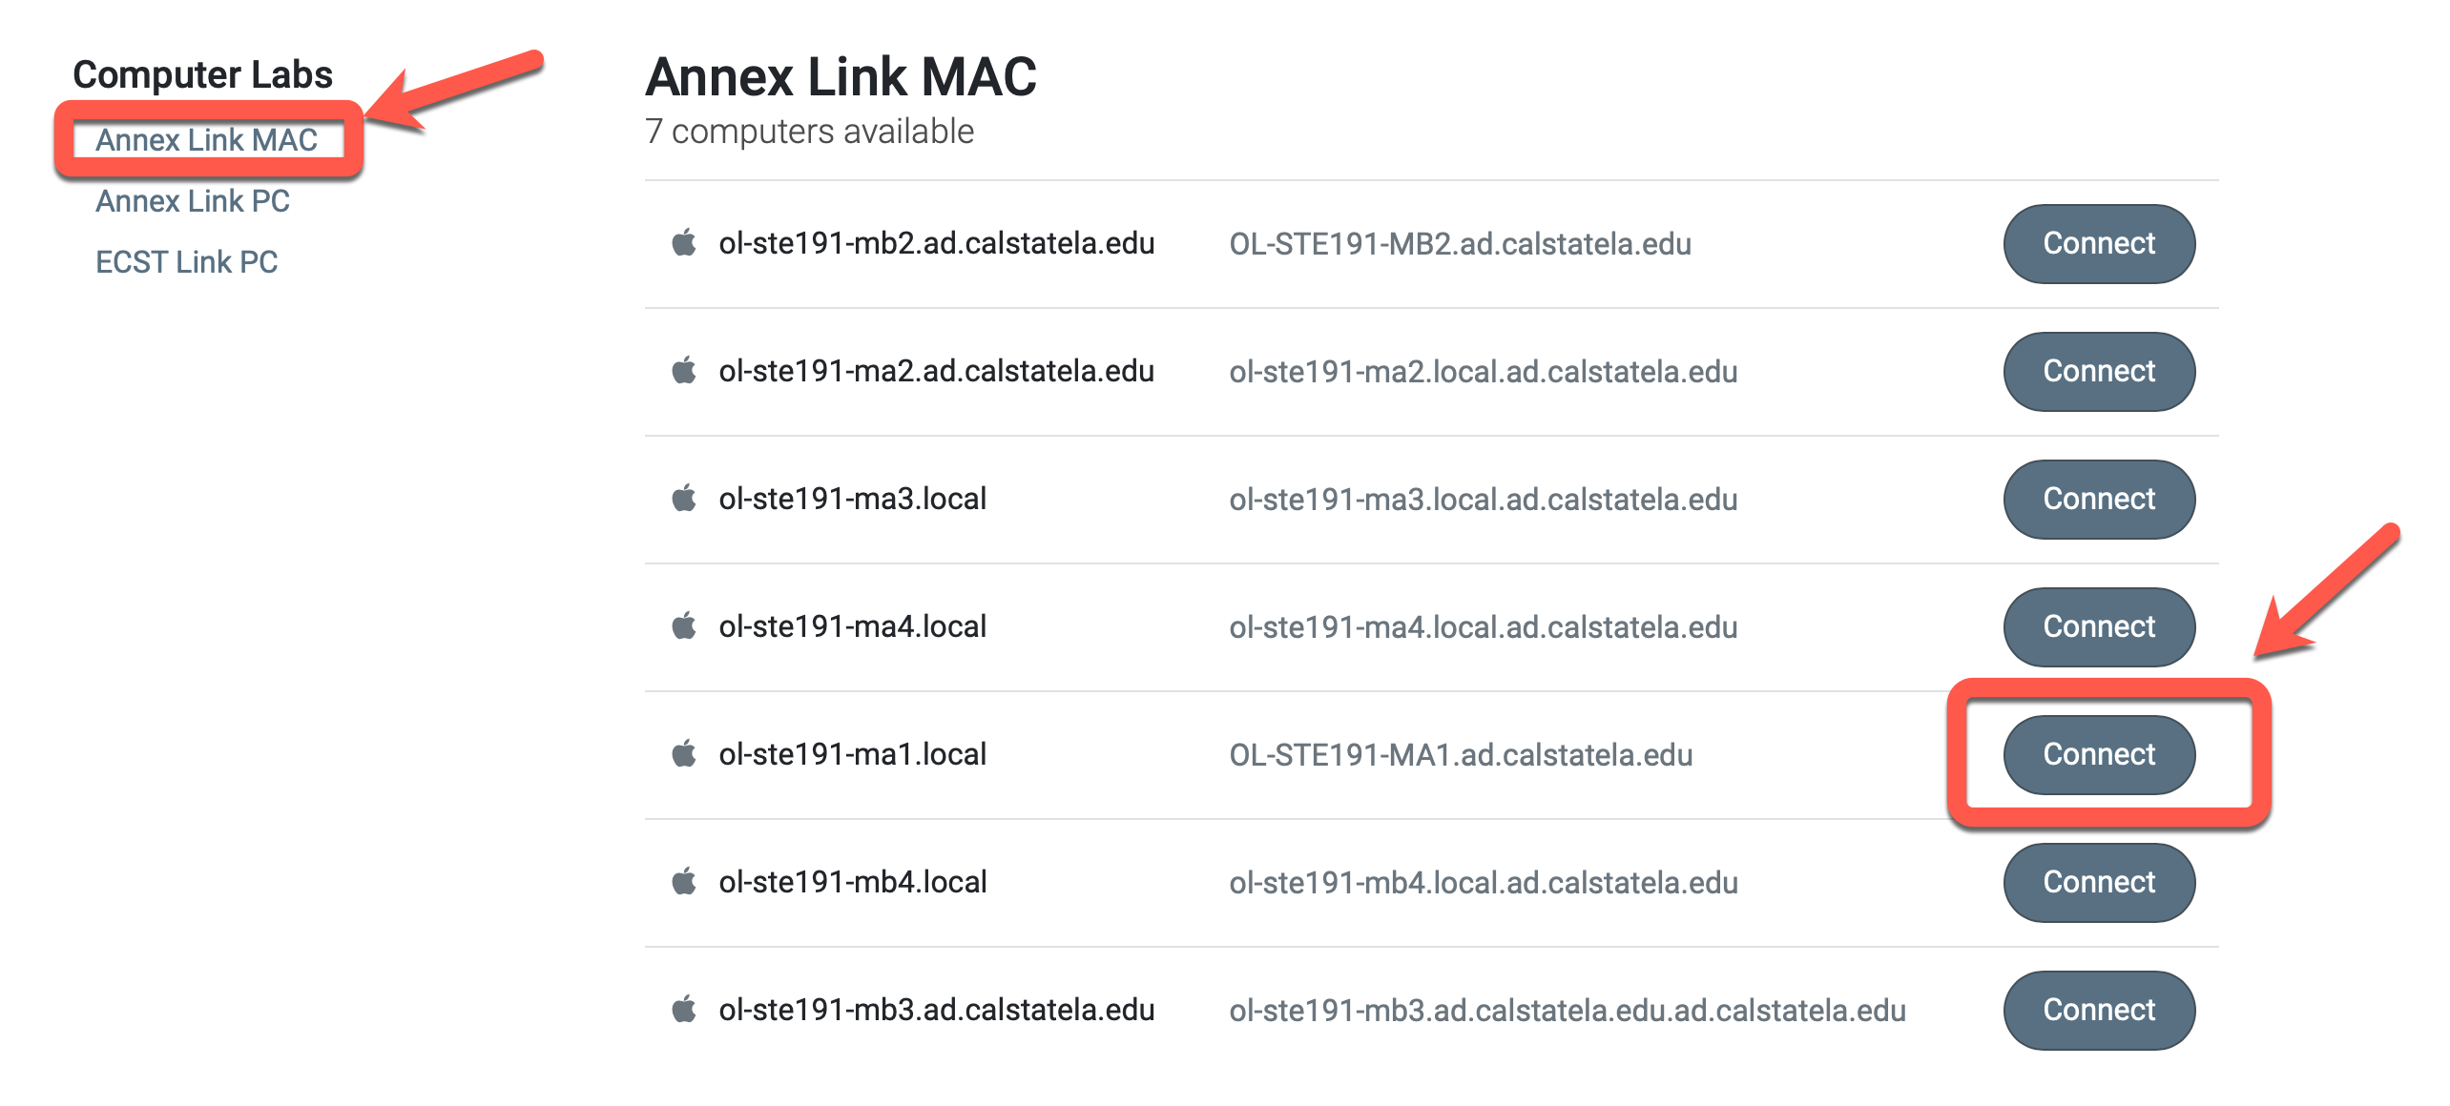
- On the following window pops up.

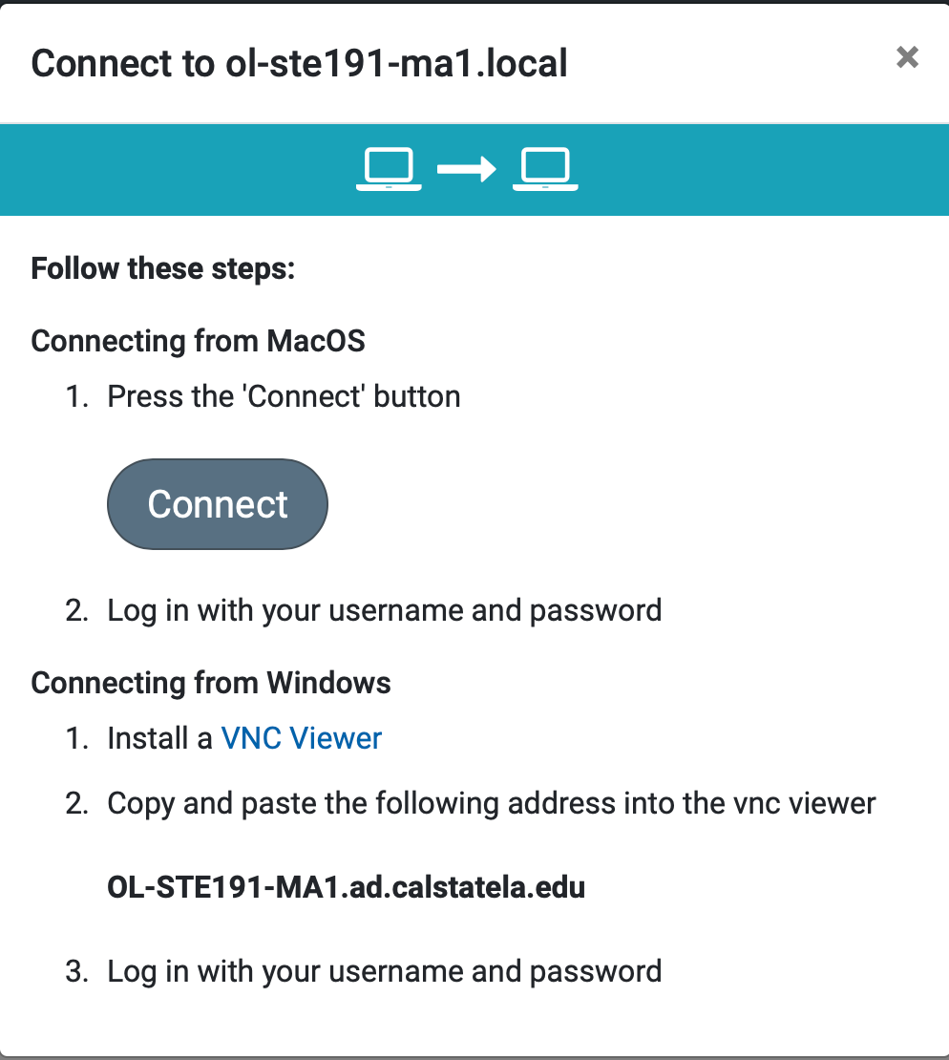

If you are using Mac, click “Connect” button.
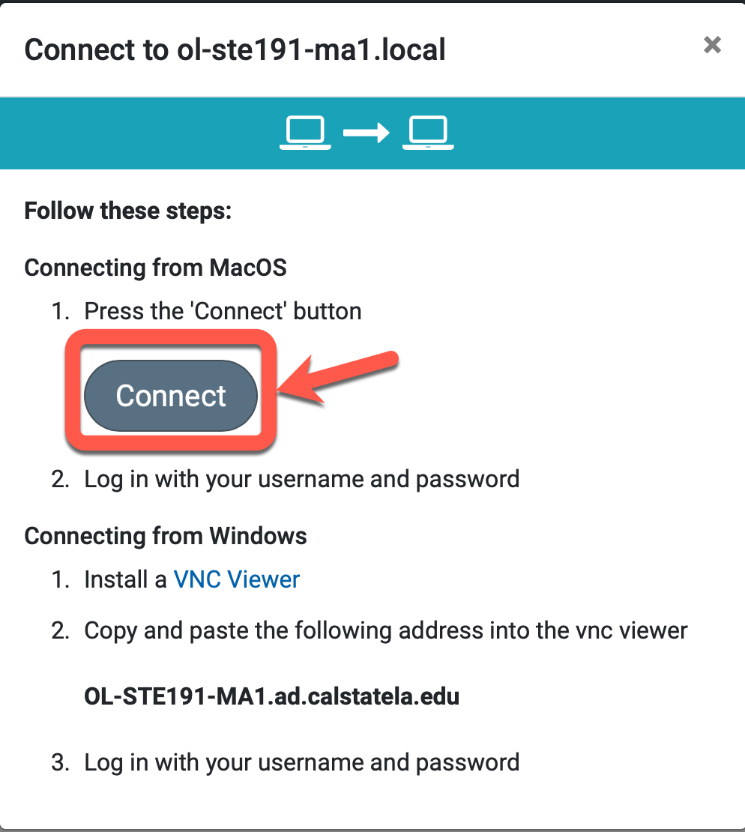

Click allow to run the screen sharing.

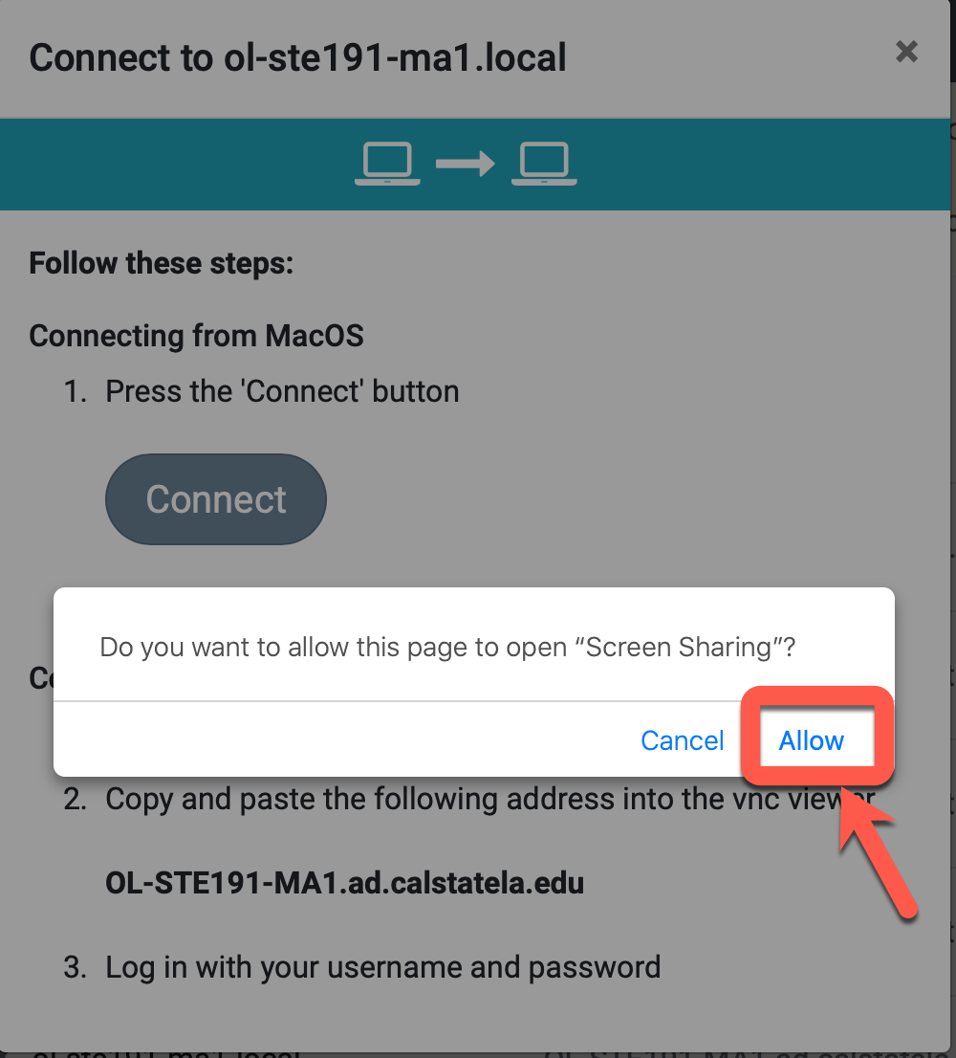

Type campus user id and password to connect the Mac. Then press “Sign in” button.
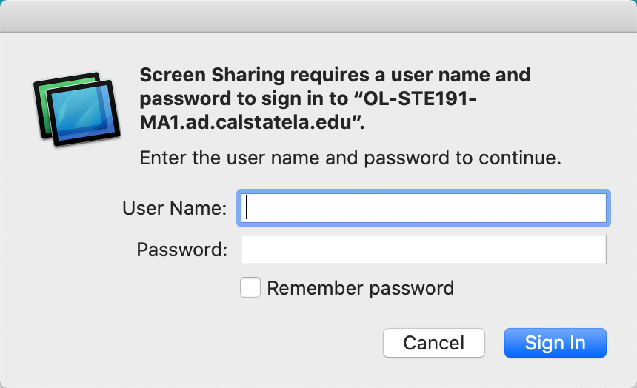

After making the connection, remote Mac’s screen shows up in Screen Sharing.
Log on to the Mac using campus user id and password to use the Mac.

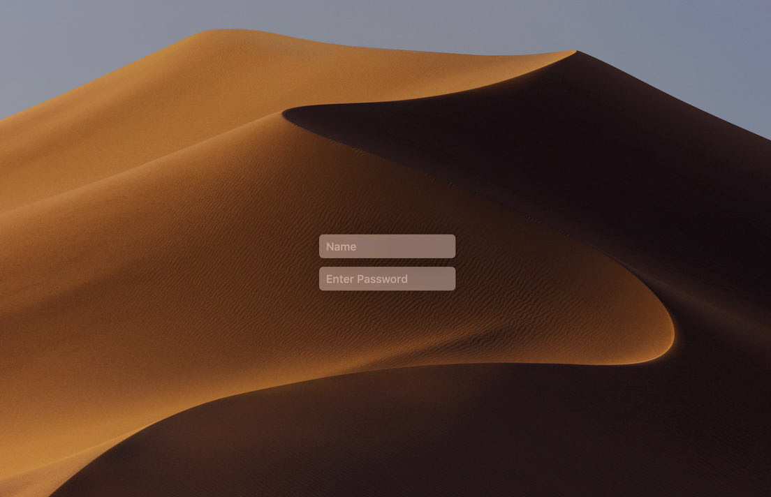

If you are using the Window, click the VNC Viewer link to install the VNC Viewer.

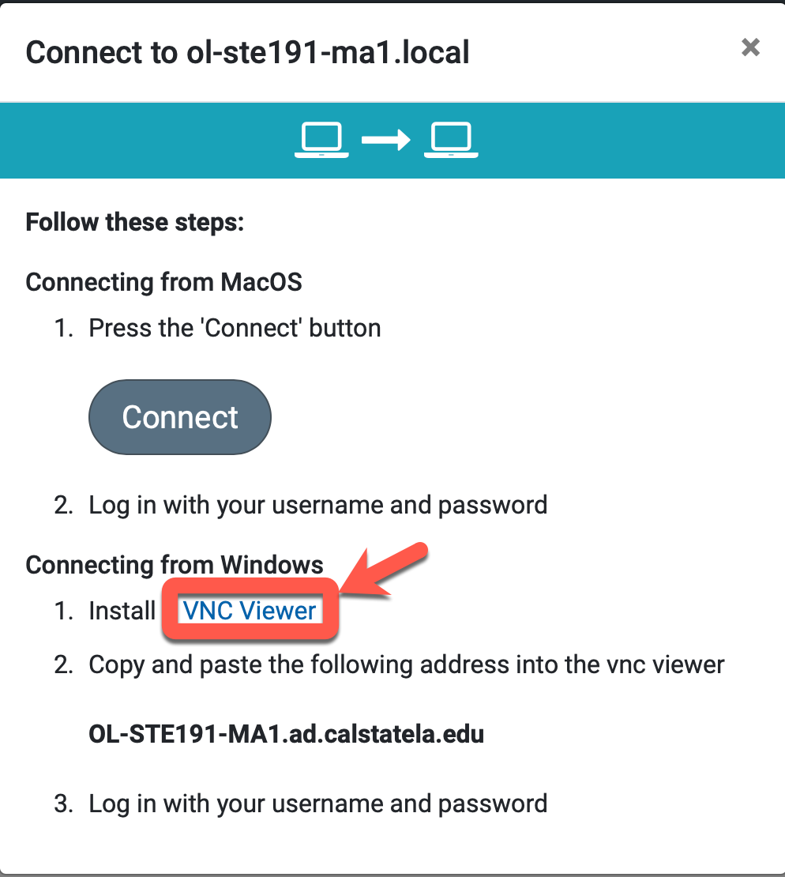

From the VNC page, click download button and install the VNC viewer.

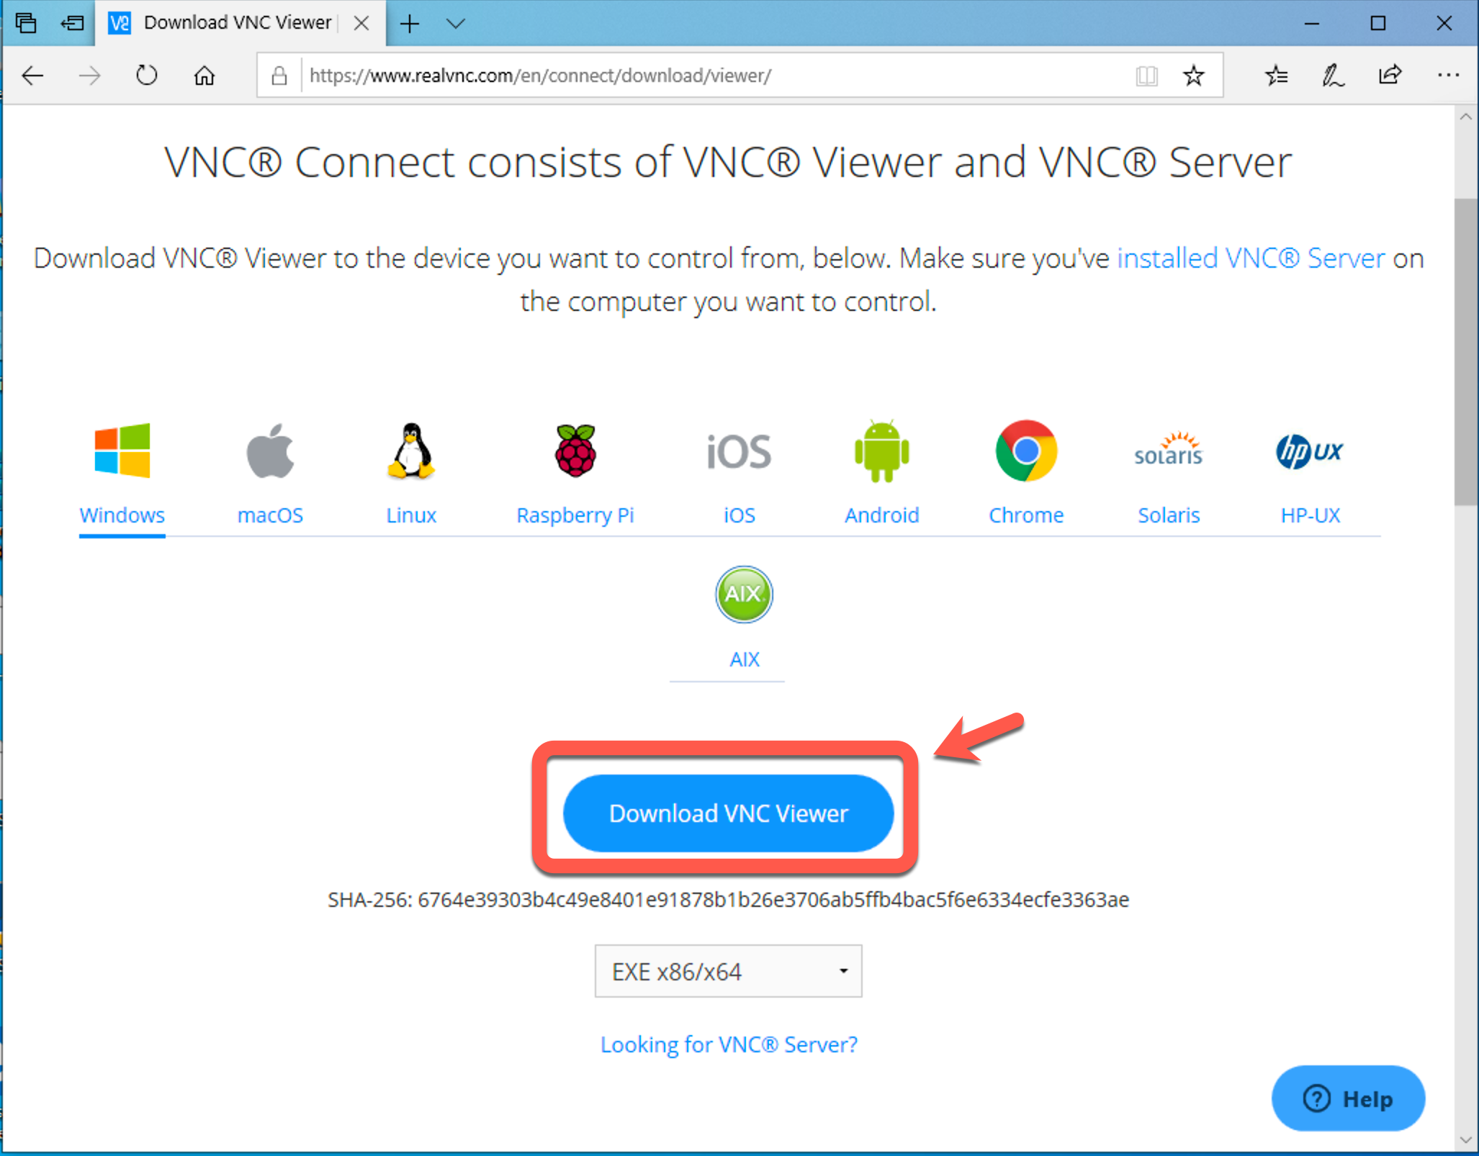

After finish installing the VNC viewer, launch the VNC viewer.
Click File New connection.
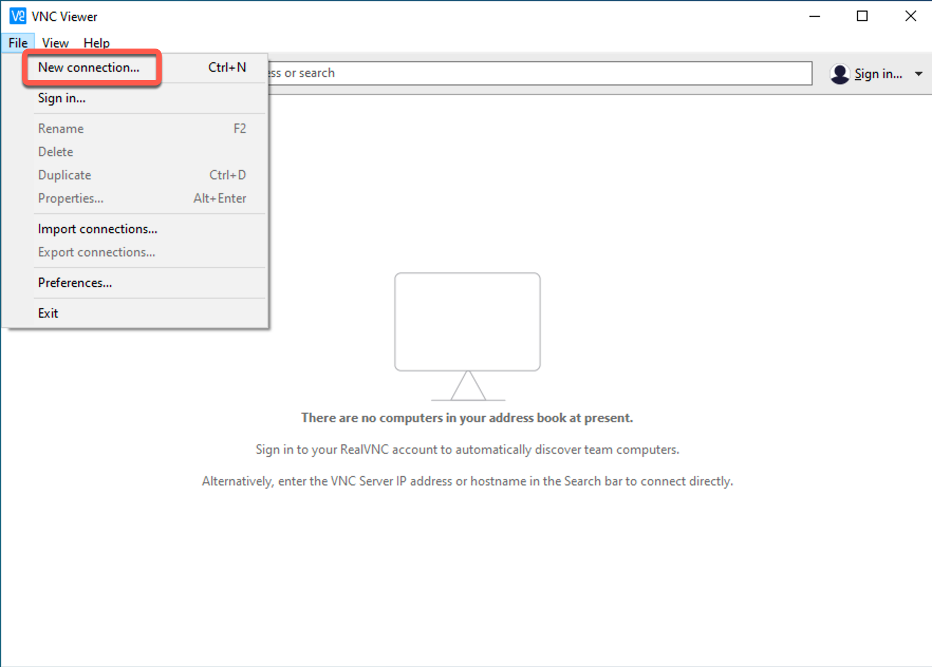

Copy the host name.
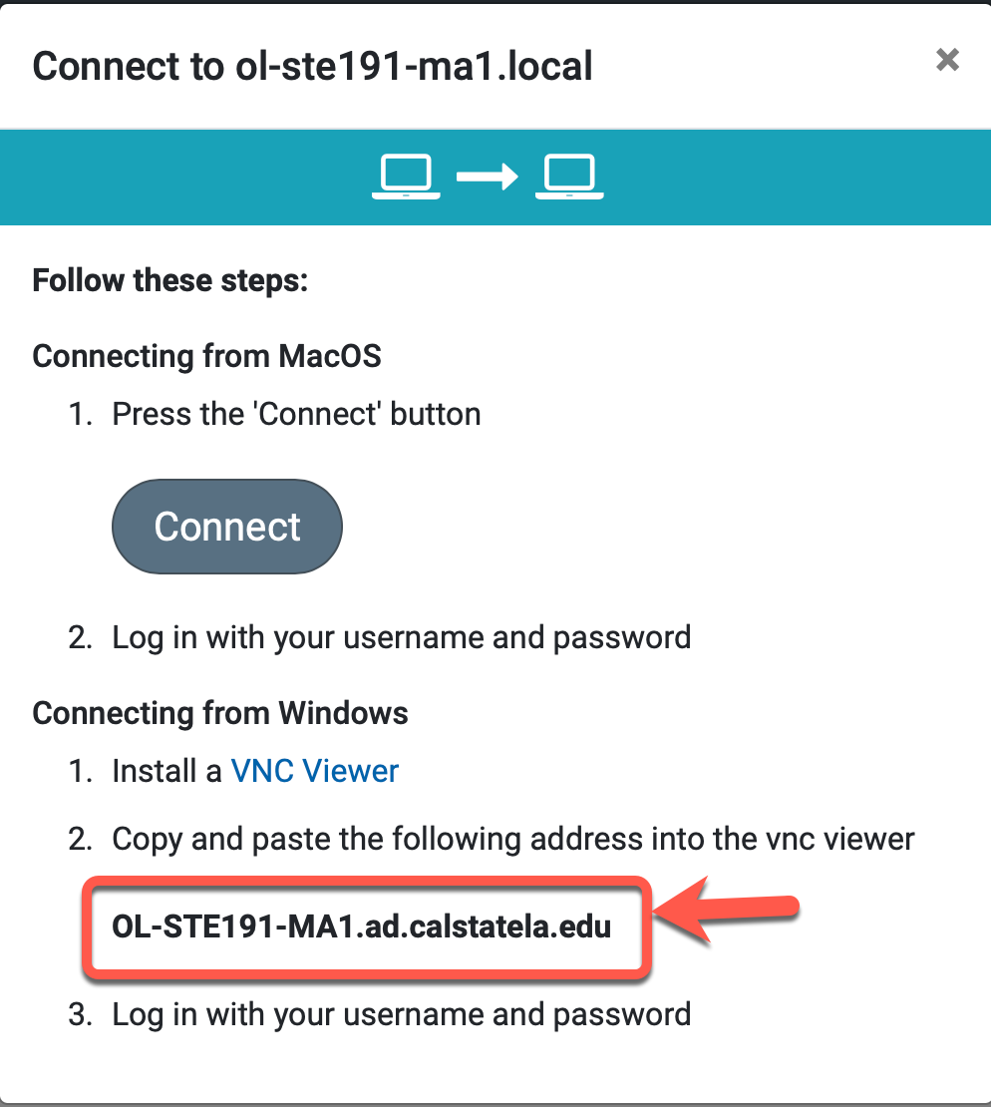

Paste it into the VNC server and press OK.
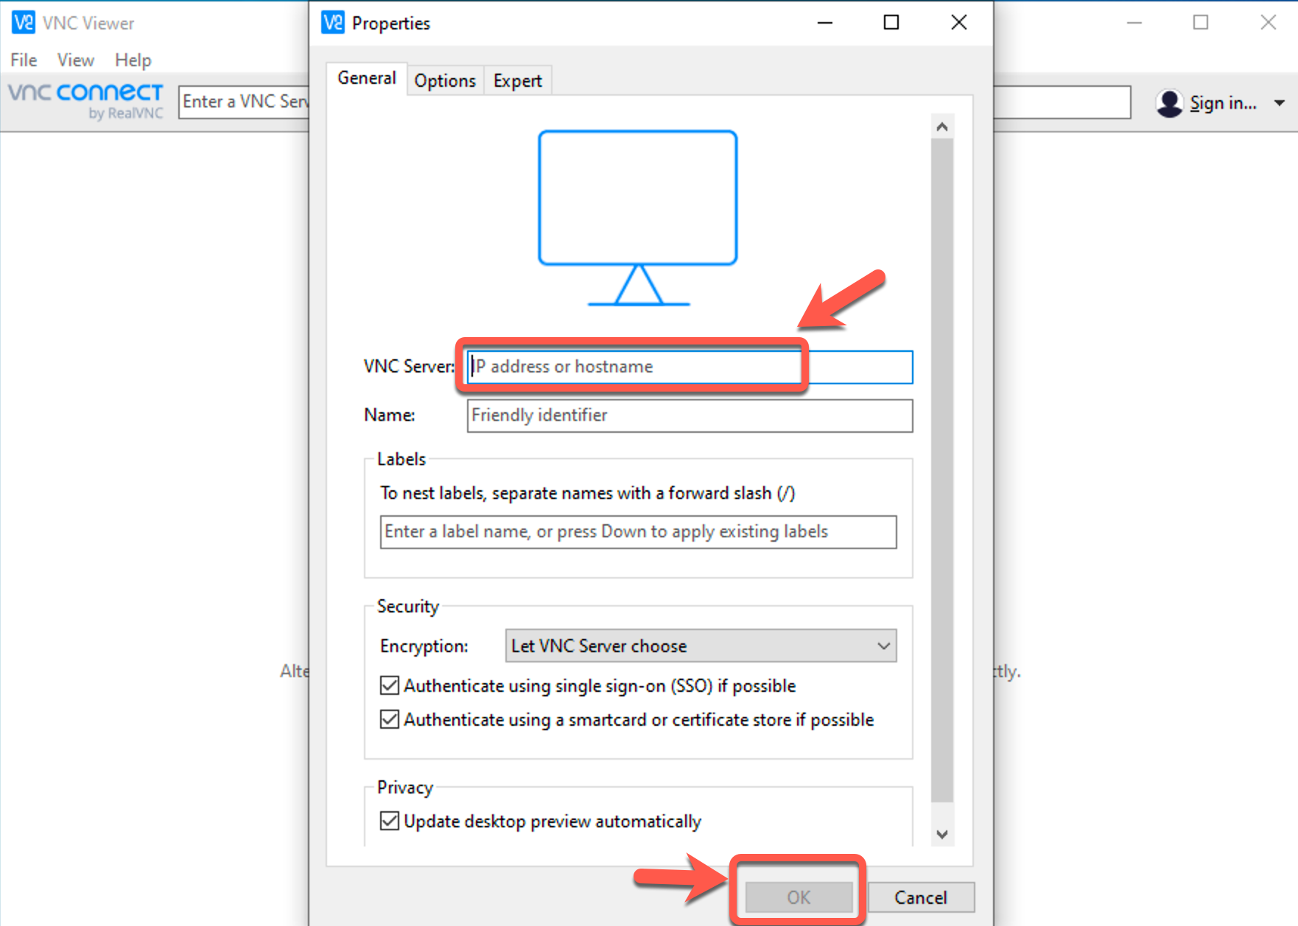

Double click the host in VNC viewer to make connection.

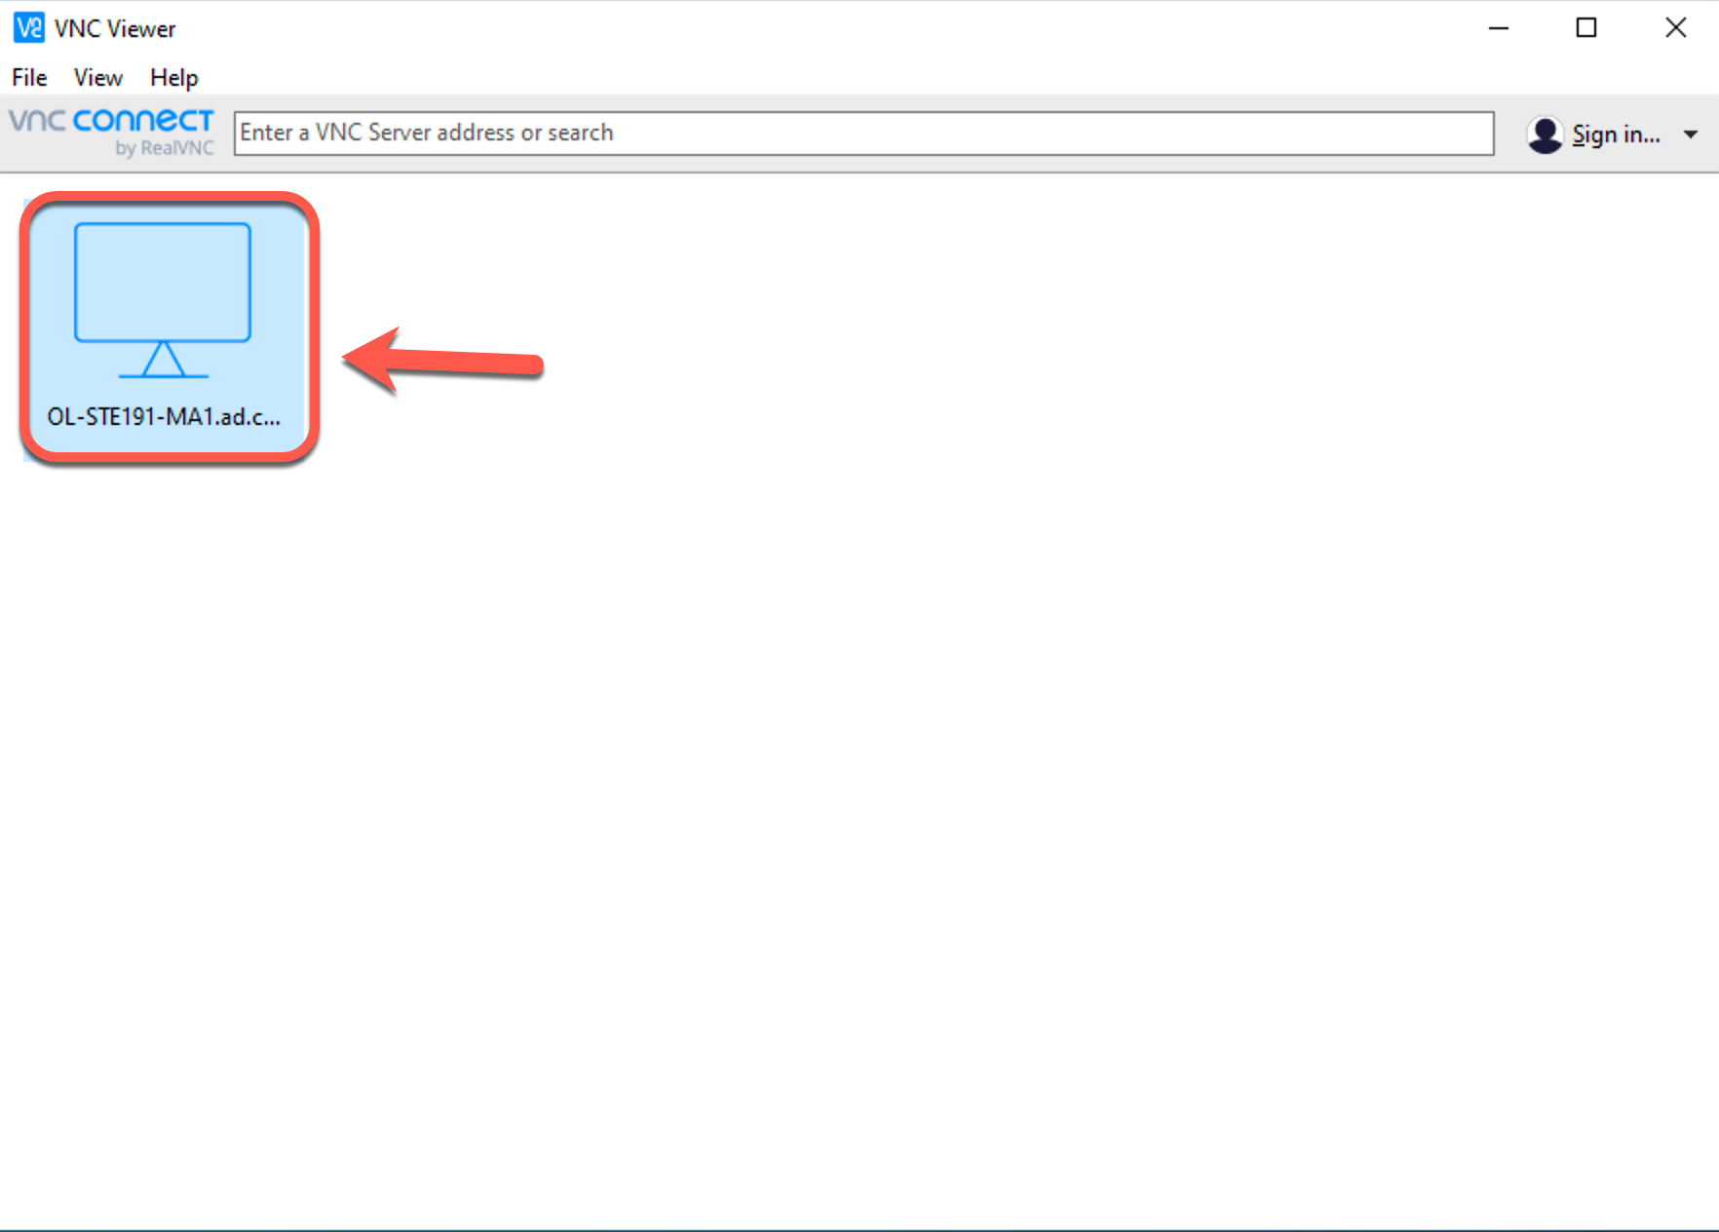

Check the box on “Don’t warn me about this again” and click “Continue”

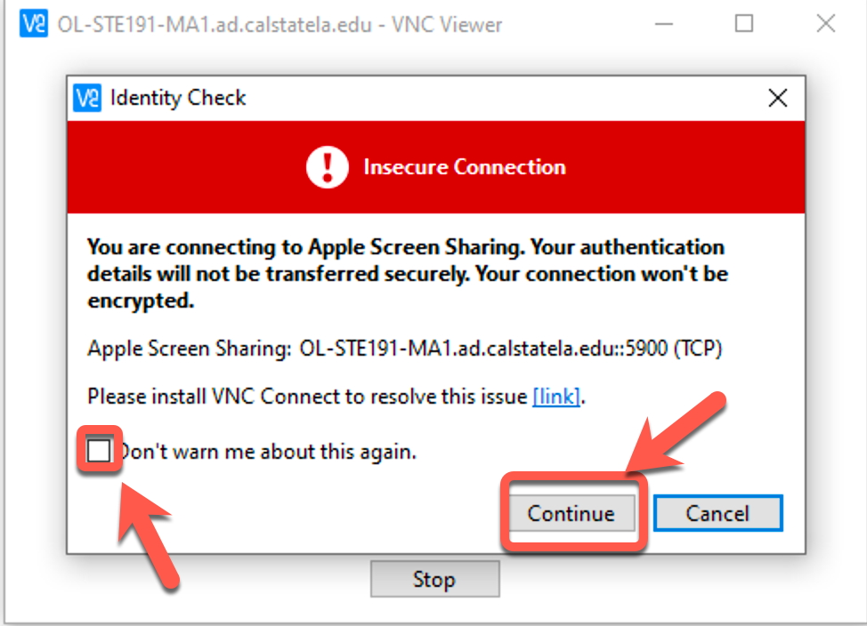

Type user name and password, then press “OK”

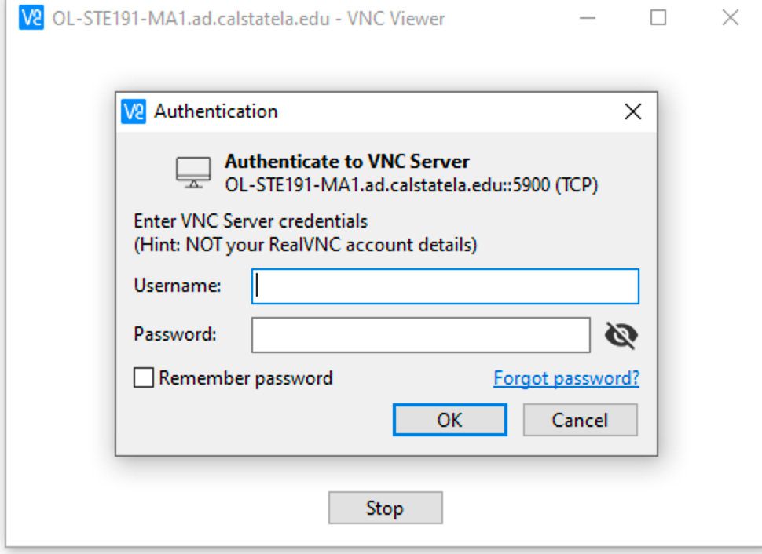

The remote MAC screen shows up, type user name and password to log on the Mac.

