Instructions for Completing, Sharing, and Forwarding

DEAN RTP Periodic/Lecturer Reviews

The Dean is the person designated in Interfolio as the manager at your level of review. You are responsible for:
- Completing the form in Interfolio
- Sharing the report with the candidates
- Forwarding the case to the next level

  - Enter the case the same way you would to review the file.
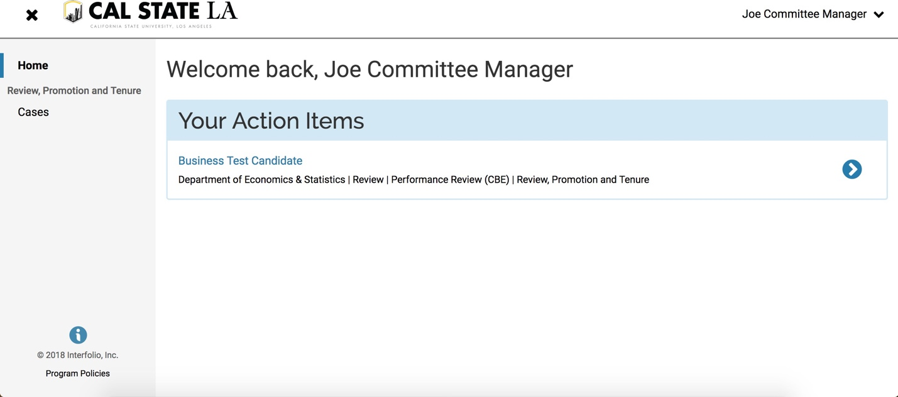

  - Click on “Case Details”.
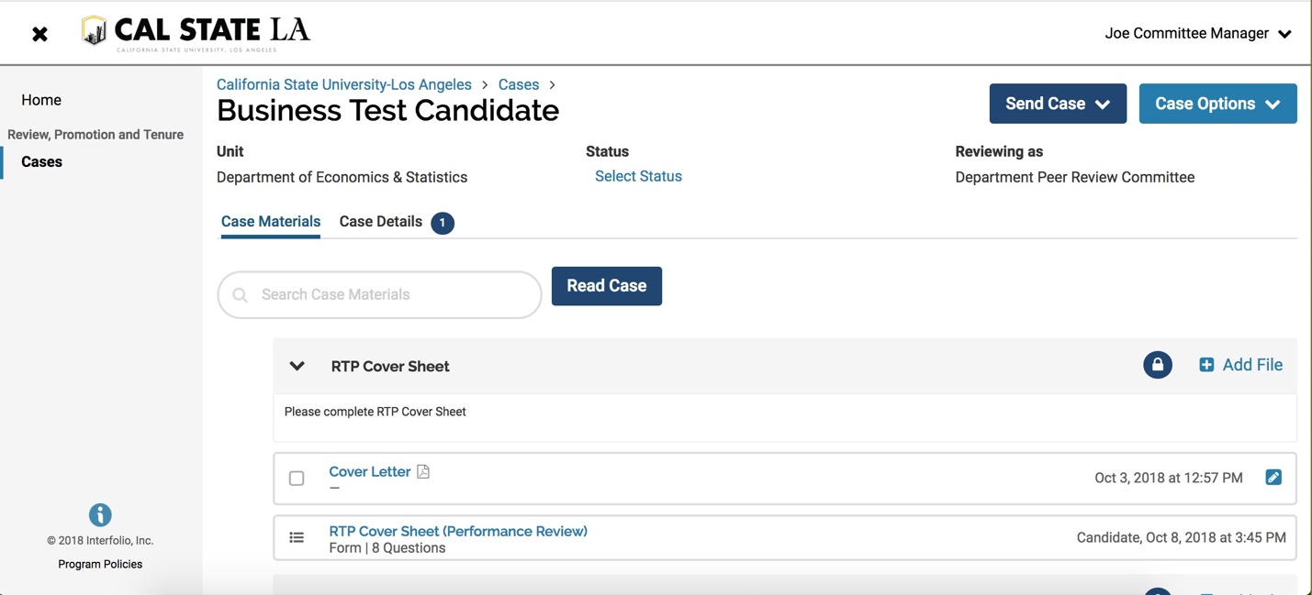
  - Under required documents, you will see a place to fill out a form. Click on “Fill Out Form.”

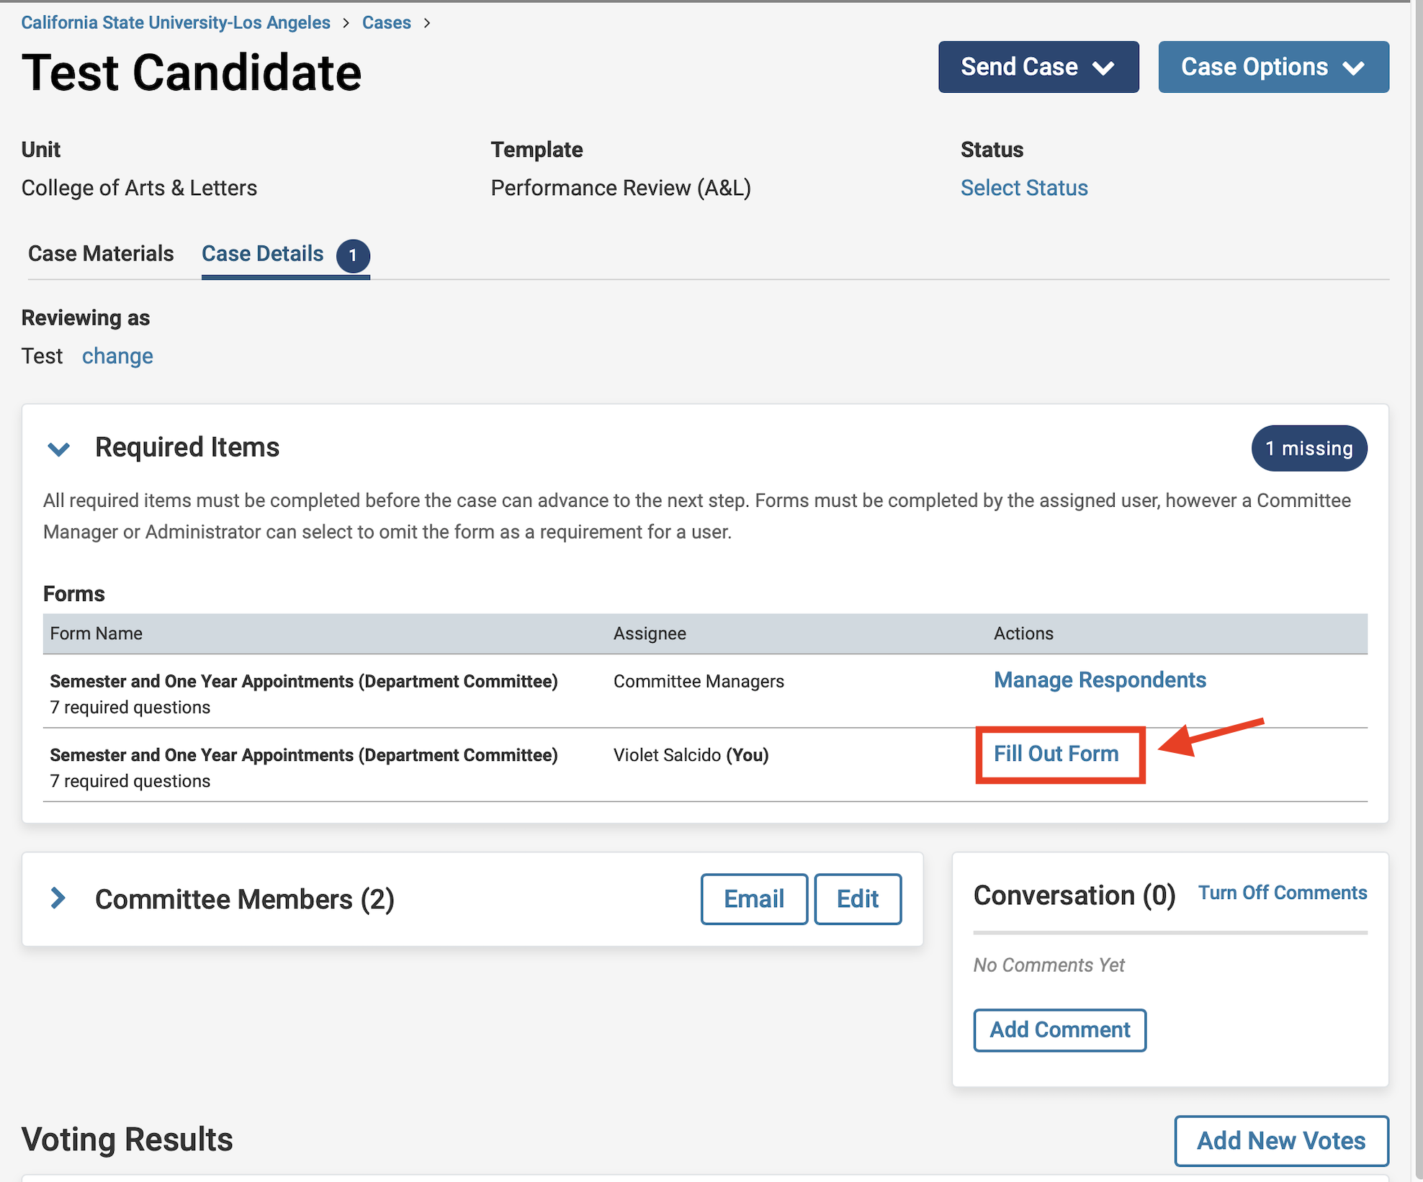

  - If you want to cut and paste from an existing document, you will have to use “CTRL + V” to paste it in the Interfolio form. You cannot paste tables.
- Please keep in mind that there is an 8000 character limit in each section and 10,000 overall. If you have more than 8000 characters in a section, you will need to contact Faculty Affairs. We will remove the form requirement and you will need to upload the document.

  - After you finish completing the form, click on “Submit Form”.

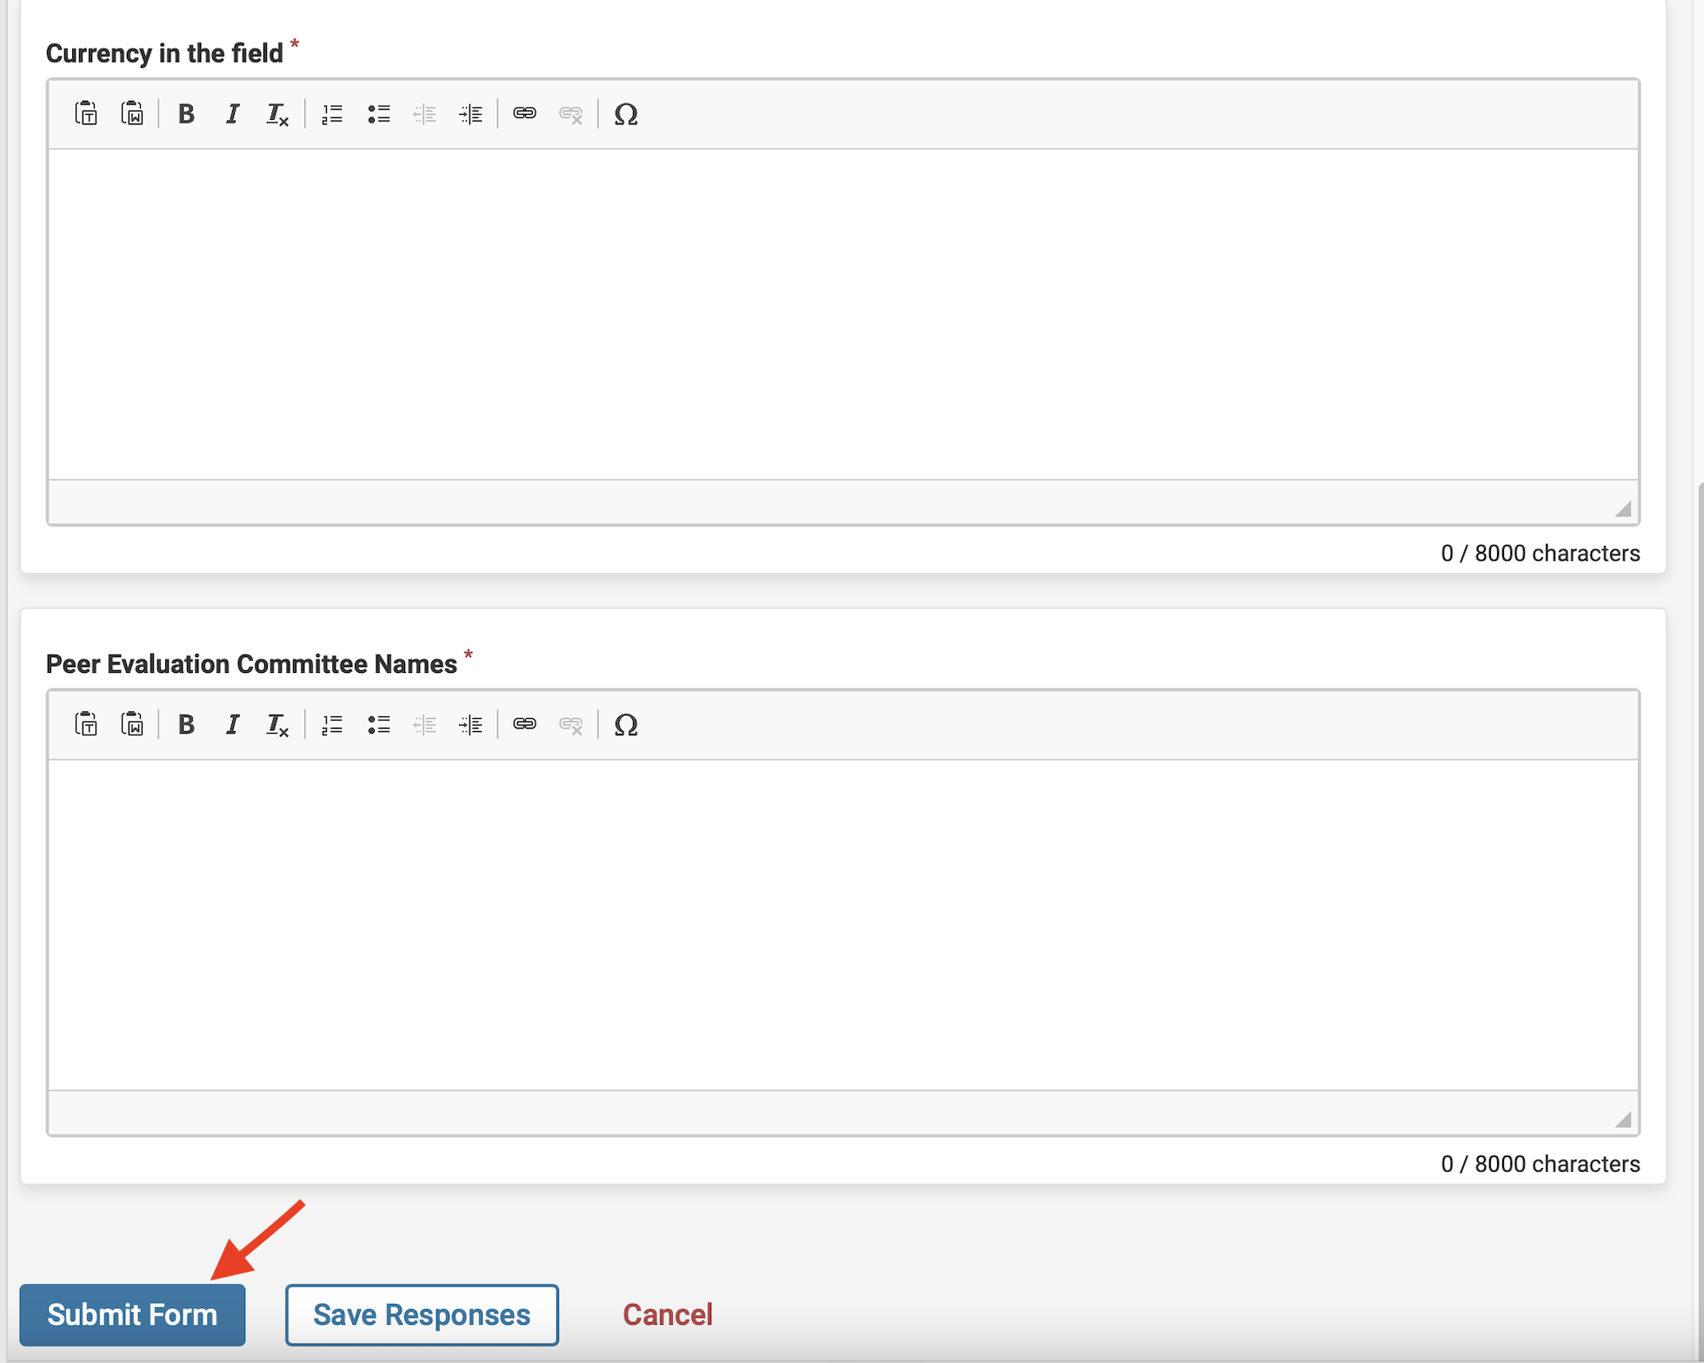

  - After submitting the form, you will see “Edit Submission”. That means that you have completed the form, but you can still change your responses, as long as you have not moved the case forward or shared it with the candidate.
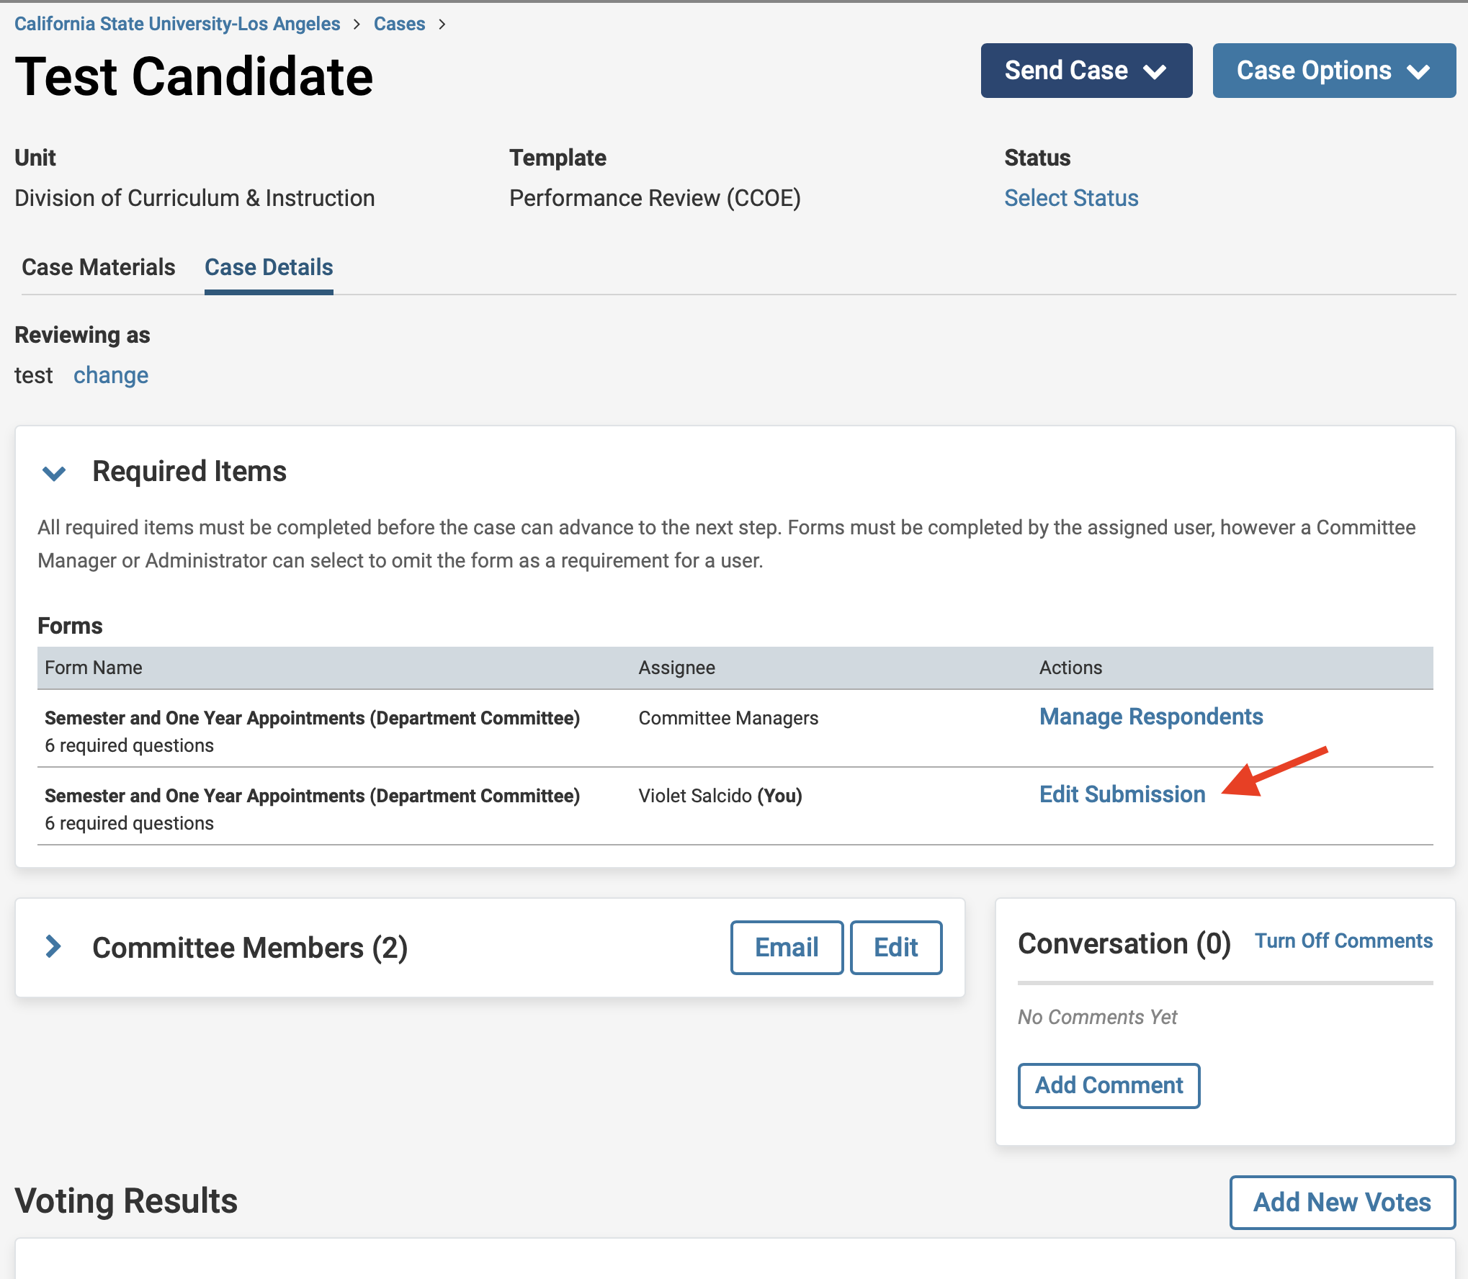
  - IMPORTANT: Click on “Case Materials” near the top-left of the page.

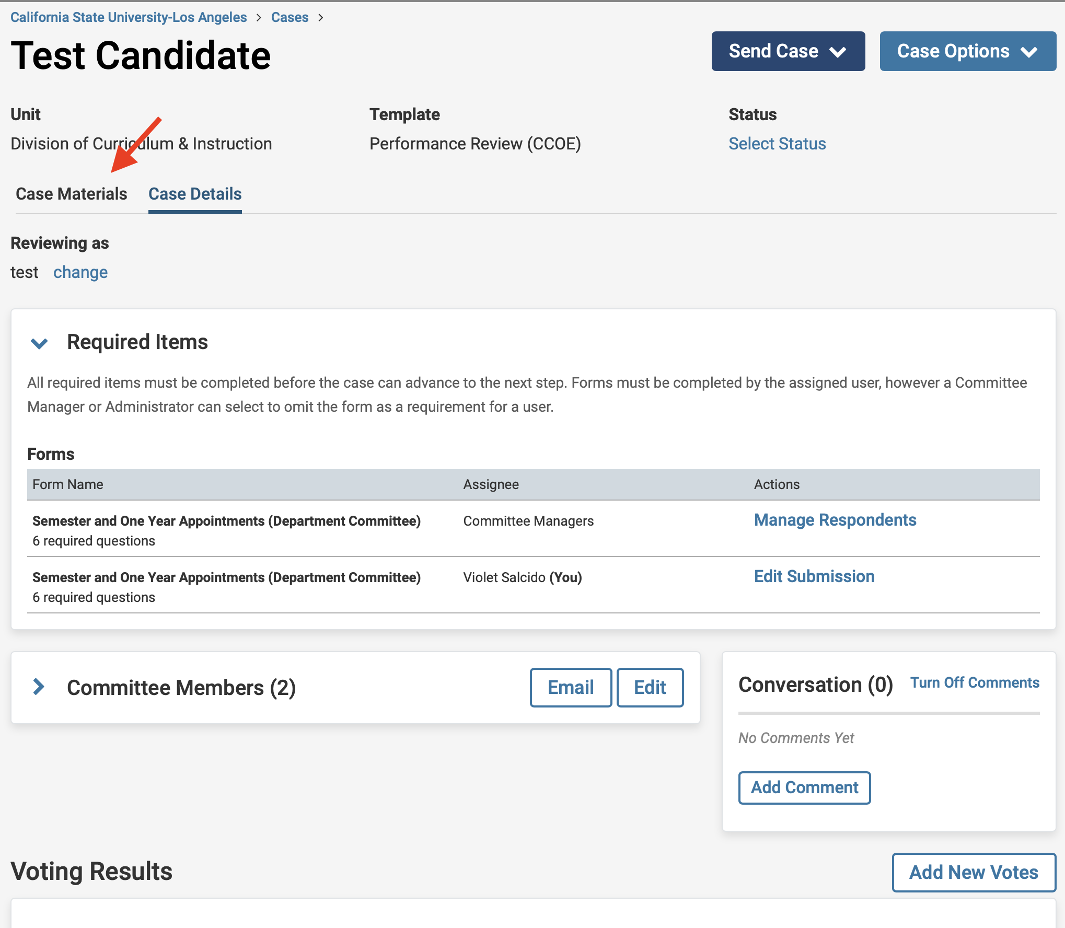

  - NEXT, SCROLL DOWN to “(Performance Review or Periodic Evaluation) Report Submission (All Levels)” and CHECK THE BOX NEXT TO THE DOCUMENT TITLE.
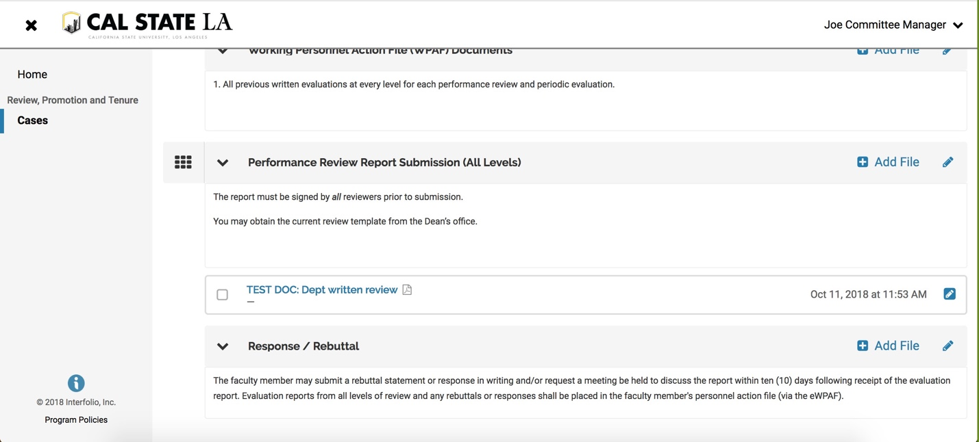

  - Click on the box next to the file name. Please make sure that the report has finished uploading and it does not say pending.
Click on “Share,” and when the pull down menu opens, select “With Candidate.”

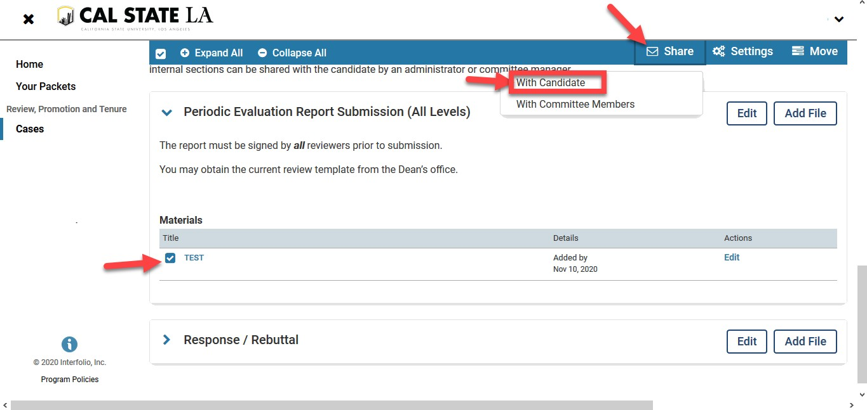
  - 1. In the Subject line box, type: “Your Dean’s Review.”
- In the Message Box type:
“Please see your review document. You have 10 days (after the committee deadline as posted on the University RTP Calendar, http://www.calstatela.edu/FacultyAffairs/current-calendars) to provide an optional response or rebuttal to this review. A response or rebuttal is not required. ”

- In the grey box on the right, click “Enable.” If you do not see the enable box, you did not click on the box next to the file name and there is nothing attached, or the file is still pending.
- The attachment appears below the message. If there is nothing there, no file is attached.

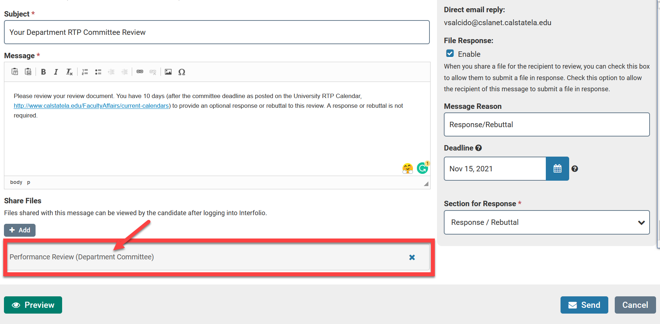

- In Message Reason, type “Response/Rebuttal.”

- For “Deadline,” use the correct Optional Rebuttal Deadline from the RTP Calendar.

- From the pull down menu on the bottom-right side, select: “Response/Rebuttal”
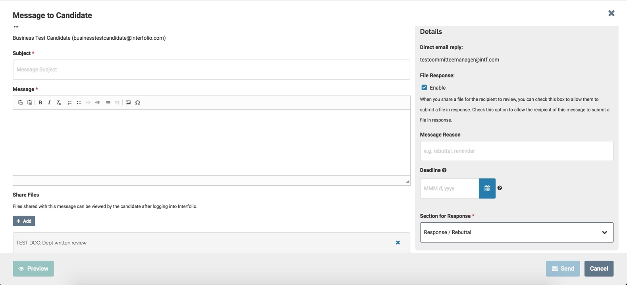

  - Click “Send.”

  - After sharing the evaluation with the candidate, since the Dean is the last step, you do not need to send the case forward. The case will be closed after the rebuttal period.

