CSU Learn: Viewing Transcripts and Certificates
Spring 2019, Version 1.2

Training Transcript
The Training Transcript displays user information as well as details about your completed training (i.e., including trainings completed before December 31, 2018) such as Start Date, Completion Date, Score, and more. The Training Transcript is viewable by custom Date Range and may be printed as well as exported to PDF. In addition to obtaining the full transcript, users may also obtain their Certificates of Completion from the Activities list.
To navigate to the Training Transcript:
- Log in to CSU Learn by visiting the Portal and logging in with your campus account.
- Once logged in, click the CSU Learn Quicklaunch link.
- A new tab will open in the browser and you will be logged in to CSU Learn.
- Click the Transcript button on the homepage to view your completed training and certificates of completion (see Figure 1).
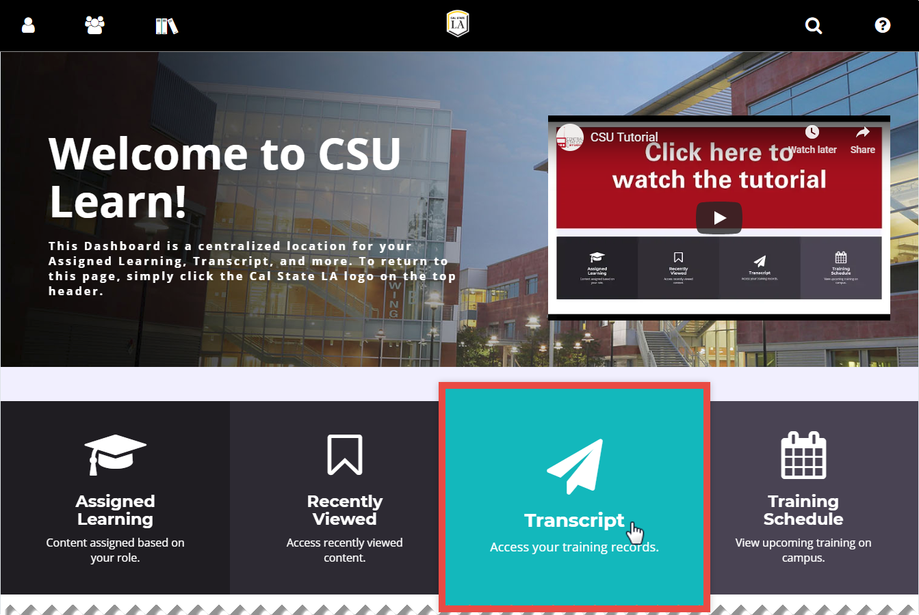
Figure 1 – CSU Learn homepage with Training Transcript highlighted
- The Training Transcript may be printed or exported to an Adobe PDF document and the details about the completed trainings may be viewed in the Activities section (see Figure 2).
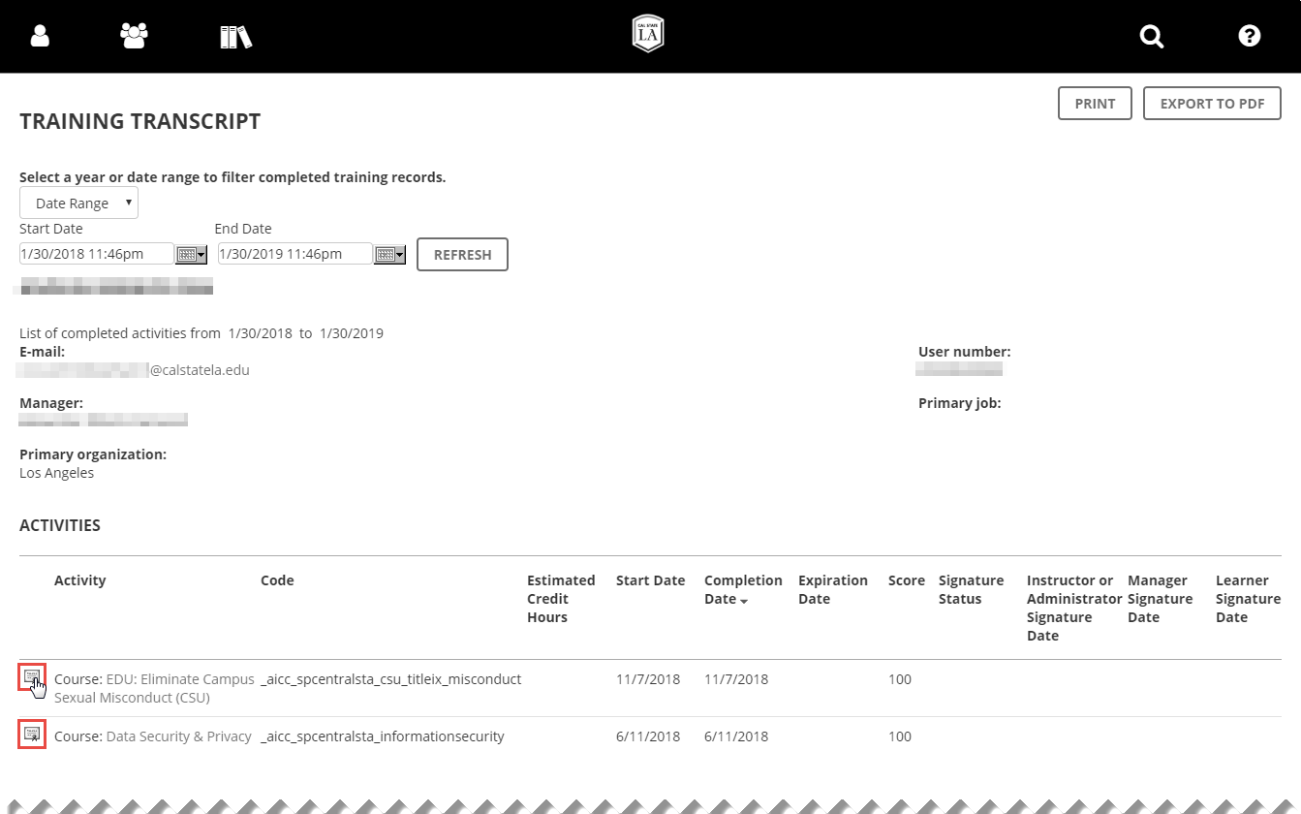
Figure 2 – User’s Training Transcript displayed

Viewing a Certificate of Completion
A certificate is proof that you successfully completed the requirements of a learning activity. You can print or download a certificate as a PDF after successfully completing an activity. Depending on the requirements and type of training, some online training in CSU Learn issue certificates while others do not. An example of training that issues a certificate of completion is a compliance training such as Conflicts of Interest.
To view a certificate of completion:
- While in the Training Transcript, scroll to the Activities section at the bottom of the screen.
- Locate the desired completed training by verifying the name of the training in the Activity column.
- Once the desired training has been located, click the Certificate button to view the certificate (see Figure 3).
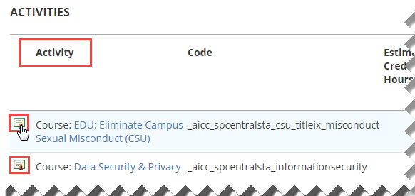
Figure 3 – List of completed training in Activities section
- The certificate is displayed on the screen and may be printed if desired (see Figure 4).
NOTE: To download a PDF version of the certificate, click the Print button and use the Print to PDF or Save as PDF option. Before printing or saving, ensure the certificate is in the Landscape orientation or layout.
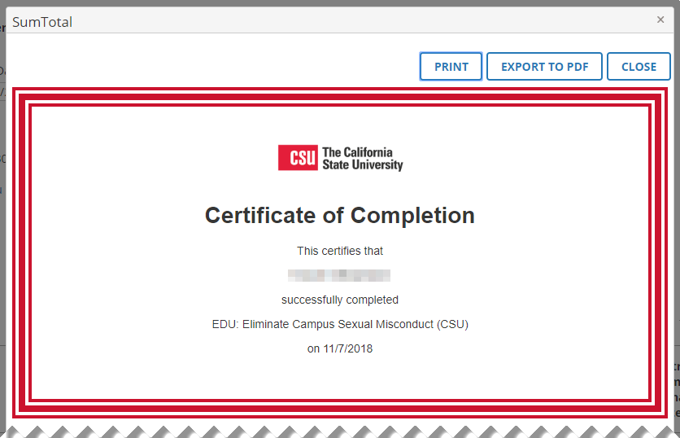
Figure 4 – User’s Certificate of Completion

