**Encrypting files and folders**

# **Password-protect using 7-Zip**

1. 7-Zip should be installed on all University-issued workstations. If the software is not on the workstation, please download the software at the following link by the appropriate operating system: <https://www.7-zip.org/download.html>
2. Locate the file/folder of where the sensitive information is located.

Right-click on the located file/folder and there should be a 7-Zip selection. Hover over 7-Zip to open the following options:

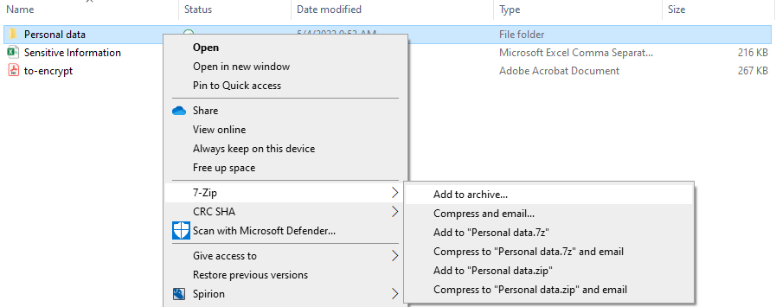

1. There are 6 options 7-Zip allows.
   1. **Add to archive…:** If this is your first time adding to a 7-Zip archive, click this option to add a new archive as a 7z file. This would be the same as the option **Add to “/filename/.7z”**. If you have a 7z file archive that you would like to add the file/folder to, click on this option.
   2. **Compress and email…:** Asks you to add to a 7-Zip archive through a pop-up with different compression options (.7z, .zip, etc.), and attaches the archive to a newly drafted email.
   3. **Add to “/filename/.7z”:** Creates a new archive under the same filename as a 7z file immediately.
   4. **Compress to “/filename/.7z” and email…:** Creates a new archive under the same filename as a 7z file immediately and attaches the archive to a newly drafted email.
   5. **Add to “/filename/.zip”:** Creates a compressed zip folder immediately using the same filename.
   6. **Compress to “/filename/.zip” and email:** Creates a compressed zip folder immediately using the same filename and attaches the zipped folder to a newly drafted email.

Select the option that is most appropriate to you. We suggest clicking “Add to archive…” as it is the most customizable.

1. A pop-up should show up with the following options:

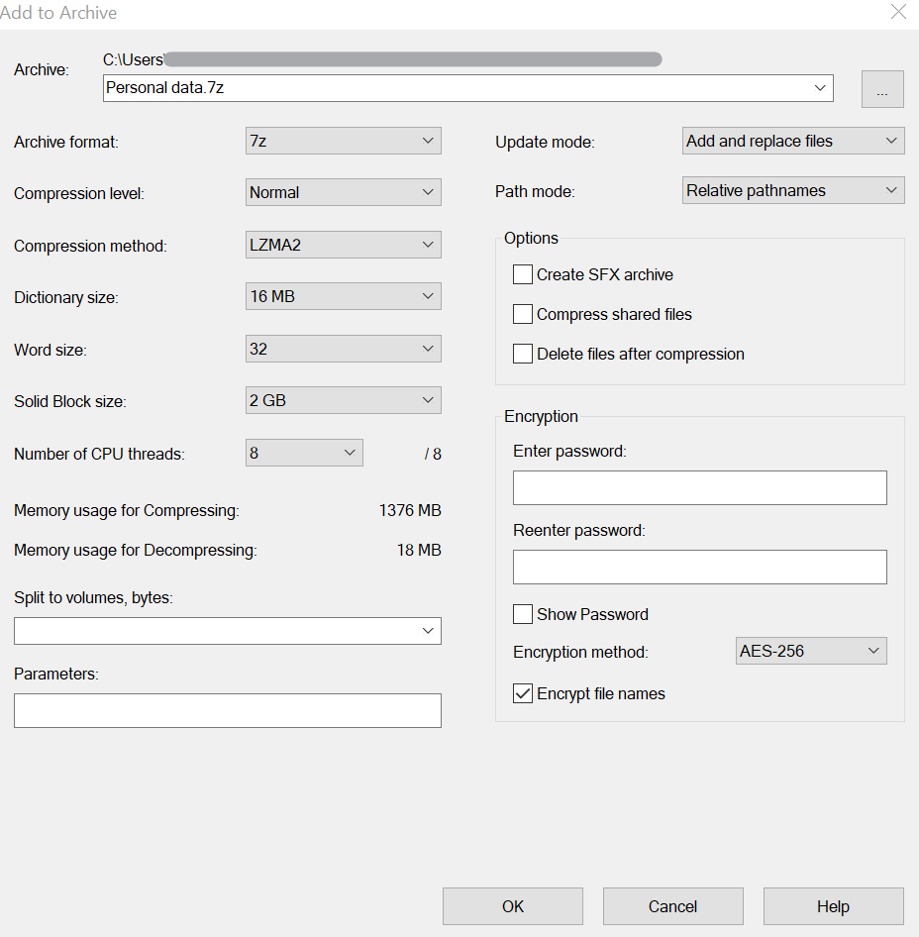

1. Locate the Encryption section. There are two fields for entering a new password. Enter a strong password of at least 8 characters using capital and lowercase letters, numbers, and special characters in the first field. Reenter the same password in the second field.

**Note: Do not lose this password as it is crucial for accessing this data**

1. Locate the Options section. Click on “Delete files after compression” to easily delete the non-encrypted file/folder from the PC.
   1. You may skip this step, but **you would need to delete the original file/folder after compression**. It will still be in the same directory, with one non-encrypted and the other encrypted, such as the following:  
      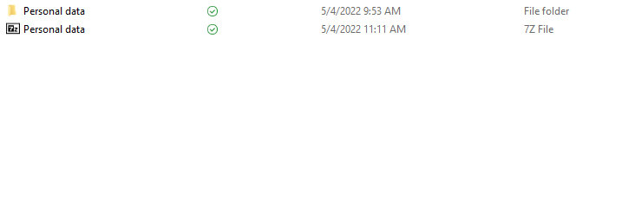
   2. If the option was selected, the original file/folder will immediately be deleted, as it is already saved to the encrypted archive file. **This is recommended as users may forget to delete the original unprotected file/folder after compression.**
2. Click OK at the bottom of the pop-up to save your selections/entries. You have now successfully created a password-protected archive to store sensitive data.

# **Viewing/Extracting the password-protected files/folders**

1. To view or extract the files, right click on the encrypted file and hover over the 7-Zip selection to expand the options:  
   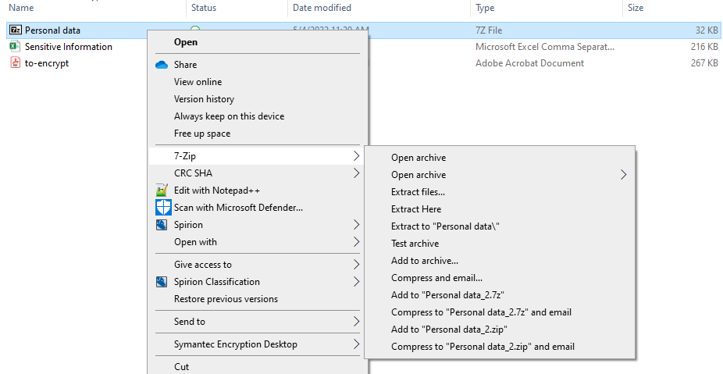
2. If you were to click any of the options, you will see 7-Zip pop up a password prompt:

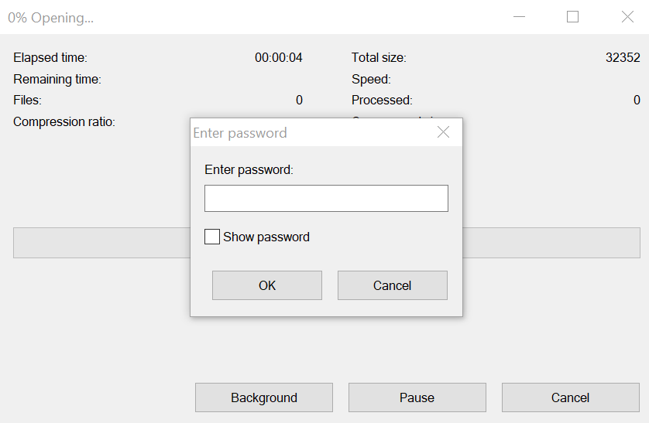

This ensures that all the data in the file is protected. Enter the strong password that was created, and the files/folders that were added should now be viewable.

# **Adding additional sensitive files/folders**

1. For additional files/folders with sensitive information, you may choose to create a new archive with a unique, strong password. Otherwise, you can add the files/folders to the archive you already created. Right-click on the file(s)/folder(s) (if there are multiples, hold Ctrl and click the additional files/folders) you would like to add to archive, and hover over the 7-Zip selection.  
   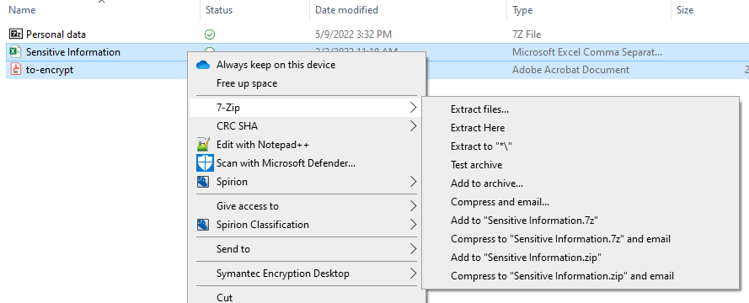
2. Click on “Add to archive…”. You will see the same prompt as if you were creating a new archive, as mentioned in the previous steps.
3. Change the archive using the downwards carrot sign at the right of the “Archive” field or click on the ellipses button to browse for the desired archive on your PC.

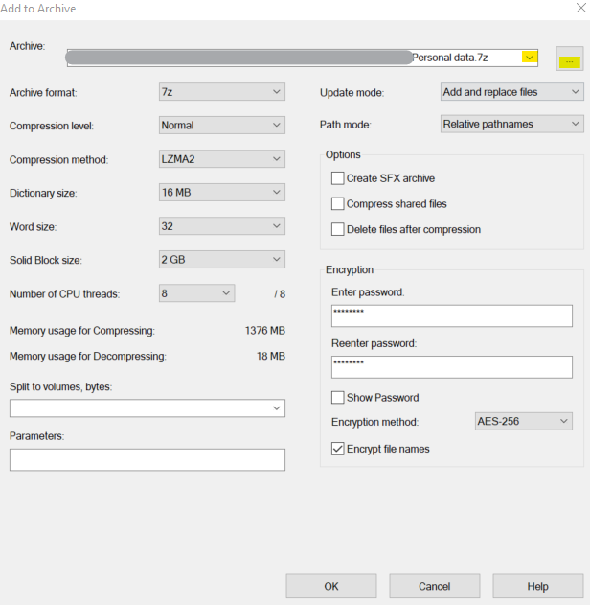

1. Click on “Delete files after compression” to easily delete the non-encrypted file/folder from the PC, as mentioned in the previous section.
2. Re-enter the archive’s password under the Encryption section.

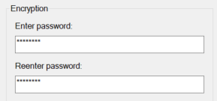

1. Click “OK” at the bottom to store the files to the archive.
2. You will now see the files/folders that you just added to the archive when you open it. Please see the previous section on how to view/extract the files/folders.

You have successfully password-protected sensitive information on your workstation. Thank you for your cooperation!

|  |  |
| --- | --- |
|  | **IT Security & Compliance** [**ITSecurity@calstatela.edu**](mailto:ITSecurity@calstatela.edu)**California State University, Los Angeles 5151 State University Drive Los Angeles, CA 90032 T 323.343.2575** [**calstatela.edu**](http://www.calstatela.edu/) **|  *Pushing Boundaries*** |