Executive Committee Meeting Minutes

July 9, 2020
Time: 12:45 – 2:45 p.m.
Place: Zoom Meeting

Present: S. Burstein, M. Cates, J. Cleman, S. Felszeghy, J. Galvan, A. Gonzalez, M. Huld, D. Keane, J. Kirchner, D. Margaziotis, K. Reilly, W. Taylor, A. Winnick
Absent: P. Brier, J. Fisher-Hoult, N. Hunt, S. Ladochy, B. Sinclair, F. Stahl

- Announcements
  - Bill announced he anticipated that the third edition of the Emeritimes for the 2019-2020 year will be mailed before the end of July. We considered printing and mailing it as usual, emailing it, or placing it on the website as usual with an email notice to access it there. Printing and mailing is the preferable delivery method. This is primarily because our mailing addresses are more complete than emailing addresses. We don’t have email addresses for about 27% of the emeriti.
Reprographics is down to a skeleton crew as is the mailroom during the pandemic.
They will be able to help us but they also have other demands. Anna Caudillo in the
President’s Office has, as usual, been helpful in facilitating preparation and delivery of the
Emeritimes.
  - There was further discussion of the stuffing and mailing of the Emeritimes. Bill will pick up the materials when they are ready and deliver them to the people who will do the stuffing (Bill, John C., Alfredo, Ellen, and Kathy – Martin and John K. offered if more help is needed). Bill will then collect them and deliver them to President’s office for forwarding to mailroom.
  - Marshall announced that last year the amount in the savings account triggered an I 1099 form so this year he transferred the amount of savings into the checking account which now has a balance of $26,912.
- Approval of Agenda
2.1 M/S/P as presented
3.0 Approval of the Minutes:
3.1 Minutes of the Executive Committee Meeting: February 13, 2020
3.1.1 M/S/P with following change: 1.2 delete from Hema Chari’s name as Emerita
“removed since she is out of the country”. Note: Steve F. will check the database
to determine rationale for this.
3.2 Minutes of the Executive Committee vote on April 30, 2020 to Expend $10,000
in 2020/2021 from the Emeriti Fellowship Fund for Fellowships.
3.2.1. An action proposed by the Fellowship Committee was based on the following
background information:
For the fellowships to be awarded this spring we could allocate $20,000 for Emeriti
Fellowships. This would be in addition to the named fellowships which could total about
$5,000. Given the economy in the past few months, Alfredo Gonzales and Bill Taylor
discussed this amount with Marshall Cates. His suggestion was we allocate $10,000 and roll
the remaining $10,000 forward given the potential impact of the Coronavirus pandemic on
investment funds. If future payouts on the Emeriti Fund investments are lower than in the past,
the rolled over $10,000 will provide us a base for fellowship awards in the following year.
Factors are that the number of applications for our fellowships is down from last year and last
year we expended $8,000 from the Emeriti Fellowship Fund. Limiting the amount expended
from the Emeriti Fund in 20/21 will allow us to carryover enough money to award
approximately the same number of fellowships in 21/22 and same number of fellowships in
22/23.
3.2.2 The Fellowship Committee met Friday, April 24, 2020 and considered this issue. They
unanimously passed the following motion: M/S/P that we expend $10,000 in 20/21 from the
Emeriti Fellowship Fund for fellowships.
3.2.3 This needed immediate action so the Fellowship Committee could proceed with review of
fellowship applications. The background information and action proposed by the
Fellowship Committee were then emailed to all Executive Committee members for their input
with a response deadline of April 30, 2020. M/S/P by a unanimous majority of Executive
Committee members to accept the Fellowship Committee proposed action.

4.0 Officer and Committee Reports and Recommendations
4.1 Life Long Learning: Peter Brier Postpone until the next meeting
4.2 Fellowship Chair: Alfredo Gonzalez Postpone until the next meeting
4.3 Academic Senate: John Cleman, Nancy Hunt Postpone until the next meeting
4.4 Treasurer’s Report: Marshall Cates Postpone until the next meeting
4.5 Fiscal Committee Report: Marshall Cates Postpone until the next meeting
4.6 Webmaster Report: Demetrius Margaziotis Postpone until the next meeting

5.0 New Business
5.1 Nominations - Proposed Action Plan for Approving Nominations Committee Slate: Time Certain 1:00 p.m.
5.1.1. The following proposed action plan was discussed:
Article VII of Constitution – Nominations Procedures
The President shall appoint a Nominations committee that shall present a slate of
candidates for open offices at the annual meeting; additional nominations may be
made from the floor at the annual meeting.
Because of the campus closure due to the corona virus the Emeriti Association was
not able to hold the annual spring meeting. It is proposed that the following
procedure be followed in lieu of elections at the annual meeting:
- The Executive Committee reviews this procedure and approves or makes modifications and
approves.
- The slate of officers is then emailed to Emeriti members. Emeriti members are given one week to make additional nominations.
- The slate of officers, including additional nominations, is then emailed to Emeriti members for their approval. Emeriti members are given one week to vote yes or no for each candidate on the slate of officers.
5.1.2. Discussion centered around whether it was necessary to have two emailings to members.
The constitution calls for nominations from the floor during the annual
meeting; thus the first email requesting nominations from the members would satisfy this
requirement. If additional nominations were received, they would be added to the slate.
5.1.3. The proposed action plan was M/S/P unanimously as presented.
5.1.4. It was M/S/P to proceed with this plan before the approval of the minutes of this meeting.
5.2 Nominations Committee Proposed Slate for 2020/2021: Time Certain 1:30 p.m.
5.2.1. The following slate was presented:
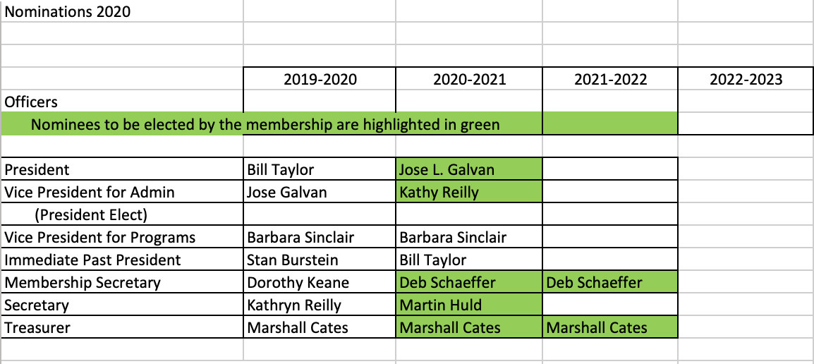

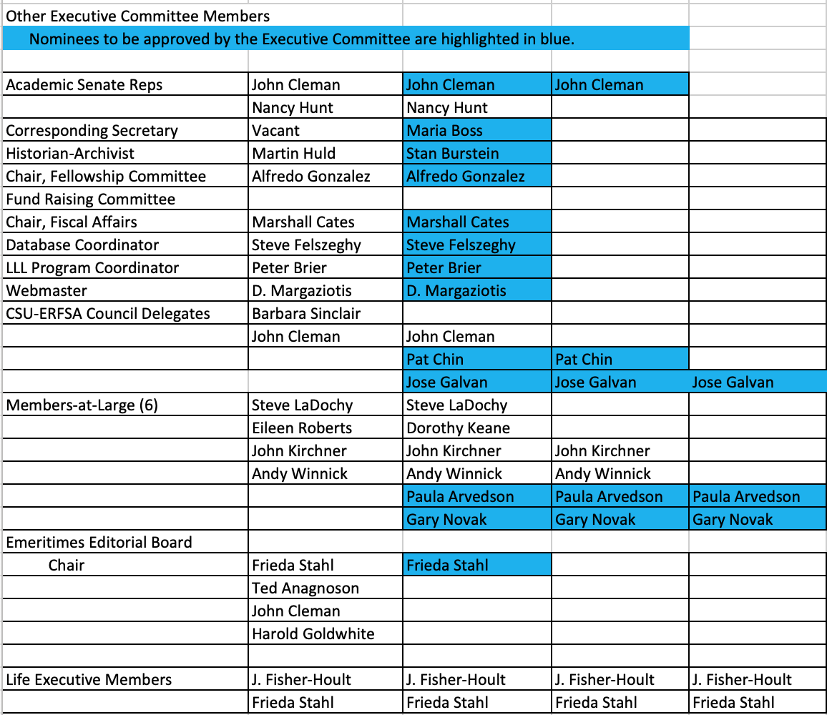
5.2.2. The slate was M/S/P with one abstention.
5.2.3 It was M/S/P to proceed with this plan before the approval of the minutes of this meeting.
5.3 Plan Senate Meeting Presentation Postpone until the next meeting
5.4 Schedule of Emeritimes Postpone until the next meeting
5.5 Brochure for Emeriti Association Postpone until the next meeting
5.6 Fall Election Event Postpone until the next meeting
5.7 ERFSA Membership Drive Postpone until the next meeting

6.0 Old Business
6.1 Emeriti Involvement in Campus Address to Student Homelessness and Undernourishment: Time Certain 2:15 p.m. (Dorothy Keane, Kathy Reilly and Andy Winnick) Postpone until the next meeting
6.2 Len’s Plaque Postpone until the next meeting

7.0 Adjournment
7.1 The meeting was adjourned at 1:20 p.m.
7.2 The next meeting will be held by Zoom on Thursday, August 13 at 12:45 p.m.

Submitted by Kathy Reilly

