California State University, Los Angeles
Emeriti Association Meeting Minutes

Thursday, March 9, 2017
Time: 12:30-2:45 p.m.
Place: SA 110

Present: S. Burstein, J. Casanova, M. Cates, D. Dewey, N. Fabris, S. Felszeghy,
J. Galvan, A. Gonzalez, D. Keane, D. Klein, D. Margaziotis, B. Sinclair, B. Taylor

Absent: J. Adenika, P Brier, J. Cleman, J. Fisher-Hoult, R. Marshall-Holt, L. Mathy, K. Reilly, F. Stahl, W. Taylor

Stan Burstein chaired the meeting in the absence of John Cleman
- Announcements
1.1 Alfredo Gonzalez explained the writing class.
1.2 Barbara Sinclair inquired about inviting College Deans to our luncheons
1.3 Stan Burstein reported that he, Dimitri, Steve and John met with AVP Tosha Pham to discuss ITS related problems that we are having. Dimitri will give more information in his report.
1.4 Mr. Walter Askin invited a small group of 5 or 6 to his gallery for a personal tour.
If interested, let John know.
1.5 Ellen needs volunteers to write the obituaries for Borman and Jim Boulgarides
1.6 Roberto Cantu’s conference will be April 14-15. Roberto mentioned that he may have a funding stream available through the Mexican Consulate.
1.7 Dimitri reported on an email he received from Connie Wong and Cheryl Simmons,
who teach service learning classes in School of Kinesiology. They would like to meet
with a representative from our committee to see how emeriti can be informed of
opportunities for individual and group exercise on campus. They stated, “We
believe that students learn best through real life/real world experiences. We love
the idea of former CSLA professors coming back to benefit from the skills of current
students. Your members have much to offer also, in terms of insights and perspectives.” Ms. Wong was referred to John to make suitable arrangements.
1.8 Dorothy and Barbara updated the committee on Rosemarie Marshall’s condition.
Barbara gave the address of the hospital where Rosemarie is being treated:
Californian-Pasadena Convalescent Hospital, 120 Bellfontaine St., Pasadena, CA
91105
1.9 Barbara Sinclair mentioned that our campus, Dominguez Hills and San Diego are
the three highest collectors of Shoes for Souls. Keep it up; spread the word.

- Approval of Agenda
  - M/S/P with the addition of item 6.7, Who should be invited to the Emeriti luncheons

- Approval of Minutes of February 9, 2017
  - M/S/P to approve the minutes

4.0 Officer and Committee Reports and Recommendations

4.1 Vice President for Administration: Stan Burstein
4.1.1 Stan mentioned the History of Cal State LA project to VP Mahoney.
She seemed to show interest. Stan is making contacts on campus to
involve students in writing the history. More will be reported later.

4.2 Vice President for Programs: Jean Adenika
In Jean’s absence it is assumed that the planning for the Spring luncheon is progressing nicely.

4.3 Treasurer: Marshall Cates
4.3.1 Marshall distributed the Treasurer’s Report.
4.3.2 Marshall reported the balance in the checking account is $21,550.18
4.3.3 The FCU savings account balance is $10,039.17. There are donors’ checks totaling $1595.00 that were picked up today and will be reported on the next month’s report.

4.4 Fiscal Policy Chair: Marshall Cates
4.4.1 We have a problem with Life Long Learning’s account being part of our
account as they officially are not affiliated with the campus. We are working on ways to resolve this problem.
4.4.2 Membership: the best time to renew Emeriti Association membership is
in May. It is best to have a separate mailing for membership renewal.
The President’s office will support this.

4.5 Fellowship Chair: Alfredo Gonzalez
4.5.1. Alfredo reported that the application period for 2017-18 scholarships/
fellowships is March 6 – 28. One common application will be matched
to our fellowships. Reference letters are due April 6; two reminders
are emailed to faculty who agreed to submit reference letters.
June 1 is deadline for submitting fellowship recipients to financial
Aid office. Alfredo asked for volunteers to review applications.
There will be a reviewer orientation meeting on April 13.
4.5.2 Sixteen fellowships can be funded at the $1000.00 level; the
Mathy fellowship is funded at $2000.00

4.6 Webmaster: Dimitri Margaziotis
4.6.1 Dimitri gave details of the meeting with AVP Pham (item 1.3 above) to discuss problems with our listserv and other ITS related issues.
AVP Pham was receptive to Emeriti needs and she will put in place procedures to deal with our problems more efficiently including better service of the listserv, addressing needs of our website and communicating with ITS

4.6.2 Discussion of software availability for emeriti faculty:
Software for home use is available to faculty with a calstatela.edu email address only. The software distribution is handled by an outside vendor (Kivoto) who receives eligible names from the university. Regular faculty are on the approved list automatically if they are on Outlook 365. Emeriti faculty (especially those who are not otherwise employed-teaching by the university) may have to be added manually by ITS. Emeriti can make a purchase as follows:
1. Sign on to the myCalstatela portal, https://my.calstatela.edu using current CSULA credentials (user name and password). When you are logged in you will see a screen with a panel on the left that looks like this:
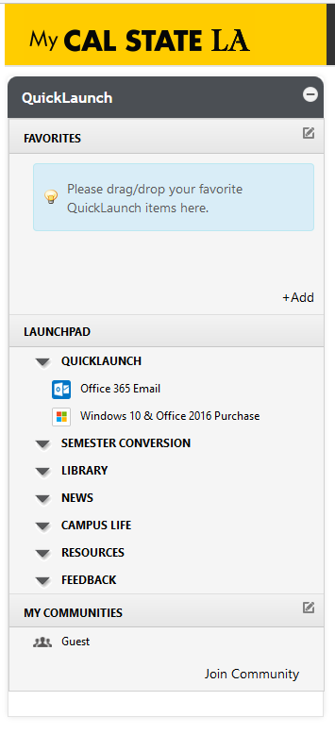
Note the option “Windows 10 & Office 2016 purchase”, half way down on this sample panel. If you are able to see this line, you are already eligible for the purchase of these two software items. To make a purchase click on this link and follow the links for the desired software (under the Microsoft tab) until your purchase process is completed. Download versions of the software are downloaded immediately. Hard copies (DVD) of Office 2016 only, if desired, will be mailed by the vendor within 4-6 weeks (download versions are ~$10, DVDs are ~$14). In order to purchase the DVD, one must purchase the download version first.

If you don’t see the line “Windows 10 & Office 2016 purchase”, your email address will need to be supplied to ITS so that you may be added to Kivoto’s approved list. You may do this on your own by visiting the ITS Help Desk (ground floor, Library Palmer Wing) with your campus ID card and asking the Help Desk to add your name/email address. Alternately, you may give your email address to the Emeriti Association president who, in turn, will forward it to ITS. Once this is done, you will be able to see the “Windows 10 & Office 2016 purchase” line and proceed from there. Additional software from companies other than Microsoft are also available through this process.
4.7 Emeritimes Editorial Board Chair: Frieda Stahl (absent; no report)

5.0 Old Business
5.1 Emeriti Fellowships/Scholarship
5.1.1 The number of fellowship awards for 2016-17 will be 16 fellowships
5.1.2 Alfredo moved two recommendations from the ad hoc Fellowship
Procedures and Practices Committee (Cleman, Galvan, Gonzalez).
a) M/S What are currently referred to as Emeriti Fellowships be given one of the two following designations as determined by the members who selected the fellowship recipients based on the distinctive characteristics of the recipient:
* Emeriti Association Golden Eagle Fellowship for Academic Excellence
and Service
Or
* Emeriti Association Fellowship for Outstanding Achievement and Commitment to (insert what distinguished this candidate to the fellowship reviewer)
After much discussion, it was
M/S/P To make a substitute motion
M/S/P What are currently referred to as Emeriti Fellowships be renamed Emeriti Association Fellowship for Academic Excellence in (the Student’s Area of Study).
b) The following criteria are being proposed, respectively, for each of the following named Emeriti Fellowships:
* James M. Rosser: Major in science, public administration, or education and evidence of interest in public service and/or athletics.
*Sidney Albert: Major in Philosophy, Literature, Theater, or other area
of humanities.
Carol Smallenburg: Major in any area of education
Jane Matson: Major in Counselor Education or other area of counseling or social service.
M/S Carol Smallenburg criteria be amended to focus on her work in
secondary education social sciences, global, urban and multicultural education
M/S/P to postpone discussion until our next meeting.
M/S/P to extend the meeting for 5 minutes.
Adjournment at 2:55 p.m.

Submitted by Dorothy Keane

